Grazioso Salvare CRUD Python Module
CS 340 Client/Server Development
Name : Isela Flores
Purpose :
This CRUD Python module serves as a reusable interface between Python programs and Grazioso Salvare's MongoDB database. The Austin Animal Center Outcomes database's animal shelter records can be created, read, updated, and deleted by users using this module. This feature facilitates the creation of a client-server program that can assist in determining whether dogs are appropriate for rescue training programs.

MongoDB Python Driver :
Python and MongoDB were connected using the PyMongo driver. Because PyMongo is the official MongoDB driver for Python and offers dependable support for database connectivity and CRUD operations, it was selected. The driver facilitates effective direct communication between Python applications and MongoDB collections and documents.

CRUD Operations :
Create :
- Inserts new documents into MongoDB
- Returns True if successful
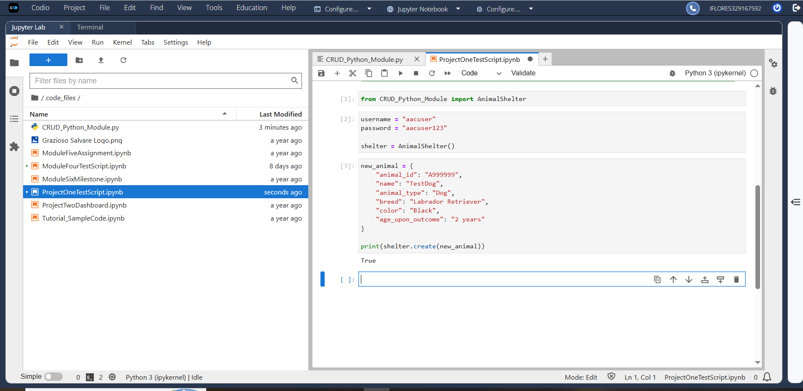
Read :
- Uses MongoDB read()
- Returns list of matching documents
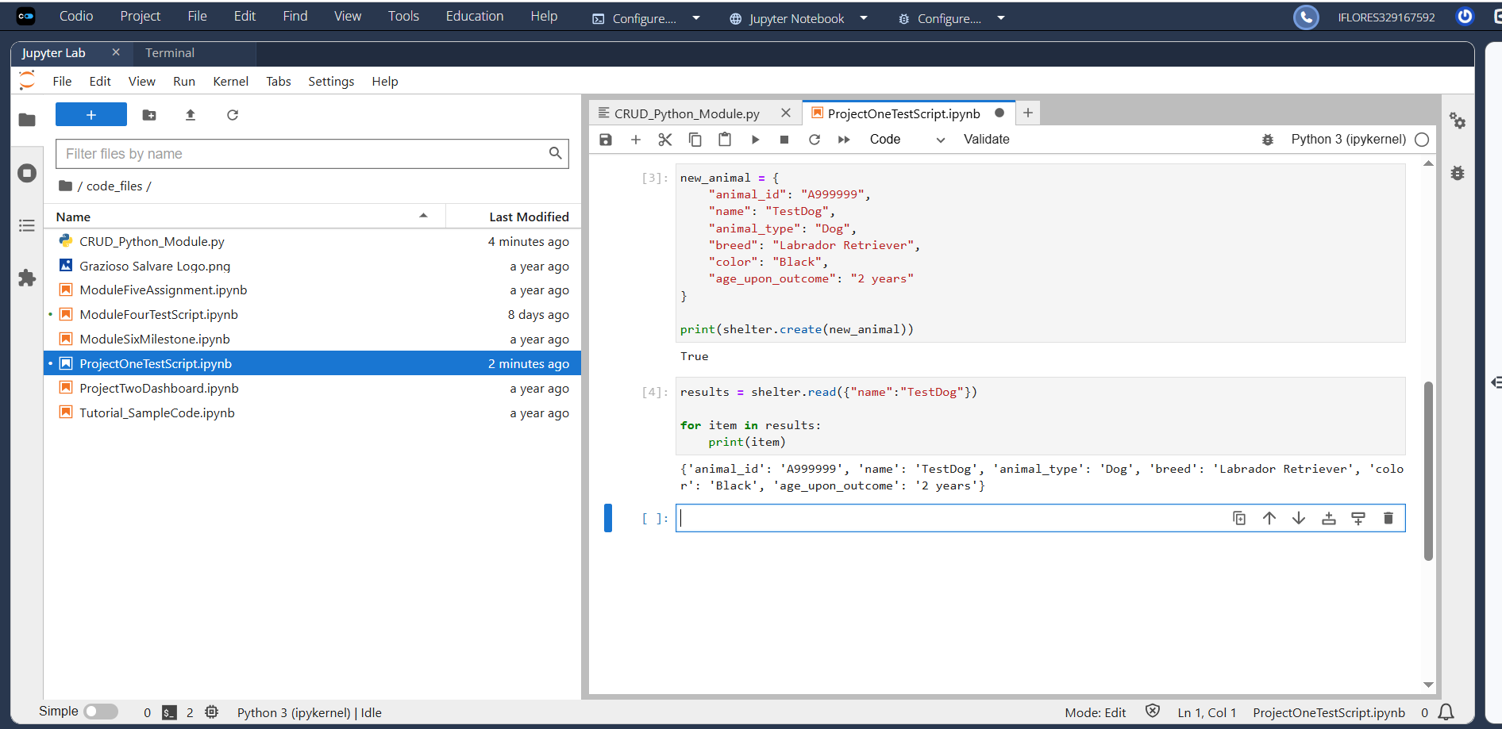
Update :
- Uses update()
- Modifies matching records
- Returns number modified
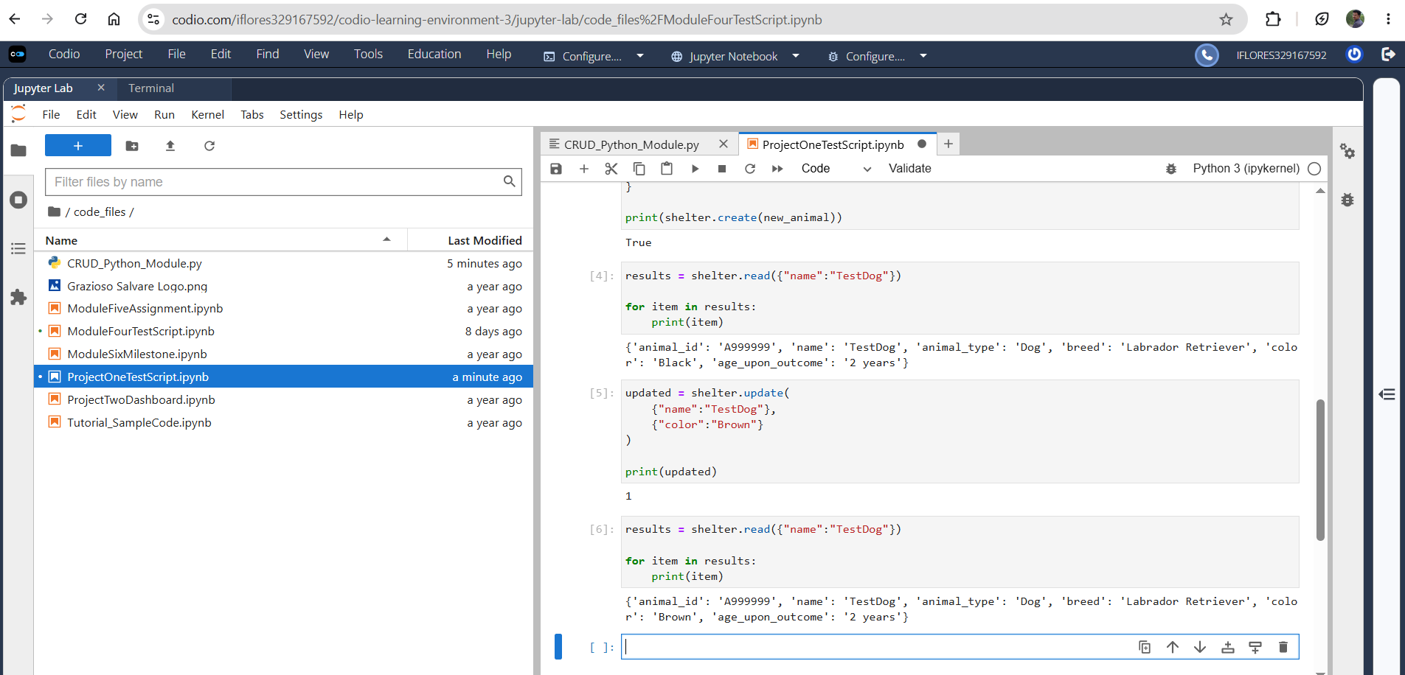
Delete :
- Uses delete()
- Removes matching documents
- Returns number deleted
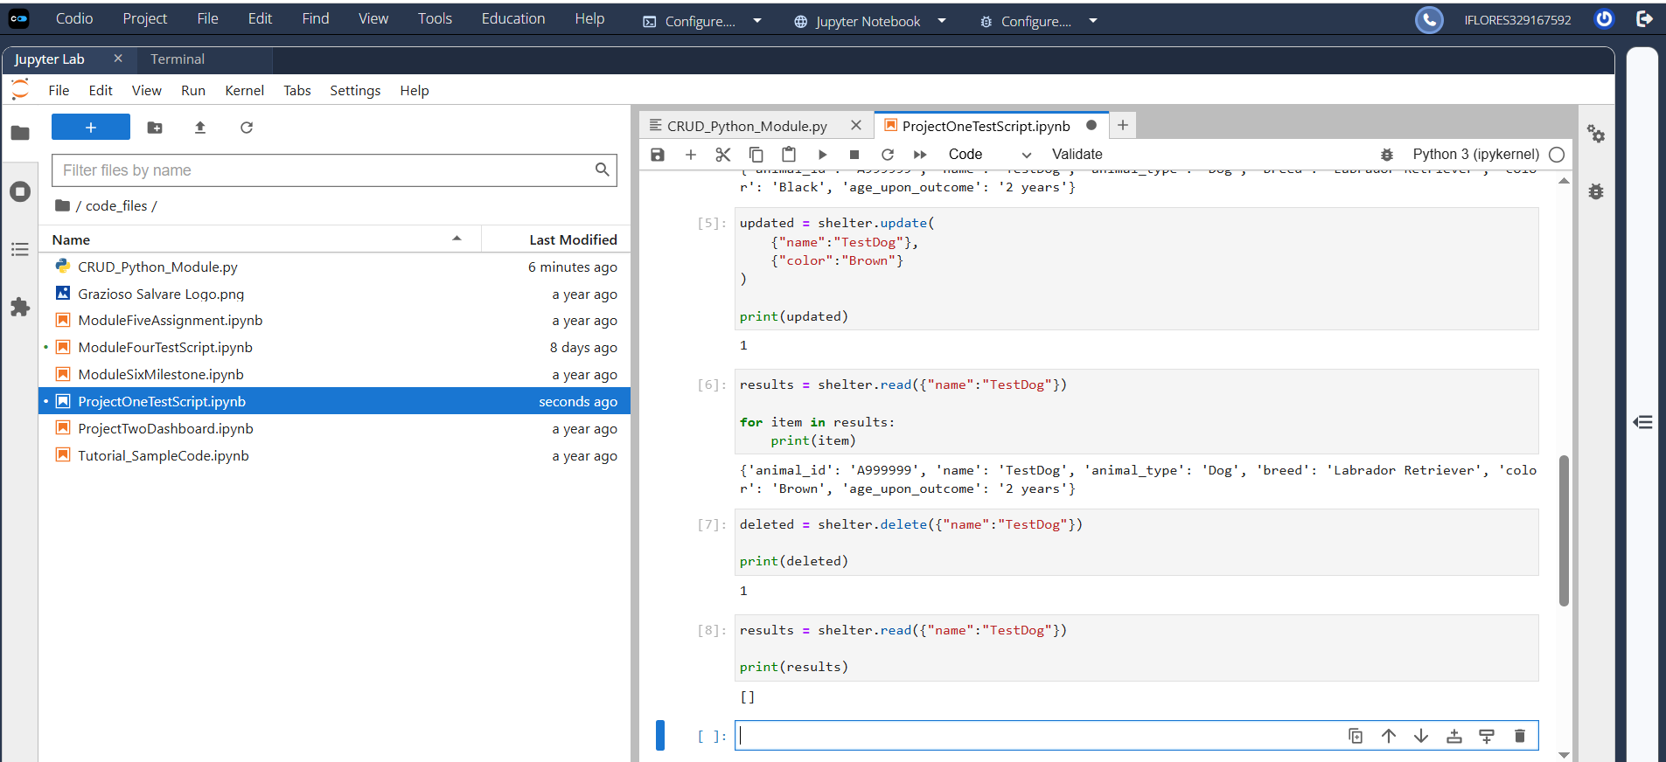
Mongo Import Execution :
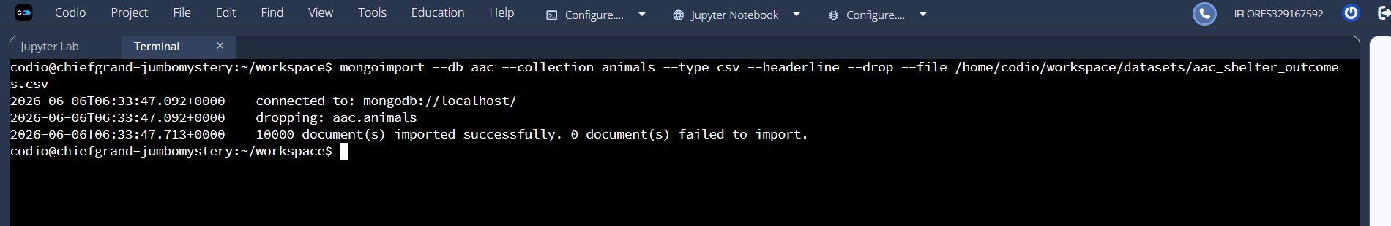
MongoDB User Authentication :
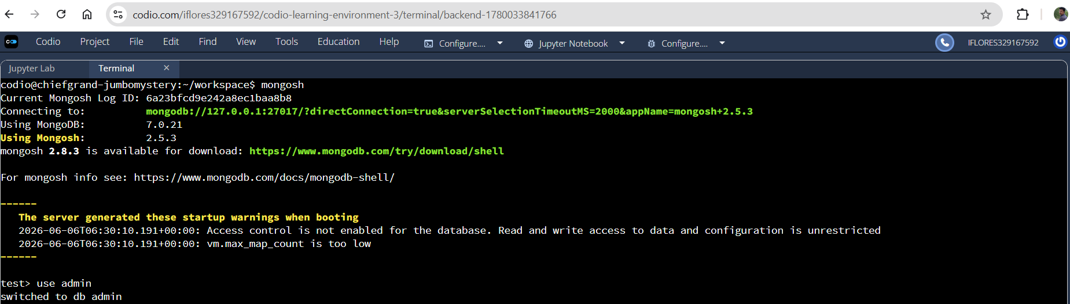
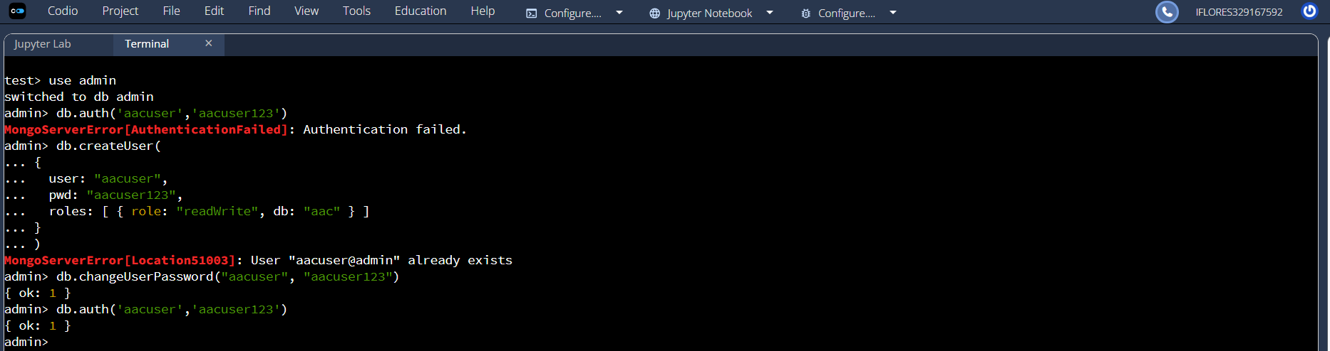
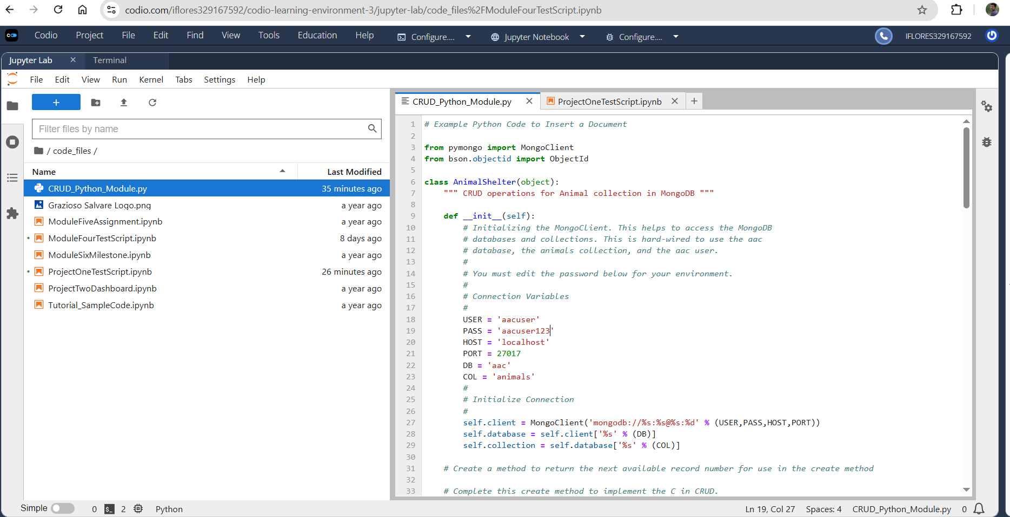
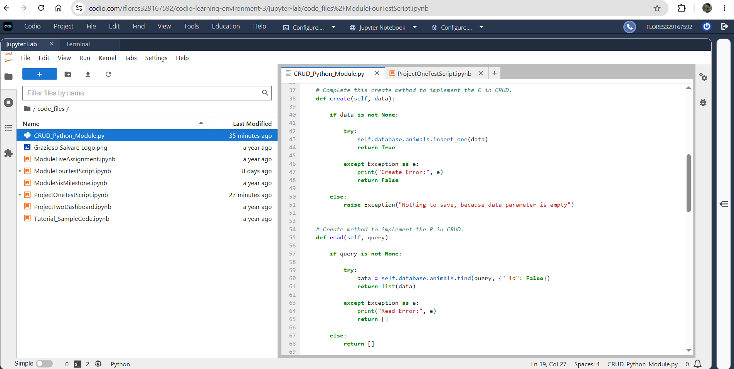
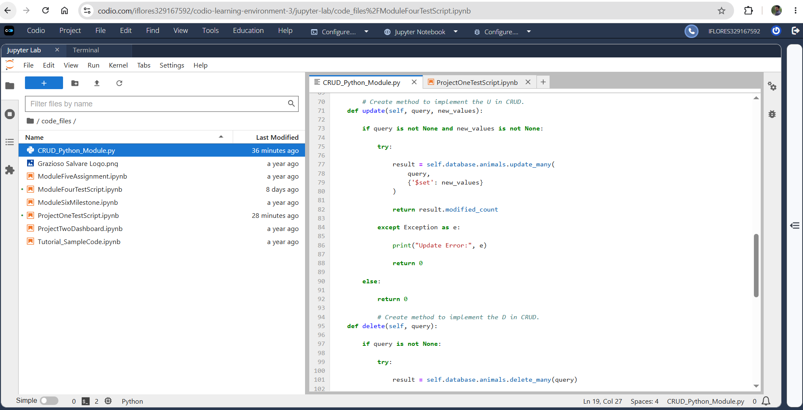
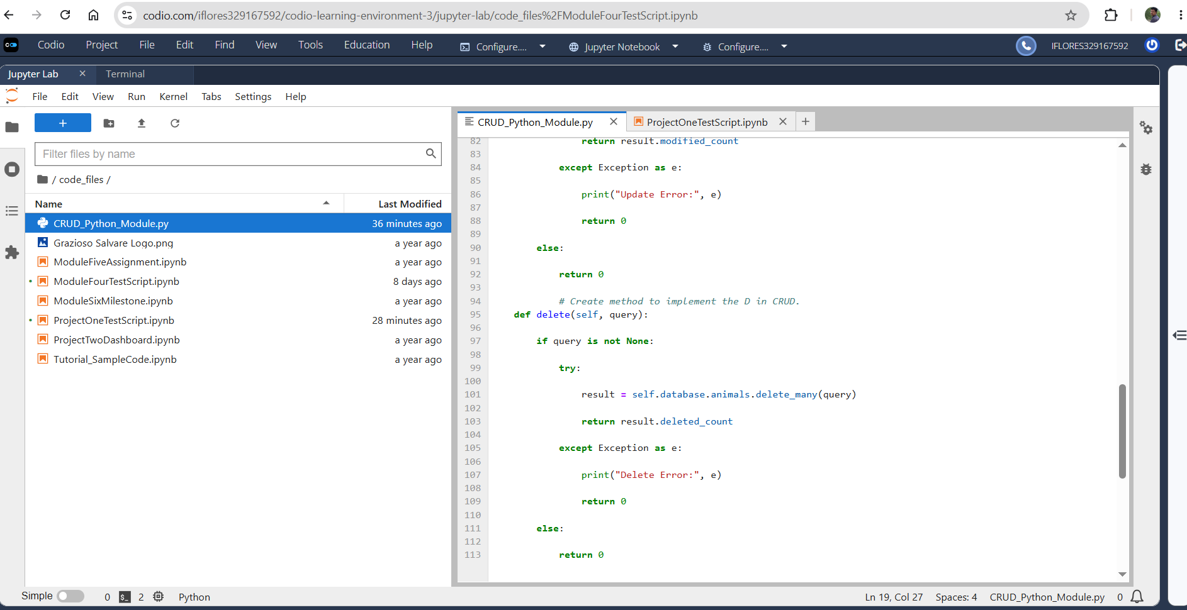
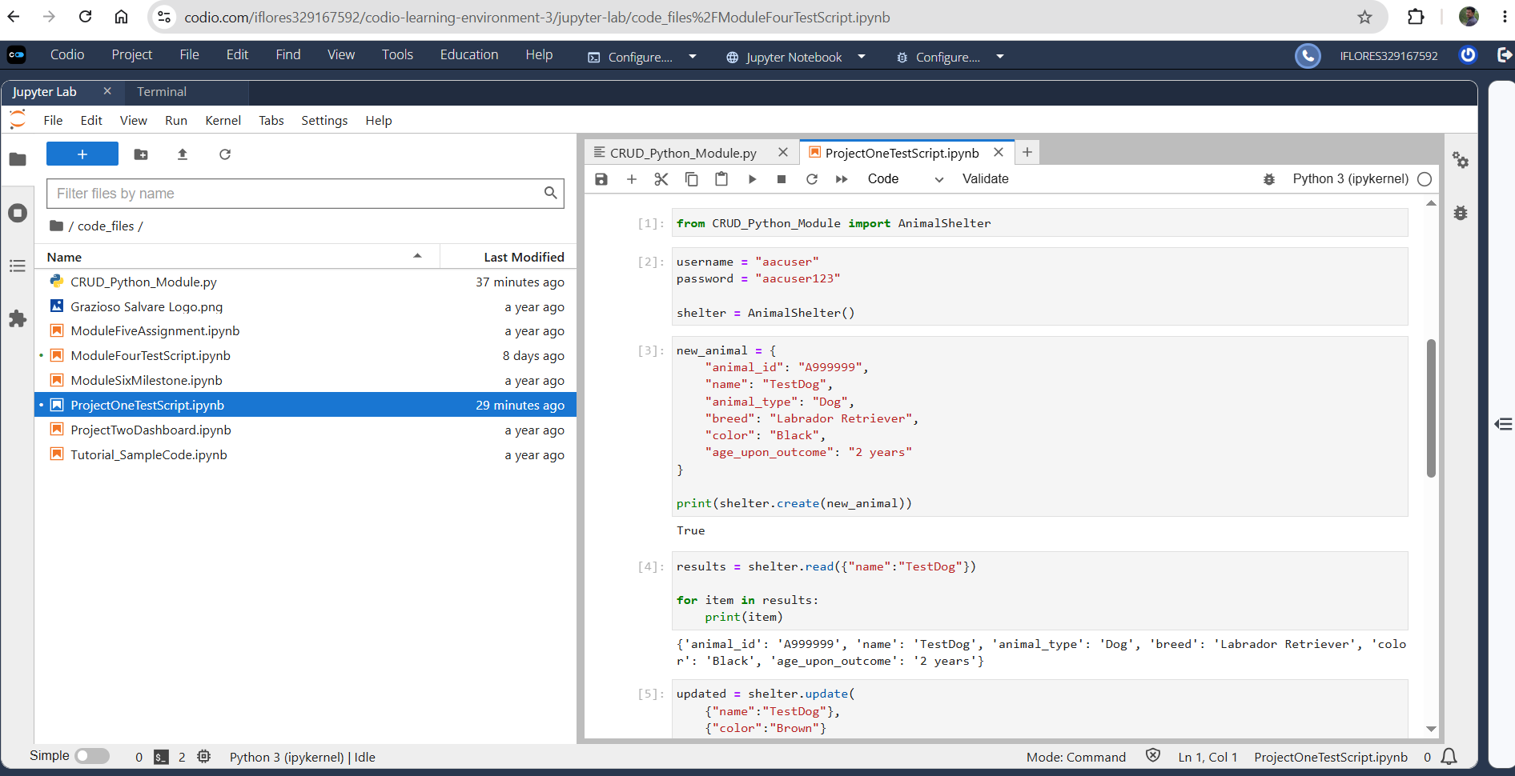
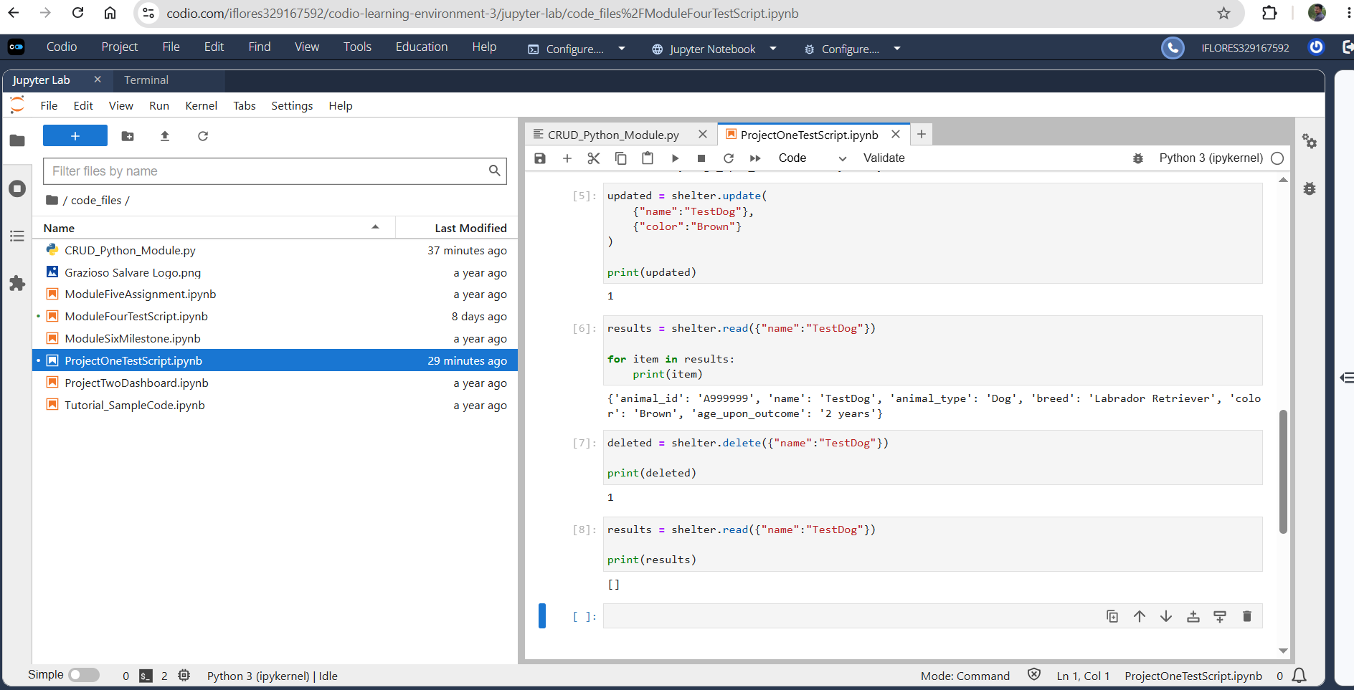
Conclusion :
This project effectively illustrated how to use Python and MongoDB to build CRUD capabilities in a client-server setting. A Jupyter Notebook test script successfully tested the database after it was set up with authentication and linked using the PyMongo driver. The finished module offers reusable features that can help Grazioso Salvare's dashboard development in the future.

