CS 499 Milestone Three
Algorithms and Data Structure – Artifact Enhancement Narrative
Student | Isela Flores
Artifact | Travlr Full-Stack Travel Application
Milestone | Milestone Three
Category | Algorithms and Data Structure

Brief Description of the Artifact

My Travlr full-stack travel application has been chosen as the artifact for Milestone Three. I created the program in 2026 for my CS465 Full Stack Development coursework, and it was later improved for CS499. Travlr offers an Angular administration application for trip record management as well as a customer-facing travel website.
Trip records are retrieved from the REST API and presented in an Angular interface by the administrative application. Trip names, trip durations, and price ranges are all searchable and filterable by administrators. CRUD (create, read, update, and delete) operations for trip data are also supported by the application.

2. Why I Selected This Artifact and How It Was Improved
Because Travlr includes a real-world data-processing problem that may showcase algorithms and data-structure abilities, I chose it. The administrative program uses a set of trip records, and users must find information quickly based on several criteria. Because of this, the trip-search and filtering features were suitable for an algorithm and data-structure improvement.
By arranging the collected records in a suitable data structure and using an understandable search/filter technique, I intended to improve the way travel data is searched and filtered. In addition to taking efficiency, scalability, and trade-offs into account, the improvement was made to allow filtering by trip name, trip length, minimum price, and maximum price.
I used the JavaScript/TypeScript array data structure and the Array.filter() function to carry out the intended improvement. Each trip is assessed using the chosen criteria by the filtering logic, which then creates a collection with just the data that match. It is possible to apply several criteria at once.

2.1 Algorithm and Data Structure
The enhanced implementation uses an array as the primary data structure for the collection of retrieved trip records. An array is appropriate because the application receives a list of trips and needs to examine each record against user-selected conditions.
The filtering algorithm follows this process:
- Retrieve the available trip records.
- Read the user's search and filter criteria.
- Examine each trip in the trip array.
- Compare the trip name, length, and price with the selected criteria.
- Keep a trip when it satisfies all active criteria.
- Return/display the resulting collection of matching trips.
- Report the number of matching records to the user.

2.2 Efficiency and Trade-Offs
The implemented filtering approach performs a linear scan of the trip array. If n represents the number of trips examined, the filtering operation has O(n) time complexity because each trip may need to be checked. The result collection requires additional space proportional to the number of matching records, approximately O(k), where k is the number of returned matches.

Because it maintains an easy-to-understand implementation and allows various filtering conditions without requiring a more complex indexing structure, this method is simple and suitable for the present Travlr dataset. Every filtering action may necessitate reexamining the collection, which is a trade-off. An indexed or database-level filtering approach would lessen the need for frequent client-side scanning for a significantly bigger dataset, but that would increase implementation complexity. As a result, the improvement shows that algorithmic efficiency and design trade-offs were taken into account.

3. Course Outcome Coverage and Updates
I intended to utilize this artifact in Module One to show how the Computer Science program's goal of creating and assessing computing solutions utilizing algorithmic principles and computer science practices was being met. Because the trip-search function necessitates choosing a data structure, developing filtering logic, taking complexity into account, and assessing trade-offs, the enhancement directly supports that strategy.
Additionally, I intended to show how I was making progress toward the goal of using solid methods, abilities, and resources to apply computing solutions that provide value. By utilizing TypeScript and Angular to transform the algorithmic filtering needs into a functional feature in the administrative application, the finished enhancement supports this result.
For this milestone, I achieved the anticipated outcome coverage. My revised strategy is to keep utilizing the Travlr item in my ePortfolio as proof of algorithmic problem solving and to explicitly record how the implemented method, the chosen data structure, complexity, testing, and the user-facing outcome relate to each other.

4. Reflection on the Enhancement Process
I learned by improving Travlr that data structures and algorithms are not just for stand-alone programming tasks. They are incorporated into the creation of useful software features. An actual issue with the trip-management page was that administrators had to search through a collection for particular travel records. Instead of only seeing the search and filtering feature as a user interface feature, I now see it as an algorithmic process.
Understanding the connection between the algorithm and the data structure was one of the most crucial lessons. It was able to implement a clear linear filtering procedure by using an array. Additionally, rather than judging an implementation solely on its effectiveness, I learnt to take time and space complexity into account when determining if an approach is appropriate.
Integrating the improvement with the current Angular application while maintaining the CRUD functionality presented a problem. I used various search and filtering parameters to test the feature, such as looking for the Gale Reef trip, removing the filters, and confirming that the displayed result count changed as expected. Additionally, I confirmed that legitimate CRUD operations continued to function and that trip photographs continued to display correctly.
Managing secured API calls presented another difficulty during development and testing. When there was a problem with authentication, browser developer tools displayed HTTP 401 Unauthorized answers. I was able to comprehend that a front-end algorithmic improvement must still function properly within the wider software architecture by looking at the request and authentication flow.
The enhancement also reinforced the importance of input validation. The trip price validation prevents negative values from being saved, while valid positive values continue to work. This testing helped me verify that the enhancement did not break important existing application behavior.

5. Evidence of the Completed Enhancement
Insert the screenshots below as evidence of the implemented enhancement. The screenshots should be readable and should show the actual running Travlr application.

Figure 1 – Search by Trip Name
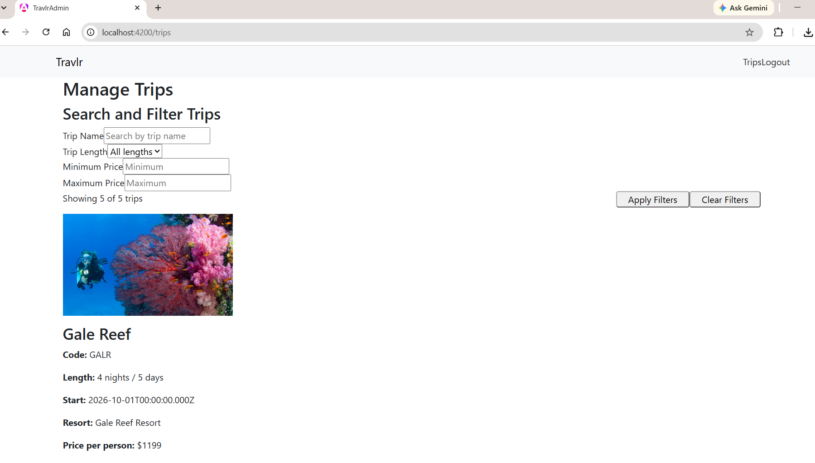
Screenshot showing the Trips page with “Claire” entered in the Trip Name field and the matching result displayed.

Figure 2 – Filter Result Count
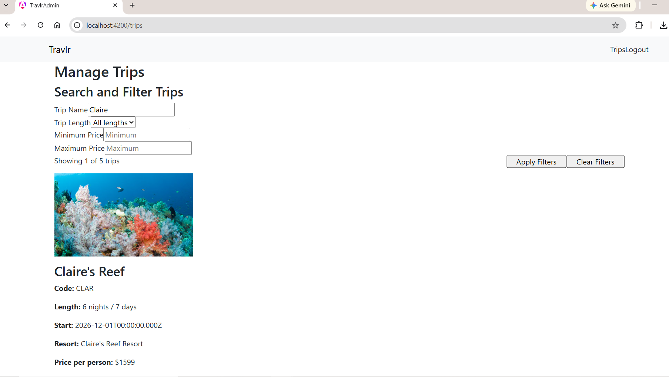Screenshot showing the filtered result count, such as “Showing 1 of 5 trips,” demonstrating that the algorithm reduced the collection to matching records.

Figure 3 – Clear Filters
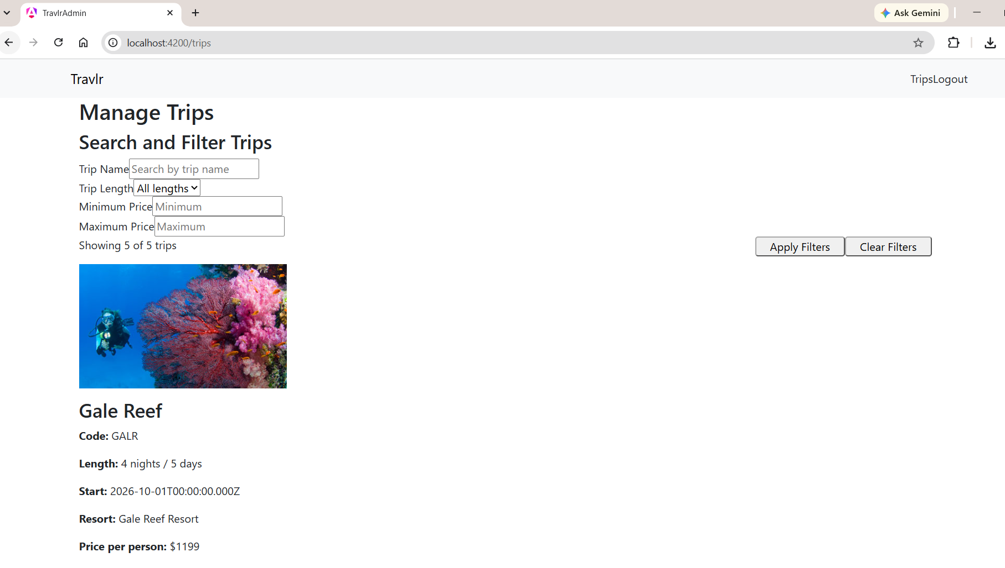Screenshot showing the Clear Filters operation and the full trip collection restored, such as “Showing 5 of 5 trips.”

Figure 4 – Multiple Filtering Criteria
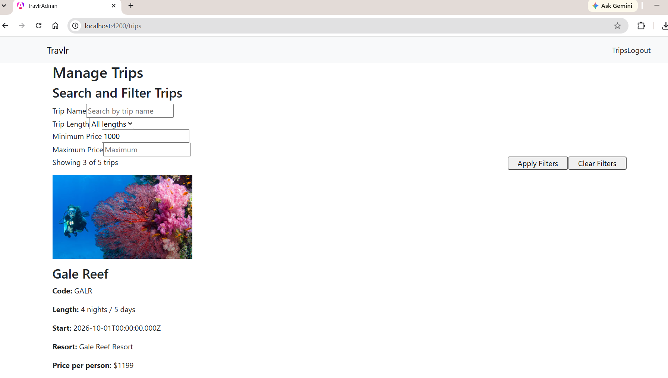Screenshot showing the minimum/maximum price or trip-length filtering controls being used and the resulting filtered collection.

Figure 5 – Negative Price Validation
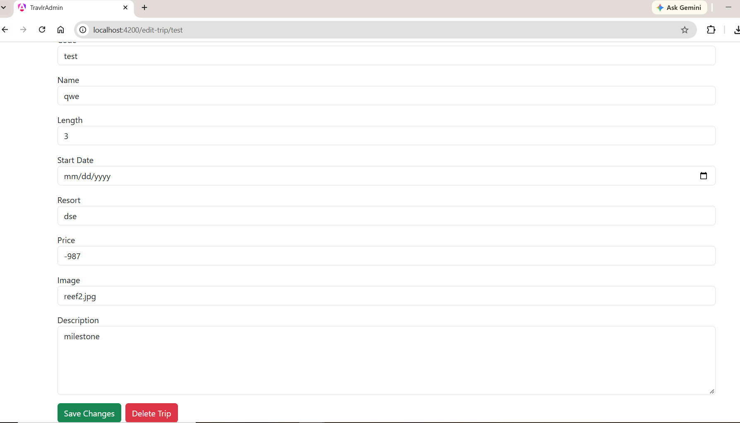Screenshot showing that a negative trip price is not saved.

6. Testing of the Enhancement
I tested the enhanced Travlr application through the running Angular administration interface. The tests focused on whether the filtering algorithm returned the expected records and whether existing application functionality continued to operate.
Test | Action | Expected/Observed Result | Status
Trip-name search | Search for Gale | Matching Gale Reef record displayed | Passed
Clear filters | Click Clear Filters | Full trip collection displayed again | Passed
Length filter | Select a trip-length criterion | Only matching records displayed | Passed
Price range | Enter minimum/maximum values | Records outside the range are excluded | Passed
Combined filters | Use more than one criterion | Records must satisfy active criteria | Passed
Image display | Open Trips page | Trip image loads and displays | Passed
Valid CRUD | Add/edit a valid trip | Record is saved successfully | Passed
Negative price | Submit a negative price | Invalid value is not saved | Passed

7. Conclusion

By transforming the Travlr trip-search need into a defined filtering method using an array data structure, the Milestone Three upgrade shows advancements in algorithms and data structures. The finished improvement was tested in the live application, supported a variety of search and filtering criteria, and was assessed using time and space complexity. My comprehension of how algorithmic choices impact useful software design has improved as a result of the approach.

8. AI Usage Acknowledgment

Parts of this story were organized and drafted with the help of generative artificial intelligence. I examined the material and am still in charge of ensuring that my personal artifact, enhancement work, testing, learning, and reflection are appropriately represented in the final submission. I'll acknowledge and cite generative AI use in accordance with the relevant Southern New Hampshire University rules.

References
Southern New Hampshire University. CS 499 Milestone Three assignment instructions and rubric.

