Step 1: Navigate to <https://nodejs.org/en/>

Step 2: Choose to download the LTS version of Node

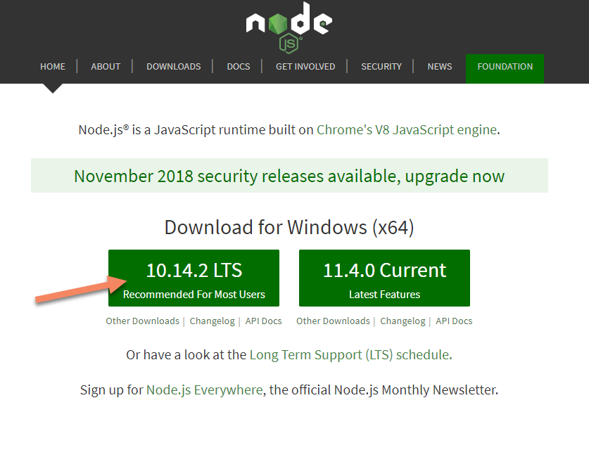

Step 3: Click on .msi file downloaded (screenshot from Chrome)

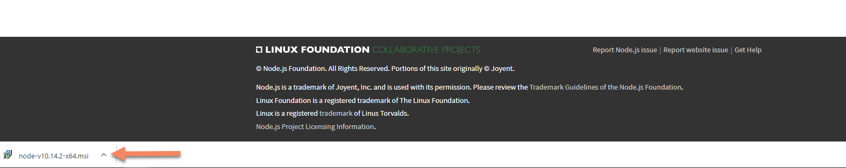

Step 4: Follow the prompts on the installer (defaults should work fine)

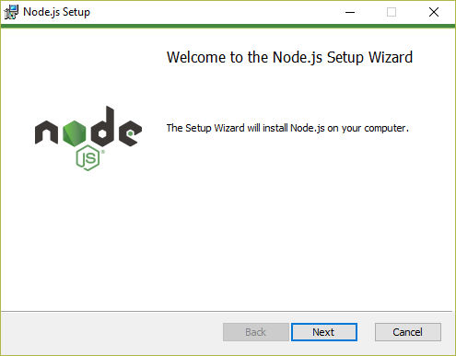

Once installation is complete, type “node –version” into a command prompt to verify installation is complete

