Section 3: Mono

* Preview02:16
* Why we need Mono?
* Maven Dependencies
* Project Setup
* Stream Lazy Behavior
* [Mono] - Just
* [Mono] - Subscribe - Part 1
* [Mono] - Subscribe - onError
* Simple Refactor
* Use Of Faker
* [Mono] - Emitting Empty / Error
* [Mono] - From Supplier
* [Mono] - From Callable
* [Mono] - Pipeline Build vs Execution
* [Mono] - Where is Async?
* [Mono] - Block
* [Mono] - From Future
* [Mono] - From Runnable
* [Mono] - Summary
* [ASSIGNMENT] - File Service
* [ASSIGNMENT-SOLUTION] - File Service Implementation - Part 1
* [ASSIGNMENT-SOLUTION] - File Service Implementation - Part 2
* Quiz

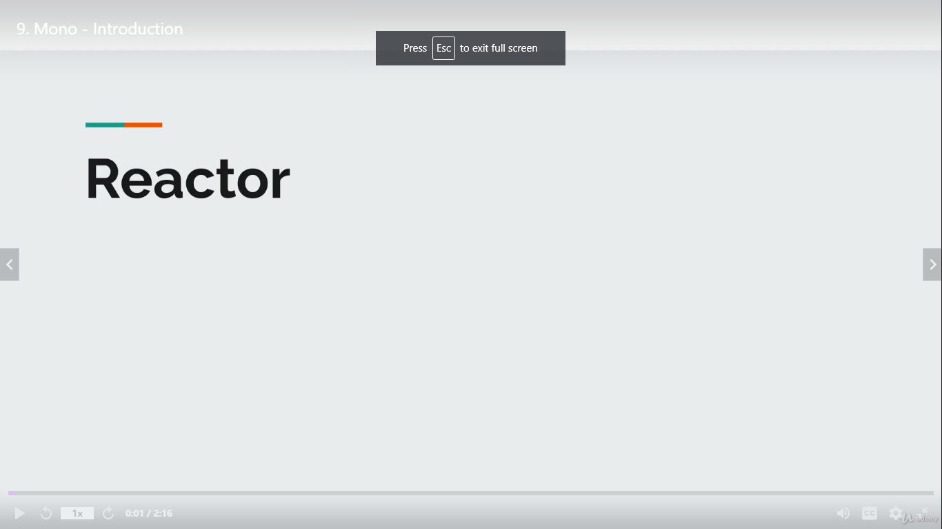

Reactive stream is a specification and Reactor is a library ie one of the implementation

