Sub query
Syntax :
SELECT column_name
FROM table_name
WHERE column_name expression operator
(SELECT column_name FROM table_name WHERE ...);

1. DATABASE TABLE
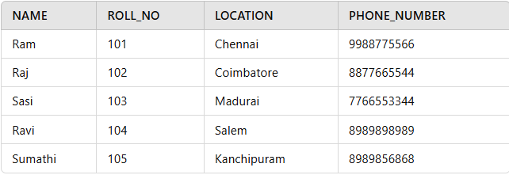
Database Table
2. STUDENT TABLE
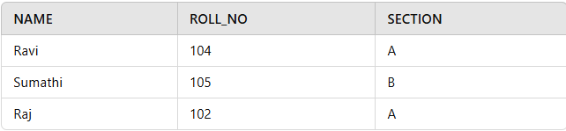
Select details of student in section A

Select * from database
where roll_no in (
Select roll_no from student where section=’A’)
insert all records from the Student2 table into the Student1 table
insert into student 1
select *from student2
Student1 Table
NAME | ROLL_NO | LOCATION | PHONE_NUMBER
Ram | 101 | chennai | 9988773344
Raju | 102 | coimbatore | 9090909090
Ravi | 103 | salem | 8989898989
Student2 Table
NAME | ROLL_NO | LOCATION | PHONE_NUMBER
Raj | 111 | chennai | 8787878787
Sai | 112 | mumbai | 6565656565
Sri | 113 | coimbatore | 7878787878
Query:
INSERT INTO Student1
SELECT * FROM Student2;
Output
NAME | ROLL_NO | LOCATION | PHONE_NUMBER
Ram | 101 | chennai | 9988773344
Raju | 102 | coimbatore | 9090909090
Ravi | 103 | salem | 8989898989
Raj | 111 | chennai | 8787878787
Sai | 112 | mumbai | 6565656565
Sri | 113 | coimbatore | 7878787878

The subquery retrieves roll numbers of students from Student1 where the location is ‘Chennai‘. The outer query then deletes records from Student2 whose roll numbers match those from the subquery.
Delect from student2
Where roll_no in
(
Select roll_no from student1 where location=’Chennai’
)

The subquery retrieves the locations of ‘Raju’ and ‘Ravi’ from Student1. The outer query then updates the NAME in Student2 to ‘Geeks’ for all students whose LOCATION matches any of the retrieved locations.
Update student2 set location=’Geeks’
Where location in
(
Select location from student1 where name in(‘Raju’,’Ravi’)
)

