Unrolled Linked List | Set 1 (Introduction)

Like array and linked list, unrolled Linked List is also a linear data structure and is a variant of linked list. Unlike simple linked list, it stores multiple elements at each node. That is, instead of storing single element at a node, unrolled linked lists store an array of elements at a node. Unrolled linked list covers advantages of both array and linked list as it reduces the memory overhead in comparison to simple linked lists by storing multiple elements at each node and it also has the advantage of fast insertion and deletion as that of a linked list.

[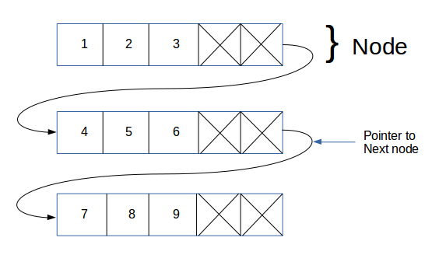](http://degottd575b1t.cloudfront.net/wp-content/uploads/unrolledLinkedList.png)

**Advantages:**

* Because of the Cache behavior, linear search is much faster in unrolled linked lists.
* In comparison to ordinary linked list, it requires less storage space for pointers/references.
* It performs operations like insertion, deletion and traversal more quickly than ordinary linked lists (because search is faster).

**Disadvantages:**

* The overhead per node is comparatively high than singly linked lists. Refer an example node in below code.