Preparing for a job interview in the NoSQL database domain involves understanding a range of concepts from the basics of NoSQL databases to more complex querying and database design.

Here’s a mix of 17 fundamental and intermediate questions that are suitable for freshers applying for positions involving NoSQL databases. These questions cover a broad spectrum of topics relevant to NoSQL technologies:

In this article

* [Questions and Answers about NoSQL Databases for Freshers](https://www.ejable.com/tech-corner/tech-interviews/nosql-db-interview-questions-freshers/#Questions_and_Answers_about_NoSQL_Databases_for_Freshers)
* [Other Tech Interview Questions Lists](https://www.ejable.com/tech-corner/tech-interviews/nosql-db-interview-questions-freshers/#Other_Tech_Interview_Questions_Lists)

**Questions and Answers about NoSQL Databases for Freshers**

**Q1. What is NoSQL?**

NoSQL is a category of database management systems that differs from traditional relational database management systems (RDBMS) in several ways. These databases are designed to handle large volumes of data and support scalable, high-performance applications.

Unlike RDBMS, which use a structured query language (SQL) for data manipulation and follow a fixed schema, NoSQL databases are schema-less and support a variety of data models, including key-value, document, column-family, and graph databases.

NoSQL databases are particularly effective for applications that require real-time analytics, large-scale data storage, and managing data that does not fit neatly into a tabular structure. NoSQL databases are chosen for their flexibility, scalability, and performance benefits when dealing with big data and real-time web applications.

It would also be better to check out the [**NoSQL interview questions for experienced**](https://www.ejable.com/tech-corner/tech-interviews/nosql-db-interview-questions-experienced/) candidates, even if you are a fresher in the field.

**Q2. Why use NoSQL databases?**

NoSQL databases are used for their scalability, flexibility, and performance with large volumes of unstructured or semi-structured data. They excel in situations where traditional relational databases may struggle, such as handling rapid growth or databases that are distributed across multiple locations.

**Q3. What are the main types of NoSQL databases?**

The main types of NoSQL databases are:

1. **Key-Value Stores:** These are the simplest form of NoSQL databases, storing data as a collection of key-value pairs. They are highly efficient for lookups and are used in scenarios requiring fast data retrieval.
2. **Document Databases:** These databases store data in documents (similar to JSON, BSON, etc.) and are ideal for storing, retrieving, and managing semi-structured data. They allow complex data structures to be stored as documents.
3. **Column-Family Stores (Wide column):** These databases store data in columns rather than rows, making them efficient for reading and writing large volumes of data. They are suitable for analytical applications that require fast data aggregation and querying.
4. **Graph Databases:** Designed to store and navigate relationships, graph databases are ideal for interconnected data. They excel in scenarios where relationships and connections between data points are key to the application.

**Q4. Explain CAP Theorem.**

The CAP Theorem states that a distributed database system can only simultaneously provide two out of the following three guarantees:

1. **Consistency**: Every “read” receives the most recent “write” or an error.
2. **Availability**: Every request receives a response without guarantee of it containing the most recent write.
3. **Partition Tolerance**: The system continues to operate despite a number of message losses or failures of part of the system (partitions).

In essence, the theorem outlines the trade-offs involved in designing and using distributed systems.

This indicates that while you can optimize for two of these attributes, you cannot simultaneously ensure all three. For instance, a system might choose to prioritize consistency and partition tolerance at the expense of availability, or any other combination depending on the application’s specific needs and requirements.

**Q5. What is Brewer’s Theorem?**

Brewer’s Theorem is nothing but another name for the CAP theorem.

**Q6. What is eventual consistency in NoSQL?**

“**Eventual consistency**” is a consistency model used in many NoSQL databases where it is guaranteed that if no new updates are made to a given data item, eventually all accesses to that item will return the same value. It means that the system allows for temporary inconsistencies during which different nodes might have different versions of the same data.

However, over time, all replicas of the data will converge to the same state. This model allows for high availability and partition tolerance by sacrificing strict consistency. It is particularly useful in distributed systems where immediate consistency of all data across all nodes is not feasible or necessary, providing a balance between performance and data accuracy.

**Q7. How does sharding work in NoSQL databases?**

Sharding in NoSQL databases is a method of distributing data across multiple servers or nodes to enhance performance, scalability, and manageability.

It involves breaking down a database into smaller, more manageable pieces called shards, each of which can be hosted on a different server or physical location. Each shard contains a subset of the database’s data, allowing operations to be performed more quickly and efficiently because they can be processed in parallel across multiple shards.

Sharding strategies can be based on different criteria, such as the value of a specific key (range-based sharding) or a hash of a key (hash-based sharding), to evenly distribute data and workload across shards. This helps in managing large datasets and high throughput operations by reducing the load on any single server and increasing the overall capacity of the database system.

Proper sharding can lead to significant improvements in application responsiveness and scalability.

**Q8. What is a document-oriented database?**

A document-oriented database is a type of NoSQL database designed to store, retrieve, and manage semi-structured data in the form of documents.

Unlike relational databases that store data in tables with fixed schemas, document databases use a more flexible model where each document can contain different data structures. Documents are typically stored in formats like JSON, BSON, or XML, allowing for nested data and arrays within the documents.

This flexibility makes document-oriented databases ideal for applications requiring agile development and the ability to store complex data types without a predefined schema.

They are well-suited for content management systems, e-commerce applications, and any scenario where the data model may evolve over time. Document databases provide a high level of scalability and performance for querying and indexing data, making them a popular choice for web, mobile, and IoT applications.

**Q9. Explain the concept of a key-value store.**

A key-value store is a type of NoSQL database that stores data as a collection of key-value pairs, where a unique key is associated with a value. It’s one of the simplest database types, providing a highly efficient method for data retrieval by key. In a key-value store, the value is a blob that is entirely opaque to the database, meaning the database does not interpret the value itself.

This model allows for fast and scalable data access, making key-value stores ideal for applications that require rapid, high-volume data retrieval, such as caching, session storage, and real-time recommendation systems.

Due to their simplicity and efficiency, key-value stores are often used in scenarios where the data structure is simple or where the application does not require complex queries or relationships between data points.

**Q10. What are secondary indexes in NoSQL databases?**

Secondary indexes in NoSQL databases are structures that allow you to query data based on non-primary key attributes.

**While the primary key index allows for efficient querying by the primary key, secondary indexes provide a way to access data through other attributes or fields within your data model. This means you can perform queries based on values that are not the primary key, enhancing the database’s flexibility and query capabilities**.

Implementing secondary indexes can significantly improve the performance of read operations for specific query patterns, making it easier to retrieve data based on criteria other than the primary key.

However, it’s important to use them judiciously, as they can introduce additional overhead for write operations, since each write may require updating one or more secondary indexes. Secondary indexes are particularly useful in scenarios where you need to support diverse query requirements and access patterns in your application.

**Q11. How do transactions work in NoSQL databases?**

Transactions in NoSQL databases vary significantly across different types of databases and their implementations.

Traditionally, NoSQL databases were designed to optimize for scalability, performance, and flexibility, often at the expense of strict transactional guarantees provided by ACID (Atomicity, Consistency, Isolation, Durability) properties common in relational databases.

However, many NoSQL databases now support transactions to some extent, allowing for atomic operations across multiple documents, keys, or entries. These transactions can range from simple, single-document updates to more complex, multi-document and cross-collection operations.

1. **Atomicity:** Ensures that all operations within a transaction are completed successfully or none at all.
2. **Consistency:** Guarantees that a transaction brings the database from one valid state to another, maintaining database invariants.
3. **Isolation:** Controls how and when the changes made by one transaction are visible to other transactions.
4. **Durability:** Ensures that once a transaction has been committed, it will remain so, even in the event of a system failure.

**Q12. What is data modeling in the context of NoSQL?**

Data modeling in the context of NoSQL involves designing the structure and organization of data in a way that optimizes for the strengths and use cases of NoSQL databases, such as scalability, performance, and flexibility.

Unlike traditional relational data modeling, which relies on a fixed schema and relationships defined by foreign keys, NoSQL data modeling focuses on how data is accessed and used by the application.

This process includes deciding on the appropriate NoSQL database type (e.g., key-value, document, column-family, graph) based on the application’s requirements, structuring data to support efficient queries, and considering how the data will scale across distributed systems.

It often involves denormalization, or the duplication of data, to reduce the need for joins and to improve read performance. Additionally, data modeling for NoSQL databases takes into account the trade-offs between consistency, availability, and partition tolerance (as per the CAP theorem), ensuring that the data architecture supports the application’s specific needs for performance and reliability.

**Q13. Can NoSQL databases be used for relational data?**

Yes, NoSQL databases can be used to store and manage relational data, but with some considerations.

While NoSQL databases are not inherently designed for relational data management, they can accommodate relationships through different modeling techniques such as embedding documents (in document databases), using adjacency lists (in key-value or column-family stores), or directly leveraging graph databases for inherently relational data.

However, when using NoSQL for relational data, it’s important to carefully design the data model to ensure efficient access patterns and query performance, as NoSQL databases do not support joins and other relational operations in the same way SQL databases do.

This often involves denormalizing data or implementing application-level joins, which can complicate the application logic but can offer scalability and performance benefits for certain types of queries and workloads. The choice to use NoSQL for relational data should be driven by specific requirements such as scalability, flexibility, and the nature of the data and queries.

**Q14. What is a graph database, and give an example of its use case?**

A graph database is a type of NoSQL database designed to store, manage, and query complex networks of data as graphs.

It represents data as nodes (entities), edges (relationships), and properties (information about entities and relationships). Graph databases excel at managing interconnected data and are optimized for traversing relationships in real-time, making them ideal for use cases where relationships between data points are key to the application.

One common use case for graph databases is social networking applications. In these applications, users are represented as nodes, and the relationships between them (such as friendships, likes, or follows) are represented as edges.

Graph databases allow for efficient querying and analysis of the network, enabling features like finding the shortest path between two users, recommending new friends based on mutual connections, or analyzing social networks to identify influencers and communities.

Other use cases include recommendation engines, fraud detection, network and IT operations, and more, where the ability to quickly navigate and analyze complex relationships can provide significant advantages.

**Q15. How do you ensure data integrity in NoSQL databases?**

Ensuring data integrity in NoSQL databases involves a combination of database features, application logic, and best practices tailored to the specific NoSQL database type and use case. Here are key strategies:

1. **Schema Design:** Thoughtful data modeling and schema design can help maintain data integrity by structuring data in a way that reduces redundancy and inconsistency. For document databases, embedding related data in a single document can ensure atomic updates.
2. **Transactions:** Utilize transactions where supported. Some NoSQL databases offer ACID-compliant transactions for operations involving multiple documents or keys, ensuring atomicity, consistency, isolation, and durability.
3. **Validation:** Implement validation at the application level. Since NoSQL databases are schema-less or have flexible schemas, it’s important to validate data before writing it to the database, ensuring it meets the expected format and constraints.
4. **Use of Constraints**: Where possible, apply constraints such as unique constraints on key attributes to prevent duplicate data entries.
5. **Version Control:** Implement version control mechanisms for documents or rows to manage concurrent updates, ensuring that changes are applied on the correct version of data.
6. **Consistency Levels:** Leverage configurable consistency levels for read and write operations (if available) to balance between performance and data accuracy based on the application’s requirements.
7. **Regular Audits and Backups:** Conduct regular data audits to check for integrity issues and maintain regular backups to ensure data can be restored in case of corruption.

**Q16. What challenges might you encounter when migrating from SQL to NoSQL?**

When migrating from SQL to NoSQL, you might encounter several challenges due to fundamental differences in data modeling, query language, and transaction management. Key challenges include:

1. **Data Modeling:** NoSQL databases often require a different approach to data modeling, focusing on denormalization and document or key-value structures. Adapting relational data models to fit NoSQL paradigms can be complex.
2. **Query Language Differences:** SQL databases use a standardized query language (SQL), while NoSQL databases may use various query languages or APIs. Developers must learn new ways to interact with data, impacting development time and complexity.
3. **Transactions:** SQL databases offer ACID transactions for consistency across multiple operations. While some NoSQL databases support transactions, they might be limited or behave differently, requiring adjustments in application logic.
4. **Consistency:** Ensuring data consistency can be more challenging in NoSQL, especially in distributed systems where eventual consistency is common. Applications may need to be designed to handle eventual consistency.
5. **Indexing and Searches:** Implementing efficient searches and indexing strategies in NoSQL can be different and sometimes more complex than in SQL databases, particularly for complex queries.
6. **Tooling and Support:** The ecosystem around NoSQL databases, including management tools, integrations, and community support, may differ, requiring teams to adapt or develop new tools.
7. **Performance Considerations:** While NoSQL can offer scalability and performance benefits, these can vary greatly depending on the data model and access patterns. Performance tuning requires understanding the specific NoSQL database’s behavior.

**Q17. Can you name some of the main NoSQL databases and briefly describe their use cases?**

Here are a few key NoSQL databases and their typical use cases:

1. **MongoDB**: A document-oriented database, ideal for applications requiring complex data structures to be stored, queried, and indexed efficiently. Commonly used in content management systems and mobile apps.
2. **Cassandra**: A wide-column store that offers high scalability and availability, making it suitable for applications that need to handle large volumes of data across multiple data centers, such as IoT and time-series data.
3. **Redis**: An in-memory key-value store, known for its speed and efficiency in caching, session management, and real-time analytics applications.
4. **Neo4j**: A graph database designed for applications that heavily rely on understanding and navigating relationships between data points, such as social networks or recommendation engines.
5. **Couchbase**: A document database that combines the flexibility of document models with the power of in-memory performance, suitable for interactive applications.
6. **DynamoDB**: A managed NoSQL database service provided by AWS, designed for applications that need consistent, single-digit millisecond latency at any scale, commonly used in gaming, mobile apps, and IoT.

**NoSQL Interview Questions and Answers**

Are you looking for a job in the database field? Are you struggling to clear a NoSQL interview and find a relevant job? Explore the top **NoSQL Interview Questions 2023** with Mindmajix. Our list of NoSQL interview questions for freshers and experienced professionals is surely going to prepare you for your NoSQL interview.

Rating: 4.7

1762

[Get Trained And Certified](https://mindmajix.com/apache-cassandra-training)

Because of the ever-increasing use of NoSQL databases by different organizations, NoSQL developers are in high demand. Its professional path offers excellent growth opportunities in terms of professional pathways and significant compensation. This article caters to providing insights into the growing importance of NoSQL in the field of Database Management.

Strive for the right choices to lead a professionally successful life! MindMajix is here to provide you with informative insights that will help you better understand NoSQL.

**Power your critical applications by embracing NoSQL**

1. NoSQL was created with huge data collections in mind. These databases are versatile because they can store and process unstructured and semi-structured data that RDBMS can't handle.

2. In real-time online applications, NoSQL aids in processing large amounts of data. NoSQL databases are used by large-scale enterprises such as Google, Amazon, Facebook, and others to manage their massive datasets.

3. NoSQL databases are scalable, improve performance, and provide a more cost-effective approach to building, implementing, and sharing software. It can manage large amounts of organized, semi-structured, and unstructured data.

4. A NoSQL developer can upto $155000 annually.

If you want to work in the NoSQL field, you should prepare for the NoSQL Interview Questions. Though each interview is unique, as is the job scope, we can assist you with the top **NoSQL Interview Questions and Answers** to enable you to take the leap and succeed in your interview.

We have categorized NoSQL Interview Questions - 2024 (Updated) into 2 levels they are:

* [**For Freshers**](https://mindmajix.com/nosql-interview-questions#freshers)
* [**For Experienced**](https://mindmajix.com/nosql-interview-questions#experienced)
* [**NoSQL FAQs**](https://mindmajix.com/nosql-interview-questions#faqs)

**Most Commonly Asked NoSQL Interview Questions**

* [**Write down the NoSQL's different features?**](https://mindmajix.com/nosql-interview-questions#features)
* [**Clarify the key value in the NoSQL database?**](https://mindmajix.com/nosql-interview-questions#key-value)
* [**What is a Graph database?**](https://mindmajix.com/nosql-interview-questions#graph-database)
* [**What do u know about database sharding in the NoSQL database?**](https://mindmajix.com/nosql-interview-questions#sharding)
* [**What is the meaning of document-oriented DB?**](https://mindmajix.com/nosql-interview-questions#document-oriented)
* [**What do you know about Big SQL in NoSQL?**](https://mindmajix.com/nosql-interview-questions#big-sql)
* [**What is eventual consistency in the context of NoSQL?**](https://mindmajix.com/nosql-interview-questions#consistency-context)
* [**What is the role of the aggregate-oriented database?**](https://mindmajix.com/nosql-interview-questions#aggregate-oriented)
* [**Why do we use impala in the NoSQL database?**](https://mindmajix.com/nosql-interview-questions#impala-use)
* [**How can you perform column view data presentation in NoSQL?**](https://mindmajix.com/nosql-interview-questions#column-view)

**NoSQL Interview Questions and Answers for Freshers**

**1. What do you understand by NoSQL?**

**Ans:** Nowadays, developers are dealing with a large volume of data which is called big data. So naturally, big complexity and big issues will be there. Once most of the systems are getting online, so data load increases. NoSQL helps to manage unstructured, messy, and complicated data. This is not a traditional database or relational database management.

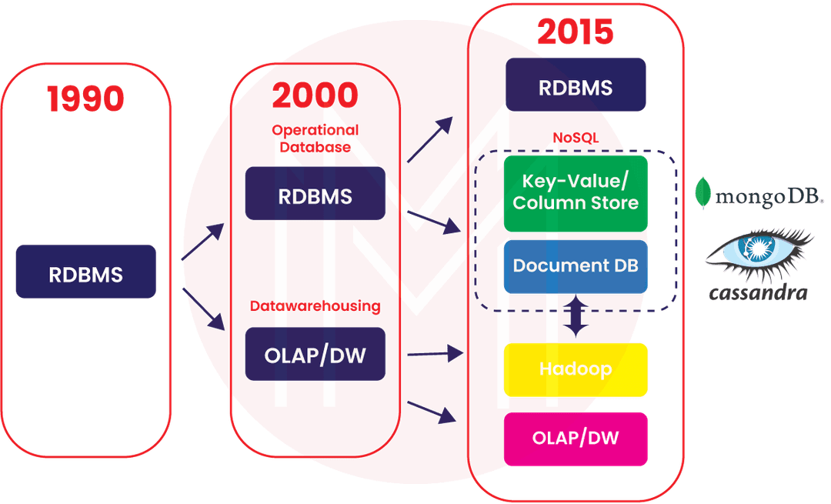

**2. How many types of mechanism works in NoSQL? Write down their name?**

**Ans:** There are four types of mechanisms:

A. Graph database  
B. Key value calculation  
C. Document oriented  
D. Column view presentation

|  |
| --- |
| *Enthusiastic about exploring the skill set of****Cassandra****? Then, have a look at the*[***Cassandra Online Course***](https://mindmajix.com/apache-cassandra-training)*together with additional knowledge.* |

**3. Write down the difference between vertical and horizontal databases?**

|  |  |
| --- | --- |
| **Vertical Database** | **Horizontal Database** |
| You can do vertical scaling, adding more power to the present PC. | Here you can do horizontal scaling with more equipment. |
| All data will be stored in a single node. | Only part data will be stored in all nodes. |
| Multi-core scaling will be done. | Single-core scaling will be done. |
| Example: Amazon cloud | Example: Cassandra |

**4. Can you tell me when you should use NoSQL in place of the normal database?**

**Ans:** If you are looking for key-value stores with massive high-speed performances, you can use NoSQL. Because in the relational databases, we use ACID transactions. Once we use this kind of transaction, the schema-based process will slow down the database performance.

Suggestive possible situations to use NoSQL are:

A. If you use multiple JOIN queries.  
B. If the client wants high traffic site.  
C. If you are using denormalized data.

***[Also Read:***[***What is NoSQL?***](https://mindmajix.com/cassandra/what-is-nosql-and-why-nosql)***]***

**5. Write down the NoSQL's different features?**

**Ans:** These are different features of NoSQL:

A. It can store a big amount of unstructured, structured, and semi-structured data.  
B. It is object-oriented programming based, which is best for a web application.  
C. It is agile, sprints based, which is best for project management.  
D. It is cost-effective with scale-out architecture and efficiency.

**6. What do you know about polyglot persistence in NoSQL?**

**Ans:** Once the applications are used and developed with mixed programming languages, debugging becomes easy in databases. However, tough complex problems will be there. Now let's talk about an e-commerce web application with a huge database of carts that is highly available to the buyer and will be easy to manage by this hybrid concept of polyglot. This hybrid technology helps the database to give suggestions to buyers.

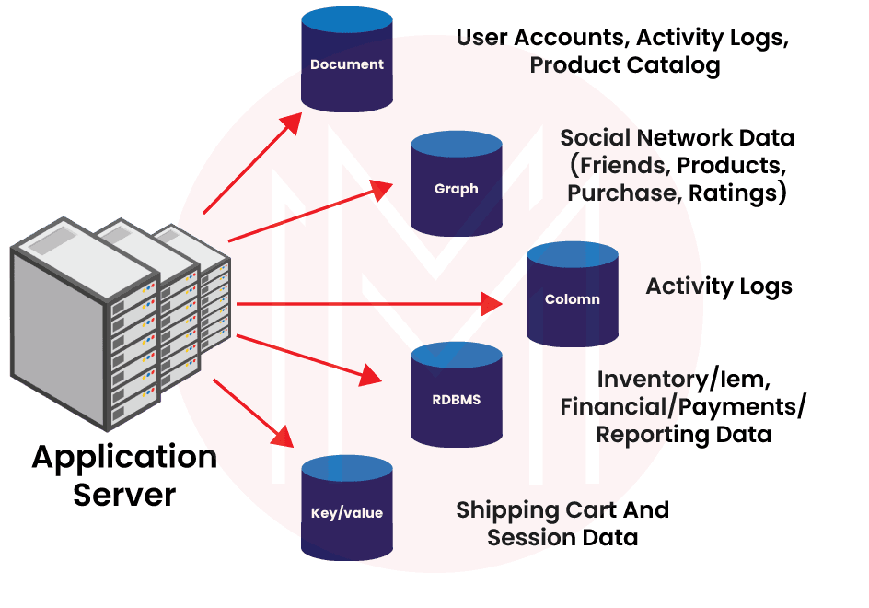

**7. Can we use NoSQL in an Oracle-based database?**

**Ans:** Yes, NoSQL is applicable in the Oracle database to record data. This database helps to find out the data records through external table functions. As well, it is easier to perform some queries in the Oracle base database. It is very flexible and key-value based.

***[Related Article:***[***NoSQL Performance Management***](https://mindmajix.com/cassandra/nosql-performance-management)***]***

**8. Clarify the key value in the NoSQL database?**

**Ans:**Generally, in a database, we store the data in a table. In NoSQL, we usually store data in the hash table. These all have tables are having unique identities. If you are finding some data, then using a key-value store is a better option than working with joins. This key value will be picking up data faster from the hash table.

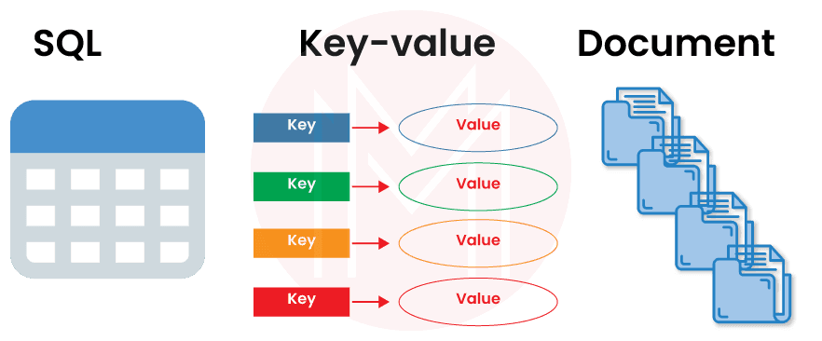

**9. What is a hash table? How does it work in NoSQL?**

**Ans:** This is like a data structure that provides an associative array of abstract data types. This table uses to function in a complex database. You need to write has code-based queries in this type of database.

[](https://bit.ly/3if9dmk)

**10. What is the meaning of document-oriented DB?**

**Ans:** This is one of the features of the NoSQL database. It helps to store the data as schema-free. As a result, JavaScript object notation will be used, and scalability will be higher. The project will be developed faster at a low cost too. You can use given below these DocumentDB:

A. MongoDB  
B. Amazon DocumentDB  
C. Microsoft Azure CosmosDB

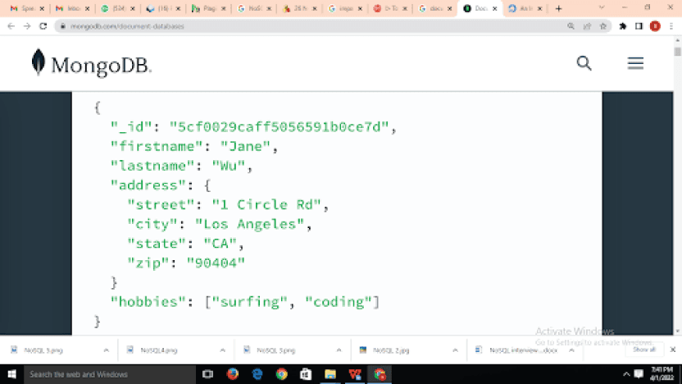

**11. How can you perform column view data presentation in NoSQL?**

**Ans:** If you are looking for a highly analytical output, you can use this column view data presentation. This NoSQL can store a huge analytical amount of data in columns rather than rows. You can also build subgroups by collecting columns. You don't need to give any key names to this type of database. This is mainly recommended for the data belonging to the data science field.

***[Explore More:***[***MongoDB vs DynamoDB***](https://mindmajix.com/mongodb-vs-dynamodb)***]***

**12. How to increase scalability in the NoSQL database?**

**Ans:**All these databases are heavy and need good server configuration on PC. To increase scalability, you can use a vertical database or a horizontal database also. Now on the PC, you can increase the RAM and SSD hard disk size so that the PC will be running faster. This way also, you can increase the scalability in NoSQL.

**13. What is a Graph database?**

**Ans:** A graph database is one of the most important of all databases. It is mainly specific for storing and navigating data relationships. The concept is entity information, and edges will store data relationships. This database is used by banks or social media or new channels etc.

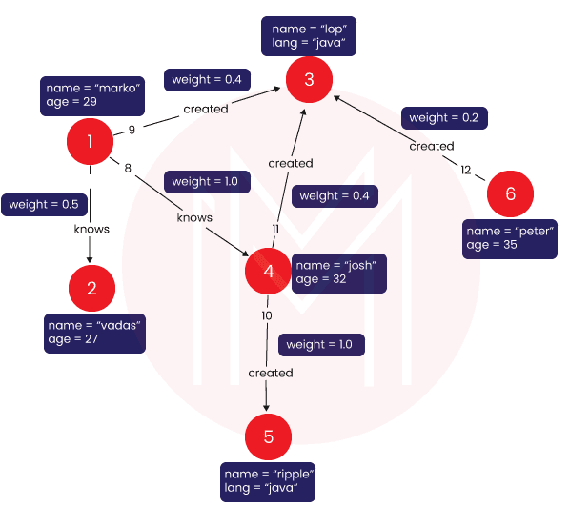

**14. Explain the CAP theorem in NoSQL?**

**Ans:** It is the most reliable three guarantees for a database. CAP theorem is expertise with skills like consistency, availability, and partition tolerance. The nodes will be working in the network seamlessly. As a result, the database will work faster.

***[Also Read Related Article:***[***Cassandra Tutorial***](https://mindmajix.com/cassandra-tutorial)***]***

**15. What do u know about database sharding in the NoSQL database?**

**Ans:** In NoSQL, database sharding means partitioning the database in patterns for the NoSQL age. You can store data by sharding in different potentially separate servers around the world. Then, a database administrator can access these stored data easily with high data speed performances from all over the world.

**NoSQL Interview Questions and Solutions for Experienced**

**1. How does the NoSQL database control machine price range memory?**

**Ans:**The replication node that manages the NoSQL database save information is the replication node. It is likewise the primary client of reminiscence. The java heap and the cache length that the replication node can utilize are the critical elements in performance phrases. By default, those matters are calculated via way of means of NoSQL in phrases of the quantity of memory to be had to the storage node. Specification of the to be had reminiscence for a storage node is recommended. The memory can be calmly divided among all of the RNs if the garage node hosts a couple of replication node.

**2. What do you know about Big SQL in NoSQL?**

**Ans:** This Big SQL is developed by IBM. This is a high-speed performance database that follows MPP ( Massive parallel processing) SQL engine for a large amount of data managed by Hadoop. Mainly enterprise data will be stored by this process. By using Big SQL, you can access data from across the organization with the permission of the database administrator. It is fully secured too. Mainly banking industries are using this.

**3. How is this impedance mismatch happening in the database?**

**Ans:**Let's talk about the main difference between NoSQL and relational databases. This is a problem statement that happens due to the miss-match of database models and programming languages. If you want to use a richer memory structure, then you have translated this database to a relational database to store on disk. As a result, impedance mismatch will occur.

**[Related Article:**[**EY Interview Questions**](https://mindmajix.com/ey-interview-questions)**]**

**4. What is the role of the aggregate-oriented database?**

**Ans:** Actually, this is a collection of data that interacts with other data as a unit. By using ACID operations and key-value, all data can be seen as a form of an aggregate-oriented database. It helps to manage the storage over the cluster. This often reduces computation.

**5. Write down the script for NoSQL DB config?**

**Ans:** If you are looking forward to building a NoSQL DB connection repeatedly, then you need to admin CLI commands. It can be used as scripted in different ways. For example, you can build a file that will store a sequence of commands to run using any programming language suitable for the particular database. Please go through the given below script:

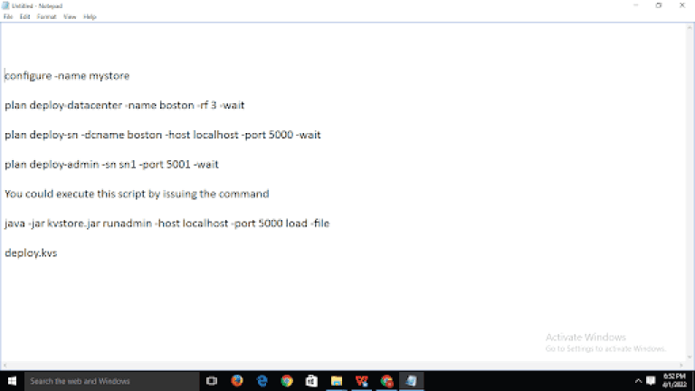

**6. If we ask you to track data record relations in NoSQL, how will you do?**

**Ans:**You can follow these steps to track data records in NoSQL:

A. First, you can embed all data in any user object.  
B. Then, you can create the user id credentials.  
C. By using login id, need to give comments value with a list of comments.  
D. Your expected data will be found.

|  |
| --- |
| *Explore*[***Cassandra Sample Resumes***](https://mindmajix.com/cassandra-sample-resumes)*! Download & Edit, Get Noticed by Top Employers!* |

**7. What is eventual consistency in the context of NoSQL?**

**Ans:**In the database, we do use service logic. Once you execute these service logics, the database system will be left in a constant state. To increase the data availability, you can use this concept. It has a distributed database system too.

**8. Explain the base property of the NoSQL database?**

**Ans:**These are the base property of NoSQL:

A. Availability of stored data after even multiple data search failures.  
B. In the soft state, all base data will be stored in the ACID model.  
C. Regularity.

**9. Why do we use impala in the NoSQL database?**

**Ans:** Once the database administrators handle big data with the Hadoop system, then this impala provides parallel processing in database technology. You can also do low latency queries by using impala. Due to this parallel processing, data fetching time will be less.

**Top 10 Frequently Asked NoSQL Interview Questions**

**1. Is NoSQL occurring in a normal database table?**

**Ans:**NoSQL does not mean no to SQL; obviously, SQL is there. It works in the non-tabular form. Actually, you do not need to create any table for this type of database. By using NoSQL, you can improve the database performance. Mostly in dynamic SQL, to make parameterized queries, database developers use this NoSQL.

**2. What is the main target of NoSQL?**

**Ans:**The main target of NoSQL is to create an alternate database in SQL. It helps to store textual data in a database easily that is also in a non-structured format.

**3. Can you tell me what the main principle of NoSQL is?**

**Ans:**The main principle of NoSQL is to make the database high availability.

**4. If I learn NoSQL, what will be my future career scope?**

**Ans:** Data Science is booming nowadays. It's all about a huge amount of data management by adopting a big data methodology. If you see, other types of databases are not going to business on a large scale, but NoSQL is coming up with high demand in business. It has very faster career growth.

**5. Do you give me any idea which particular NoSQL database is most demanding?**

**Ans:** See, there are many database systems under NoSQL. But MongoDB is a most helpful and efficient database as it is a document-based NoSQL database. It is also use case sensitive.

MongoDB is the best if anyone wants to do read and write operations in the database.

**6. What is your opinion on NoSQL replacing SQL?**

**Ans:** The answer is yes. As per market demand, the database is also changing and getting replaced by NoSQL. Because it can manage big data, the cost is less, the latest technologies are compatible with this new database, but the traditional database is costly as well as doe's not matched with new technologies.

**7. Can I learn NoSQL easily?**

**Ans:**Yes, of course, you can learn NoSQL easily and quickly. It is a bit different from the traditional database, but it has some easily understandable logic. Here you don't need to maintain schemas or normalize at all. As a result, your workload will be less.

**8. Name a few of the companies that are using NoSQL?**

**Ans:** There are lots of companies that are using NoSQL. Mostly these companies are using a huge volume of data and also using AI, Data science to pretend the future business. In this situation, NoSQL is the best solution. Companies are:

A. Google  
B. Amazon  
C. Netflix  
D. Facebook

**9. What do you think, NoSQL uses normalization?**

**Ans:** Yes, normalization is used by the NoSQL database. One of the famous NoSQL named Cassandra is based on normalization to finding stored data. It creates a series of tables related to the different fields. All these fields will be given true value in the table.

**10. What kind of data can we manage in NoSQL?**

**Ans:** Mainly this NoSQL types database can manage semi-structured data as well as unstructured data. Moreover, it has a flexible data model system.

**Concluding Remarks:**

Modern applications require flexibility since fields might change, and data structure modifications must be simple and quick. Therefore, it's important to deal with a flexible tool to upscale your organizational performance. We are confident that this content will help you qualify for the NoSQL Interview and help you bag your next six-figure job offer.

**Join our newsletter**

25 NoSQL interview questions

1. What is NoSQL, and how does it differ from traditional SQL databases?
2. Explain the different types of NoSQL databases and provide examples for each.
3. What are the advantages and disadvantages of using NoSQL databases?
4. Describe the CAP theorem and its significance in NoSQL databases.
5. How do you model data in a NoSQL database compared to a relational database?
6. Write a simple query to insert a document into a MongoDB collection.
7. How would you retrieve all documents from a specific collection in MongoDB?
8. Explain the concept of eventual consistency in NoSQL databases.
9. Write a query to update a specific field in a document in a MongoDB collection.
10. What is a key-value store? Provide an example and explain its use cases.
11. Write a code snippet to connect to a Redis database and set a key-value pair.
12. Explain the differences between document stores and column-family stores.
13. Write a query to delete a document from a MongoDB collection based on a specific condition.
14. What is sharding in NoSQL databases, and why is it important?
15. Write a code snippet to perform a basic aggregation operation in MongoDB.
16. How do you handle relationships between data in a NoSQL database?
17. Write a query to find documents in a MongoDB collection that match a specific condition.
18. What are some common use cases for using a graph database?
19. Write a code snippet to create a new table in Cassandra and insert data into it.
20. Explain the concept of indexing in NoSQL databases and its importance.
21. Write a query to perform a join operation in a NoSQL database that supports it.
22. What are the differences between strong consistency and eventual consistency?
23. Write a code snippet to retrieve data from a Couchbase bucket.
24. How do you perform data migration from a SQL database to a NoSQL database?
25. Discuss the role of data modeling in NoSQL databases and how it differs from relational databases.

1. What is NoSQL, and how does it differ from traditional SQL databases?

**Why you might get asked this:** Interviewers often ask "What is NoSQL, and how does it differ from traditional SQL databases?" to assess your foundational understanding of database technologies, which is crucial for roles such as Database Administrator or Data Engineer.

**How to answer:**

* Define NoSQL as a category of database management systems designed for large-scale data storage and for massively-parallel, high-performance data processing across a distributed architecture.
* Explain that NoSQL databases are schema-less, allowing for flexible data models, unlike traditional SQL databases which require predefined schemas.
* Highlight the differences in scalability, with NoSQL databases typically offering horizontal scaling, while SQL databases often rely on vertical scaling.

**Example answer:**

*"NoSQL is a category of database management systems designed for large-scale data storage and high-performance data processing across a distributed architecture. Unlike traditional SQL databases, NoSQL databases are schema-less, allowing for flexible data models and horizontal scalability."*

2. Explain the different types of NoSQL databases and provide examples for each.

**Why you might get asked this:** Interviewers ask "Explain the different types of NoSQL databases and provide examples for each" to evaluate your comprehensive knowledge of NoSQL database categories and their practical applications, which is essential for roles like Data Engineer or Database Administrator.

**How to answer:**

* Identify the four main types of NoSQL databases: key-value stores, document stores, column-family stores, and graph databases.
* Provide a brief description of each type, highlighting their unique characteristics and use cases.
* Give specific examples for each type, such as Redis for key-value stores, MongoDB for document stores, Cassandra for column-family stores, and Neo4j for graph databases.

**Example answer:**

*"NoSQL databases come in four main types: key-value stores, document stores, column-family stores, and graph databases. Examples include Redis for key-value stores, MongoDB for document stores, Cassandra for column-family stores, and Neo4j for graph databases."*

3. What are the advantages and disadvantages of using NoSQL databases?

**Why you might get asked this:** Interviewers ask "What are the advantages and disadvantages of using NoSQL databases?" to gauge your ability to critically evaluate database technologies, which is crucial for roles such as Data Engineer or Database Administrator.

**How to answer:**

* Discuss the flexibility and scalability of NoSQL databases, emphasizing their ability to handle large volumes of unstructured data.
* Mention the potential drawbacks, such as eventual consistency and the lack of standardization across different NoSQL systems.
* Highlight specific use cases where NoSQL databases excel, such as real-time analytics and content management systems.

**Example answer:**

*"NoSQL databases offer flexibility and scalability, making them ideal for handling large volumes of unstructured data. However, they may face challenges with eventual consistency and lack of standardization across different systems."*

4. Describe the CAP theorem and its significance in NoSQL databases.

**Why you might get asked this:** Interviewers ask "Describe the CAP theorem and its significance in NoSQL databases" to assess your understanding of fundamental principles that impact the design and performance of distributed systems, which is crucial for roles such as Data Engineer or Software Architect.

**How to answer:**

* Define the CAP theorem, explaining its three components: Consistency, Availability, and Partition Tolerance.
* Discuss how the CAP theorem states that a distributed system can only guarantee two out of the three components at any given time.
* Highlight the significance of the CAP theorem in NoSQL databases, emphasizing how it influences design decisions and trade-offs.

**Example answer:**

*"The CAP theorem states that in a distributed system, you can only achieve two out of three guarantees: Consistency, Availability, and Partition Tolerance. This theorem is crucial for NoSQL databases as it guides the trade-offs and design decisions to balance these components based on specific use cases."*

5. How do you model data in a NoSQL database compared to a relational database?

**Why you might get asked this:** Interviewers ask "How do you model data in a NoSQL database compared to a relational database?" to evaluate your ability to adapt data modeling techniques to different database paradigms, which is essential for roles such as Data Engineer or Database Administrator.

**How to answer:**

* Explain that NoSQL data modeling focuses on denormalization and embedding related data within a single document or entity.
* Highlight the importance of understanding the access patterns and queries to optimize the data model for performance.
* Mention that NoSQL databases often use flexible schemas, allowing for dynamic and evolving data structures.

**Example answer:**

*"In a NoSQL database, data modeling focuses on denormalization and embedding related data within a single document or entity. This approach optimizes performance by reducing the need for complex joins, unlike relational databases that rely on normalized schemas and relationships."*

6. Write a simple query to insert a document into a MongoDB collection.

**Why you might get asked this:** Interviewers ask "Write a simple query to insert a document into a MongoDB collection" to assess your practical skills in using MongoDB, ensuring you can perform basic database operations, which is essential for roles such as Backend Developer or Database Administrator.

**How to answer:**

* Explain the basic syntax of the insert operation in MongoDB.
* Provide an example query to insert a document into a collection.
* Mention the importance of specifying the correct collection name and document structure.

**Example answer:**

*"To insert a document into a MongoDB collection, you can use the insertOne method. For example, db.collection.insertOne({ name: 'John Doe', age: 30, city: 'New York' })."*

7. How would you retrieve all documents from a specific collection in MongoDB?

**Why you might get asked this:** Interviewers ask "How would you retrieve all documents from a specific collection in MongoDB?" to evaluate your practical knowledge of MongoDB query operations, which is essential for roles such as Backend Developer or Database Administrator.

**How to answer:**

* Explain the basic syntax of the find operation in MongoDB.
* Provide an example query to retrieve all documents from a collection.
* Mention the importance of ensuring the collection name is correct.

**Example answer:**

*"To retrieve all documents from a specific collection in MongoDB, you can use the find method. For example, db.collection.find({}) will return all documents in the collection."*

8. Explain the concept of eventual consistency in NoSQL databases.

**Why you might get asked this:** Interviewers ask "Explain the concept of eventual consistency in NoSQL databases" to assess your understanding of consistency models in distributed systems, which is crucial for roles such as Data Engineer or Software Architect.

**How to answer:**

* Define eventual consistency as a consistency model where updates propagate to all nodes over time.
* Explain that while immediate consistency is not guaranteed, the system will become consistent eventually.
* Highlight its importance in distributed systems for ensuring availability and partition tolerance.

**Example answer:**

*"Eventual consistency is a consistency model where updates to a database will propagate to all nodes over time, ensuring that all nodes will eventually hold the same data. This model prioritizes availability and partition tolerance, making it suitable for distributed systems."*

9. Write a query to update a specific field in a document in a MongoDB collection.

**Why you might get asked this:** Interviewers ask "Write a query to update a specific field in a document in a MongoDB collection" to evaluate your practical skills in performing database operations, which is essential for roles such as Backend Developer or Database Administrator.

**How to answer:**

* Explain the basic syntax of the update operation in MongoDB.
* Provide an example query to update a specific field in a document.
* Mention the importance of specifying the correct filter criteria and update operation.

**Example answer:**

*"To update a specific field in a document in a MongoDB collection, you can use the updateOne method. For example, db.collection.updateOne({ name: 'John Doe' }, { $set: { age: 31 } }) will update the age field to 31 for the document where the name is 'John Doe'."*

10. What is a key-value store? Provide an example and explain its use cases.

**Why you might get asked this:** Interviewers ask "What is a key-value store? Provide an example and explain its use cases" to assess your understanding of fundamental NoSQL database types and their practical applications, which is crucial for roles such as Data Engineer or Backend Developer.

**How to answer:**

* Define a key-value store as a simple database that uses a unique key to store and retrieve values.
* Provide an example such as Redis, which is widely used for caching and real-time analytics.
* Highlight its use cases, including session management, user profiles, and configuration settings.

**Example answer:**

*"A key-value store is a simple database that uses a unique key to store and retrieve values. An example is Redis, which is widely used for caching, session management, and real-time analytics."*

11. Write a code snippet to connect to a Redis database and set a key-value pair.

**Why you might get asked this:** Interviewers ask "Write a code snippet to connect to a Redis database and set a key-value pair" to evaluate your practical skills in using Redis, ensuring you can perform basic database operations, which is essential for roles such as Backend Developer or Database Administrator.

**How to answer:**

* Explain the basic steps to connect to a Redis database using a client library.
* Provide a code snippet demonstrating the connection and setting a key-value pair.
* Mention the importance of handling connection errors and ensuring the Redis server is running.

**Example answer:**

*"To connect to a Redis database and set a key-value pair, you can use the following code snippet: const redis = require('redis'); const client = redis.createClient(); client.set('key', 'value', redis.print);. This demonstrates a basic connection and setting operation using the Redis client library in Node.js."*

12. Explain the differences between document stores and column-family stores.

**Why you might get asked this:** Interviewers ask "Explain the differences between document stores and column-family stores" to assess your understanding of different NoSQL database models and their use cases, which is crucial for roles such as Data Engineer or Database Administrator.

**How to answer:**

* Define document stores as databases that store data in JSON-like documents, allowing for nested structures.
* Explain that column-family stores organize data into columns and rows, optimized for read and write performance.
* Highlight the use cases for each, such as content management for document stores and time-series data for column-family stores.

**Example answer:**

*"Document stores, like MongoDB, store data in JSON-like documents, allowing for nested structures and flexible schemas. In contrast, column-family stores, such as Cassandra, organize data into columns and rows, optimizing for read and write performance in large-scale distributed systems."*

13. Write a query to delete a document from a MongoDB collection based on a specific condition.

**Why you might get asked this:** Interviewers ask "Write a query to delete a document from a MongoDB collection based on a specific condition" to evaluate your practical skills in performing database operations, which is essential for roles such as Backend Developer or Database Administrator.

**How to answer:**

* Explain the basic syntax of the delete operation in MongoDB.
* Provide an example query to delete a document based on a specific condition.
* Mention the importance of specifying the correct filter criteria to avoid unintentional deletions.

**Example answer:**

*"To delete a document from a MongoDB collection based on a specific condition, you can use the deleteOne method. For example, db.collection.deleteOne({ name: 'John Doe' }) will delete the document where the name is 'John Doe'."*

14. What is sharding in NoSQL databases, and why is it important?

**Why you might get asked this:** Interviewers ask "What is sharding in NoSQL databases, and why is it important?" to evaluate your understanding of data distribution techniques and their significance in ensuring scalability and performance, which is crucial for roles such as Data Engineer or Database Administrator.

**How to answer:**

* Define sharding as a method of distributing data across multiple servers to ensure scalability.
* Explain that sharding helps in managing large datasets by splitting them into smaller, more manageable pieces.
* Highlight its importance in improving performance and ensuring high availability in distributed systems.

**Example answer:**

*"Sharding is a method of distributing data across multiple servers to ensure scalability and manage large datasets efficiently. It improves performance and ensures high availability by splitting data into smaller, more manageable pieces."*

15. Write a code snippet to perform a basic aggregation operation in MongoDB.

**Why you might get asked this:** Interviewers ask "Write a code snippet to perform a basic aggregation operation in MongoDB" to evaluate your practical skills in using MongoDB's powerful aggregation framework, which is essential for roles such as Backend Developer or Data Engineer.

**How to answer:**

* Explain the basic syntax of the aggregation framework in MongoDB.
* Provide an example query to perform a simple aggregation operation, such as grouping documents by a specific field.
* Mention the importance of understanding the pipeline stages to build complex aggregation queries.

**Example answer:**

*"To perform a basic aggregation operation in MongoDB, you can use the aggregate method. For example, db.collection.aggregate([{ $group: { _id: '$field', total: { $sum: 1 } } }]) groups documents by a specific field and calculates the total count."*

16. How do you handle relationships between data in a NoSQL database?

**Why you might get asked this:** Interviewers ask "How do you handle relationships between data in a NoSQL database?" to assess your ability to manage and optimize data relationships in non-relational databases, which is crucial for roles such as Data Engineer or Database Administrator.

**How to answer:**

* Explain that NoSQL databases often use denormalization to embed related data within a single document.
* Mention the use of references or foreign keys to link documents when embedding is not feasible.
* Highlight the importance of understanding the specific use case to choose the appropriate method for handling relationships.

**Example answer:**

*"In a NoSQL database, relationships between data are often handled through denormalization, where related data is embedded within a single document. Alternatively, references or foreign keys can be used to link documents when embedding is not feasible."*

17. Write a query to find documents in a MongoDB collection that match a specific condition.

**Why you might get asked this:** Interviewers ask "Write a query to find documents in a MongoDB collection that match a specific condition" to evaluate your practical skills in querying databases, which is essential for roles such as Backend Developer or Database Administrator.

**How to answer:**

* Explain the basic syntax of the find operation in MongoDB.
* Provide an example query to find documents that match a specific condition.
* Mention the importance of specifying the correct filter criteria to ensure accurate results.

**Example answer:**

*"To find documents in a MongoDB collection that match a specific condition, you can use the find method. For example, db.collection.find({ age: { $gt: 25 } }) will return all documents where the age field is greater than 25."*

18. What are some common use cases for using a graph database?

**Why you might get asked this:** Interviewers ask "What are some common use cases for using a graph database?" to assess your understanding of graph databases' strengths in handling complex relationships and interconnected data, which is crucial for roles such as Data Scientist or Software Engineer.

**How to answer:**

* Highlight the ability of graph databases to efficiently manage and query complex relationships.
* Mention specific use cases such as social networks, recommendation engines, and fraud detection.
* Emphasize the advantages of graph databases in visualizing and analyzing interconnected data.

**Example answer:**

*"Graph databases excel in managing and querying complex relationships, making them ideal for use cases such as social networks, recommendation engines, and fraud detection. They provide significant advantages in visualizing and analyzing interconnected data, offering insights that are difficult to achieve with other database models."*

19. Write a code snippet to create a new table in Cassandra and insert data into it.

**Why you might get asked this:** Interviewers ask "Write a code snippet to create a new table in Cassandra and insert data into it" to evaluate your practical skills in using Cassandra for database operations, which is essential for roles such as Backend Developer or Database Administrator.

**How to answer:**

* Explain the basic syntax for creating a new table in Cassandra.
* Provide a code snippet demonstrating the creation of a table.
* Include a code snippet to insert data into the newly created table.

**Example answer:**

*"To create a new table in Cassandra, you can use the following CQL command: CREATE TABLE users (id UUID PRIMARY KEY, name text, age int);. To insert data into this table, use: INSERT INTO users (id, name, age) VALUES (uuid(), 'John Doe', 30);."*

20. Explain the concept of indexing in NoSQL databases and its importance.

**Why you might get asked this:** Interviewers ask "Explain the concept of indexing in NoSQL databases and its importance" to assess your understanding of performance optimization techniques, which is crucial for roles such as Data Engineer or Database Administrator, for example.

**How to answer:**

* Define indexing as a technique to improve query performance by creating data structures that allow for faster data retrieval.
* Explain that indexes can be created on one or more fields to optimize read operations.
* Mention the trade-offs, such as increased storage requirements and potential impact on write performance.

**Example answer:**

*"Indexing in NoSQL databases is a technique to improve query performance by creating data structures that allow for faster data retrieval. It is crucial for optimizing read operations, though it may increase storage requirements and impact write performance."*

21. Write a query to perform a join operation in a NoSQL database that supports it.

**Why you might get asked this:** Interviewers ask "Write a query to perform a join operation in a NoSQL database that supports it" to evaluate your ability to handle complex data retrieval tasks, which is essential for roles such as Data Engineer or Backend Developer, for example.

**How to answer:**

* Explain that some NoSQL databases, like MongoDB, support join operations through the aggregation framework.
* Provide an example query using the $lookup stage to perform a join between two collections.
* Mention the importance of understanding the specific NoSQL database's capabilities and syntax for join operations.

**Example answer:**

*"To perform a join operation in MongoDB, you can use the $lookup stage in the aggregation framework. For example, db.orders.aggregate([{ $lookup: { from: 'customers', localField: 'customerId', foreignField: '_id', as: 'customerDetails' } }]) joins the 'orders' collection with the 'customers' collection based on the 'customerId' field."*

22. What are the differences between strong consistency and eventual consistency?

**Why you might get asked this:** Interviewers ask "What are the differences between strong consistency and eventual consistency?" to evaluate your understanding of consistency models in distributed systems, which is crucial for roles such as Data Engineer or Software Architect, for example.

**How to answer:**

* Define strong consistency as a model where all nodes see the same data at the same time after a write operation.
* Explain eventual consistency as a model where updates propagate to all nodes over time, and all nodes will eventually hold the same data.
* Highlight the trade-offs between the two, such as strong consistency prioritizing data accuracy and eventual consistency prioritizing availability and partition tolerance.

**Example answer:**

*"Strong consistency ensures that all nodes see the same data at the same time after a write operation, providing immediate consistency. In contrast, eventual consistency allows updates to propagate over time, ensuring that all nodes will eventually hold the same data, prioritizing availability and partition tolerance."*

23. Write a code snippet to retrieve data from a Couchbase bucket.

**Why you might get asked this:** Interviewers ask "Write a code snippet to retrieve data from a Couchbase bucket" to evaluate your practical skills in using Couchbase for database operations, which is essential for roles such as Backend Developer or Database Administrator, for example.

**How to answer:**

* Explain the basic steps to connect to a Couchbase bucket using a client library.
* Provide a code snippet demonstrating the connection and data retrieval.
* Mention the importance of handling connection errors and ensuring the Couchbase server is running.

**Example answer:**

*"To retrieve data from a Couchbase bucket, you can use the following code snippet: const couchbase = require('couchbase'); const cluster = new couchbase.Cluster('couchbase://localhost'); const bucket = cluster.bucket('bucket-name'); const collection = bucket.defaultCollection(); collection.get('document-key', (err, result) => { if (err) throw err; console.log(result.value); });. This demonstrates a basic connection and data retrieval operation using the Couchbase Node.js SDK."*

24. How do you perform data migration from a SQL database to a NoSQL database?

**Why you might get asked this:** Interviewers ask "How do you perform data migration from a SQL database to a NoSQL database?" to evaluate your ability to handle complex data migration tasks, which is crucial for roles such as Data Engineer or Database Administrator, for example.

**How to answer:**

* Explain the importance of understanding the data schema and relationships in the SQL database.
* Mention the need to choose the appropriate NoSQL database and data model based on the use case.
* Highlight the steps to extract, transform, and load (ETL) data from SQL to NoSQL, ensuring data integrity and consistency.

**Example answer:**

*"To perform data migration from a SQL database to a NoSQL database, you need to understand the existing data schema and relationships in the SQL database. Then, choose the appropriate NoSQL database and data model, and follow the ETL (Extract, Transform, Load) process to ensure data integrity and consistency."*

25. Discuss the role of data modeling in NoSQL databases and how it differs from relational databases.

**Why you might get asked this:** Interviewers ask "Discuss the role of data modeling in NoSQL databases and how it differs from relational databases" to evaluate your ability to adapt data modeling techniques to different database paradigms, which is essential for roles such as Data Engineer or Database Administrator, for example.

**How to answer:**

* Explain that data modeling in NoSQL focuses on denormalization and embedding related data within a single document.
* Mention that NoSQL data models are designed to optimize for specific access patterns and queries.
* Highlight the flexibility of NoSQL schemas, allowing for dynamic and evolving data structures.

**Example answer:**

*"Data modeling in NoSQL databases focuses on denormalization and embedding related data within a single document to optimize for specific access patterns and queries. Unlike relational databases, NoSQL schemas are flexible, allowing for dynamic and evolving data structures."*

Tips to prepare for NoSQL questions

* **Understand the Different NoSQL Types:** Familiarize yourself with the four main types of NoSQL databases—key-value stores, document stores, column-family stores, and graph databases. Know their unique characteristics and use cases.
* **Master Data Modeling Techniques:** Learn how to model data in NoSQL databases, focusing on denormalization and embedding related data within a single document. Understand how to optimize data models for specific access patterns and queries.
* **Get Hands-On Experience:** Practice writing queries and performing operations in popular NoSQL databases like MongoDB, Cassandra, and Redis. Real-world experience will help you answer practical questions confidently.
* **Know the CAP Theorem:** Be prepared to explain the CAP theorem and its significance in NoSQL databases. Understand how it influences design decisions and the trade-offs between consistency, availability, and partition tolerance.
* **Highlight Use Cases:** Be ready to discuss specific use cases where NoSQL databases excel, such as real-time analytics, content management systems, and handling large volumes of unstructured data. This demonstrates your ability to apply NoSQL solutions effectively.