# 30 Most Asked ZooKeeper Interview Questions and Answers

Today, we will see the best 30 ZooKeeper Interview Questions. While it comes to making a career in Apache **ZooKeeper**, there are many leading companies which are offering ZooKeeper Jobs.

So, to prepare for these job roles we need to prepare for ZooKeeper very well as there is a huge competition. Hence, we are listing some best ZooKeeper interview Questions which will help you go far in the ZooKeeper career.

These Includes all 3 types, like Basic, Intermediate and Advanced Level of Interview Questions for both newbies, as well as experienced learners.

So, let’s begin tricky ZooKeeper Interview Questions.

## Apache ZooKeeper Interview Questions

So, here is the list of top Zookeeper Interview Questions and Answers:

**Que 1. What is ZooKeeper?**

Ans. A highly available service for the maintaining purpose of small amounts of coordination data, or to notify clients of changes in that data, and also to monitor clients for their failures, is what we call Zookeeper.

Basically, to manage the large set of hosts we use ZooKeeper distributed coordination service. Since, it was difficult to Coordinate and manage, in a distributed environment, ZooKeeper makes it easy with its simple architecture as well as API.

In addition, developers can focus on core application logic without even worrying about the distributed nature of the application with the help of Zookeeper.

**Que 2. What are the Benefits Of Distributed Applications?**

Ans. There are various benefits of Distributed **Applications**, such as:

**a. Reliability:**  
It one or a few systems fails, it does not make the whole system to fail.

**b. Scalability:**  
By adding more machines with the minor change in the configuration of the application with no downtime, we can increase the Performance if needed.

**Que 3. What are the challenges Of Distributed Applications?**

Ans. As same as benefits, there are several challenges also:

[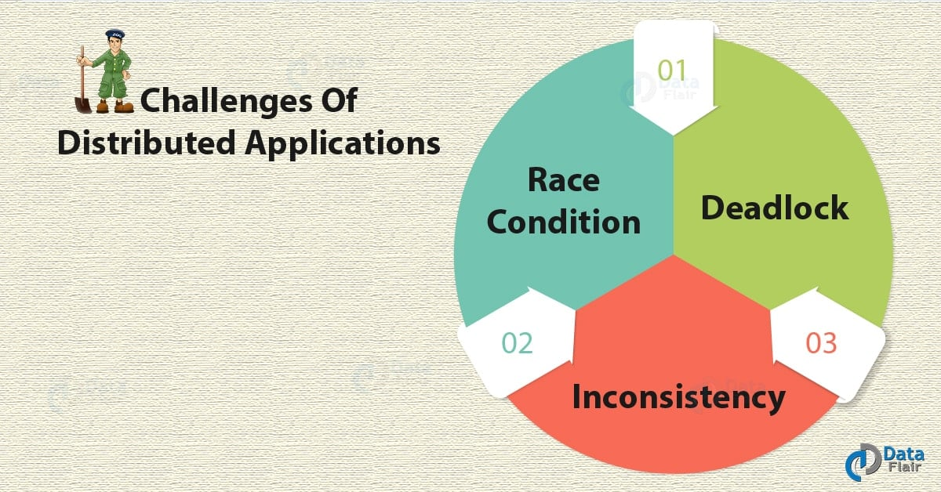](https://data-flair.training/blogs/wp-content/uploads/sites/2/2018/07/Challenges-Of-Distributed-Applications-01.jpg)

*ZooKeeper Interview Questions – challenges Of Distributed Applications*

**a. Race condition**  
It simply means while Two or more machines are doing the same task, but that needs to be done only by a single machine at any given time.

**b. Deadlock**  
While Two or more operations are waiting for each other to complete indefinitely.

**c. Inconsistency**  
There is the Partial failure of data.

**Que 4. What are the possible Job roles?**

Ans. There are various positions of Apache ZooKeeper like Senior Engineer ( **Java**, Zookeeper), **Hadoop**Developer, Software Engineer-Full Stack, Senior Developer, Director-Site reliability Engineer etc.

**Que 5. What must we know to work on Zookeeper well?**

Ans. Java is very important since its server runs on**JVM**, distributed process, and also **Linux** environment.

**Que 6. What is Apache Zookeeper Meant For?**

Ans. The common services offered by ZooKeeper are −  
a. Naming service  
b. Configuration management  
c. Cluster management  
d. Leader election  
e. Locking and synchronization service  
f. The highly reliable data registry

**Que 7. What are the Benefits Of Zookeeper?**

Ans: Following are the **benefits of using ZooKeeper**, such as:

* The simple distributed coordination process
* Synchronization
* Ordered Messages
* Serialization
* Reliability
* Atomicity

**Que 8. What do you mean by ZNode?**

Ans. The term **ZNode** is referred to every node in a ZooKeeper tree. The main purpose of the Znode is to maintain a stat structure. However, stat Structure includes version numbers for data changes and ACL changes.

**Que 9. Explain the types Of Znodes?**

Ans. There are 3 types of Znodes: persistence, sequential, and ephemeral.

[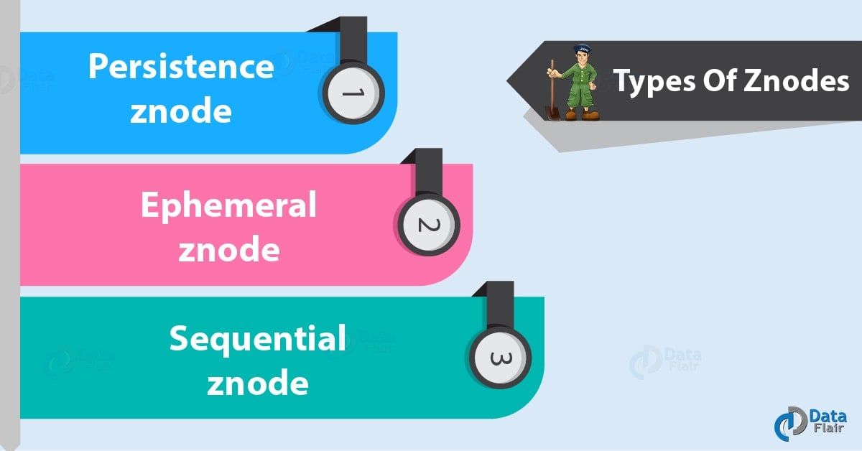](https://data-flair.training/blogs/wp-content/uploads/sites/2/2018/07/Types-Of-Znodes-01.jpg)

*ZooKeeper Interview Questions – Types of Znodes*

**1. Persistence znode**  
Persistence znode is alive even after the client, which created that particular znode, is disconnected. By default, all znodes are persistent unless otherwise specified.

**2. Ephemeral znode**  
Until the client is alive, Ephemeral znodes are active. The ephemeral znodes get deleted automatically when a client gets disconnected from the ZooKeeper ensemble. It plays an important role in Leader election.

**3. Sequential znode**  
Simply putting, Sequential znodes can be either persistent or ephemeral.

**Que 10. Explain the CLI In Zookeeper?**

**Ans.** In order to interact with the ZooKeeper ensemble for development purpose, we use **ZooKeeper Command Line Interface (CLI)**. Firstly, turn on the ZooKeeper server (“bin/zkServer.sh start”) and then, the ZooKeeper client (“bin/zkCli.sh”), in order to perform ZooKeeper CLI operations.  
As soon as the client starts, we can perform the various operations:

* Create znodes
* Get data
* Watch znode for changes
* Set data
* Create children of a znode
* List children of a znode
* Check Status
* Remove / Delete a znode

**ZooKeeper Interview Questions for freshers – Q.1,2,3,4,5,6,7,8,9**

**ZooKeeper Interview Questions for experienced – Q.10**

**Que 11. What is the model of a ZooKeeper cluster?**  
**Ans.** Leader and Follower

**Que 12. What is the zookeeper daemon name?**  
**Ans.** Quorumpeermain

**Que 13. What is the ZooKeeper ensemble?**  
**Ans.** Basically, an array of nodes (or servers, if you like) that form our Distributed Computer Ecosystem is what we call Ensemble. Especially, we use multiple zookeeper servers to create an ensemble, when we want to have high availability in zookeeper server.

**Que 14. What is ZooKeeper quorum?**

**Ans.** As we can run ZooKeeper in a replicated mode in production, so, that replicated group of servers in the same application is what we call the quorum.

**Que 15. What is the difference between the ZooKeeper ensemble and ZooKeeper quorum?**

**Ans.** A very basic difference is the full set of peer servers in a ZooKeeper cluster is Ensemble whereas the minimum number of nodes that must agree on a transaction before it is considered committed is what we call Quorum.

**Que 16. Explain the Methods Of ZooKeeper class?**

**Ans.** The ZooKeeper API’s central part is ZooKeeper class. Though, it offers options to connect the ZooKeeper ensemble in its constructor and also has several methods :

**connect –** connect to the ZooKeeper ensemble  
ZooKeeper(String connectionString, int sessionTimeout, Watcher watcher)

**create –** create a znode  
create(String path, byte[] data, List acl, CreateMode createMode)

**exists –** It helps to check whether a znode exists and also its information  
exists(String path, boolean watcher)

**getData –** get data from a particular znode  
getData(String path, Watcher watcher, Stat stat)

**setData –** set data in a particular znode  
setData(String path, byte[] data, int version)

**getChildren –** get all sub-nodes available in a particular znode  
getChildren(String path, Watcher watcher)

**delete –** get a particular znode and all its children  
delete(String path, int version)

**close –** close a connection

**Que 17. Explain Zookeeper Queues?**

**Ans.** Simply they are the common data structure. Hence, to implement a distributed queue, designate a Znode to hold the queue, the queue node, in ZooKeeper.

**Que 18. What is ZooKeeper Atomic Broadcast (ZAB) protocol?**

**Ans.** This protocol is the core of the system. So, we can see ZooKeeper as an atomic broadcast system, by which updates are totally ordered.

**Que 19. What are the key elements in ZooKeeper Architecture?**

**Ans.** Basically, the key elements in the **Zookeeper architecture** are:

[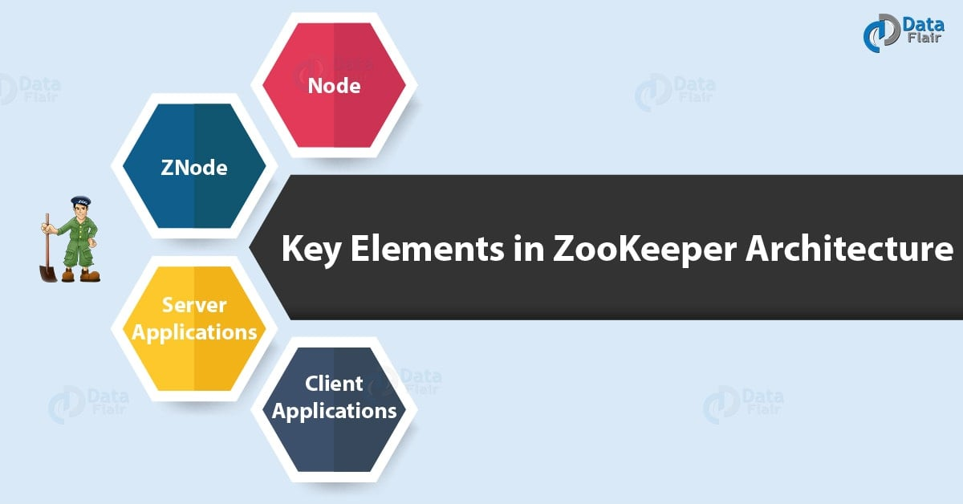](https://data-flair.training/blogs/wp-content/uploads/sites/2/2018/07/Key-elements-in-ZooKeeper-Architecture-01.jpg)

*ZooKeeper interview Questions – Zookeeper Elements*

**Node:**Nodes are the systems which are installed on the cluster.

**ZNode:** The nodes where the status is updated by other nodes in the cluster.

**Client Applications:** These applications are the tools those interact with the distributed applications.

**Server Applications:** Allows the client applications to interact using a common interface.

**Que 20. What is the Data model, and the hierarchical namespace?**

**Ans.** As like that of a standard file system, Zookeeper offers the namespace. In other words, it is the sequence of path elements which is separated by a slash (/). So, by a path only, every node in ZooKeeper’s namespace is identified.

**ZooKeeper Interview Questions for freshers – Q.11,12,13,14,17,19,20**

**ZooKeeper Interview Questions for experienced – Q.15,16,18**

**Que 21. What are Watches in ZooKeeper?**

**Ans.** Basically, on Znodes, Clients can set a**watch in Zookeeper**. And when the znode changes, the watch will be triggered and removed. The client will receive a local notification if the connection between the client and one of the ZooKeeper servers is broken.

**Que 22. What is org.apache.jute package?**

**Ans.** For simplifying serialization and deserialization of records in a language-neutral manner, org.apache.jute – Hadoop record I/O contains classes and a record description language translator.

**Que 23. What are the barriers?**

**Ans.** Basically, a primitive which enables a group of processes in order to synchronize the beginning and the end of a computation is what we call **ZooKeeper barriers**. The main concept of implementation is to have a barrier node which serves the purpose of being a parent for individual process nodes.

**Que 24. Constituents of Apache ZooKeeper Architecture?**

**Ans.** Here are the constituents from the architecture of **[ZooKeeper](https://zookeeper.apache.org/" \t "_blank)** are:

[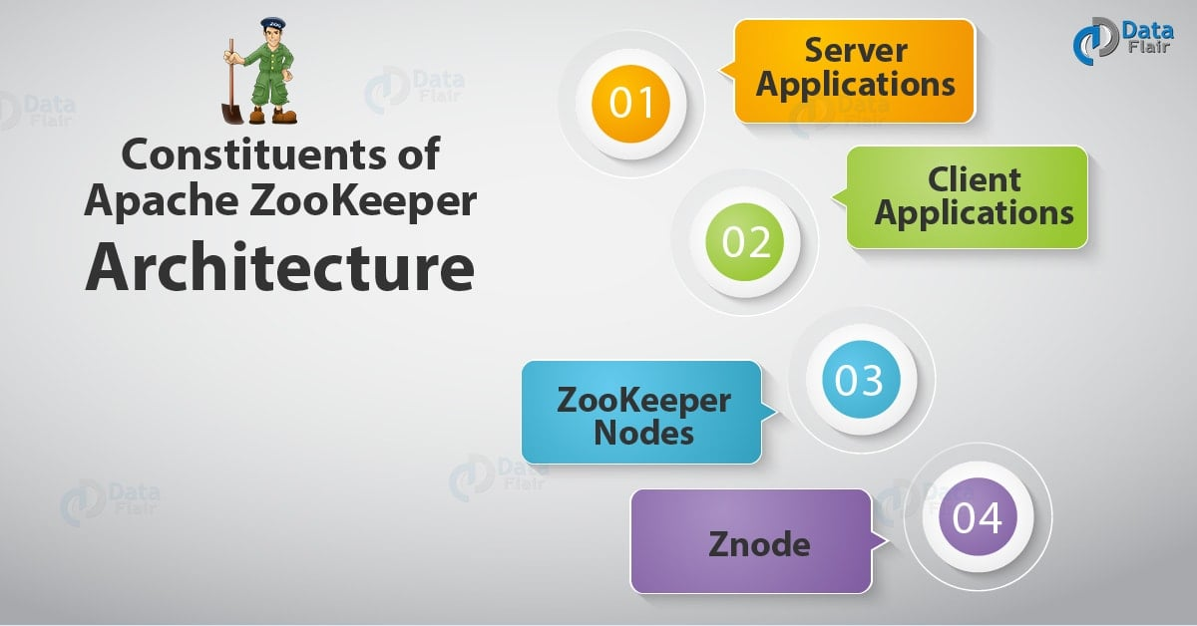](https://data-flair.training/blogs/wp-content/uploads/sites/2/2018/07/Constituents-of-Apache-ZooKeeper-Architecture-01.jpg)

*Zookeeper Interview Questions – Architecture of ZooKeeper*

**a. Server Applications:** Through a common interface, these applications facilitate interaction with client applications.

**b. Client Applications:** There are several tools which help to interact with distributed applications.

**c. ZooKeeper Nodes:** These are the systems on which a cluster runs.

**d. Znode:** By any node in the cluster, we can update or modify Znode.

**Que 25. Containerizing ZooKeeper With Docker?**

**Ans.** Generally, it is possible to containerize ZooKeeper, with Docker. So, as the best feature, we can add as well as remove the nodes on demand. Moreover, using the Docker containerization, it permits dynamic reconfiguring of the entire Hadoop cluster, as a feature of using the Docker container.

**Que 26. What is ZooKeeper Client?**

**Ans.** As same as distributed application, Zookeeper distributed application also consists of the server and client. It has a centralized interface by which clients can connect to the service. However, these clients could be command line or a GUI client.

Basically, the tools that are available for interacting with the ZooKeeper distributed application, is what we call ZooKeeper client applications.

**Que 27. What is Zookeeper Cluster?**

**Ans.** To have the system at the optimal value when we are running the Apache ZooKeeper at scale, the ZooKeeper infrastructure must be in cluster mode. The other name of the ZooKeeper cluster is an ensemble.  
**Que 28. State about ZooKeeper WebUI?**

**Ans.** Basically, an easier way to work with ZooKeeper resource management is the ZooKeeper WebUI or Web user interface. This WebUI helps to work with ZooKeeper using the web user interface to interact with the ZooKeeper application.

**Que 29. What are the applications of Apache ZooKeeper?**

**Ans.** In simple words, it is mostly considered while creating highly available distributed systems at scale. Also, it helps companies to function smoothly in the big data world just by offering a solid base to implement different big data tools.

However, it is most preferred applications to be implemented at a large scale, only due to its ability to give multiple privileges at once.

**Que 30. Explain Zookeeper Leader election.**

**Ans.** Simply a server which is selected by the ensemble of servers, that is a **Leader**. In order to order client requests which change the ZooKeeper state, Leader is used. Though, when a process starts it enters the ELECTION state.

**ZooKeeper Interview Questions for freshers – Q.21,23,24,25,26,27,29**

**ZooKeeper Interview Questions for experienced – Q.22,28**

# Top 25 Apache ZooKeeper Interview Questions and Answers

Prepare for your Apache ZooKeeper interview with our comprehensive guide featuring top questions and detailed answers, ensuring you stand out to potential employers.

[](https://interviewprep.org/users/8535/profile/interviewprep-it-career-coach)

[InterviewPrep IT Career Coach](https://interviewprep.org/users/8535/profile/interviewprep-it-career-coach)

Published Jun 6, 2023

Apache ZooKeeper is an open-source, high-performance coordination service designed for distributed applications. As a critical component in the architecture of many large-scale systems, it offers robust features such as configuration management, synchronization, and naming registry for widely dispersed computing clusters. Its primary goal is to simplify the inherent complexity associated with distributed systems by providing developers with a centralized infrastructure that guarantees reliability, consistency, and scalability.

ZooKeeper’s success can be attributed to its ability to maintain and manage configurations across nodes, ensuring fault tolerance and seamless recovery from failures. It employs a data model based on hierarchical znodes (data nodes), which enable efficient organization and retrieval of information within the system.

In this article, we have compiled a comprehensive collection of Apache ZooKeeper interview questions aimed at helping you gain a deeper understanding of this powerful coordination framework. The questions encompass key concepts, including how ZooKeeper operates, its fundamental components, use cases, and best practices for implementation. This resource serves as an invaluable guide for those seeking to excel in interviews related to distributed systems and Apache ZooKeeper.

#### **1. Can you explain the role of Apache ZooKeeper in a distributed system and its significance in managing such systems?**

Apache ZooKeeper is a critical component in distributed systems, providing coordination and management services. It ensures high availability, fault tolerance, and synchronization among nodes by maintaining configuration information, naming registry, and distributed locks.

ZooKeeper’s significance lies in its ability to maintain the overall system state despite node failures or network partitions. Its atomic broadcast protocol, Zab, guarantees consistent updates across replicas, ensuring data consistency. Additionally, it offers ephemeral nodes for temporary data storage, enabling automatic recovery of failed nodes.

By simplifying complex tasks like leader election, barrier synchronization, and group membership management, ZooKeeper reduces development effort and enhances system reliability. Furthermore, its hierarchical namespace allows efficient organization and retrieval of data.

#### **2. How does Apache ZooKeeper ensure synchronization across nodes? What role do the ZNodes play in this process?**

Apache ZooKeeper ensures synchronization across nodes by implementing a hierarchical namespace, called ZNodes, and using atomic operations. ZNodes are in-memory data structures that store metadata and form a tree-like structure. Each ZNode can have children and stores data as well as version information.

ZooKeeper uses a consensus protocol called Zab (ZooKeeper Atomic Broadcast) to maintain consistency among replicas. When a client submits an update request, the leader node proposes a new state based on the change. Followers then acknowledge or reject the proposal. If a majority of followers accept it, the change is committed, ensuring synchronization.

ZNodes play a crucial role in this process by acting as containers for data and providing watch mechanisms. Clients can set watches on specific ZNodes to receive notifications when their data changes. This allows clients to react promptly to updates, maintaining synchronization across nodes.

#### **3. What are the different data models supported by Apache ZooKeeper? How do they differ in terms of functionality and usage?**

Apache ZooKeeper supports a hierarchical data model, similar to a file system. It organizes data in znodes, which are analogous to files and directories. Znodes can store data and have children, enabling tree-like structures.

Two types of znodes exist: regular and ephemeral. Regular znodes persist until explicitly deleted, while ephemeral znodes automatically vanish when the client session that created them ends. Ephemeral nodes facilitate coordination tasks like leader election and lock management.

ZooKeeper also supports sequential znodes, appending an auto-incrementing sequence number to their names. This feature aids in implementing distributed queues and barriers.

#### **4. How does Apache ZooKeeper handle failures? Can you explain the fault tolerance mechanisms it employs?**

Apache ZooKeeper handles failures through its fault tolerance mechanisms, which include replication, atomicity, and leader election. It employs a quorum-based approach to maintain consistency across distributed systems.

Replication ensures data is stored on multiple nodes (ZooKeeper servers), providing redundancy in case of node failure. The ensemble requires a majority (quorum) of nodes to be active for the system to function.

Atomicity guarantees that operations either succeed or fail entirely, preventing partial updates. This is achieved using ZAB (ZooKeeper Atomic Broadcast) protocol, ensuring all replicas have consistent state.

Leader election occurs when the current leader fails or during startup. Nodes communicate with each other, electing a new leader based on their transaction ID and server ID. The elected leader coordinates client requests and manages cluster state.

#### **5. What is the role of a quorum in Apache ZooKeeper? How does it impact the system’s consistency and availability?**

A quorum in Apache ZooKeeper is a majority of nodes within an ensemble, ensuring fault tolerance and maintaining consistency. It plays a crucial role in achieving consensus among distributed systems by requiring at least half plus one of the total nodes to agree on any decision.

ZooKeeper uses atomic broadcast protocol (Zab) for replication, which guarantees that all updates are applied in the same order across replicas. A leader node is elected from the quorum, responsible for coordinating client requests and managing transaction logs. Followers receive proposals from the leader and acknowledge them, forming a quorum once a majority agrees.

The impact on consistency is positive, as ZooKeeper ensures strong consistency through linearizability. Clients see the same view of the system, with operations appearing instantaneously and in the correct order.

Availability is affected by the size of the quorum. Larger quorums can tolerate more failures but may increase latency due to communication overhead. Conversely, smaller quorums improve response times but reduce fault tolerance. Striking a balance between consistency and availability depends on the specific use case and requirements.

#### **6. Can you explain the concept of an ephemeral node in ZooKeeper? What are the use cases for ephemeral nodes?**

Ephemeral nodes in ZooKeeper are temporary znodes that exist only as long as the session creating them is active. When the session ends, these nodes get deleted automatically. They differ from persistent nodes, which remain until explicitly removed.

Ephemeral nodes serve various use cases:  
1. Service discovery: Services register themselves using ephemeral nodes, allowing clients to discover available instances. If a service crashes or disconnects, its node disappears, notifying clients.  
2. Leader election: Nodes compete for leadership by attempting to create an ephemeral node with the same path. The successful creator becomes the leader; others watch for changes and retry if the leader fails.  
3. Distributed locks: Ephemeral nodes can represent locks, ensuring exclusive access to shared resources. Lock release occurs when the session expires or terminates.  
4. Cluster membership: Members of a distributed system create ephemeral nodes under a common parent, enabling monitoring and coordination among members based on their presence.

#### **7. What is the difference between sequential and hierarchical ZNodes in ZooKeeper, and how does each contribute to the overall functionality of the system?**

Sequential ZNodes have unique, auto-incrementing identifiers appended to their names, ensuring a total order among siblings. Hierarchical ZNodes follow a tree structure, organizing data in parent-child relationships. Sequential ZNodes facilitate coordination tasks like leader election and task distribution by providing an ordered list of candidates or tasks. Hierarchical ZNodes enable efficient organization and retrieval of configuration data, access control, and metadata across distributed systems.

#### **8. How does the choice of a database for ZooKeeper impact its performance? What are some of the key considerations when selecting a database?**

The choice of a database for ZooKeeper significantly impacts its performance, as it affects data consistency, latency, and scalability. Key considerations when selecting a database include:

1. Consistency: Strong consistency is crucial for ZooKeeper’s coordination service. The chosen database should support atomic operations and maintain strict ordering guarantees.

2. Latency: Low-latency databases enhance ZooKeeper’s response time, improving overall system performance. Consider databases with efficient read/write capabilities and optimized storage engines.

3. Scalability: As the number of clients and requests increase, the database must scale horizontally or vertically to accommodate growth without compromising performance.

4. Durability: Data loss can be detrimental to ZooKeeper’s functionality. Select a database that ensures durability through replication, backup mechanisms, and fault tolerance features.

5. Deployment complexity: Ease of deployment and maintenance are essential factors, especially in large-scale distributed systems. Choose a database with straightforward setup procedures and robust management tools.

6. Compatibility: Ensure the selected database is compatible with ZooKeeper’s requirements, such as Java-based platforms and specific API interfaces.

#### **9. Can you explain the ZAB (ZooKeeper Atomic Broadcast) protocol and its role in Apache ZooKeeper’s functionality?**

ZAB protocol ensures reliable distributed coordination in ZooKeeper by providing atomic broadcast and maintaining a consistent state across replicas. It consists of two modes: recovery and broadcast.

In recovery mode, ZAB establishes a new leader after failures or during startup. The leader synchronizes followers’ states to ensure consistency. Once synchronized, the system transitions to broadcast mode.

In broadcast mode, the leader proposes updates (Zxid) to followers, who acknowledge receipt. Upon receiving a majority of acknowledgments, the leader commits the update and informs followers. This guarantees total order and durability of transactions.

#### **10. How does ZooKeeper handle client session management? What happens when a client session expires?**

ZooKeeper manages client sessions through session IDs and timeouts. When a client connects, it receives a unique session ID and specifies a timeout period. ZooKeeper tracks the session’s liveliness by monitoring heartbeats from the client.

If no heartbeat is received within the timeout period, ZooKeeper considers the session expired. Upon expiration, ephemeral nodes created by the client are deleted, and watches set by the client are triggered with a “session expired” event. Clients must establish a new session to reconnect.

#### **11. What is the role of a watcher in ZooKeeper? How do watchers impact the system’s performance and scalability?**

A watcher in ZooKeeper is a callback mechanism that allows clients to receive notifications when the state of a znode changes. Clients can register watchers on specific znodes, and once an event occurs (e.g., data update or child addition/deletion), the server sends a notification to the client, triggering the watcher.

Watchers impact performance and scalability by increasing the load on servers due to additional communication overhead. As the number of watchers grows, so does the amount of network traffic generated for notifications. However, this trade-off enables clients to efficiently monitor znode states without continuous polling, which would be more resource-intensive.

To mitigate potential issues, ZooKeeper employs a one-time trigger policy for watchers, meaning they must be re-registered after each event. This prevents unnecessary notifications and reduces the likelihood of overwhelming the system with excessive watcher registrations.

#### **12. How does ZooKeeper deal with network partitioning and split-brain scenarios?**

ZooKeeper mitigates network partitioning and split-brain scenarios through its consensus protocol, Zab. When a partition occurs, ZooKeeper’s ensemble divides into two or more disjoint sets of servers. The set containing a majority (quorum) continues to provide service, while the minority set becomes unavailable.

In case of a split-brain scenario, where multiple subsets believe they have a quorum, ZooKeeper employs leader election. Each server has a unique identifier, and the one with the highest epoch number is elected as the leader. If there’s a tie in epoch numbers, the server with the lowest identifier wins. This ensures that only one leader exists at any given time, preventing conflicting decisions.

When the network partition heals, the minority set rejoins the majority. Any changes made during the partition are discarded, and the minority servers synchronize their state with the leader before resuming service.

#### **13. How do you tune ZooKeeper for optimal performance? What are some of the key configuration parameters to consider?**

To tune ZooKeeper for optimal performance, consider these key configuration parameters:

1. tickTime: Adjust the base time unit (in milliseconds) to balance between latency and throughput.  
2. initLimit: Set an appropriate limit for server connection establishment based on network conditions.  
3. syncLimit: Configure a suitable synchronization limit to ensure timely data propagation among servers.  
4. maxClientCnxns: Increase this value to accommodate more simultaneous client connections without overloading the system.  
5. autopurge.snapRetainCount & autopurge.purgeInterval: Define snapshot retention count and purge interval to manage disk space efficiently.

Monitor metrics like latency, outstanding requests, and follower state changes to evaluate tuning effectiveness.

#### **14. How does ZooKeeper handle data replication across nodes? Can you explain the process of data synchronization?**

ZooKeeper uses a consensus protocol called Zab (ZooKeeper Atomic Broadcast) for data replication across nodes. It ensures that all servers in the ensemble maintain a consistent state by electing a leader and replicating transactions to followers.

The process of data synchronization involves:  
1. Leader election: When a new server joins or the current leader fails, ZooKeeper initiates an election to choose a new leader.  
2. Synchronization phase: The newly elected leader synchronizes its state with followers by sending them missing transactions.  
3. Broadcasting updates: Once synchronized, the leader starts processing client requests and broadcasts updates to followers.  
4. Acknowledgment: Followers acknowledge receipt of updates, ensuring durability and consistency.  
5. Commitment: After receiving a majority of acknowledgments, the leader commits the update and informs followers.

#### **15. What is a ZooKeeper ensemble? How does it benefit the overall system?**

A ZooKeeper ensemble is a group of ZooKeeper servers working together to provide high availability, fault tolerance, and consistency in distributed systems. It typically consists of an odd number of nodes (minimum 3) to avoid split-brain scenarios.

The ensemble benefits the overall system by:  
1. Ensuring high availability: If one server fails, others continue providing service.  
2. Providing fault tolerance: The ensemble can recover from failures without data loss.  
3. Maintaining consistency: All servers store the same data, ensuring clients receive consistent responses.  
4. Balancing load: Client requests are distributed among ensemble members, preventing overloading individual servers.

#### **16. Can you discuss the role of Apache Curator in ZooKeeper? How do the two technologies complement each other?**

Apache Curator is a high-level Java library that simplifies interaction with ZooKeeper, addressing common challenges and providing useful recipes. It enhances reliability, reduces boilerplate code, and improves maintainability.

ZooKeeper is a distributed coordination service for managing configurations, synchronization, and naming registry. However, it has a low-level API which can be complex to use directly. Curator complements ZooKeeper by offering an abstraction layer, making it easier for developers to work with the system.

Curator provides several key features:  
1. Connection management: Automatically handles connection loss and retries.  
2. Recipes: Pre-built solutions for common patterns like leader election, locks, and barriers.  
3. Frameworks: Simplified APIs for TreeCache and PathChildrenCache, enabling efficient data monitoring.

By using Curator, developers can focus on implementing their application logic rather than dealing with ZooKeeper’s intricacies. This combination of technologies allows for more robust and scalable distributed systems.

#### **17. How does ZooKeeper manage access control and security? Can you explain the authentication mechanisms it employs?**

ZooKeeper manages access control and security through Access Control Lists (ACLs) and authentication mechanisms. ACLs define permissions for znodes, with each entry containing a scheme, ID, and set of permissions. Common schemes include ‘world’, ‘auth’, ‘digest’, and ‘ip’. The ‘world’ scheme has a single ID (‘anyone’) granting universal access, while ‘auth’ grants access to authenticated clients.

Authentication in ZooKeeper is pluggable, allowing custom implementations. Built-in mechanisms include SASL (Simple Authentication and Security Layer) and X509 certificates. SASL supports Kerberos and DIGEST-MD5. Clients authenticate by sending an AuthPacket to the server, which verifies credentials using configured authentication providers. Successful authentication associates the client’s session with its identity, enabling ACL enforcement based on that identity.

#### **18. What are the key limitations of Apache ZooKeeper? How can these limitations be addressed?**

Apache ZooKeeper has several key limitations:

1. Limited scalability: As a centralized service, it can become a bottleneck when handling large-scale systems. To address this, consider partitioning the data and using multiple ZooKeeper instances.

2. Write performance: Due to its consensus-based approach, write operations are slower than reads. Improve write performance by batching writes or employing asynchronous APIs.

3. Data size constraints: ZooKeeper is not designed for storing large amounts of data. Store only metadata in ZooKeeper and use external storage systems for larger data.

4. Complexity: Implementing distributed coordination tasks can be complex. Utilize existing recipes like leader election, locks, and barriers to simplify development.

5. Single point of failure: A single ZooKeeper server may fail, causing downtime. Deploy a multi-node ensemble with an odd number of servers to ensure fault tolerance and high availability.

6. Network latency: Sensitive to network delays, affecting overall performance. Optimize network configurations and choose geographically close nodes to minimize latency.

#### **19. How can you monitor and troubleshoot Apache ZooKeeper? What tools and methodologies can you use to diagnose performance issues?**

To monitor and troubleshoot Apache ZooKeeper, use the following tools and methodologies:

1. Four Letter Words (4LWs): Send commands like ‘stat’, ‘mntr’, and ‘ruok’ to ZooKeeper for quick status checks and performance metrics.

2. JMX: Java Management Extensions provide MBeans for monitoring various components of ZooKeeper, such as server state, request latency, and watch counts.

3. Log Analysis: Analyze ZooKeeper logs for errors, warnings, or unusual patterns that may indicate issues.

4. zkCli.sh: Use this command-line tool to interact with ZooKeeper, check node data, and perform operations like creating/deleting nodes.

5. Performance Monitoring Tools: Utilize tools like JConsole, VisualVM, or Prometheus to collect and analyze JVM metrics, garbage collection statistics, and other performance indicators.

6. Distributed Tracing: Implement distributed tracing using frameworks like Zipkin or Jaeger to trace requests across multiple services and identify bottlenecks in the system.

7. Stress Testing: Conduct stress tests using tools like ZK-smoketest or custom scripts to simulate high load scenarios and evaluate how ZooKeeper performs under pressure.

#### **20. Can you describe the CAP theorem? How does ZooKeeper fit into the CAP theorem’s categories?**

The CAP theorem states that a distributed system can only achieve two out of three properties: Consistency, Availability, and Partition Tolerance. Consistency ensures all nodes have the same data; Availability guarantees every request receives a response; Partition Tolerance means the system continues to function despite network failures.

ZooKeeper fits into the CAP theorem as a CP (Consistent and Partition-tolerant) system. It prioritizes consistency by using atomic broadcast protocols like Zab to ensure all replicas have the same state. ZooKeeper also handles partition tolerance well, maintaining functionality during network partitions. However, it sacrifices availability in certain scenarios, such as when a majority of nodes are unavailable or disconnected.

#### **21. How does ZooKeeper handle data integrity and consistency? Can you explain the concept of a version number in ZooKeeper?**

ZooKeeper ensures data integrity and consistency through atomicity, sequential ordering, and durability. It uses a consensus protocol called Zab (ZooKeeper Atomic Broadcast) to replicate data across nodes in the ensemble, ensuring fault tolerance. Write operations are forwarded to the leader node, which assigns a global transaction ID (zxid) for total order. Followers apply changes in zxid order, guaranteeing consistent state.

Version numbers play a crucial role in maintaining consistency. Each znode has a version number that increments with every update. Clients must provide the current version when attempting an update; if mismatched, ZooKeeper rejects the operation, preventing concurrent modifications. This optimistic concurrency control mechanism is known as compare-and-swap.

#### **22. What is an election in ZooKeeper? How is a leader chosen and what is its role in the system?**

An election in ZooKeeper refers to the process of selecting a leader among its nodes, called Znodes. This is crucial for maintaining coordination and consistency across distributed systems. The leader election algorithm used by ZooKeeper is called Zab (Zookeeper Atomic Broadcast).

During an election, each node proposes itself as a candidate with a unique identifier (zxid). Nodes exchange their zxids, comparing them to determine the highest value. The node with the highest zxid becomes the leader. In case of a tie, node IDs are compared, and the one with the lowest ID wins.

The leader’s role includes coordinating updates, managing cluster state, and ensuring data consistency. It receives write requests from clients, assigns global transaction identifiers, and broadcasts changes to followers. Followers acknowledge receipt, and once a majority confirms, the leader commits the change. This ensures fault tolerance and prevents split-brain scenarios.

#### **23. How do you scale Apache ZooKeeper horizontally? What are the challenges in scaling ZooKeeper and how do you address them?**

To scale Apache ZooKeeper horizontally, deploy it in an ensemble of multiple servers (odd number recommended). This increases fault tolerance and read performance. However, write performance may decrease due to consensus requirements.

Challenges:  
1. Network latency: As the ensemble size grows, network latency can impact performance. Address this by optimizing network configurations and using low-latency hardware.  
2. Data consistency: Ensuring data consistency across nodes is crucial. ZooKeeper’s atomic broadcast protocol (Zab) maintains consistency through leader election and quorum-based decisions.  
3. Load balancing: Distribute client connections evenly among ensemble members to prevent overloading individual servers. Use load balancers or client-side connection management strategies.  
4. Monitoring and maintenance: Monitor server health, disk space, and other metrics for proactive issue resolution. Regularly update software versions and apply security patches.

#### **24. Can you compare and contrast Apache ZooKeeper with alternative coordination services, such as etcd or Consul?**

Apache ZooKeeper, etcd, and Consul are distributed coordination services that provide key-value stores for configuration management, service discovery, and synchronization. However, they differ in various aspects:

1. Implementation: ZooKeeper is written in Java, while etcd and Consul are implemented in Go, making them more lightweight and easier to deploy.  
2. Data Model: ZooKeeper uses a hierarchical data model resembling a file system, whereas etcd and Consul use flat key-value structures.  
3. Performance: Etcd has better write performance due to its Raft consensus algorithm, while ZooKeeper’s ZAB protocol prioritizes read performance.  
4. Scalability: Consul supports multi-datacenter deployments out-of-the-box, while ZooKeeper and etcd require additional configurations for such setups.  
5. Service Discovery: Consul provides built-in health checks and DNS-based service discovery, while ZooKeeper and etcd need external tools or custom solutions.  
6. Security: Etcd and Consul support TLS encryption and authentication, but ZooKeeper requires third-party plugins like Apache Curator for similar security features.

#### **25. How does Apache ZooKeeper integrate with other Big Data technologies, such as Hadoop, Kafka, or HBase?**

Apache ZooKeeper provides coordination services for distributed systems like Hadoop, Kafka, and HBase. It manages configuration information, synchronization, and group services, ensuring high availability and fault tolerance.

In Hadoop, ZooKeeper aids in managing the High Availability (HA) feature of HDFS NameNode and YARN ResourceManager. It monitors active and standby nodes, facilitating automatic failover during failures.

For Kafka, ZooKeeper maintains broker metadata, such as partition ownership and consumer offsets. It also handles controller election, ensuring a single active controller at any time.

In HBase, ZooKeeper coordinates master and region server processes, tracks server states, and stores metadata. It helps maintain consistency and reliability across the cluster.