# Write a program to print all permutations of a given string

A permutation, also called an “arrangement number” or “order,” is a rearrangement of the elements of an ordered list S into a one-to-one correspondence with S itself. A string of length n has n! permutation.  
Source: Mathword(<http://mathworld.wolfram.com/Permutation.html>)

Below are the permutations of string ABC.  
ABC ACB BAC BCA CBA CAB

## [We strongly recommend that you click here and practice it, before moving on to the solution.](http://www.practice.geeksforgeeks.org/problem-page.php?pid=382" \t "_blank)

Here is a solution that is used as a basis in backtracking.

[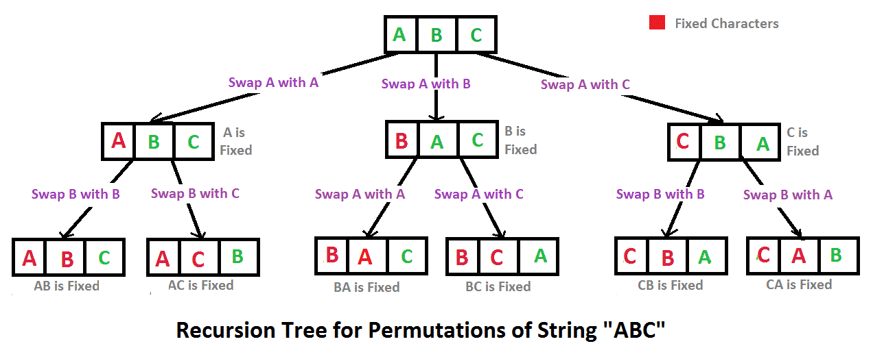](http://d1gjlxt8vb0knt.cloudfront.net/wp-content/uploads/NewPermutation.gif)