Sub query

Syntax :

SELECT column_name  
FROM table_name  
WHERE column_name expression operator   
 (SELECT column_name FROM table_name WHERE ...);

**1. DATABASE TABLE**

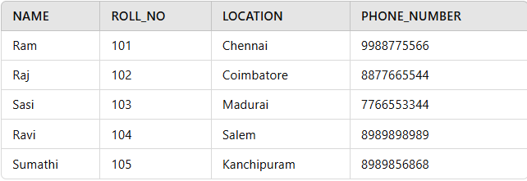

*Database Table*

**2. STUDENT TABLE**

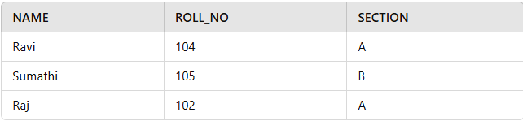

Select details of student in section A

Select * from database

where roll_no in (

Select roll_no from student where section=’A’)

insert all records from the **Student2** table into the **Student1** table

insert into student 1

select *from student2

**Student1 Table**

| **NAME** | **ROLL_NO** | **LOCATION** | **PHONE_NUMBER** |
| --- | --- | --- | --- |
| Ram | 101 | chennai | 9988773344 |
| Raju | 102 | coimbatore | 9090909090 |
| Ravi | 103 | salem | 8989898989 |

**Student2 Table**

| **NAME** | **ROLL_NO** | **LOCATION** | **PHONE_NUMBER** |
| --- | --- | --- | --- |
| Raj | 111 | chennai | 8787878787 |
| Sai | 112 | mumbai | 6565656565 |
| Sri | 113 | coimbatore | 7878787878 |

**Query:**

INSERT INTO Student1   
SELECT * FROM Student2;

**Output**

| **NAME** | **ROLL_NO** | **LOCATION** | **PHONE_NUMBER** |
| --- | --- | --- | --- |
| Ram | 101 | chennai | 9988773344 |
| Raju | 102 | coimbatore | 9090909090 |
| Ravi | 103 | salem | 8989898989 |
| Raj | 111 | chennai | 8787878787 |
| Sai | 112 | mumbai | 6565656565 |
| Sri | 113 | coimbatore | 7878787878 |

The subquery retrieves roll numbers of students from **Student1** where the location is ‘**Chennai**‘. The outer query then deletes records from **Student2** whose roll numbers match those from the subquery.

Delect from student2

Where roll_no in

(

Select roll_no from student1 where location=’Chennai’

)

The subquery retrieves the locations of ‘Raju’ and ‘Ravi’ from **Student1**. The outer query then updates the **NAME** in **Student2** to ‘Geeks’ for all students whose **LOCATION** matches any of the retrieved locations.

Update student2 set location=’Geeks’

Where location in

(

Select location from student1 where name in(‘Raju’,’Ravi’)

)