**Crazy Tree 3**

Max. Marks: 100

The challenge is over and this problem has been moved to practice area. You can either submit your solution here or   
[Go to Practice Area](https://www.hackerearth.com/problem/algorithm/crazy-tree-3-12/). Also further submissions won't affect the leaderboard.

**PROBLEM**

**EDITORIAL**

**MY SUBMISSIONS**

Abhimanyu has a complete binary tree of **level L**, called **Crazy Tree**. Levels are numbered **1, 2, ..., L** from top to bottom and root is at level 1. Abhimanyu numbers all the leaf nodes **1, 2, 3, ...** from left to right. The value of the parent node is the product of values of its child node.

Below are **level 2** (left) and **level 3** (right) crazy trees

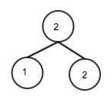 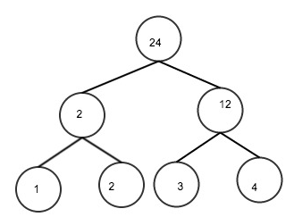

Abhimanyu defines a magical function **S**:

* **S(N, X, Y)**: This gives the sum of **Xth, (X + 1)th, (X + 2)th, ..., Yth** nodes at level **N**.

Abhimanyu wants to find the value of **S(N, X, Y) % M** for given values of N, X, Y, where **M = 1299709**.

**Input**

First line of input contains two space separated integers **L** and **Q**, where **L** is number of levels in the crazy tree and **Q** is total number of queries. Each of the next Q lines contains three space separated integers **N**, **X** and **Y**.

**Output**

Output the value of **S(N, X, Y) % M** in single line for each test case.

**Constraints**

* **1 <= L <= 21**
* **1 <= Q <= min(106, (2L - 1) (2L + 4) / 6)**, where min(a, b) is minimum of a and b
* **1 <= N <= L**
* **1 <= X <= 2(L - 1)**
* **X <= Y <= 2(L - 1)**

**SAMPLE INPUT**

3 14

1 1 1

3 1 4

2 1 2

2 2 2

3 4 4

3 3 3

3 3 4

2 1 1

3 1 2

3 1 3

3 2 2

3 2 4

3 1 1

3 2 3

**SAMPLE OUTPUT**

24

10

14

12

4

3

7

2

3

6

2

9

1

5

**Explanation**

As Tree has 3 levels you can refer to right image above.

Now for query 2 1 2 At level 2, Value of node 1 = 2 At level 2, value of node 2 = 12

So, S(2, 1, 2) = 2 + 12 = 14

**Time Limit:**2.0 sec(s) for each