## Card Removal

====================================

John has **n** cards. He is a playing a game with his friend Bob.

In each turn they remove half of the cards.But they cannot perform this move if the number of cards remaining are odd.

Calculate the number of times they can perform this move.

**Input Format**

Input consists of a single integer denoting **n**.

**Constraints**

**Output Format**

Print a single integer denoting the number of times they can perform this move.

**Sample Input 0**

4

**Sample Output 0**

2

**Explanation 0**

He performs a move and removes 2 cards. There are 2 remaining. He performs the move again and removes half of the remaining i.e. 1. So 1 remains. Since it is odd, he cannot remove any more cards. Hence, 2 moves are performed

**Sample Input 1**

5

**Sample Output 1**

0

**Explanation 1**

There are odd number of cards so he cannot perform any move.

**Sample Input 2**

6

**Sample Output 2**

1

**Explanation 2**

He performs the move and removes 3 cards. There are 3 remaining. Odd number of cards remain so he cannot make any move further. So only 1 time he performed the move.

## VISA and String Encryption

Making the cards secure is one of the challenges that VISA faces. To enhance the security, VISA has devised a new algorithm to encrypt the customer names on their cards.

They choose a window of size  K and write a single number  to represent the characters in the window. X is calculated as the product of the number of vowels and consonants in the window. This is done for all the windows of size K possible for a given string. At the end of this operation for a string of size N, they write N-K+1 integers, denoting the string in its encrypted form.

Now, VISA wants to know what will the encrypted form of a given string for a window of size .K

**Inpu t Format**

The first line contains an integer T, the number of test cases. Each of the next T lines contain:

1. A string   S consisting of lower-case English alphabet, denoting the name of the customer.
2. An integer K denoting the window size for the given string.

**Constraints**

* 1<,t<=10 pow 2
* 1<=n<=10 pow 4
* 1<=k<=n

**Output Format**

For each of the  strings, print one string on a new line, containing the encrypted form of the input string.

**Sample Input 0**

1

hello 2

**Sample Output 0**

1101

**Explanation 0**

The string given to us  and the window size is . The following steps describe the solution for the case:

1. Consonants = , Vowels = , Product =
2. Consonants = , Vowels = , Product =
3. Consonants = , Vowels = , Product =
4. Consonants = , Vowels = , Product =

Thus, concatenating the products, we get encrypted string as .

**Sample Input 1**

1

character 3

**Sample Output 1**

2222222

## Rotation Queries

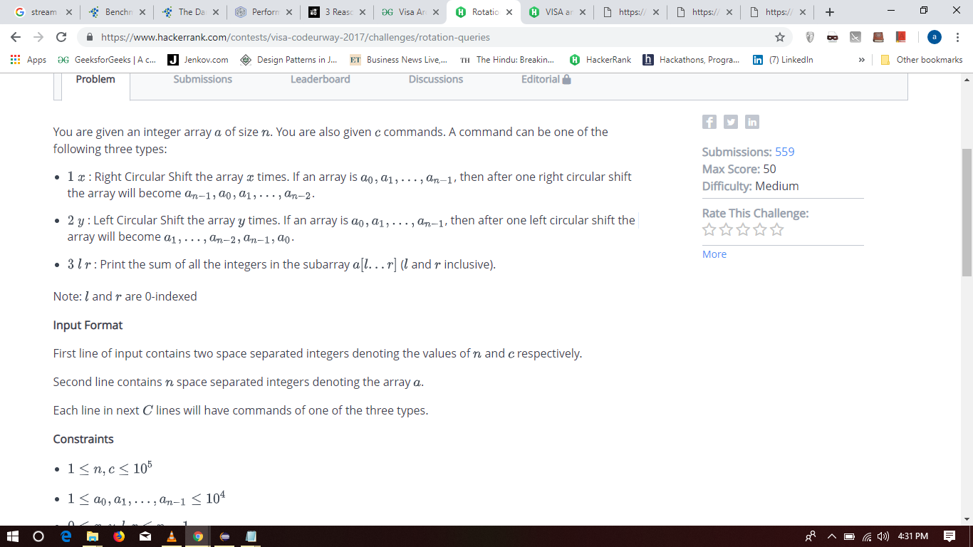

You are given an integer array  of size . You are also given  commands. A command can be one of the following three types:

* : Right Circular Shift the array  times. If an array is , then after one right circular shift the array will become .
* : Left Circular Shift the array  times. If an array is , then after one left circular shift the array will become .
* : Print the sum of all the integers in the subarray  ( and  inclusive).

Note:  and  are 0-indexed

**Input Format**

First line of input contains two space separated integers denoting the values of  and  respectively.

Second line contains  space separated integers denoting the array .

Each line in next  lines will have commands of one of the three types.

**Constraints**

**Output Format**

Output the answer of every command of third type in separate line.

**Sample Input 0**

5 4

1 2 3 4 5

1 3

3 0 2

2 1

3 1 4

**Sample Output 0**

12

11

## XOR And Queries

XOR of an integer array is defined as the XOR of all the elements present in it.

You are given an integer array  of size  with elements . You need to answer  queries. Every query will have two integers  and . You need to find the XOR of XORs of all the subarrays of an array having elements .

As the answer can be large, you need print the answer

**Input Format**

First line contains two space separated integers denoting the values of  and  respectively.

Second line contains  space separated integers denoting the array .

In next  lines, every line will have two space separated integers representing the value of  and .

**Constraints**

**Output Format**

Output will have  lines having single integer in each line where  line will be the answer to the  query.

As the output can be large. So, you need to print the answer *modulo*

