**Registro Alumnos**

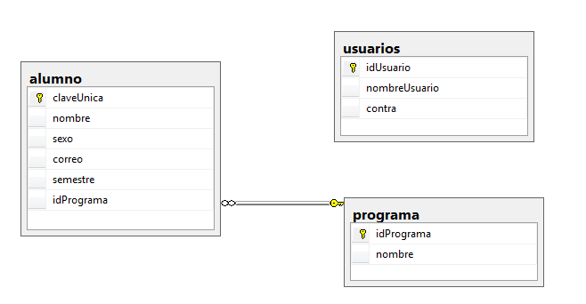

create database baseSistemaAlumno;

use baseSistemaAlumno;

create table programa

(idPrograma smallint not null primary key,

nombre char(30));

create table alumno

(claveUnica smallint not null primary key,

nombre char(50),

sexo char(10),

correo varchar(30),

semestre smallint,

idPrograma smallint references programa);

create table usuarios

(idUsuario smallint not null primary key,

nombreUsuario varchar(30),

contra varchar(30));

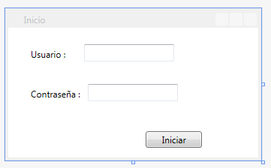

Interfaz inicio

<Button Content="Iniciar" HorizontalAlignment="Left" Margin="183,138,0,0" VerticalAlignment="Top" Width="75" />

<Label Content="Usuario :" HorizontalAlignment="Left" Margin="25,22,0,0" VerticalAlignment="Top"/>

<Label Content="Contraseña :" HorizontalAlignment="Left" Margin="25,75,0,0" VerticalAlignment="Top"/>

<TextBox x:Name="txUsuario" HorizontalAlignment="Left" Height="23" Margin="101,22,0,0" TextWrapping="Wrap" VerticalAlignment="Top" Width="120"/>

<TextBox x:Name="txPassword" HorizontalAlignment="Left" Height="23" Margin="106,75,0,0" TextWrapping="Wrap" VerticalAlignment="Top" Width="120"/>

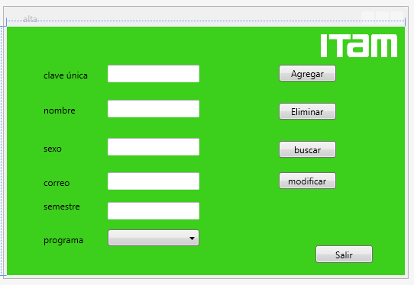

Interfaz alta

<Label Content="clave única" HorizontalAlignment="Left" Margin="43,50,0,0" VerticalAlignment="Top"/>

<Label Content="nombre" HorizontalAlignment="Left" Margin="43,96,0,0" VerticalAlignment="Top"/>

<Label Content="sexo" HorizontalAlignment="Left" Margin="43,146,0,0" VerticalAlignment="Top"/>

<Label Content="correo" HorizontalAlignment="Left" Margin="43,191,0,0" VerticalAlignment="Top"/>

<Label Content="semestre" HorizontalAlignment="Left" Margin="43,222,0,0" VerticalAlignment="Top"/>

<Label Content="programa" HorizontalAlignment="Left" Margin="43,266,0,0" VerticalAlignment="Top"/>

<TextBox x:Name="tbFolio" HorizontalAlignment="Left" Height="23" Margin="132,50,0,0" TextWrapping="Wrap" VerticalAlignment="Top" Width="120"/>

<TextBox x:Name="tbNombre" HorizontalAlignment="Left" Height="23" Margin="132,96,0,0" TextWrapping="Wrap" VerticalAlignment="Top" Width="120"/>

<TextBox x:Name="tbSexo" HorizontalAlignment="Left" Height="23" Margin="132,146,0,0" TextWrapping="Wrap" VerticalAlignment="Top" Width="120"/>

<TextBox x:Name="tbCorreo" HorizontalAlignment="Left" Height="23" Margin="132,191,0,0" TextWrapping="Wrap" VerticalAlignment="Top" Width="120"/>

<TextBox x:Name="tbSemestre" HorizontalAlignment="Left" Height="23" Margin="132,230,0,0" TextWrapping="Wrap" VerticalAlignment="Top" Width="120"/>

<ComboBox x:Name="cbProgramas" HorizontalAlignment="Left" Margin="132,266,0,0" VerticalAlignment="Top" Width="120"/>

<Button x:Name="btAgregar" Content="Agregar" HorizontalAlignment="Left" Margin="356,50,0,0" VerticalAlignment="Top" Width="75" />

<Button x:Name="btEliminar" Content="Eliminar" HorizontalAlignment="Left" Margin="356,100,0,0" VerticalAlignment="Top" Width="75" />

<Button x:Name="btSalir" Content="Salir" HorizontalAlignment="Left" Height="23" Margin="404,287,0,0" VerticalAlignment="Top" Width="75"/>

<Button x:Name="btModificar" Content="modificar" HorizontalAlignment="Left" Margin="356,191,0,0" VerticalAlignment="Top" Width="75"/>

<Button Content="buscar" HorizontalAlignment="Left" Margin="356,150,0,0" VerticalAlignment="Top" Width="75"/>

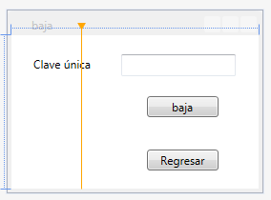

Interfaz baja

<Label Content="Clave única" HorizontalAlignment="Left" Margin="18,17,0,0" VerticalAlignment="Top"/>

<TextBox x:Name="tbFolio" HorizontalAlignment="Left" Height="23" Margin="115,20,0,0" TextWrapping="Wrap" VerticalAlignment="Top" Width="120" />

<Button x:Name="btBaja" Content="baja" HorizontalAlignment="Left" Margin="142,64,0,0" VerticalAlignment="Top" Width="75" Click="btBaja_Click" />

<Button x:Name="btRegresar" Content="Regresar" HorizontalAlignment="Left" Margin="142,120,0,0" VerticalAlignment="Top" Width="75" Click="btRegresar_Click" />

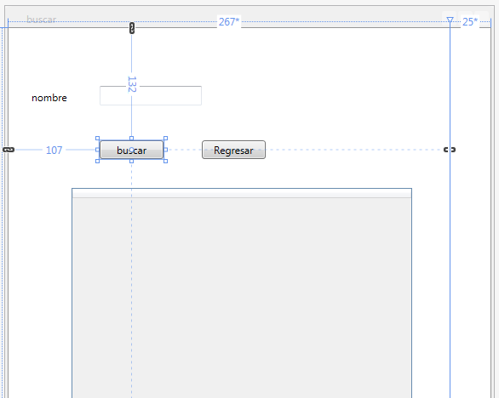

Interfaz buscar

<Grid.ColumnDefinitions>

<ColumnDefinition Width="267*"/>

<ColumnDefinition Width="25*"/>

</Grid.ColumnDefinitions>

<TextBox x:Name="tbNombre" HorizontalAlignment="Left" Height="23" Margin="107,68,0,0" TextWrapping="Wrap" VerticalAlignment="Top" Width="120"/>

<Label x:Name="nobme" Content="nombre" HorizontalAlignment="Left" Margin="22,68,0,0" VerticalAlignment="Top"/>

<Button Content="buscar" HorizontalAlignment="Left" Margin="107,132,0,0" VerticalAlignment="Top" Width="75" Click="Button_Click" />

<DataGrid x:Name="dgDatos" HorizontalAlignment="Left" Margin="74,188,0,0" VerticalAlignment="Top" Height="300" Width="400" Grid.ColumnSpan="2"/>

<Button Content="Regresar" HorizontalAlignment="Left" Margin="227,132,0,0" VerticalAlignment="Top" Width="75" Click="Button_Click_1"/>

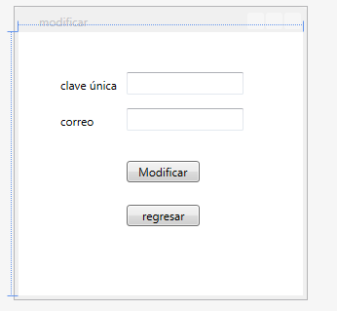

Interfaz modificar

<Label Content="correo" HorizontalAlignment="Left" Margin="38,78,0,0" VerticalAlignment="Top"/>

<TextBox x:Name="tbCorreo" HorizontalAlignment="Left" Height="23" Margin="111,78,0,0" TextWrapping="Wrap" VerticalAlignment="Top" Width="120"/>

<Button x:Name="tbModificar" Content="Modificar" HorizontalAlignment="Left" Margin="111,132,0,0" VerticalAlignment="Top" Width="75" Click="tbModificar_Click" />

<Button x:Name="tbRegresar" Content="regresar" HorizontalAlignment="Left" Margin="111,177,0,0" VerticalAlignment="Top" Width="75" Click="tbRegresar_Click" />

<TextBox x:Name="tbFolio" HorizontalAlignment="Left" Height="23" Margin="111,41,0,0" TextWrapping="Wrap" VerticalAlignment="Top" Width="120"/>

<Label Content="clave única&#xD;&#xA;" HorizontalAlignment="Left" Margin="38,41,0,0" VerticalAlignment="Top"/>