DEPARTMENT OF COMPUTER SCIENCE
Air University Islamabad


NOVAPAY BANK ATM
Automated Teller Machine Simulation
Computer Organization & Assembly Language (COAL) | 8086 Assembly
SUBMITTED BY
Student Name | Ifra Abdullah Khan
Student ID / Roll No. | 242719
SUBMITTED TO
Instructor Name | Mr. Danial Haider
CLASS DETAILS
Class / Section | BSCS-EVE-F24-B
Semester | 4th Semester
Session | Spring 2025
SUBMISSION INFO
Submission Date | 05/MAY/2026

NovaPay Bank ATM · COAL Project · 8086 Assembly Language
NOVAPAY BANK ATM
LAB PROJECT

1. Introduction
This project implements a functional ATM (Automated Teller Machine) simulation using 8086 Assembly Language under DOS. The program demonstrates low-level programming concepts taught in the Computer Organization and Assembly Language (COAL) course.
The ATM system is named NovaPay Bank ATM and provides core banking operations: PIN-based authentication, balance enquiry, cash withdrawal, and cash deposit — all implemented with direct hardware-level DOS interrupt calls (INT 21h) and fundamental register operations. The code is structured exclusively around topics covered in the COAL lab course (Weeks 2, 3, 6, 7, 9, and 13): standard INT 21h service routines, CMP-based conditional jumps, the LOOP instruction with arrays, user-defined procedures, and PUSH/POP stack operations for register preservation.

2. Scope
The project covers the following scope within the COAL course context:
- Simulates a real-world ATM interface for NovaPay Bank inside a DOS console environment.
- PIN verification with 3-attempt lockout for improved security (PIN: 1234).
- PIN digits are masked with * characters so the PIN is not visible on screen.
- 32-bit balance arithmetic to support values beyond the 16-bit limit (up to ~4 billion).
- Input validation: only digit characters (0–9) accepted; Enter confirms the amount.
- Modular code design using separate user-defined procedures (Week 9) for each functional unit: CheckPIN, PrintBalance, InputNumber32, and PrintNumber32.
- Practical use of DOS INT 21h services for I/O without high-level libraries.

3. Functionalities
3.1 PIN Authentication (with Masking & Retry)
On startup the user is prompted for a 4-digit PIN. Each digit is read with INT 21h/AH=08h (no echo) and a * is printed instead. The user gets up to 3 attempts before the program locks out and exits.
3.2 Main Menu
After successful login, a text-based menu is displayed with four options:
- 1. Check Balance — displays the current account balance.
- 2. Withdraw Cash — deducts an entered amount from the balance.
- 3. Deposit Cash — adds an entered amount to the balance.
- 4. Exit — terminates the program with a farewell message.
3.3 Balance Enquiry
Reads the 32-bit balance (bal_hi:bal_lo) and prints it as a decimal via PrintNumber32.
3.4 Withdrawal
Accepts a numeric amount via InputNumber32. Compares with the 32-bit balance using a two-stage CMP (high word then low word). If sufficient, subtracts using SUB/SBB; otherwise prints "Insufficient Balance".
3.5 Deposit
Accepts a numeric amount and adds it to the 32-bit balance using ADD/ADC. A success message confirms the transaction.
3.6 Exit
Prints a thank-you message and calls INT 21h/AH=4Ch to terminate cleanly.

4. COAL Concepts Used
Segment Registers & Memory Model (Week 2)
.model small; DS loaded with @data at runtime.
Data Segment Definitions (Week 2)
DB for $-terminated strings; DW for 16-bit words; two DWs for 32-bit balance (bal_hi:bal_lo); two DWs as 32-bit input accumulator (tmp_hi:tmp_lo); DB array pin_buf (4 bytes) for PIN storage; DB attempts counter; DW ten = 10 used as divisor in PrintNumber32.
Register Usage (Weeks 2, 6, 7, 9, 13)
AX/DX as 32-bit hi:lo pair for arithmetic and procedure return values; BX as carry holder in InputNumber32; CX as LOOP counter (PIN read) and digit counter (PrintNumber32); SI as array pointer (pin_buf) and low-word holder during division. All registers saved/restored with PUSH/POP at procedure boundaries (Week 13).
DOS INT 21h Services (Week 2)
AH=09h print string | AH=08h read no-echo | AH=02h print char | AH=4Ch exit.
Conditional & Unconditional Jumps (Week 6)
JE, JNE, JA, JB, JNZ used for PIN digit comparison, menu dispatch, 32-bit balance comparison (two-stage high-word then low-word), and digit-loop termination. JMP (unconditional) used for menu_loop, pin_try, and in_loop back-edges.
Arrays & LOOP Instruction (Week 7)
pin_buf is a 4-byte DB array (db 4 dup(0)) used to store PIN digits — an indexed array accessed via the SI pointer register. The PIN-read loop uses LOOP with CX=4 to read exactly four characters into successive array elements. The digit-print loop in PrintNumber32 also uses LOOP with CX = digit count.
Stack & Procedure Calls (Weeks 9 & 13)
CALL/RET for all four procedures (CheckPIN, PrintBalance, InputNumber32, PrintNumber32). All procedures save and restore registers via PUSH/POP at entry and exit — PUSH/POP is also used in PrintNumber32 to build a digit stack so digits print in the correct (most-significant-first) order.
32-bit Arithmetic — ADD/ADC and SUB/SBB (Week 6)
ADD/ADC for deposit; SUB/SBB for withdrawal — correct carry propagation across word boundary.
MUL / DIV Instructions (Week 2)
InputNumber32 uses MUL×10 for 32-bit accumulation; PrintNumber32 uses a two-stage 16-bit DIV by 10 to extract digits one at a time. The divisor constant (ten dw 10) is declared in the .data segment and referenced without a segment override, removing the non-standard CS: prefix used in the original code.
ASCII Arithmetic (Week 2)
SUB AL,'0' to value; ADD DL,'0' back to ASCII. Range check against '0'/'9' validates input.
PIN Masking — INT 21h AH=08h (Week 2)
INT 21h/AH=08h suppresses echo; * is manually printed per digit with AH=02h.
Retry Counter (Weeks 2, 3 & 6)
attempts db 3 declared in .data segment; DEC decrements the counter on each wrong PIN (Week 2: arithmetic); CMP/JE checks for zero and jumps to pin_locked (Weeks 3 & 6: CMP + conditional jump). The remaining count is converted to ASCII with ADD DL,'0' and printed with AH=02h.

5. Flow Chart
The following table traces the full execution flow of the ATM program:
Step / Decision | Description
START | Program begins; initialise DS register
Display Welcome | Print "NOVAPAY BANK ATM" banner
Call CheckPIN | Prompt for 4-digit PIN; read with masking (*)
Attempts < 3? | Retry loop — up to 3 incorrect PIN entries allowed
PIN Correct? | Compare each byte against stored PIN (1 2 3 4)
NO → Wrong PIN | Increment attempt counter; retry or lockout & EXIT
YES → Main Menu | Print numbered menu options 1–4
Read Choice (AH=01h) | Read single keypress into AL
Choice = 1 → Check Balance | Call PrintBalance32; print 32-bit balance; back to menu
Choice = 2 → Withdraw | Call InputNumber32; compare 32-bit amount vs balance
Sufficient? | YES: SUB/SBB balance; print success  NO: print Insufficient Balance
Choice = 3 → Deposit | Call InputNumber32; ADD/ADC to balance; print success
Choice = 4 → Exit | Print farewell; INT 21h AH=4Ch
Invalid key | Print error; JMP back to main_menu
END | Process terminates; returns to DOS

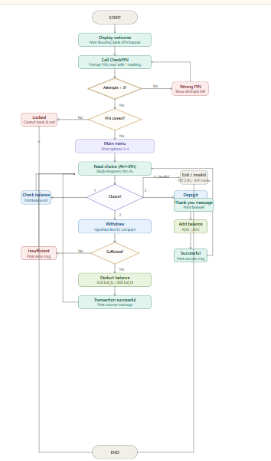
6. Screenshots of Code and Output
All screenshots below were captured from the EMU8086 emulator running the NovaPay Bank ATM program.
6.1 Welcome Screen & PIN Masking (Wrong PIN with Retry)
Welcome banner + masked PIN entry + wrong PIN with retry message
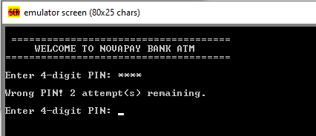

6.2 Successful PIN Login → Main Menu
Two wrong PIN attempts shown, then correct PIN accepted → main menu
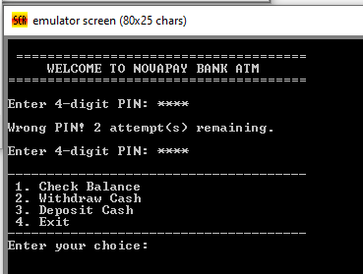

6.3 Check Balance — Initial Balance Rs. 5000
Menu option 1 selected → "Your Current Balance: Rs. 5000"
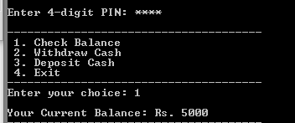

6.4 Withdraw Rs. 3560 — Transaction Successful
Menu option 2 → withdraw Rs. 3560 → "Transaction Successful!"
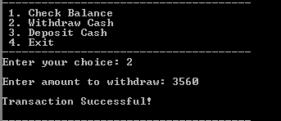

6.5 Balance after Withdrawal — Rs. 1440
Balance after withdrawal: Rs. 1440
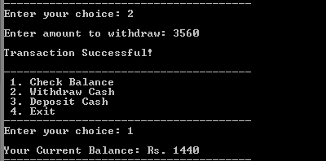

6.6 Deposit Rs. 5600 — Balance becomes Rs. 7040
Menu option 3 → deposit Rs. 5600 → balance becomes Rs. 7040
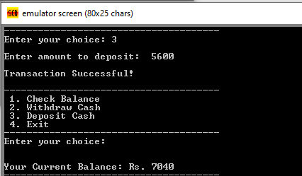

6.7 Large Deposit Rs. 50000 — 32-bit Balance Rs. 57040
32-bit deposit test: Rs. 50000 deposited → balance Rs. 57040 (proves 32-bit works)
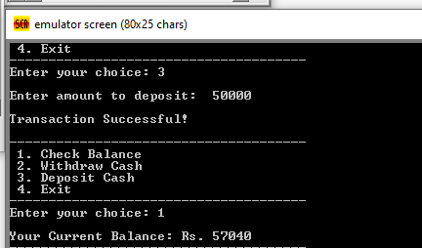

6.8 Exit — Thank You Message
Menu option 4 → "Thank you for using NovaPay Bank ATM!" exit
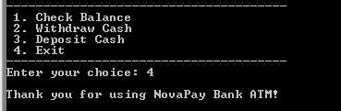

NovaPay Bank ATM | COAL Project | 8086 Assembly Language

