RESTAURANT ORDER MANAGEMENT SYSTEM
Project README / Reference Document
A web-based Restaurant Order Management System developed using Python, Flask, HTML5, CSS3, Bootstrap 5, and JavaScript. The application helps food service establishments manage multi-cuisine menus, customer orders via an interactive sliding cart drawer, and real-time kitchen order tracking through a clean and professional dashboard.

Features
- • Multi-Cuisine Menu Management across various culinary categories with pricing.
- • Interactive Sliding Cart Drawer allowing seamless item review and quantity updates.
- • Real-time Order Placement via asynchronous JSON API requests.
- • Live Kitchen Orders Tracker Dashboard displaying incoming active orders.
- • Order Status Tracking supporting Pending, Processing, and Completed states.
- • Responsive Bootstrap 5 Interface optimized for multi-device viewing.
- • Professional Dark & Modern Dashboard Design providing high usability.

Tech Stack
- Frontend: HTML5, CSS3, Bootstrap 5, JavaScript
- Backend: Python, Flask Framework
- Data Handling: Python Dictionaries & Lists (Easily expandable to SQLite/SQLAlchemy)

Project Structure
restaurant_system/
│
├── app.py
├── requirements.txt
├── README.md
├── static/
│ ├── style.css
│ └── script.js
└── templates/
├── base.html
├── welcome.html
├── menu.html
└── kitchen.html

Core Data Entities

Menu Item Structure
- • id: Unique menu item identifier • • name: Name of the dish
- • price: Price in Indian Rupees (₹)
- • cuisine: Category or cuisine type (North Indian, South Indian, Italian, Chinese)
- • image: Image URL reference for visual appeal

Order Structure
- • id: Unique order identifier
- • items: List of selected dishes and quantities ordered
- • total: Calculated total monetary value of the order
- • status: Current operational status of the order (Pending/Completed)

Application Workflow
- 1. Launch application and view the welcome splash page.
- 2. Navigate to the multi-cuisine menu page.
- 3. Browse food items across different categories with pricing in ₹.
- 4. Add desired dishes to the active order cart.
- 5. Toggle the sliding cart drawer to review items and total price.
- 6. Click 'Place Order Now' to submit order payload via backend API.
- 7. Access the Kitchen Dashboard to view live incoming orders.
- 8. Monitor and update order fulfillment statuses in real time.

Installation Guide
- 1. Clone or download the project repository.
- 2. Open terminal and navigate to the project root directory: cd restaurant_system
- 3. Create a Python virtual environment: python -m venv venv
- 4. Activate virtual environment (Windows: venv\Scripts\activate | Mac/Linux: source venv/bin/activate)
- 5. Install project dependencies: pip install -r requirements.txt (Flask)

Run the Application
Execute the following command in your terminal to start the development server:
python app.py

Open your web browser and navigate to: http://127.0.0.1:5000/

Screenshots Reference
- • Welcome Page:
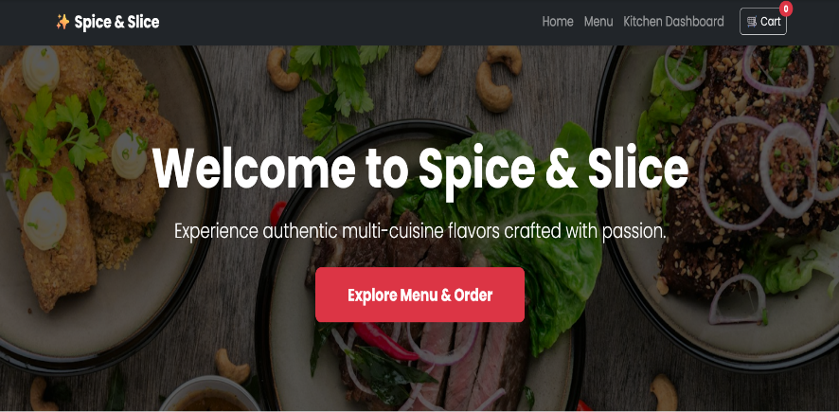
- • Menu Page:
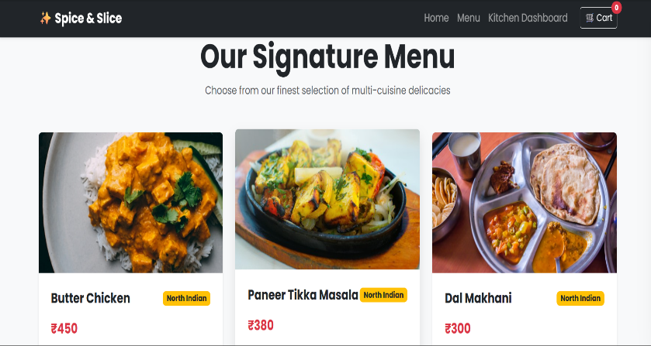
- • Cart Drawer:
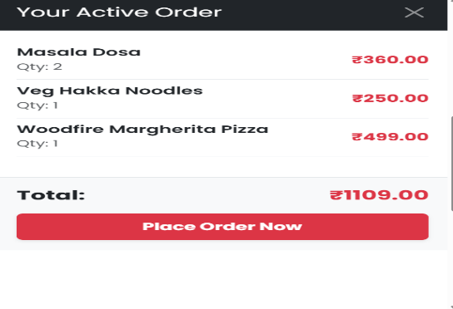
- • Kitchen Dashboard:
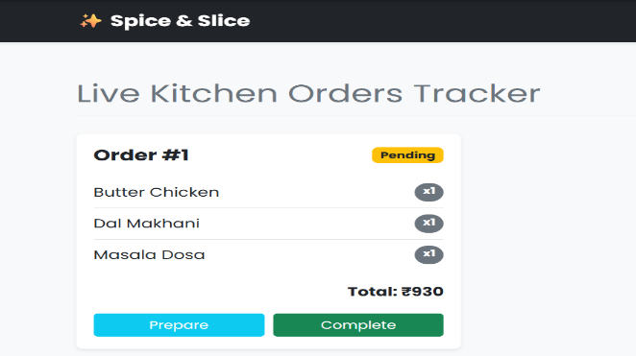

Future Enhancements
- • Customer Authentication and User Login
- • Role-based Access Control (Admin, Chef, Customer)
- • Persistent Database Integration (SQLite / PostgreSQL)
- • Payment Gateway Integration
- • SMS and Email Order Confirmations

Learning Outcomes
- • Python programming and server-side routing fundamentals
- • Flask web application framework development
- • Frontend layout creation using HTML, CSS, and Bootstrap 5
- • Asynchronous client-server communication using JavaScript Fetch API

Author & Metadata
Student Name: Ifraa shariff
USN: U18IN24S0019
Course: BCA
Project Title: Restaurant Order Management System
Technologies: Python | Flask | Bootstrap 5 | JavaScript

GitHUB
https://github.com/ifraashariff17-code/Restaurant_system.git

License
Developed for educational, academic, internship, and portfolio purposes.

