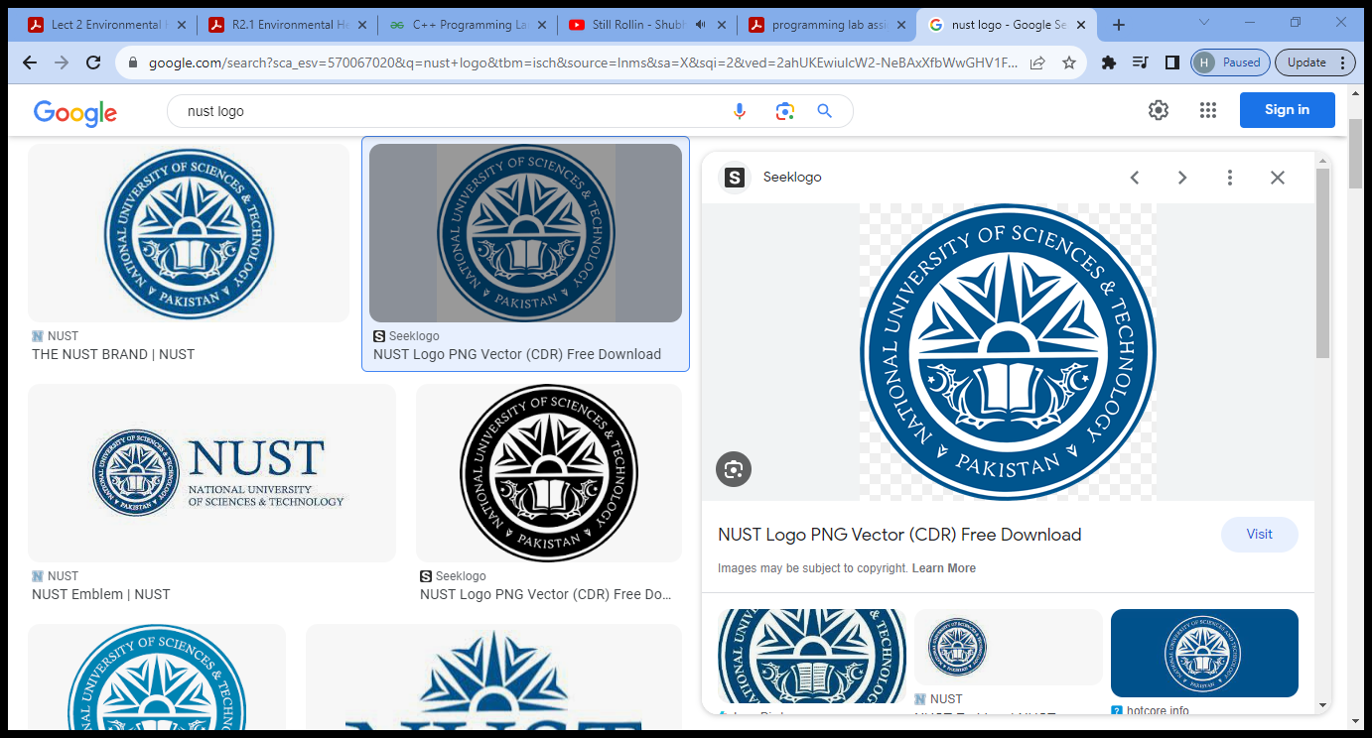

School Of Mechanical & Manufacturing Engineering,

NUST Department of Mechanical Engineering

> CS-114 - Fundamental of Programing

> Assignment # 0 1

> Course Instructor: Dr Jawad Khan

> Lab Instructor: Muhammad Affan

> Student Name: Ifra Murtaza

> CMS ID: 454546

DATE: 28/09/2023

# 1__Distance between two points :

D = (x2-x1)2 + (y2-y)

# CODE:

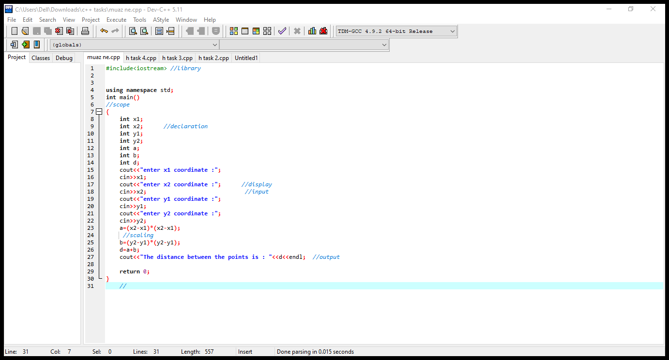

# RESULTS:

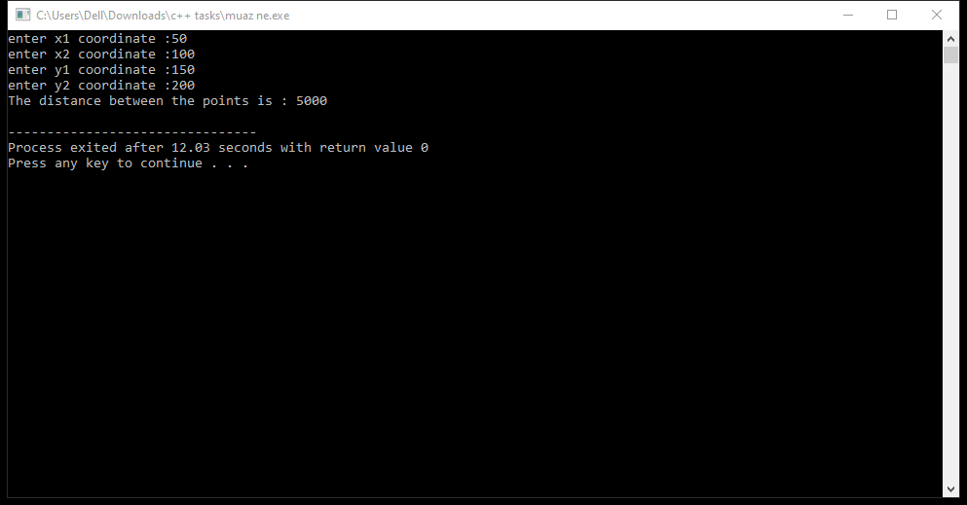

# 2__Converting Centimeters into meters and kilometers:

# CODE:

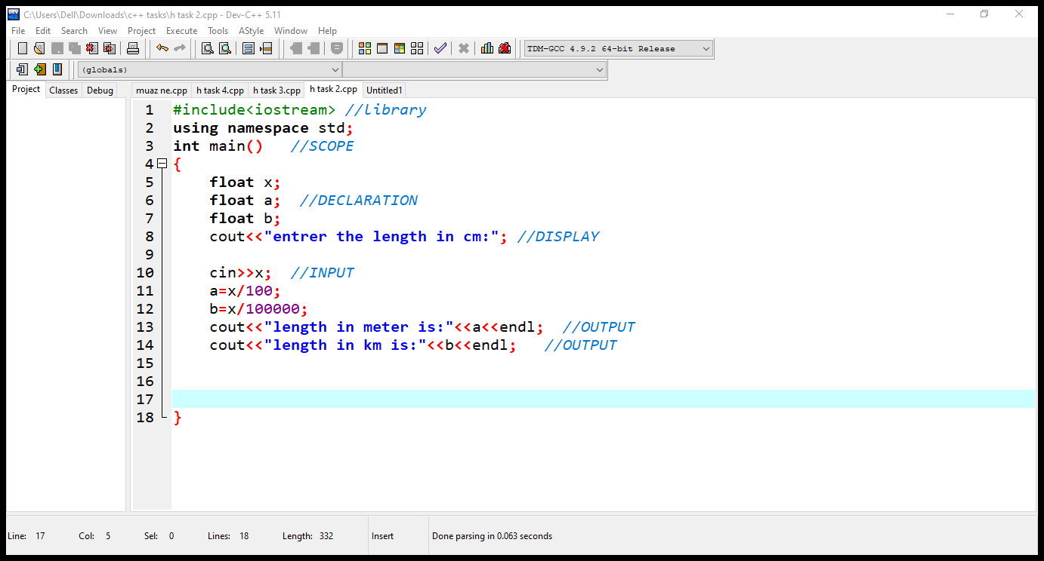

# RESULTS:

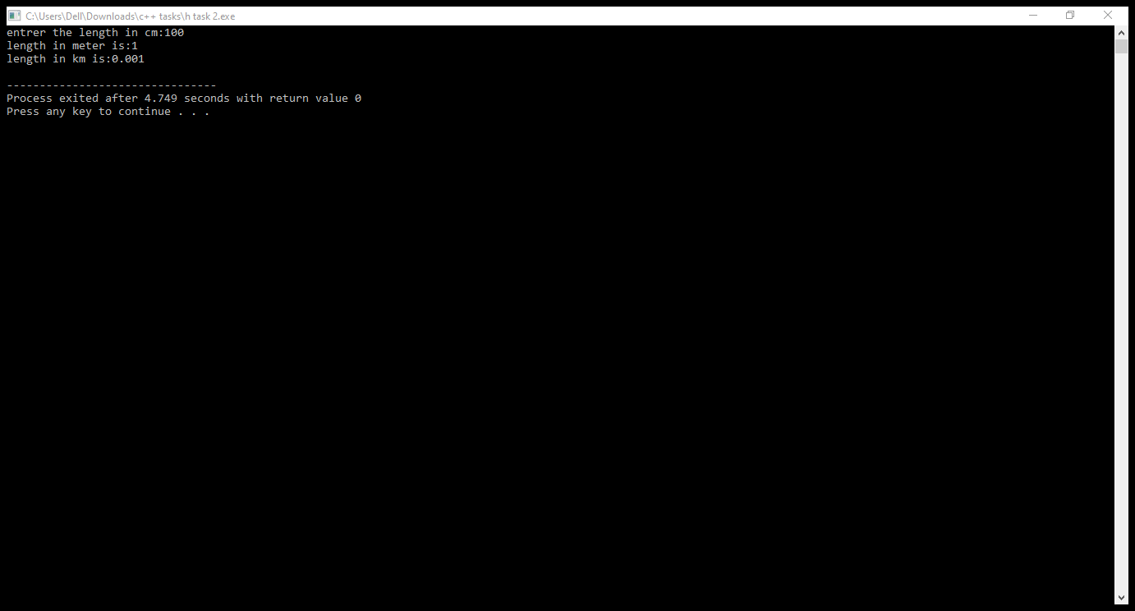

# 3__Result of polynomial :

# a2 +2ab +b2 :

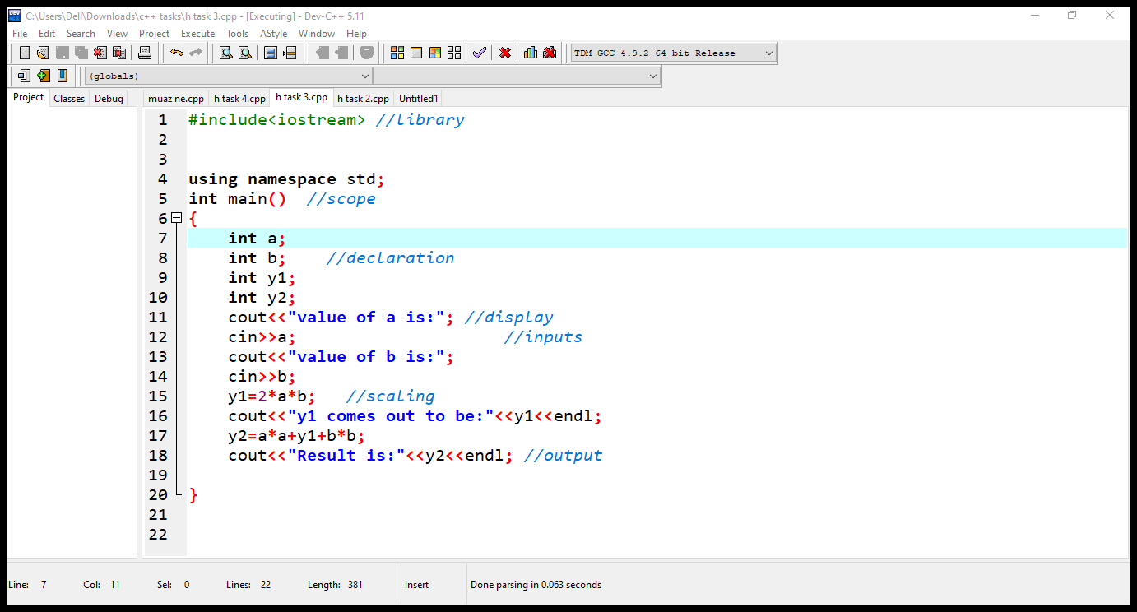

# RESULTS:

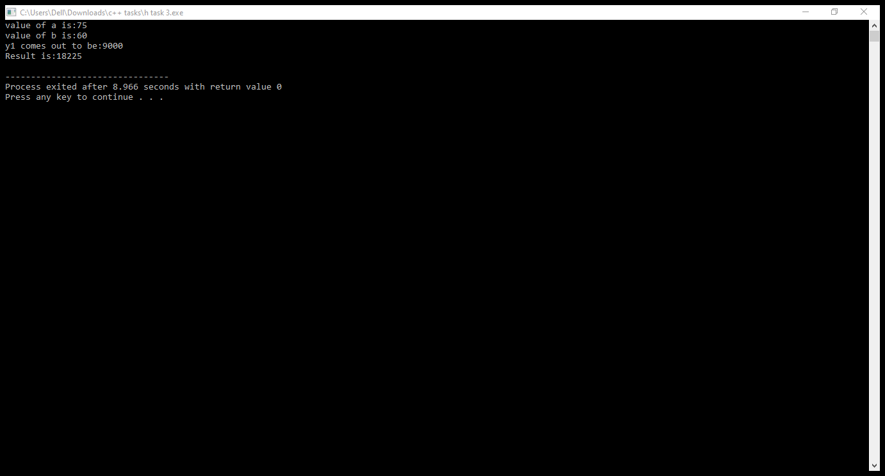

# 4__Converting Fahrenheit into Celsius:

# CODE:

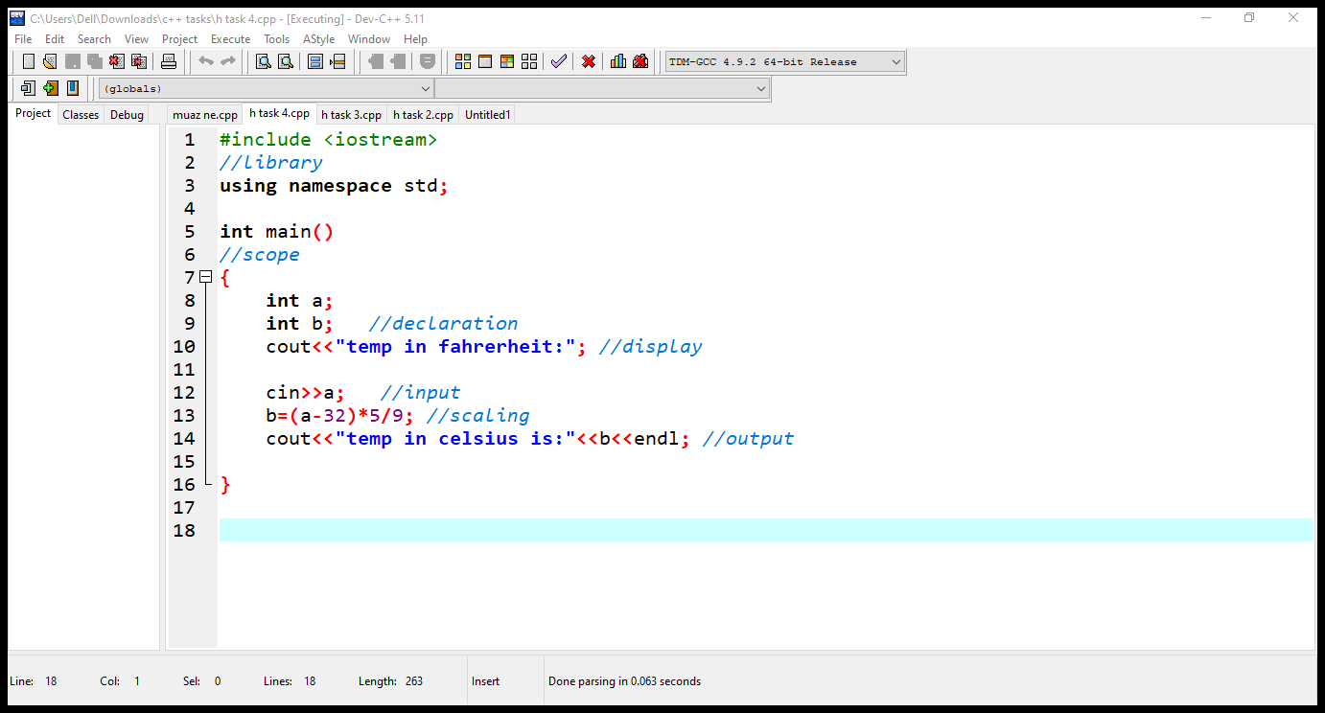

# RESULTS:

