FUNDAMENTALS OF PROGRAMMING

TASK: LAB MANUAL 9

NAME: IFRA MURTAZA

CMS ID: 454546

CLASS: ME 15 A

LAB INSTRUCTOR: SIR AFFAN

1.Make 2D Array in C++ and print left diagonal and right diagonal sum of a 3x3 matrix.

Code

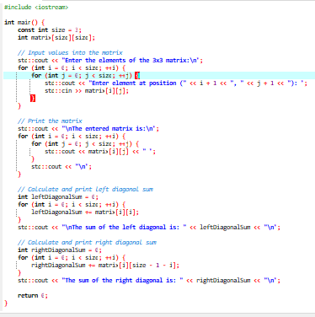

Output

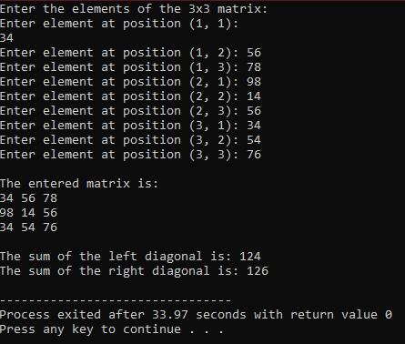

1. Write a function to add two 2D arrays of size 3x3.

Code

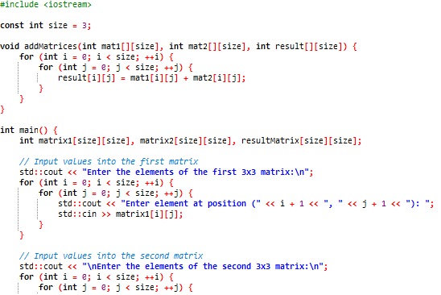

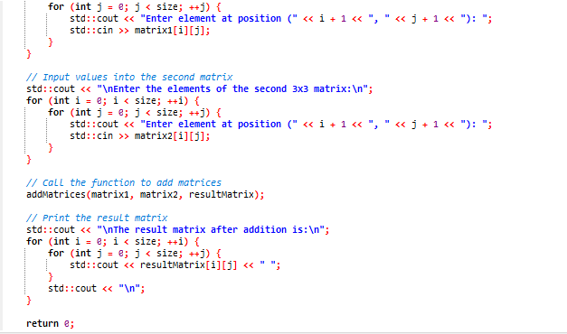

Output

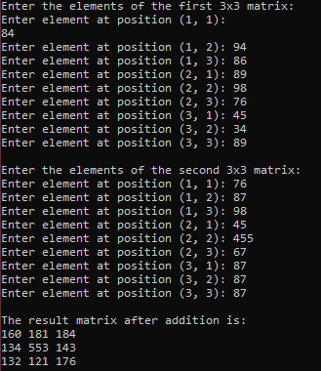

3.Using 2D arrays in C++, take transpose of a 3x3 matrix. Make a transpose function

Code

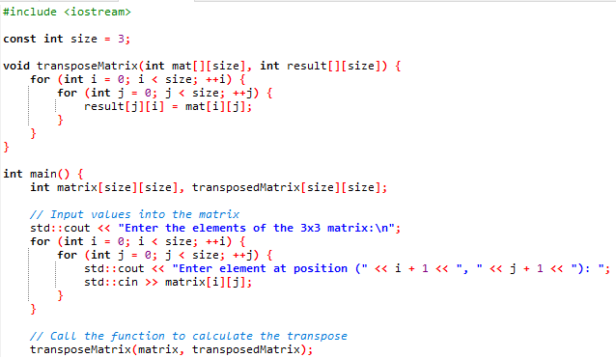

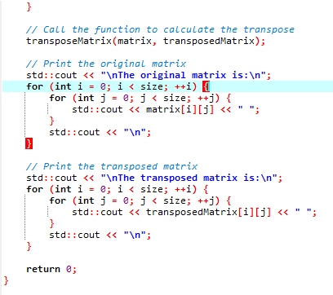

Output

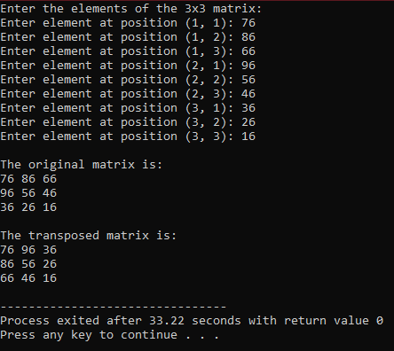

4.Using 2D arrays in C++, implement 3x3 matrix multiplication. Make a function

Code

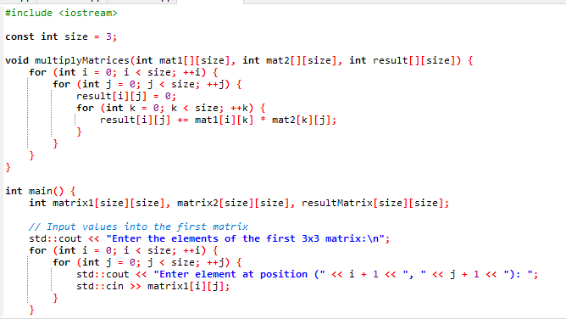

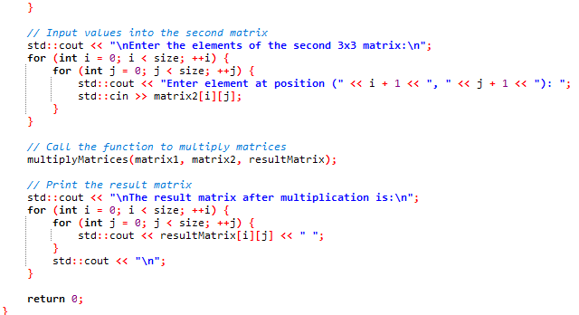

Output

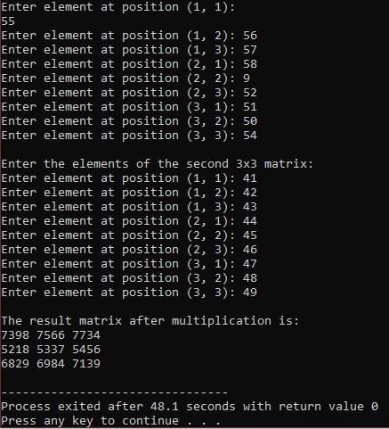

5.Print the multiplication table of 15 using recursion.

Code

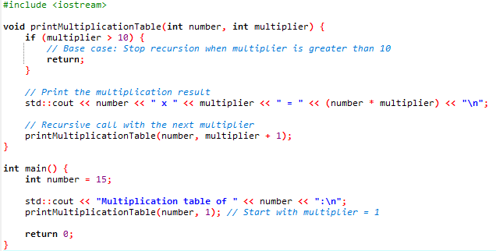

Output

