**FUNDAMENTALS OF PROGRAMMING**

**LAB MANUAL 8**

**NAME: IFRA MURTAZA**

**CMS ID:454546**

**CLASS: ME 15 A**

**Question 1**

1. **Write a C++ program to calculate average of numbers of array.**

**Code:**

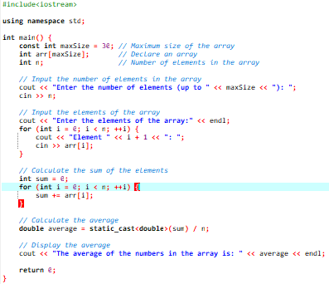

**Output**

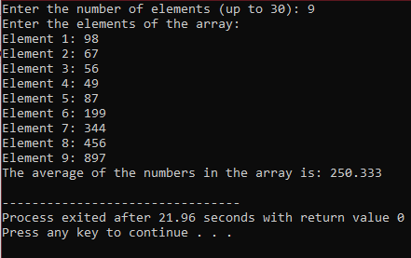

**Question 2**

**2. Implement Bubble sort on an array of 5 integers.**

**Code**

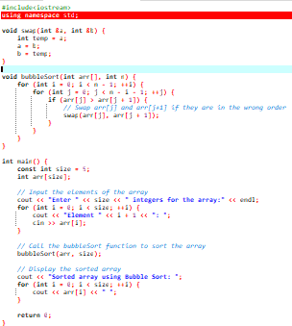

**Output**

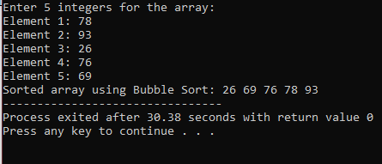

**Question 3**

**3. Implement Selection Sort on an array of 5 integers**

**Code**

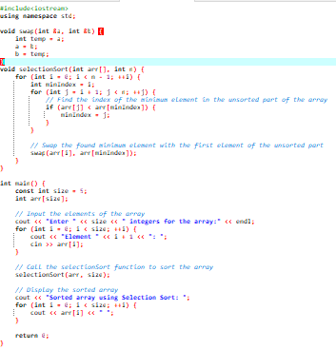

**Output**

