LUONGO CARRY-REGIME MODEL V2
France, London, CHF substitution, and the EUR/GBP-EUR/JPY constraint surface
Research specification + public-data test harness update

Purpose: translate Tom Luongo's revised hypothesis into distinct, testable channels without pretending public proxies identify more than they do.

V1 finding | Tom correction | V2 treatment
DE-JP 10Y residual compressed to ~30 bp | Keep it, but refine the actual trade mechanics | Long-end diagnostic; executable carry still requires forwards/basis/repo
BTP-Bund tightened while DE-JP compressed | Italy is not the weak link; BTP-Bund spikes flag ECB intervention pressure | Reclassify Italy from victim to policy/intervention-state signal
UK-Bund widened | London/UK remains independently interesting | Separate UK/London stress channel
Europe was too aggregated | France is the likely continental weak link | OAT-Bund + France CDS/repo/bank funding becomes primary continental stress block
JPY carry focus | CHF/SNB may now supply carry capacity | Add CHF short rates, FX, Swiss yields, and basis
EUR/JPY mattered | Why defend EUR/GBP 0.85 and EUR/JPY 180? | Treat 0.85 and 180 as pre-specified regime-boundary hypotheses and test every crossing

Source note: Tom Luongo feedback after reviewing the V1 empirical report; V1 public-data run supplied by Jason St George.

1. Executive update
The V2 model is materially better identified than V1. The central change is ontological: we now distinguish the funding/carry state, the vulnerable node, and the policy-response signal instead of asking one sovereign spread to play all three roles.
Funding state -> vulnerable node -> policy response -> collateral/liquidity consequences
Under Tom's correction, the first continental victim candidate is France, not Italy. BTP-Bund becomes a thermometer for fragmentation/intervention pressure. UK/London remains its own channel. CHF is added as a substitute funding source as Japan exits the zero-rate regime.
The new empirical question is not simply whether "Europe weakens." It is whether deterioration in carry capacity and FX crosses first appears in France and/or London, and whether BTP-Bund subsequently behaves like an ECB constraint/intervention signal.
V2 hypothesis | Observable implication | What would falsify it
H1: JPY carry capacity is being withdrawn | JPY short rates rise; effective EUR-funded-via-JPY carry compresses | All-in hedged carry remains stable/attractive despite BOJ normalization
H2: CHF substitutes for JPY | CHF funding becomes cheaper than JPY; CHF-based basis/forward activity rises | CHF basis/flows do not expand when JPY funding gets dearer
H3: France is the continental weak link | OAT-Bund/CDS/repo/bank funding deteriorate before broader Eurozone stress | France remains systematically stronger than peers in identified stress windows
H4: Italy signals ECB pressure | BTP-Bund spikes cluster around fragmentation/intervention episodes | BTP-Bund has no relation to identifiable ECB response or funding stress
H5: UK/London is separate | Gilt/SONIA/repo/LDI/dealer stress responds to carry/FX shocks | UK channel does not respond after controls
H6: EUR/JPY 180 and EUR/GBP 0.85 matter | Crossings/breaches predict stress/intervention beyond generic FX moves | Thresholds add no out-of-sample/event predictive power

2. What survives from V1
The V1 public-data result that motivated continued work remains intact: the German-Japanese 10-year residual collapsed from roughly 170 bp in January 2023 to about 30 bp in June 2026. The same June observation reproduced Tom's spread arithmetic almost exactly: U.S.-Japan about 177 bp minus U.S.-Germany about 147 bp = about 30 bp.
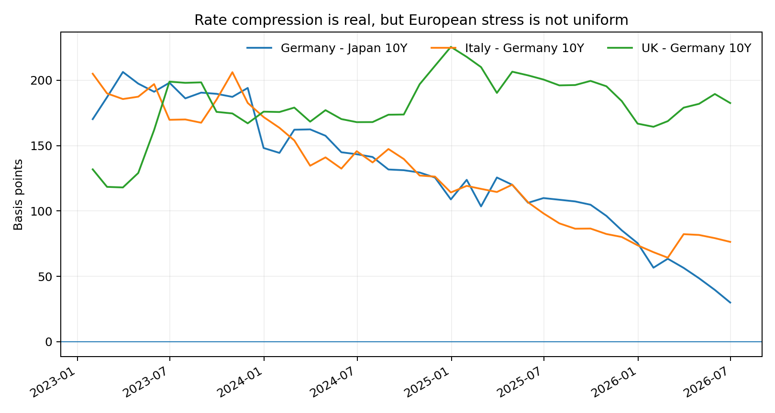
Source note: V1 public-data panel generated from FRED/OECD long-term yield series; this is a diagnostic yield residual, not executable carry.
The other V1 finding also survives: EUR/JPY moved strongly in the direction that would support an unhedged or partially hedged euro asset funded in yen while the raw rate advantage compressed. That made the FX leg look more important, not less.
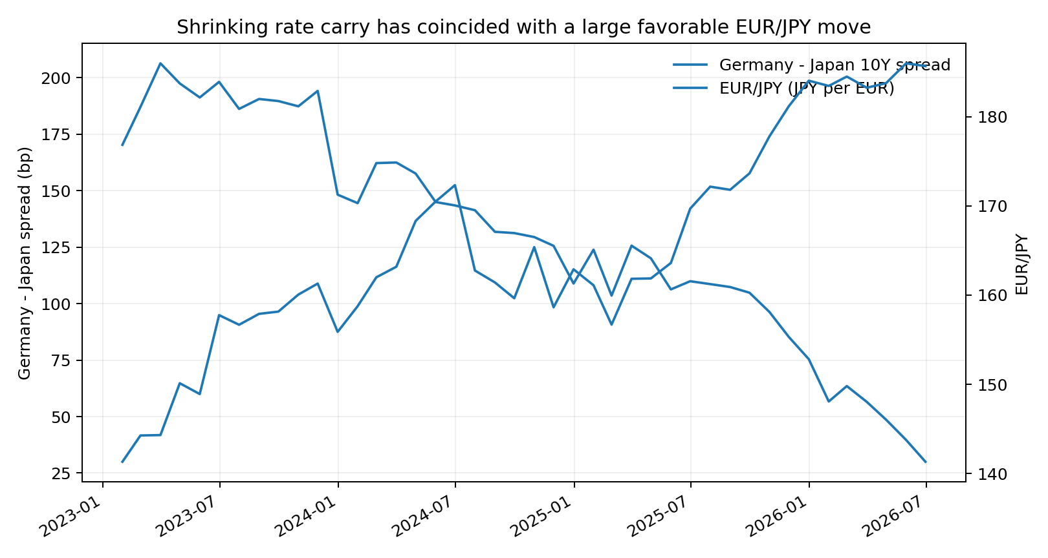
V2 therefore preserves the V1 core but raises the bar: long-yield geometry is only an alarm signal. The economic trade must be reconstructed from short funding, forwards, cross-currency basis, repo, hedge ratio, margin, and the actual European asset return.

3. Correcting the European stress map

3.1 France as the candidate weak link
Tom's correction is that Italy is not especially interesting as the terminal weak link. The more relevant continental candidate is France. Public data give us a first approximation through OAT-Bund; premium data should extend that into French sovereign CDS, bank CDS, OAT repo specialness, auction quality, wholesale bank funding, and collateral haircuts.
As of June 2026, the OECD/FRED 10-year proxy was 3.68% for France and 2.97% for Germany, or roughly a 71 bp OAT-Bund spread. The V1 panel put BTP-Bund at roughly 76.4 bp in the same month. The closeness of those raw spreads is not proof France is weaker; it is precisely why the richer France-specific funding and collateral variables matter.
Source note: FRED/OECD IRLTLT01FRM156N and IRLTLT01DEM156N; V1 monthly panel for Italy/Germany.

3.2 Italy becomes an ECB intervention-state variable
The V1 interpretation treated BTP-Bund as a generic European stress dependent variable. Tom's correction changes its role: spikes in BTP-Bund are useful because they show when fragmentation pressure becomes severe enough to constrain or provoke ECB action. That is conceptually consistent with the ECB's own description of TPI as a tool against unwarranted disorderly market dynamics that threaten monetary-policy transmission.
Source note: ECB Transmission Protection Instrument framework, 21 July 2022.
ECB_state_t = z24(Delta BTP-Bund_t) [signal only; align against actual ECB operations]
This matters for interpretation. A compressed BTP-Bund spread does not necessarily say "no stress." It may say fragmentation has been successfully suppressed, expected to be suppressed, or shifted elsewhere. V2 therefore asks whether France/London stress leads and BTP-Bund/ECB actions follow.

3.3 UK/London remains separate
UK-Bund widened materially during the period in which BTP-Bund tightened in V1. That observation fits Tom's intuition that London should be modeled separately from the euro sovereign periphery. V2 keeps a UK/London block rather than forcing it into a single Europe index.
- Gilt-Bund and gilt-US spread diagnostics
- SONIA and sterling/dollar funding basis
- Gilt repo specialness and haircuts
- Pension/LDI stress and margin requirements
- UK bank/dealer CDS and wholesale funding

4. US/UK/JP: useful triangle, but avoid a tautology
Tom notes an obvious link between U.S., U.K., and Japanese carry spreads. There is one important mathematical caution: at a common maturity the three sovereign spreads are mechanically linked.
(US - JP) - (US - UK) = (UK - JP)
Therefore, a high correlation between US-JP and UK-JP 10-year spreads is not independent evidence of a hidden carry system; they share the Japanese yield by construction. V2 still plots the triangle as a diagnostic, but the real test moves to short-term funding rates, FX forwards, cross-currency basis, repo, and actual hedge costs.
Carry_US/UK<-JP ~= asset return - synthetic funding cost - repo - hedge - margin/capital cost
The nontrivial question becomes whether changes in Japanese funding conditions alter the relative cost of financing U.S. versus U.K./European assets after hedging, and whether the resulting position changes appear in dealer/flow data.
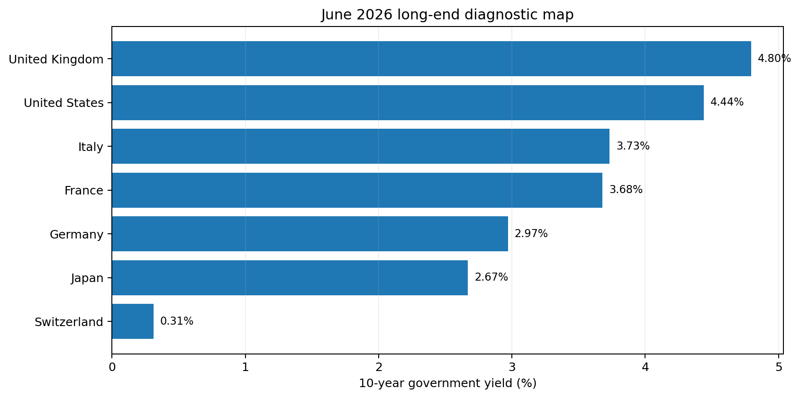
Source note: June 2026 long-term yields: V1 panel plus FRED/OECD France and Switzerland series. Diagnostic only.

5. CHF/SNB as replacement carry capacity
Tom's CHF observation is one of the most concrete V2 extensions. The SNB policy rate is 0%, while the BOJ is guiding the overnight rate around 1%. Public 3-month proxies point the same way: Swiss 3-month interbank was -0.045% in June 2026, while the latest Japanese 3-month interbank observation was about 1.274% in May 2026.
CHF funding advantage vs JPY ~= r_JPY,3m - r_CHF,3m ~= 132 bp [latest common-nearby public observations]
That does not prove institutions have actually migrated their books into CHF funding. It does establish a large enough public-rate incentive to justify testing the substitution mechanism directly with CHF forwards, USD/CHF and EUR/CHF basis, dealer flows, and Swiss funding-market data.
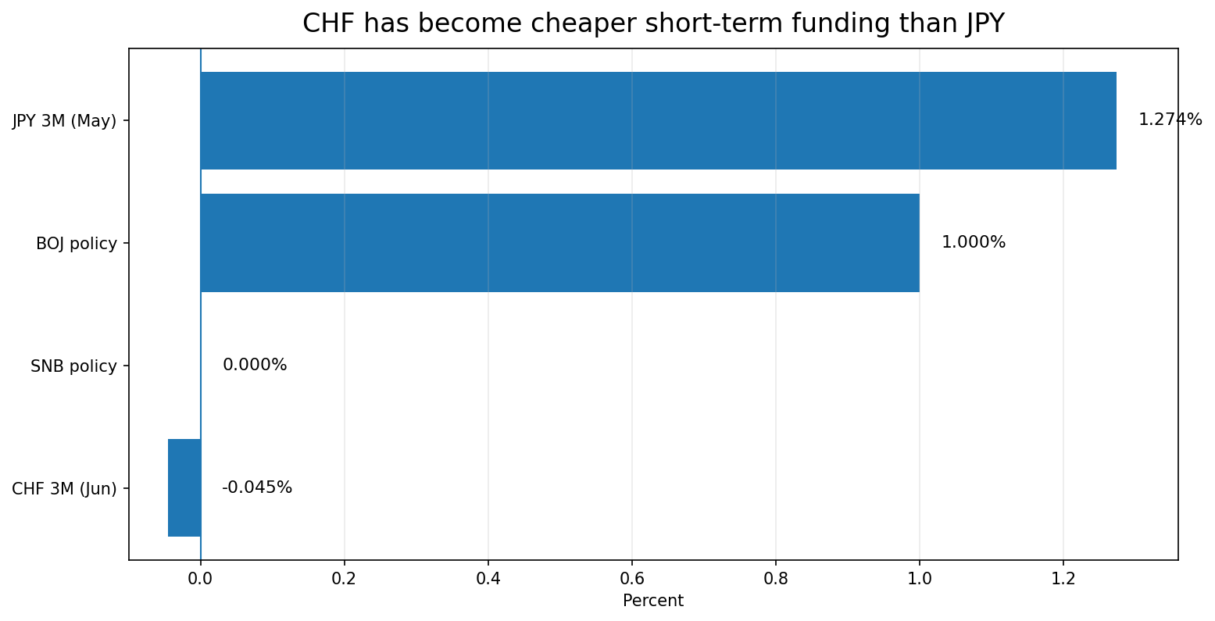
Source note: SNB policy rate; BOJ June 2026 guideline; FRED/OECD Switzerland and Japan 3-month interbank series. Japanese 3M latest public observation is May 2026; dates are labeled.
Test | Public proxy | Decisive upgrade
Funding substitution | JP 3M - CH 3M | CHF FX forwards and cross-currency basis
Balance-sheet migration | CHF/JPY and EUR/CHF spot behavior | Dealer/prime-broker or BIS currency exposures
Capacity constraint | Swiss rates and SNB policy | Repo haircuts, dealer capital, swap notional/tenor
Stress transfer | JPY shocks followed by CHF funding uptake | Institution-level position changes

6. The 180 / 0.85 hypothesis becomes a real test
Tom's most specific V2 question is why the ECB appears so sensitive to EUR/JPY below 180 and EUR/GBP below 0.85. These are ideal research hypotheses because the levels are supplied ex ante rather than discovered by our code.
On 7 August 2026, Federal Reserve H.10/FRED spot observations imply EUR/JPY around 182.10 and EUR/GBP around 0.85635 - only about 1.17% and 0.75%, respectively, above Tom's proposed levels. That proximity is intriguing, but it is not evidence that the levels are policy boundaries.
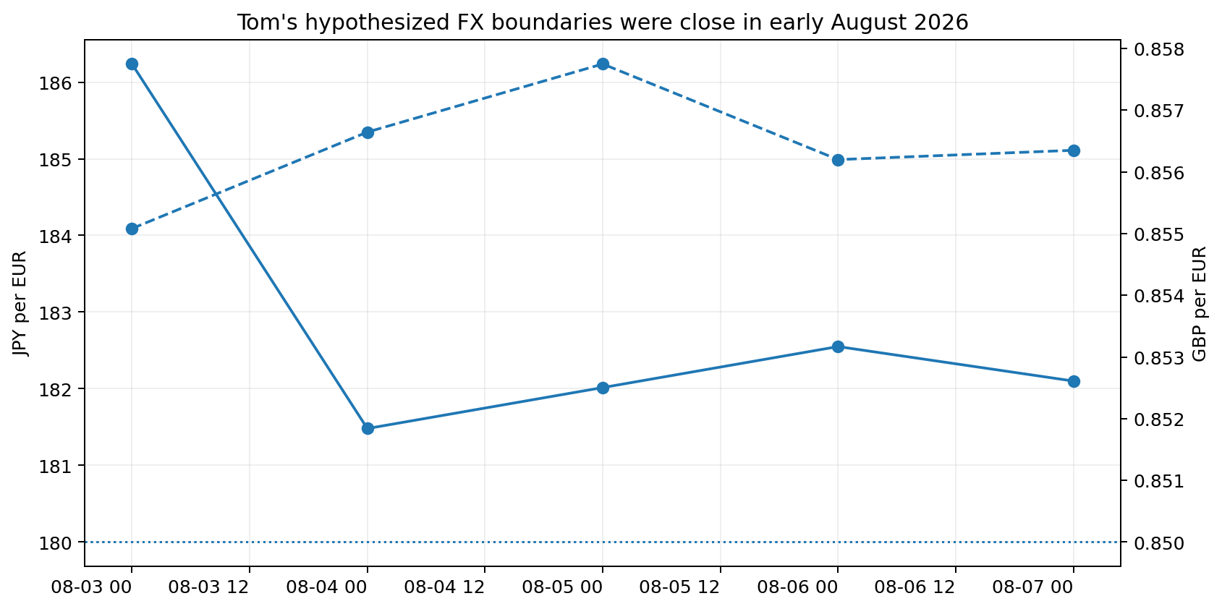
Source note: Derived from FRED/Federal Reserve H.10 DEXUSEU, DEXUSUK and DEXJPUS observations for 3-7 August 2026.
B_JPY(t) = 1[EURJPY_t < 180]
B_GBP(t) = 1[EURGBP_t < 0.85]
Constraint state C_t = B_JPY(t) + B_GBP(t)
V2 automatically identifies every crossing above and below both levels. It then measures subsequent changes over actual observed trading dates rather than calendar rows. Price/index variables are measured as log percentage changes; spreads and rates are measured as level changes.
- Compare below-threshold versus above-threshold regimes without optimizing the thresholds.
- Run event windows around each downward crossing and upward recovery.
- Condition France, UK/London and BTP-Bund responses on the threshold state.
- Test whether the two thresholds jointly matter more than either one alone.
- Use placebo thresholds (for example neighboring levels) to test whether 180/0.85 are special rather than arbitrary.
- Hold out recent data or use rolling estimation so the supplied thresholds must earn out-of-sample predictive power.

7. Updated causal architecture
Layer | V2 state variable | Interpretation
A. Funding/carry | JPY and CHF short rates; FX; basis; repo | Where cheap leverage is available and at what real all-in cost
B. FX constraint | EUR/JPY vs 180; EUR/GBP vs 0.85 | Tom's proposed boundaries on maintaining the structure
C. Continental victim | OAT-Bund + France CDS/repo/bank funding | Candidate weak link on the continent
D. London victim | Gilt/SONIA/repo/LDI/dealer funding | Separate offshore/UK stress channel
E. ECB response | BTP-Bund spike state + actual PEPP/TPI/reinvestment | Intervention/fragmentation thermometer
F. System repair | Dollar funding, gold, collateral, swap usage | Whether intervention stabilizes dollar liquidity and reprices collateral

BOJ normalization -> JPY carry compression -> {France stress, London stress}
JPY carry compression -> CHF substitution (if CHF capacity is available)
{EURJPY < 180, EURGBP < 0.85} -> higher probability of stress/intervention [to be tested]
France/London stress -> BTP-Bund fragmentation signal -> ECB response
Policy support -> dollar funding stabilization + collateral repricing [separate branch]
The strongest V2 model does not require every political attribution to be true. If the market sequence appears with the predicted signs and timing, the economic mechanism can be supported independently of whether policymakers deliberately engineered it.

8. What the V2 code now does
- Adds France 10Y (OAT proxy), Switzerland 10Y, CHF/USD, GBP/USD, and U.S./U.K./Japan/Switzerland 3-month public rates.
- Builds OAT-Bund, France-Japan, UK-Japan, U.S.-UK, Switzerland-Japan and short-rate carry-capacity diagnostics.
- Computes CHF funding advantage versus JPY so the substitute-carry hypothesis has an explicit state variable.
- Reclassifies BTP-Bund into a rolling fragmentation/intervention-state signal rather than using it as the primary victim variable.
- Computes EUR/GBP directly from USD/EUR and USD/GBP and tracks distance from 0.85; tracks EUR/JPY distance from 180.
- Extracts all threshold crossings automatically and runs a separate crossing event study.
- Fixes the V1 event-study bug: windows now use actual observed dates; price levels get log percentage changes while spreads/rates get level changes.
- Writes threshold_crossings.csv, threshold_crossing_event_study.csv, threshold_regime_summary.csv, revised scorecard/regressions, and new charts.

8.1 Run command
export FRED_API_KEY='YOUR_KEY'
python luongo_model_test_v2.py --start 2006-01-01 --events events_v2_template.csv --output outputs/v2_public
Add --optional-market-data optional_market_data_v2_template.csv once practitioner/vendor data are available. The public-only run remains useful and should not fail merely because premium inputs are absent.

8.2 Important data caveat
The public U.K. 3-month OECD/FRED interbank series appears stale relative to the other countries. V2 will load it if available but the report should always inspect last-observation dates before treating cross-country short rates as contemporaneous. Premium SONIA/OIS or another consistent vendor curve is preferable for serious work.

9. V2 falsification matrix
Claim | Required observation | Failure condition
France is weak continental node | Carry/FX shocks lead OAT-Bund/CDS/repo/bank stress | France does not underperform peers in identified windows
Italy is intervention signal | BTP-Bund spikes align with fragmentation and actual ECB response | No relation to ECB operational response after controls
London is separate weak node | Gilt/SONIA/repo/LDI/dealer stress responds independently | No incremental UK response after common risk controls
CHF replaces JPY carry capacity | CHF becomes cheaper and basis/flows/activity expand as JPY normalizes | No migration into CHF when JPY economics deteriorate
EUR/JPY 180 matters | Crossing below 180 increases future stress/intervention probability | 180 performs no better than nearby placebo levels
EUR/GBP 0.85 matters | Crossing below 0.85 increases future stress/intervention probability | 0.85 performs no better than nearby placebo levels
Joint FX boundary matters | Both breaches have nonlinear/interaction effect | Joint state adds no explanatory/predictive information
US/UK/JP link is economic | Short-rate/FX/basis data show linked position economics | Only long-yield algebra/correlation remains
Executable carry compresses | All-in covered/partial-hedge carry approaches zero | Forward/basis/repo terms preserve positive carry
Gold is repair collateral | Gold can rise as dollar funding/credit conditions improve in identified support windows | Gold only rises in classic dollar-debasement conditions

10. Where Matt Dines / Vince Lanci can materially improve the model
Tom is right that the remaining bottleneck is not more public charting; it is knowing what practitioners actually trade and how the positions are financed. The following questions are designed to turn expert feedback directly into variables and code rather than a general discussion.
- What is the actual institutional trade we should model: JPY-funded Bund/OAT/gilt, sovereign relative value, FX swaps, cross-currency basis, repo basis, pension hedging, or several linked trades?
- Which tenors are economically relevant on each leg (overnight/3M funding, 2Y/5Y/10Y sovereign, 1M/3M/1Y FX hedge)?
- What basis convention and vendor series should we use for EUR/JPY, EUR/GBP/GBP-USD, USD/JPY and USD/CHF so signs are not accidentally reversed?
- Are positions typically unhedged, partially hedged, rolling short hedges, or fully hedged? What hedge ratios are realistic?
- Which repo series, specialness measures, haircuts and margin requirements best capture Bund/OAT/gilt/JGB collateral stress?
- Which entities are plausibly the marginal vulnerable books: European banks, London dealers, pensions/LDI, macro funds, Japanese institutions, or offshore vehicles?
- For France specifically, which observable market is most diagnostic: OAT-Bund, France CDS, French bank CDS, repo, auction tails, bank wholesale funding, or collateral haircuts?
- For CHF substitution, where would the migration show first: CHF/JPY, EUR/CHF, USD/CHF basis, SARON/FX forwards, dealer balance sheets, or something else?
- What would you personally regard as evidence that EUR/JPY 180 or EUR/GBP 0.85 is a defended boundary rather than a coincidental chart level?
- What transaction or balance-sheet evidence would distinguish ECB/BOE intervention from ordinary arbitrage and correlated macro repricing?

11. Immediate next sequence
- Run V2 public baseline with the new FRED series and inspect data freshness/coverage.
- Examine every historical EUR/JPY 180 and EUR/GBP 0.85 crossing, then compare with placebo thresholds.
- Re-estimate the weak-link block using OAT-Bund as France proxy and BTP-Bund as an intervention-state variable.
- Test CHF substitution using short-rate advantage, CHF FX, and whatever basis series Matt/Vince recommend.
- Replace public U.K. short-rate proxies with consistent SONIA/OIS/vendor data if possible.
- Populate executable carry with forwards, basis, repo, asset return, hedging and margin terms.
- Only after the market mechanism is stable should we revisit stronger claims about coordinated intentionality.
What would count as a major success? Not simply another chart that looks right. A major success would be a reproducible sequence in which deteriorating JPY carry economics and/or FX threshold breaches predict France/London stress, CHF substitution appears when JPY funding becomes expensive, and BTP-Bund/ECB operations respond in the expected order.

12. Sources and status
Source | Use in V2
V1 public-data outputs (FRED/OECD, CFTC, MOF, TIC) | Baseline spread/FX findings and prior event-study lessons
Federal Reserve H.10 via FRED: DEXUSEU, DEXUSUK, DEXJPUS, DEXSZUS | EUR/GBP, EUR/JPY, CHF FX construction
FRED/OECD: IRLTLT01FRM156N | France 10Y / OAT proxy
FRED/OECD: IRLTLT01CHM156N | Switzerland 10Y
FRED/OECD: IR3TIB01JPM156N, IR3TIB01CHM156N, IR3TIB01USM156N, IR3TIB01GBM156N | Short-term funding/carry-capacity diagnostics
Swiss National Bank current interest-rate data | SNB policy rate / Swiss funding context
Bank of Japan June 2026 money-market guideline | BOJ policy-rate state
ECB TPI framework | Interpretation of fragmentation/intervention state
Tom Luongo follow-up feedback | France weak link; Italy as ECB signal; CHF substitution; 180/0.85 thresholds

Status: V2 is a research scaffold, not a claim of proof. The public inputs are enough to test several directional predictions and threshold events. The decisive all-in carry and vulnerability questions still require basis, forward, repo, margin, CDS and/or institution-level data.

