FROM THESIS
TO TEST
First public-data results on the yen-carry / collateral-regime model
Working note for Tom Luongo
Model formalization + empirical baseline + falsification protocol
August 2026 | Jason St George
Bottom line: the public baseline strongly corroborates the rate-spread geometry you identified and makes the FX leg look more important, not less. It does not yet prove executable carry compression or a Europe-wide break; those are now sharply defined empirical questions rather than narrative assumptions.
Basis for this update: Episode #255 with Larry Lepard (Aug. 6, 2026), the Aug. 9, 2026 market report, and the first successful run of the public-data test harness using FRED, MOF, TIC and CFTC inputs.

Executive result: the model survived contact with data, but became more specific
Tom - I ran the first public-data pass against the structure we pulled out of the Lepard conversation and the August 9 report. The useful result is not “confirmed” or “debunked.” The data split the model into a few pieces that look quite strong, a few that need better instrumentation, and one important proxy that currently points against the simplest version of the story.
Component | Current read | What the first pass says
Raw Germany-Japan 10Y compression | Strongly supported | 170.3 bp in Jan 2023 → 30.0 bp in Jun 2026. The ~30–35 bp geometry is real.
EUR/JPY as a survival variable | Strongly suggestive | EUR/JPY rose from 141.3 to 185.7 over the same interval, offsetting a shrinking rate differential for unhedged/partially hedged books.
Yen shocks can create nonlinear risk | Suggestive | The Jul. 31, 2024 BOJ window shows ~1.0% yen appreciation by five trading observations, VIX +11.5 points and HY OAS +32 bp.
Europe is the first-loss absorber | Mixed / not established | BTP-Bund tightened 205 → 76 bp while UK-Bund widened 132 → 183 bp. “Europe” is too coarse.
All-in covered carry is near zero | Critical data gap | The raw spread is not executable carry. We still need forwards, cross-currency basis, repo, asset total return, hedge tenor/ratio, margin and capital costs.
Gold is repair collateral | Not established yet | The unconditional joint-sign proxy is not compelling; the hypothesis needs identified intervention windows and genuine spot/GC gold data.
Deliberate policy engineering | Not identified by prices | Even a perfect market sequence cannot prove intent. This requires documentary/transaction evidence.
The most important update is conceptual: the current public data are more consistent with “rate-carry compression whose survivability depends heavily on FX, basis and leverage” than with “a 30 bp yield spread is itself the carry trade.”

What I would send as the one-paragraph takeaway
Your 30–35 bp cross-market residual is not an artifact: the public long-rate proxies reproduce almost exactly that geometry by June 2026, after falling roughly 140 bp from early 2023. At the same time, EUR/JPY moved massively in the trade’s favor, which fits your argument that FX has been doing real work keeping the structure alive as the rate spread disappears. Where the first pass becomes interesting is the weak-link question: Italy/Germany fragmentation improved dramatically while UK/Germany deteriorated, so the stress channel may be more London/UK/dealer-specific than “Europe” in general. The next decisive step is to replace the raw rate residual with executable carry - forwards, basis, repo, hedging and margin - and then test whether its compression actually precedes short-yen unwinds and UK/European funding stress.

1. Model being tested
The thesis is most useful when broken into nested hypotheses rather than treated as a single geopolitical claim:
Hypothesis | Testable proposition
H1 | BOJ normalization compresses the economics of JPY-funded European carry.
H2 | That compression forces deleveraging through FX, basis, funding, margin or asset-price channels.
H3 | The loss incidence is disproportionately European/London rather than U.S. or Japanese.
H4 | U.S.-Japan support contains dollar-liquidity stress and redirects capital toward U.S./Japan.
H5 | Gold, and potentially Bitcoin, gain monetary collateral character during the transition.
H6 | Stablecoin/T-bill rails increasingly substitute for highly leveraged offshore dollar intermediation.
H7 | The sequence is deliberately engineered by specific policymakers.
BOJ shock → JPY appreciation / basis change → effective carry ↓ → positions ↓ → London/Europe stress ↑ → capital migration
Policy support → dollar funding stress ↓ while USD remains firm and hard collateral ↑
H1-H6 are economic propositions. H7 is a claim about intent and cannot be established from prices alone.

1.1 The carry equation that actually matters
The transcript diagnostic is algebraically correct:
(US10 − JP10) − (US10 − DE10) = DE10 − JP10
But Treasuries cancel in that identity. It is therefore a useful alarm signal, not yet evidence of a particular routed trade. A fully hedged JPY-to-EUR position is approximately:
c_hedged ≈ European asset total return − EUR synthetic funding cost − repo / transaction / capital costs
EUR synthetic funding cost = JPY funding − JPY/EUR forward premium = EUR rate − cross-currency basis
For a partially hedged book, spot FX re-enters directly. That is why hedge ratio and tenor are not details: they determine whether a move in EUR/JPY is P&L, basis pressure, hedge-roll pressure, or mostly irrelevant.

1.2 Why 30 bp can still matter
A thin expected carry can be economically significant if gross leverage is high. At 20× assets-to-equity leverage:
20 × 0.30% ≈ 6% gross expected ROE
while a 50 bp adverse mark-to-market move is approximately:
20 × (−0.50%) ≈ −10% of equity
A BOJ shock can also lower expected carry, raise volatility, raise margins and increase the shadow cost of dealer balance sheet simultaneously. That is the nonlinearity we are trying to identify.

2. What the public baseline contains
The successful run pulled daily and monthly public series for FX, U.S. rates and inflation compensation, SOFR/IORB, Fed assets and swap lines, VIX, high-yield spreads, Japanese/German/Italian/UK long-rate proxies and the ECB deposit rate. The package also parsed public MOF, TIC and CFTC inputs. The result is enough for a useful first-stage test, but not enough to declare executable carry.
Block | Current public inputs | What it can tell us
Daily FX | USD/JPY, USD/EUR → derived EUR/JPY | Test spot-FX response and nonlinear yen shocks
Rates | UST 10Y, Japan/Germany/Italy/UK long-rate proxies | Reproduce Tom’s spread geometry; compare regional incidence
Dollar plumbing | SOFR, IORB, Fed assets, swap lines | Construct partial funding-stress indicators
Risk | VIX, U.S. HY OAS | See whether yen shocks coincide with broader risk stress
Flows / positions | MOF portfolio flows, TIC, CFTC JPY positioning | Test repatriation and short-yen unwind; current output still needs richer history/decomposition
Gold | Nasdaq/Credit Suisse gold index proxy | Direction/return proxy only; not spot $/oz
Important limitation: the public baseline can validate the geometry and sequencing proxies. It cannot yet tell us the all-in P&L of the actual institutional trade without FX forwards/basis, repo, hedge ratios and position-level exposure.

3. Result #1 - the 30–35 bp rate geometry is real
In January 2023, the monthly Germany-Japan 10Y proxy was about 170.3 bp. By June 2026 it was 30.0 bp. Over the same June observation, U.S.-Japan was 177 bp and U.S.-Germany was 147 bp, giving the same residual identity:
177 bp − 147 bp = 30 bp
A linear fit to the monthly Germany-Japan spread from Jan. 2023 through Jun. 2026 gives an average decline of roughly 3.8 bp per month and R² ≈ 0.93. The compression is therefore not a one-month optical artifact; it is a persistent recent trend.
Support for the model: strong. The public proxies reproduce the exact neighborhood Tom highlighted. Qualification: 30 bp is not historically unprecedented across the full 2006–2026 sample, so the important signal is the recent trajectory and interaction with FX/funding, not the level alone.
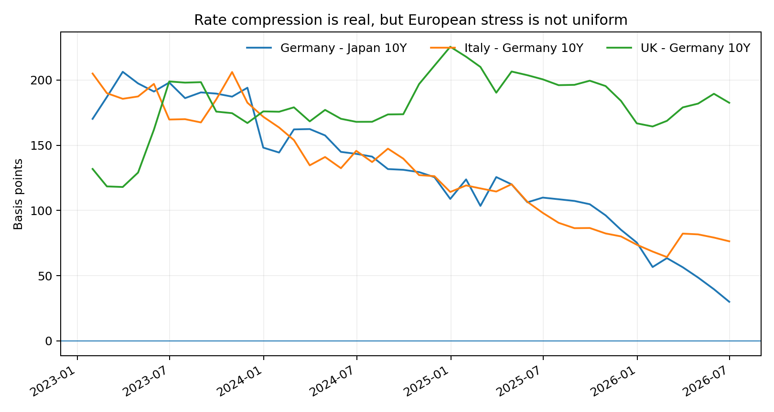
Figure 1. Monthly public-rate proxies, Jan. 2023–Jun. 2026. Germany-Japan compresses sharply, Italy-Germany also compresses, while UK-Germany remains elevated.
Source: monthly_panel.csv generated by the public-data harness; underlying long-rate proxies from FRED/OECD series used by the script.

4. Result #2 - FX appears to be doing the work Tom says it is
Over the same Jan. 2023 to Jun. 2026 interval, EUR/JPY rose from roughly 141.3 to 185.7 JPY per EUR - a 31.4% move in favor of an unhedged JPY-funded EUR asset holder. That is enormous compared with a rate carry measured in tens of basis points.
This makes the core distinction important: if the vulnerable book is unhedged or partially hedged, favorable EUR/JPY can keep the trade profitable even while the nominal rate differential collapses. If the book is fully hedged, the decisive variable becomes the forward curve and cross-currency basis rather than spot alone.
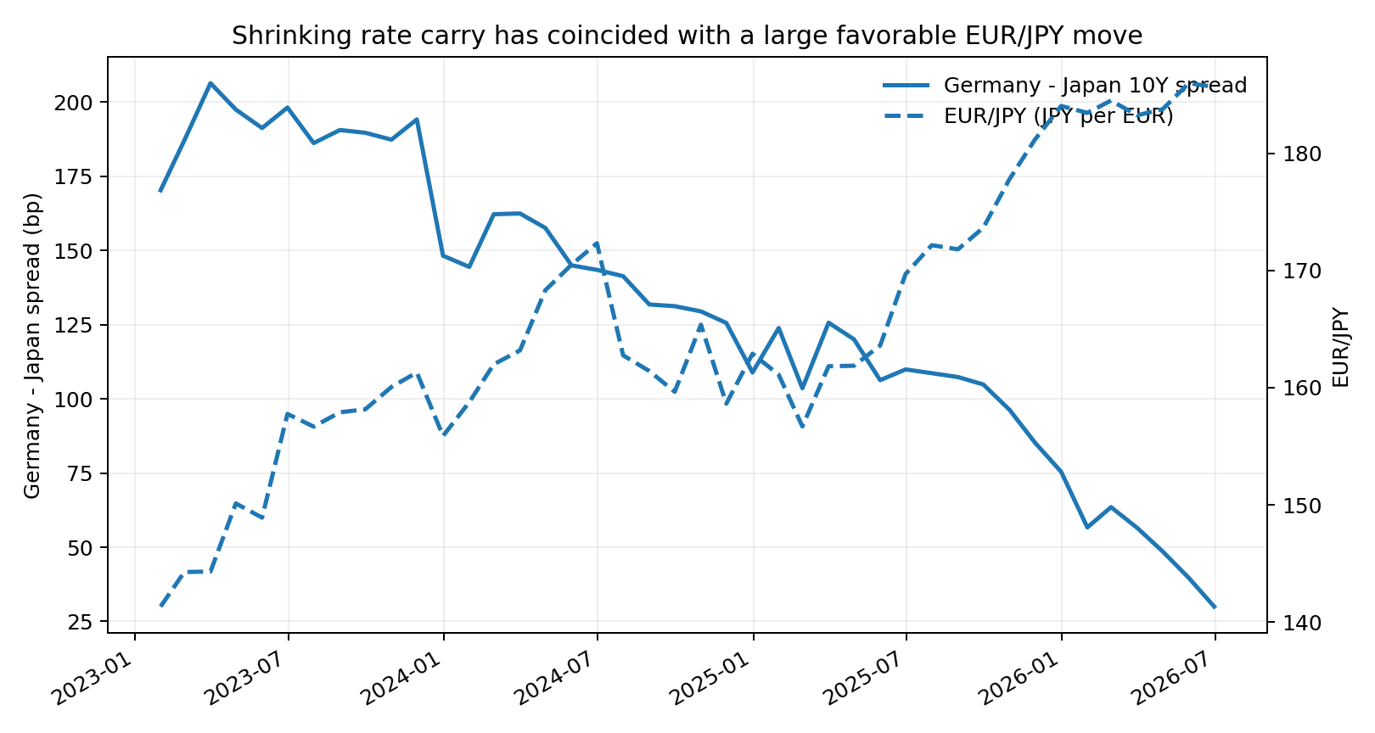
Figure 2. The Germany-Japan long-rate differential shrank while EUR/JPY moved strongly in the opposite direction. This is consistent with the idea that FX has been offsetting rate-carry compression.
Source: monthly_panel.csv. EUR/JPY is derived as JPY per USD × USD per EUR.
Implication: the next serious model variable is not “DE10 − JP10.” It is an all-in effective carry series incorporating forwards/basis, asset total return, repo, hedge ratio/tenor, margin and capital costs.

5. Result #3 - abrupt yen appreciation can be nonlinear, but not every shock becomes a credit event
The original event-study export has a coding limitation: it uses calendar rows and subtracts return columns rather than compounding them. I therefore treat its return fields as non-decisive and recompute the two key examples directly from usable level observations in daily_panel.csv.
Event | JPY move | Volatility | Credit | Read
Jul. 31, 2024 BOJ decision | ~+1.04% yen vs EUR by 5 trading observations | VIX 16.36 → 27.85 (+11.49) | HY OAS 3.25% → 3.57% (+32 bp) | Clear nonlinear risk impulse
Jun. 16, 2026 BOJ decision | ~+1.46% yen vs EUR by 5 trading observations | VIX 16.41 → 18.63 (+2.22) | HY OAS 2.71% → 2.76% (+5 bp) | FX shock visible; systemic credit stress much smaller
The scale comparison is useful. A 1% adverse FX move is roughly 3.3 times an entire year of 30 bp raw carry for an unhedged position. A 1.46% move is almost 4.9 years of 30 bp carry. With leverage, that is precisely the sort of shock that can overwhelm apparently trivial expected carry.
Support for the model: suggestive, especially for the nonlinear mechanism. But June 2026 is a useful restraint: the yen can move enough to matter without immediately producing a generalized credit event.

6. Result #4 - the weak-link question is more specific than “Europe breaks”
This is the strongest counter-signal in the first pass. If simple Japan-vs-Germany carry compression were automatically producing Eurozone fragmentation, we would expect BTP-Bund to widen as DE-JP collapses. The opposite happened in the public proxies:
Spread | Jan. 2023 | Jun. 2026 | Change
Germany-Japan 10Y | 170.3 bp | 30.0 bp | -140.3 bp
Italy-Germany 10Y | 205.0 bp | 76.4 bp | -128.6 bp
UK-Germany 10Y | 131.9 bp | 182.6 bp | +50.7 bp
Italy/Germany tightened by roughly 129 bp while UK/Germany widened by roughly 51 bp. This does not falsify a London/UK/offshore-dealer thesis; it does falsify the convenience of treating “Europe” as one homogeneous stress variable.
A full-sample monthly regression also finds that changes in the raw DE-JP spread do not significantly explain changes in BTP-Bund once basic controls are included. Monthly yen appreciation has a positive coefficient in the full 2006–2026 sample - approximately 1.8 bp of BTP-Bund widening per 1% yen appreciation - but that relationship is not stable/significant in shorter recent subsamples.
Model refinement: separate the loss centers. Test UK/London dealers, pensions, bank CDS and funding spreads independently from Italian/French sovereign fragmentation and German collateral. Tom’s own narrative is sufficiently specific to justify that decomposition.

7. Result #5 - gold-as-repair is a distinct hypothesis, but the unconditional baseline does not prove it
The report’s most interesting conceptual claim is that gold can rise as the system repairs collateral quality, rather than only as a signal of dollar debasement. The public harness uses a gold-price index as a return proxy and defines a crude “repair-sign” day as gold up + broad USD non-negative + HY spreads falling.
Using the script’s current sequence of complete observations, that joint sign appears on about 9.8% of the sample. That unconditional frequency is not persuasive evidence for a generic repair regime; more importantly, it is not the right causal test.
The actual hypothesis is conditional: after identified intervention or carry-unwind events, do we see gold rise while dollar funding stress improves and the dollar remains stable/firm? That requires event timing and a better gold instrument, not unconditional sign counting.
Current read: not established, not falsified. Upgrade the gold leg to spot/GC/GLD data and test the joint sign vector specifically around identified U.S.-Japan support and funding-stress windows.

8. Positioning and capital-flow evidence: promising inputs, not yet clean conclusions

8.1 CFTC JPY positioning
The current scorecard reports the latest leveraged-fund net JPY futures position at about +2.8% of open interest. If net = long − short, that means the snapshot is net-long yen rather than net-short. That is compatible with a post-unwind state, but one snapshot cannot establish an unwind. We need the historical path around BOJ surprises and the August 2026 episode.

8.2 Japanese portfolio flows
The MOF parser reports a latest resident foreign-security net flow of 6,262 × ¥100m (about ¥626.2bn). The current output does not preserve a sufficiently explicit sign convention and country/currency decomposition to label that number “repatriation” with confidence. The next version should expose purchases, sales and net acquisition/disposition directly in the column names.

8.3 TIC and London / custody-center attribution
TIC is useful for residence-based holdings and flows, but it cannot by itself prove that UK, Cayman, Belgium, Luxembourg or Ireland holdings represent one coherent beneficial-owner bloc. A serious London-loss-center test needs nationality/ultimate-risk data, dealer balance sheets, or transaction-level evidence.

9. Updated causal model after the first pass
The data suggest a more precise version of the thesis:
BOJ normalization → raw DE-JP carry compression
raw compression + FX/basis/hedge structure → effective carry pressure
effective carry pressure + leverage/margin → position reduction
position reduction → stress concentrated in specific intermediaries / jurisdictions
policy support → funding normalization + capital reallocation
hard collateral revaluation becomes part of the new monetary equilibrium
The first arrow is strongly visible. The FX offset is visible. The middle arrows remain the main identification problem. The final collateral-regime story is plausible but still downstream of the missing middle.

9.1 What would be genuinely supportive
- Effective, executable JPY→EUR carry approaches zero or turns negative after basis, forwards, repo and hedge costs.
- The compression precedes a measurable reduction in short-yen / European carry positioning.
- Institutions with greater JPY funding, short hedge tenors or offshore dealer dependence deteriorate more after BOJ shocks.
- UK/London funding or dealer stress rises even when intra-Eurozone sovereign spreads are suppressed by ECB mechanisms.
- Identified U.S.-Japan support reduces dollar-funding stress without requiring a generalized Fed balance-sheet explosion.
- Gold rises during those repair windows with USD firm/stable and credit/funding conditions improving.

9.2 What would make me materially downgrade the thesis
- Fully hedged all-in carry remains comfortably positive after BOJ normalization.
- BOJ surprises do not have a reliable first-stage effect on the effective carry measure.
- Carry compression does not precede position reduction or collateral/margin stress.
- The most exposed UK/European institutions do not underperform appropriate U.S./Japan controls.
- Capital-flow data do not show the expected Europe→U.S./Japan or foreign-asset→Japan migration over the relevant horizons.
- Gold’s “repair” behavior appears only when traditional debasement variables - balance-sheet expansion, falling real yields, weaker USD - dominate.

10. Current falsification scorecard
Test | Status | Current evidence | Next decisive input
Raw German-Japanese 10Y spread is thin | DESCRIPTIVE ONLY | Latest monthly proxy: 30.0 bp. | Do not call this executable carry; add forward/basis/repo inputs.
All-in covered carry approaches zero | CRITICAL DATA GAP | No basis/asset-return/funding-cost series supplied. | Populate optional market-data CSV with executable inputs.
Leveraged funds reduce short-yen exposure after shocks | PROXY AVAILABLE | Latest net share of OI: 0.028; event inference requires history. | Run live CFTC history and event study; CFTC is not the full OTC book.
Europe bears more stress than U.S./Japan | PARTIAL PROXY | Latest BTP-Bund proxy: 76.4 bp. | Add bank CDS, funding spreads, and comparable U.S./Japan stress indices.
Japanese capital repatriates | FLOW PROXY AVAILABLE | Latest resident foreign-security net flow: 6,262 x ¥100m. | Decompose by country/currency and test around BOJ surprises.
Gold trades as system-repair collateral | JOINT-SIGN PROXY | Repair-sign days: 9.8% of complete daily sample. | Use identified intervention windows; unconditional frequency is not causal proof.
The transition is deliberately engineered | NOT IDENTIFIED BY PRICE DATA | Market sequencing cannot establish intent. | Require documents, disclosed operations, or institution-specific transaction evidence.
This table is intentionally conservative. “Descriptive only,” “proxy available,” and “data gap” are useful outcomes: they prevent us from treating a visually compelling chart as proof of a mechanism.

11. Phase 2: the smallest dataset that can actually prove or break the mechanism
Block | Needed inputs | Why it is decisive
1. Executable FX carry | EUR/JPY 1m/3m/1y forwards; JPY/EUR cross-currency basis; TONA/€STR or actual funding; transaction costs | Turns the 30 bp diagnostic into a real trade P&L.
2. European asset leg | Bund/BTP/OAT total returns, repo/specialness, financing haircuts | Separates coupon carry from duration and collateral effects.
3. Hedge structure | Representative hedge ratios and hedge tenors | Determines whether spot EUR/JPY is P&L or mostly a hedge-price input.
4. Positioning | Full CFTC history plus dealer/OTC positioning if available | Tests whether shocks actually force the hypothesized unwind.
5. Weak-link panel | UK/EU bank CDS, iTraxx Financials, repo/funding spreads, pension stress, German/Italian/French sovereign metrics | Tests London/UK vs Eurozone fragmentation rather than collapsing them.
6. Intervention ledger | Exact dates/times/instruments for U.S.-Japan support, BOJ decisions, swap/repo/FX actions | Allows clean event identification.
7. Collateral response | Spot gold / GC, DXY, real yields, funding basis, credit spreads | Separates repair-collateral from classic debasement.

11.1 The core executable equation
ActualCarry_t = EuropeanAssetTotalReturn_t − SyntheticEURFunding_t − Repo_t − HedgeCost_t − Capital/MarginCost_t
Once that series exists, the empirical question becomes straightforward:
ActualCarry ↓ ?→ Positioning ↓ ?→ UK/EuropeFundingStress ↑
If those arrows hold in order around exogenous BOJ shocks, Tom has something much stronger than a persuasive macro narrative: a documented transmission mechanism.

11.2 Fix the event engine before publishing event-study results
- Use trading-observation horizons rather than calendar rows.
- Compute cumulative returns from price levels; do not subtract already-computed daily return columns.
- Freeze exact announcement times and expected-versus-surprise policy components before examining outcomes.
- Add the specific August 2026 U.S.-Japan/Bessent episode that motivated the Aug. 9 report.
- Report both immediate market response and 5/20-trading-day persistence.

12. If the next-stage data confirm the mechanism, the implications are large

12.1 Japan is not merely “the next crisis”; it is a regime-transition lever
The interpretation would shift from “Japan normalization breaks the world” to “Japan normalization withdraws a subsidy that helped sustain a leveraged offshore system.” That distinction explains why supporting Japan can simultaneously create stress elsewhere and strengthen the replacement architecture.

12.2 Dollar strength and gold strength can coexist
If the weak link is offshore/European credit rather than the dollar unit itself, capital can migrate into dollar liquidity while gold rises as higher-quality collateral. That would invalidate the simplistic rule that gold strength must imply immediate dollar collapse.

12.3 The weak link may be London/intermediation rather than Italian sovereign spreads
The first baseline already points toward this distinction: BTP-Bund improved while UK-Bund deteriorated. If dealer, pension, repo and bank-funding data confirm the asymmetry, the relevant object is not “Europe” but the institutions that transform and lever the collateral.

12.4 Stablecoins become monetary plumbing, not just crypto
If offshore leverage contracts while one-to-one T-bill-backed settlement rails grow, stablecoins can be modeled as part of a lower-leverage transition rather than as a speculative side market. That remains a downstream hypothesis, but it becomes testable using reserve composition and cross-border credit data.

12.5 The portfolio implication is about collateral hierarchy, not simply inflation
The strongest version of the thesis would favor assets according to their recognized collateral function: gold as established sovereign collateral; Bitcoin as candidate digital collateral whose institutional role still needs to be earned; silver as a mixed monetary/industrial asset. The key variable is not “inflation hedge beta” but the amount of credit the system is willing to build against the asset.
This is where I think the model gets genuinely interesting: if the middle arrows validate, “gold up” stops being the thesis. The thesis becomes a measurable transition in the architecture of funding, leverage and collateral.

13. Questions for Tom before freezing Phase 2
1. What representative trade should we actually reconstruct first: direct JPY→EUR funding, JPY→USD→EUR, long Bund/short JGB, BTP carry, bank credit, or another book?
2. What hedge ratio and hedge tenor best approximate the vulnerable institutional position?
3. When you say London/BOE is at the end of the collateral chain, which balance sheets do you expect to show the loss first: dealers, banks, pensions, hedge funds, sovereign books, or repo/FX swap markets?
4. Which exact market operation do you mean in the August 2026 U.S.-Japan support episode - spot FX, Fed swap, ESF/Treasury action, repo/credit support, verbal intervention, or a combination?
5. Which three to five event dates would you be willing to freeze ex ante as the cleanest tests of the model?
6. What observation would make you say, “this specific version of the yen-carry model is wrong,” rather than simply early?
7. What do you regard as the cleanest observable signature of gold shifting from an investment asset toward system collateral?

Appendix A. Interpretation rules
Observable | Safe interpretation | Do not infer
Raw yield residual | Diagnostic only | Do not call it executable carry.
Spot EUR/JPY | Direct P&L only for unhedged portion | For fully hedged books it mainly affects forward/basis/roll economics.
BTP-Bund | Eurozone fragmentation proxy | Not a proxy for all London/European intermediary stress.
TIC residence data | Booking/custody geography | Do not infer beneficial ownership or coordinated bloc behavior automatically.
Fed swap-line data | Dollar-liquidity support | Do not equate with direct yen-buying intervention.
Gold proxy index | Directional return proxy | Do not interpret level as $/oz or use for official revaluation arithmetic.
Market sequencing | Mechanism evidence | Cannot prove political intent without documents/transactions.

Appendix B. Data files produced by the first run
File | Use
daily_panel.csv | Daily public-price/rate/liquidity panel; 7,527 rows in the uploaded run.
monthly_panel.csv | Monthly panel with derived cross-market spreads; 248 rows.
event_study.csv | Three seed BOJ events. Current return-window implementation needs the Phase-2 fix described above.
falsification_scorecard.csv | Seven current hypothesis checks with status/evidence/next-data fields.
run.log | Confirms successful loading of the complete FRED block in the final run. Do not distribute historical unsanitized lines from earlier failed runs.

Appendix C. Source lineage
Transcript framing: Tom Luongo, Gold Goats ’n Guns market report, Aug. 9, 2026; Episode #255 conversation with Larry Lepard, Aug. 6, 2026.
Public baseline: FRED series defined in the runnable harness for FX, rates, Fed balance-sheet/liquidity, risk and long-rate proxies; Japan Ministry of Finance portfolio-flow inputs; Treasury International Capital inputs; CFTC JPY positioning inputs.
All numerical conclusions in the empirical sections above come from the uploaded daily_panel.csv, monthly_panel.csv, falsification_scorecard.csv and direct recomputation from their level observations. Where the current event-study code is under-specified or incorrect, the report says so rather than relying on the affected return fields.

Closing
I think the first run is useful precisely because it did not simply validate everything. It corroborated the narrow-spread geometry almost perfectly, made the FX leg look central, showed at least one convincing nonlinear yen-risk episode, and forced a better definition of the weak link because Italy/Germany and UK/Germany went in different directions. That gives us a much sharper Phase 2: reconstruct the actual trade, identify the affected balance sheets, and let the sequence prove or kill the mechanism.
If you think the representative trade or loss-center mapping above is wrong, that is the highest-value correction you can give us. Once those two pieces are nailed down, the rest is just data engineering and identification.

