Statistical Analysis Graphs

METRICS

1. Metrics/recall –

* Recall:
  + It tells us what proportion of Data belonging to a certain class say, class A is classified correctly as in class A by our classifier.

1. Metrics/precision

* Chart, line chart

  Description automatically generatedIt tells us what proportion of data that our classifier has classified in a certain class, say class A actually belongs to the same class A.

1. Metrics/mAP_0.5

* Mean average precision, run on validation
* compares the ground-truth bounding box to the detected box and returns a score
* The higher the score, the more accurate the model is in its detections
* mAP calculated at IOU threshold 0.5
* if we want the metrics on the testing, follow instructions here: <https://github.com/ultralytics/yolov5/issues/5442>

1. Metrics/mAP_0.5:0.95

* average mAP over different IoU thresholds, from 0.5 to 0.95, step 0.05 (0.5, 0.55, 0.6, 0.65, 0.7, 0.75, 0.8, 0.85, 0.9, 0.95)
* Chart, line chart

  Description automatically generatedIoU: Intersection over Union (IoU, IU)

TRAIN

1. Train/box_loss

* how well the algorithm can locate the center of an object and how well the predicted bounding box covers an object.
* Chart, line chart

  Description automatically generatedshould be decreasing up to a saturating point

1. Objectness loss

* Objectness is essentially a measure of the probability that an object exists in a proposed region of interest.
* If the objectivity is high, this means that the image window is likely to contain an object
* Chart, scatter chart

  Description automatically generateddegradation of an object’s ability to be recognized as an object

1. Classification loss

* Chart, line chart

  Description automatically generatedClassification loss gives an idea of how well the algorithm can predict the correct class of a given object
* Want low loss (for all losses)

VALIDATION

* Box, objectness, and classification charts represent the same values as the training values

LEARNING RATES

* 3 different learning rate hyperparameters

* Learning Rate (LR) schedulers follow predefined LR curves for the fixed number of epochs defined at training start (default=300), and are designed to fall to a minimum LR on the final epoch for best training results
* cosine learning rate schedule — with a linear warmup at the start of training
* the scheduler PyTorch-accelerated supports a k-decay argument which can be used to adjust how aggressive the annealing (decreasing) is

1. Lr0

* First learning rate

1. Lr1

* Second learning rate

1. Lr2

* Third learning rate

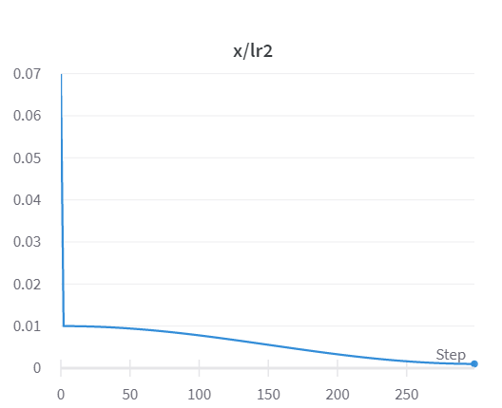

SYSTEM

* Not researched because only statistics about the GPU, CPU, and Memory usage
* (still interesting to look at!)

RESULTS

1. 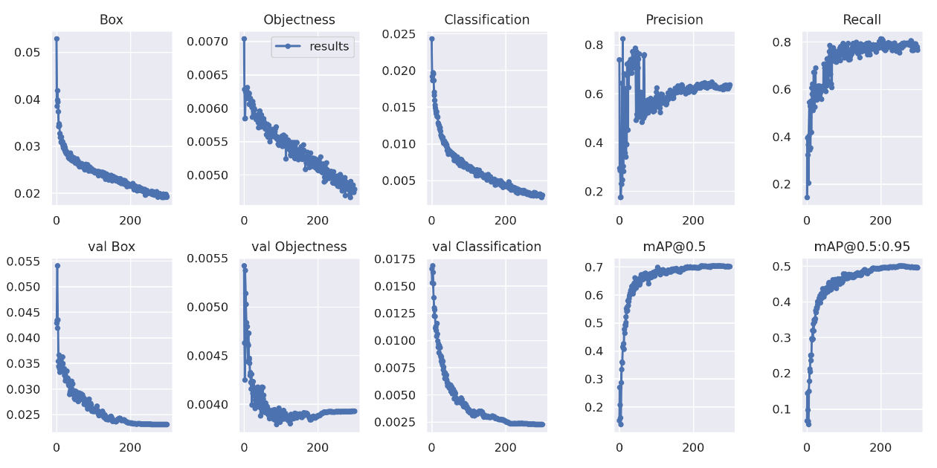Result graphs

* All same as previously stated

1. Confusion matrix

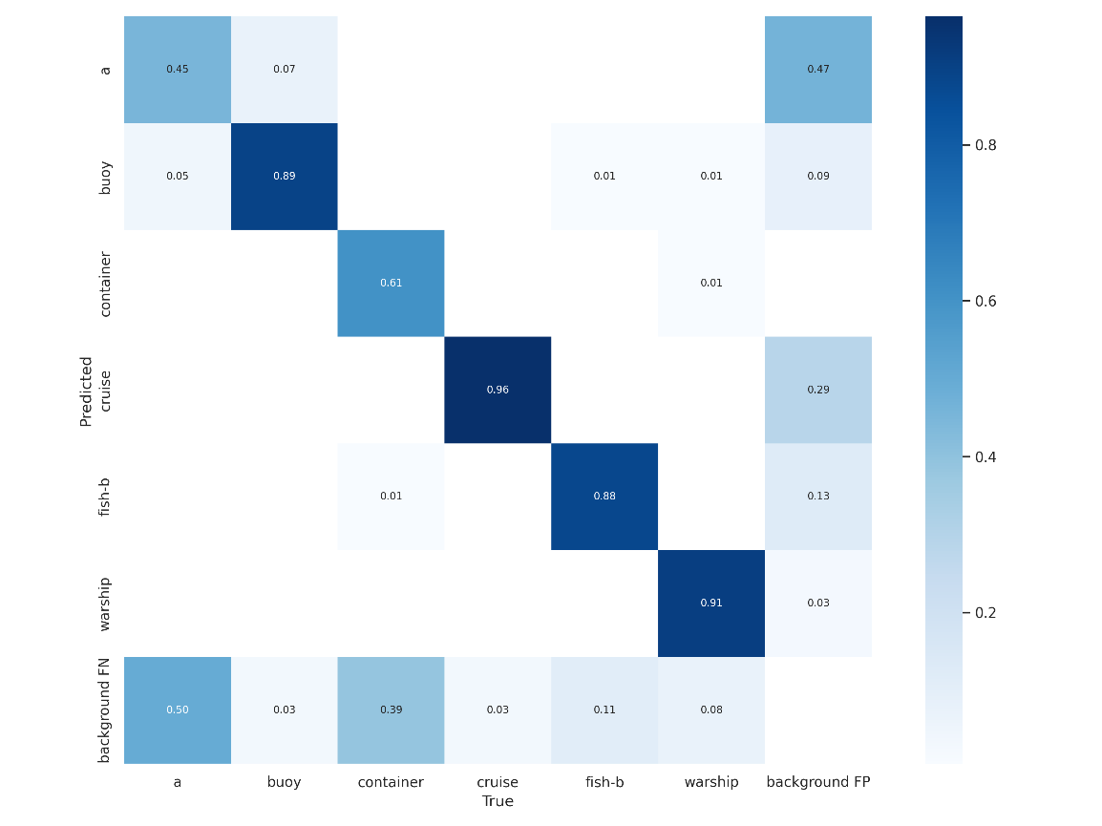

1. F1 curve

* F1-Score or F-measure is an evaluation metric for a classification defined as the harmonic mean of precision and recall
* It is a statistical measure of the accuracy of a test or model

* F1-score reaches the best value at 1 and the worst value at 0
* F1-score 1 represents the perfect accuracy and recall of the model
* A high F1-score indicates a high value for both recall and precision
* F1-score is used to compare two or more machine learning algorithms for the same data. Opt for the algorithm whose f1 score is higher.

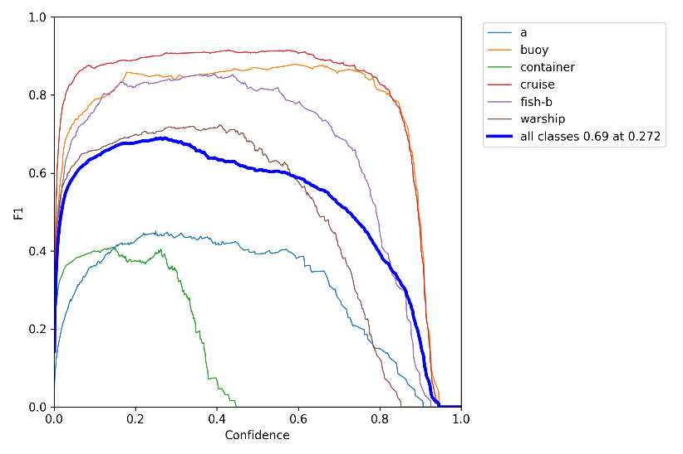

1. Precision/recall curve

* when we increase the recall, we decrease the precision
* shows amount of precision and recall in the model and the relationship between them

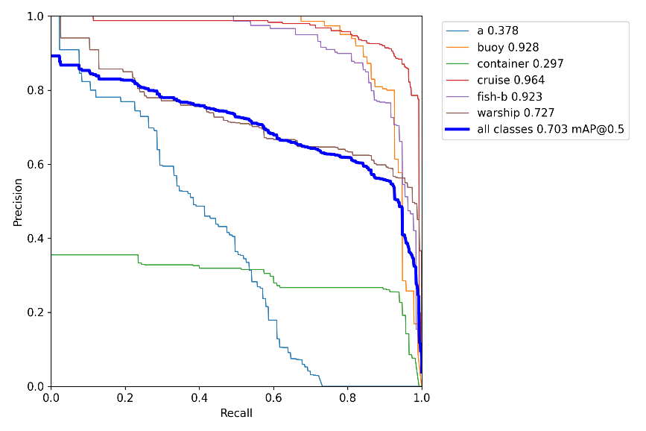

1. Precision vs. Confidence curve

* States the precision value at varied confidence levels
* Used for deciding which confidence level to use

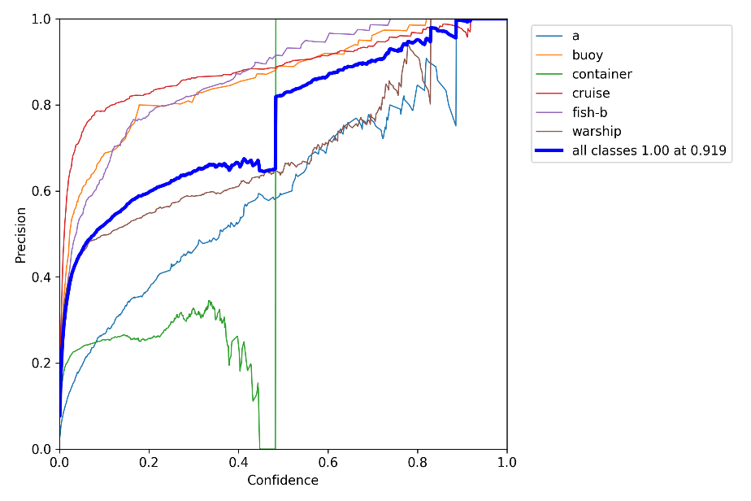

1. Recall vs. Confidence curve

* Opposite of precision vs. confidence curve

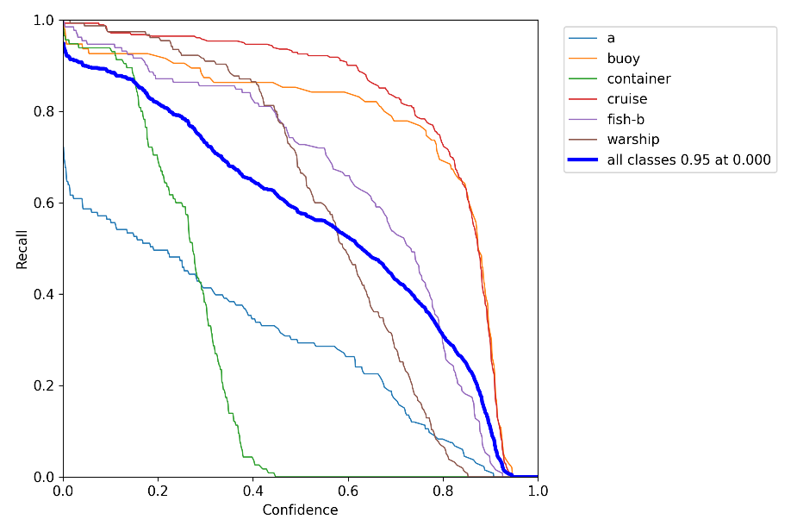

Basic yolo structure (from v4 but can be used when describing v7)

