IRA Questions Needing Verification
28 questions where the figure was auto-assigned (not explicitly named in question text or explanation).
Each entry shows the question and the FAA figure currently attached. Compare — if the chart does not match the scenario, write the correct figure number in the "Correction" blank. If correct, leave blank.

Question 1 (ID: 2217) → Currently: Figure 81
Topic: Topic 3. Navigation Systems
Which indications are acceptable tolerances when checking both VOR receivers by use of the VOT?
- A. 360° TO and 003° TO, respectively.
- B. 001° FROM and 005° FROM, respectively.
- C. 176° TO and 003° FROM, respectively.
Correct answer: C
Explanation:
A VOT transmits a 360° radial in all directions. Thus, with the course deviation indicator (CDI) centered, the omnibearing selector (OBS) should read 0° with the TO-FROM indicator showing FROM, or the OBS should read 180° with the TO-FROM indicator showing TO, with a maximum error of 4°. Answer (A) is incorrect. At 000°, FROM, not TO, should be indicated. Answer (B) is incorrect. The receiver reading 005° FROM exceeds the 4° maximum error limit.
↓ Currently shown Figure 81:
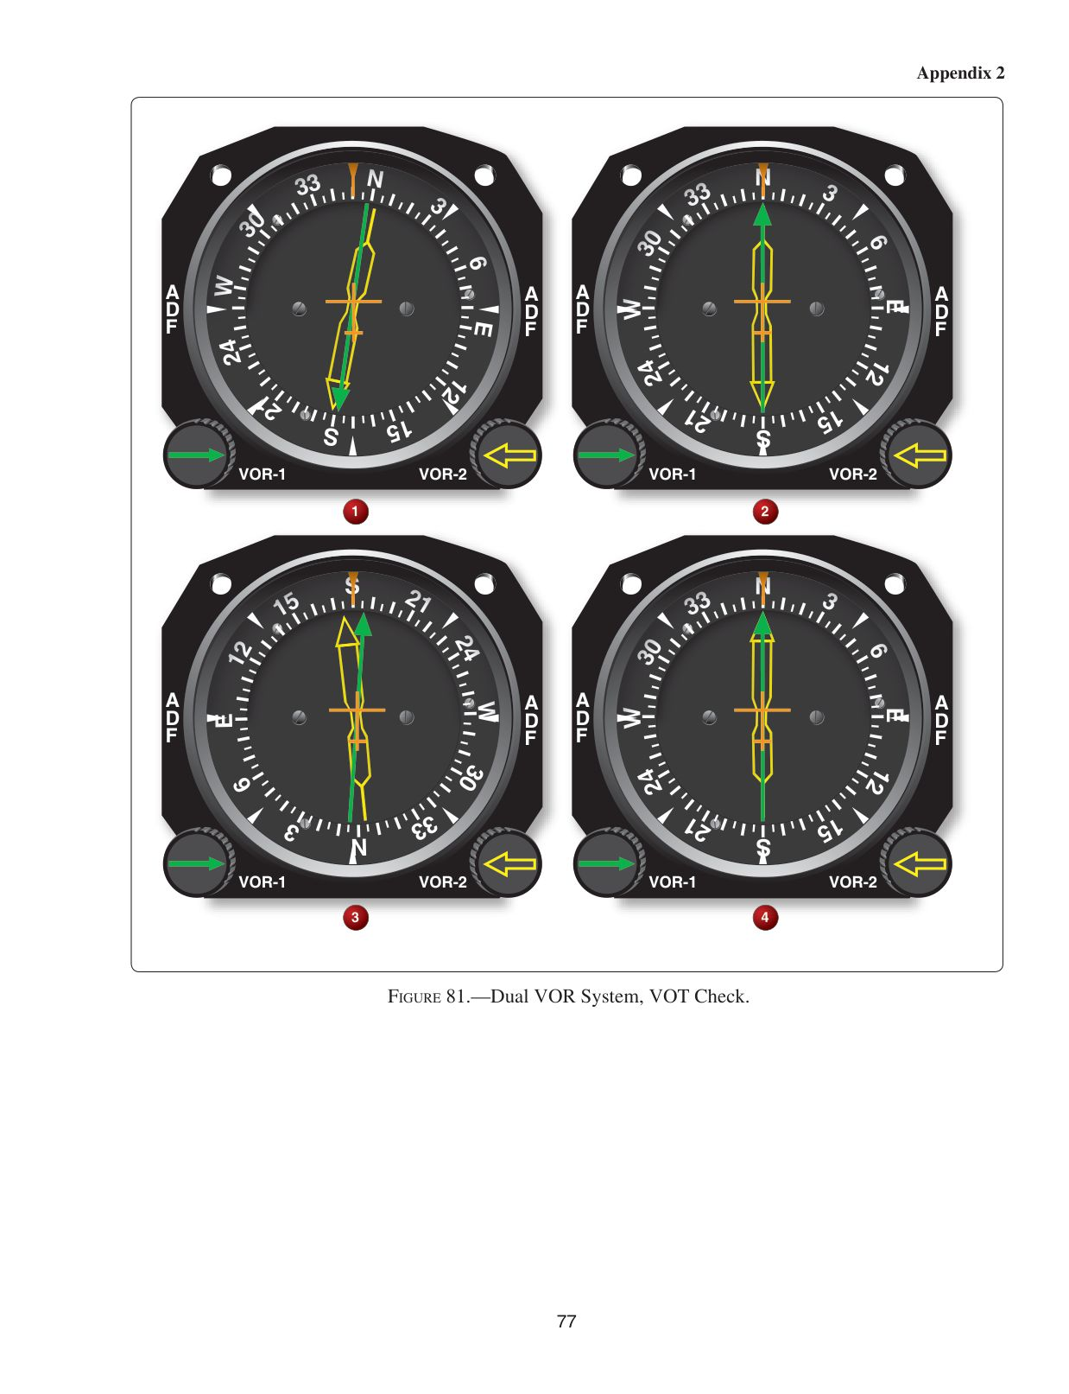
Correction (leave blank if correct): __________
────────────────────────────────────────────────────────────
Question 2 (ID: 2237) → Currently: Figure 110
Topic: Topic 3. Navigation Systems
In which general direction from the VORTAC is the aircraft located?
- A. Southwest
- B. Northwest
- C. Northeast
Correct answer: C
Explanation:
The course indicator arm (OBS) is set to 60°, and the TO-FROM indicates FROM (opposite the head of the arrow), which means the airplane is northeast of the VORTAC. Since the course deviation bar indicates a deflection of 3 dots to the right, the airplane is to the north of the 60° radial by 6°, which is in the northeast. Answer (A) is incorrect. Southwest would require a TO, not FROM, indication. Answer (B) is incorrect. Northwest would require a full right, not a 1/2-scale, deflection.
↓ Currently shown Figure 110:
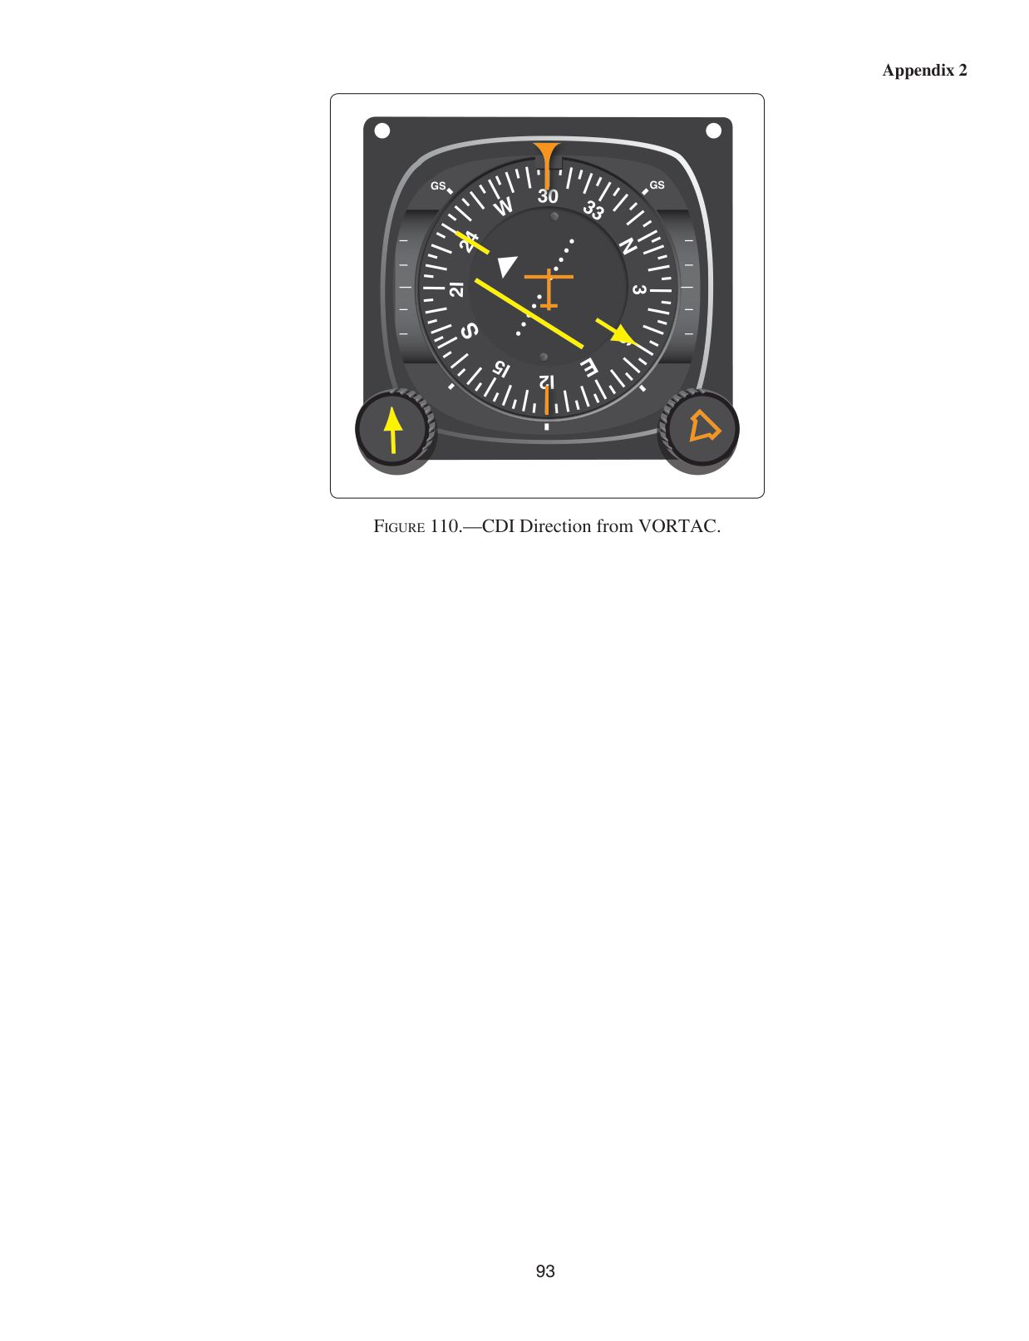
Correction (leave blank if correct): __________
────────────────────────────────────────────────────────────
Question 3 (ID: 2248) → Currently: Figure 98
Topic: Topic 3. Navigation Systems
To which aircraft position does HSI presentation "D" correspond?
- A. 4
- B. 15
- C. 17
Correct answer: C
Explanation:
On Figs. 98 and 99, HSI "D" has a VOR course selection (OBS) of 180°. Its FROM indication means the airplane is south of R-270/90. Since the course deflection bar is to the left, the airplane is west of R-180. Given the heading of 180°, the position describes airplane 17. Answer (A) is incorrect. Airplane 4 is north of the 270/090 radials, which would have a TO, not FROM, indication. Answer (B) is incorrect. Airplane 15 would have a centered deflection bar and a north, not 180°, heading.
↓ Currently shown Figure 98:
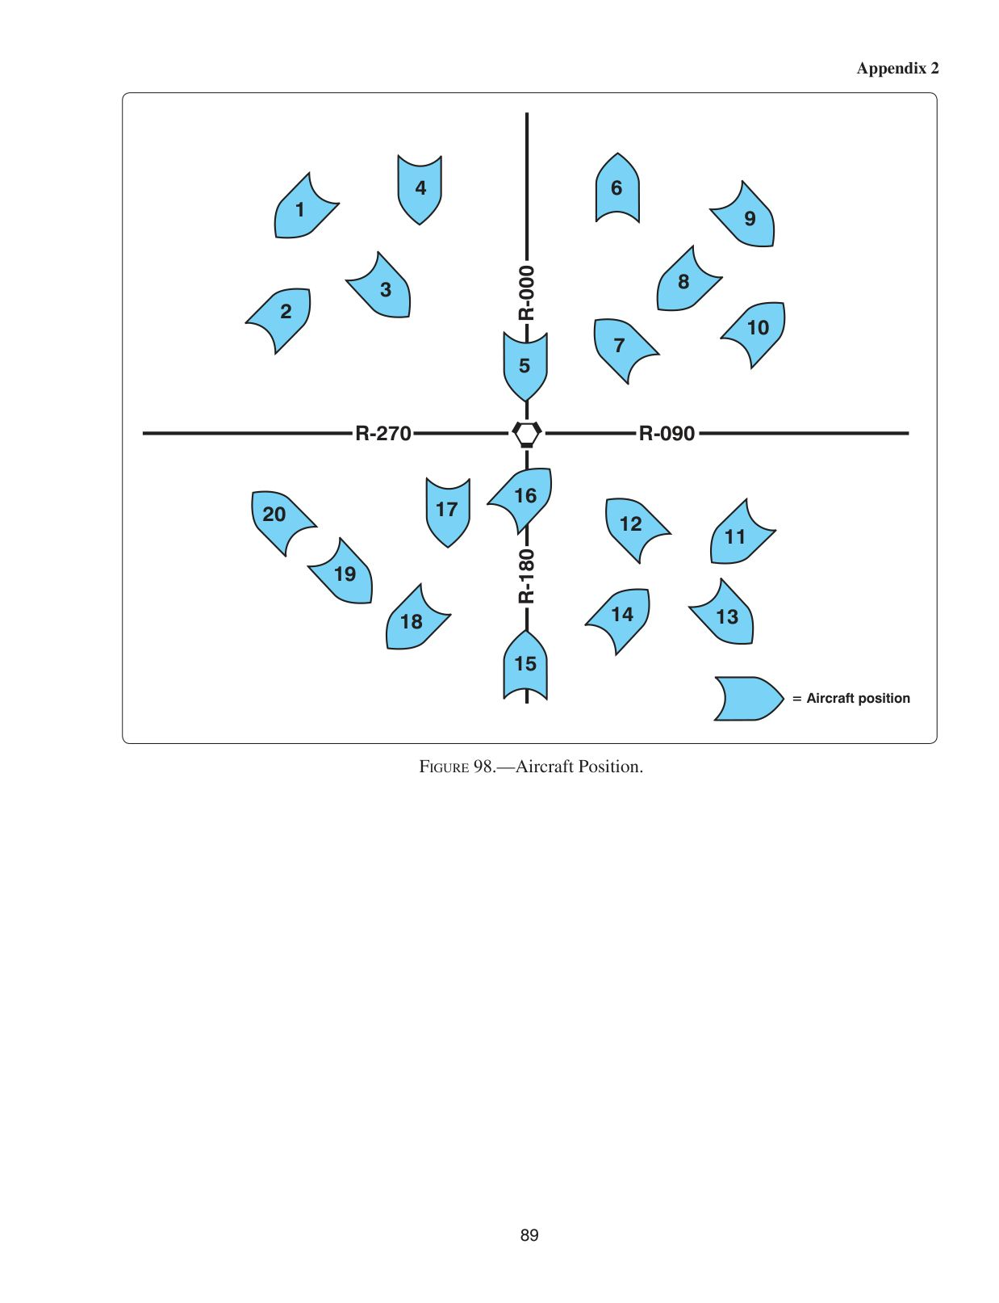
Correction (leave blank if correct): __________
────────────────────────────────────────────────────────────
Question 4 (ID: 2509) → Currently: Figure 232
Topic: Topic 6. Holding and Instrument Approaches
During the LOC RWY 35 missed approach at Duncan/Halliburton Field (DUC), what would be the appropriate entry for the holding?
- A. Direct.
- B. Teardrop.
- C. Parallel.
Correct answer: C
Explanation:
Because you will arrive at the fix aligned within approximately 25° of the reciprocal of the inbound hold, a parallel entry is appropriate. Answer (A) is incorrect. On arrival at the fix, you will be roughly aligned with the reciprocal of the inbound fix, not inbound on the fix itself. A direct entry would be impractical. Answer (B) is incorrect. You will arrive at the fix on a heading of approximately 170°, which nearly aligns with the outbound course of the hold. A teardrop entry would be for an aircraft arriving on a heading of somewhere between 77° and 147°.
↓ Currently shown Figure 232:
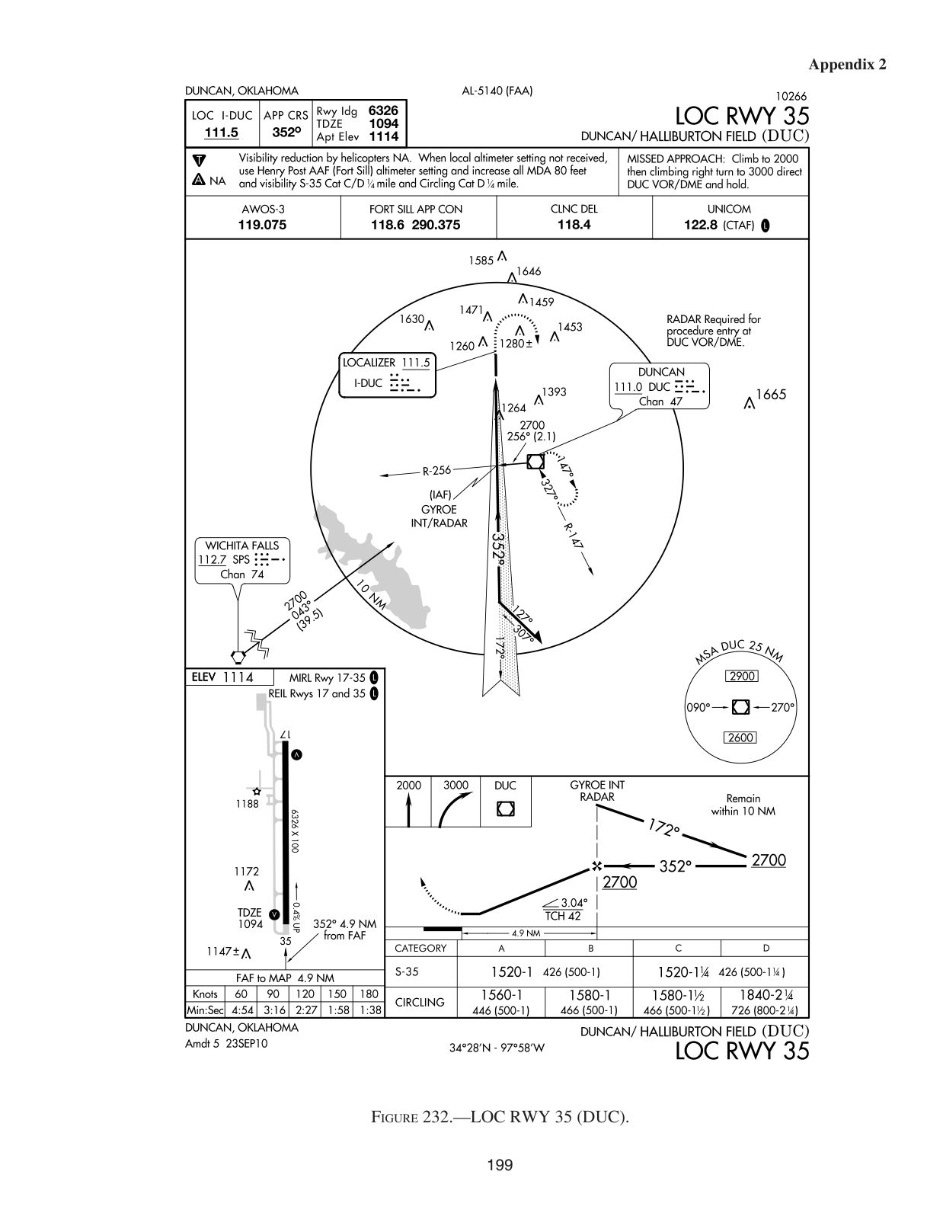
Correction (leave blank if correct): __________
────────────────────────────────────────────────────────────
Question 5 (ID: 2541) → Currently: Figure 112
Topic: 6.9 Holding
You arrive at the 15 DME fix on a heading of 350°. Which holding pattern correctly complies with the ATC clearance below, and what is the recommended entry procedure? "...HOLD WEST OF THE ONE FIVE DME FIX ON THE NINE ZERO RADIAL OF THE ARC VORTAC, FIVE MILE LEGS, LEFT TURNS..."
- A. 1; teardrop entry.
- B. 1; direct entry.
- C. 2; direct entry.
Correct answer: B
Explanation:
Answer (B) is correct. (AIM Para 5-3-7) DISCUSSION: Holding pattern 1 is correct because the holding fix is always at the end of the inbound leg. Draw the 70° line through the fix such that it intersects the outbound leg 1/3 of the leg length from abeam the fix. A 350° heading to the fix requires a direct entry, which requires a standard-rate left turn to 270° beginning over the holding fix. Answer (A) is incorrect. Approaching the fix on a heading of 350° requires a direct, not teardrop, entry. Answer (C) is incorrect. Holding pattern 2 does not show the holding fix at the end of the inbound leg.
↓ Currently shown Figure 112:
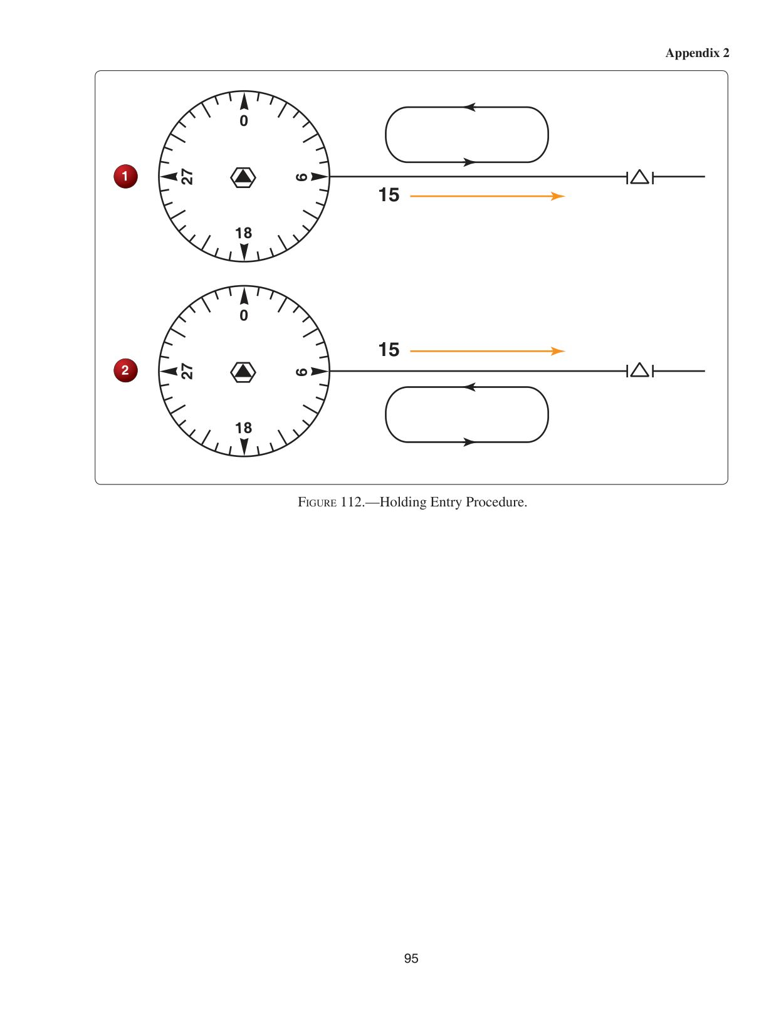
Correction (leave blank if correct): __________
────────────────────────────────────────────────────────────
Question 6 (ID: 2544) → Currently: Figure 180
Topic: Topic 6. Holding and Instrument Approaches
You receive this ATC clearance: "...CLEARED TO THE ABC VORTAC. HOLD SOUTH ON THE ONE EIGHT ZERO RADIAL..." What is the recommended procedure to enter the holding pattern?
- A. Teardrop only.
- B. Direct only.
- C. Parallel only.
Correct answer: B
Explanation:
You are cleared to hold south on the 180° radial with right turns, which means you will be to the east of R-180. Since you are coming in from the southwest (R-240), you can make a direct entry. A teardrop entry would be appropriate only from R-290 to R-360. A parallel entry would be appropriate only from R-360 to R-110.
↓ Currently shown Figure 180:
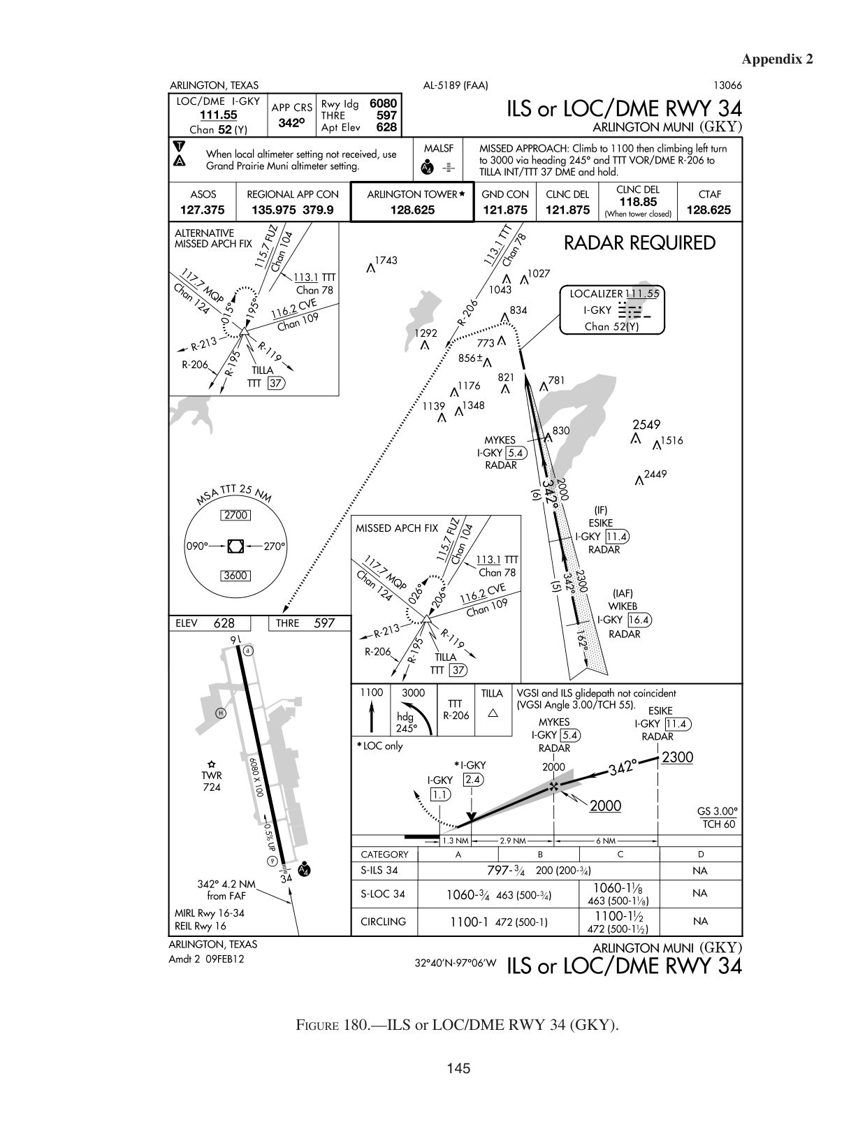
Correction (leave blank if correct): __________
────────────────────────────────────────────────────────────
Question 7 (ID: 2545) → Currently: Figure 112
Topic: Topic 6. Holding and Instrument Approaches
You receive this ATC clearance: "...CLEARED TO THE XYZ VORTAC. HOLD NORTH ON THE THREE SIX ZERO RADIAL, LEFT TURNS..." What is the recommended procedure to enter the holding pattern?
- A. Parallel only.
- B. Direct only.
- C. Teardrop only.
Correct answer: C
Explanation:
Holding north of the XYZ VORTAC with left turns on R-360 means you are on the east side of the radial. Since you are coming in from the southwest (R-240), you will be making a teardrop entry. A parallel approach would be appropriate only if you were coming in between R-070 and R-180. A direct entry is appropriate only between R-250 and R-070.
↓ Currently shown Figure 112:

Correction (leave blank if correct): __________
────────────────────────────────────────────────────────────
Question 8 (ID: 2578) → Currently: Figure 210
Topic: Topic 6. Holding and Instrument Approaches
At what minimum altitude should you cross RAMKE intersection during the S-LDA RWY 6 approach at ROA?
- A. 2,720 MSL.
- B. 4,300 MSL.
- C. 1,780 MSL.
Correct answer: B
Explanation:
The profile view of the approach includes a Maltese cross at RAMKE and a notation of 4,300 feet MSL. That is the minimum altitude you should cross the intersection. Answer (A) is incorrect. 2,720 feet MSL. Answer (C) is incorrect. The SKIRT minimum for the S-LDA 6 approach is 1,780 ft. MSL.
↓ Currently shown Figure 210:
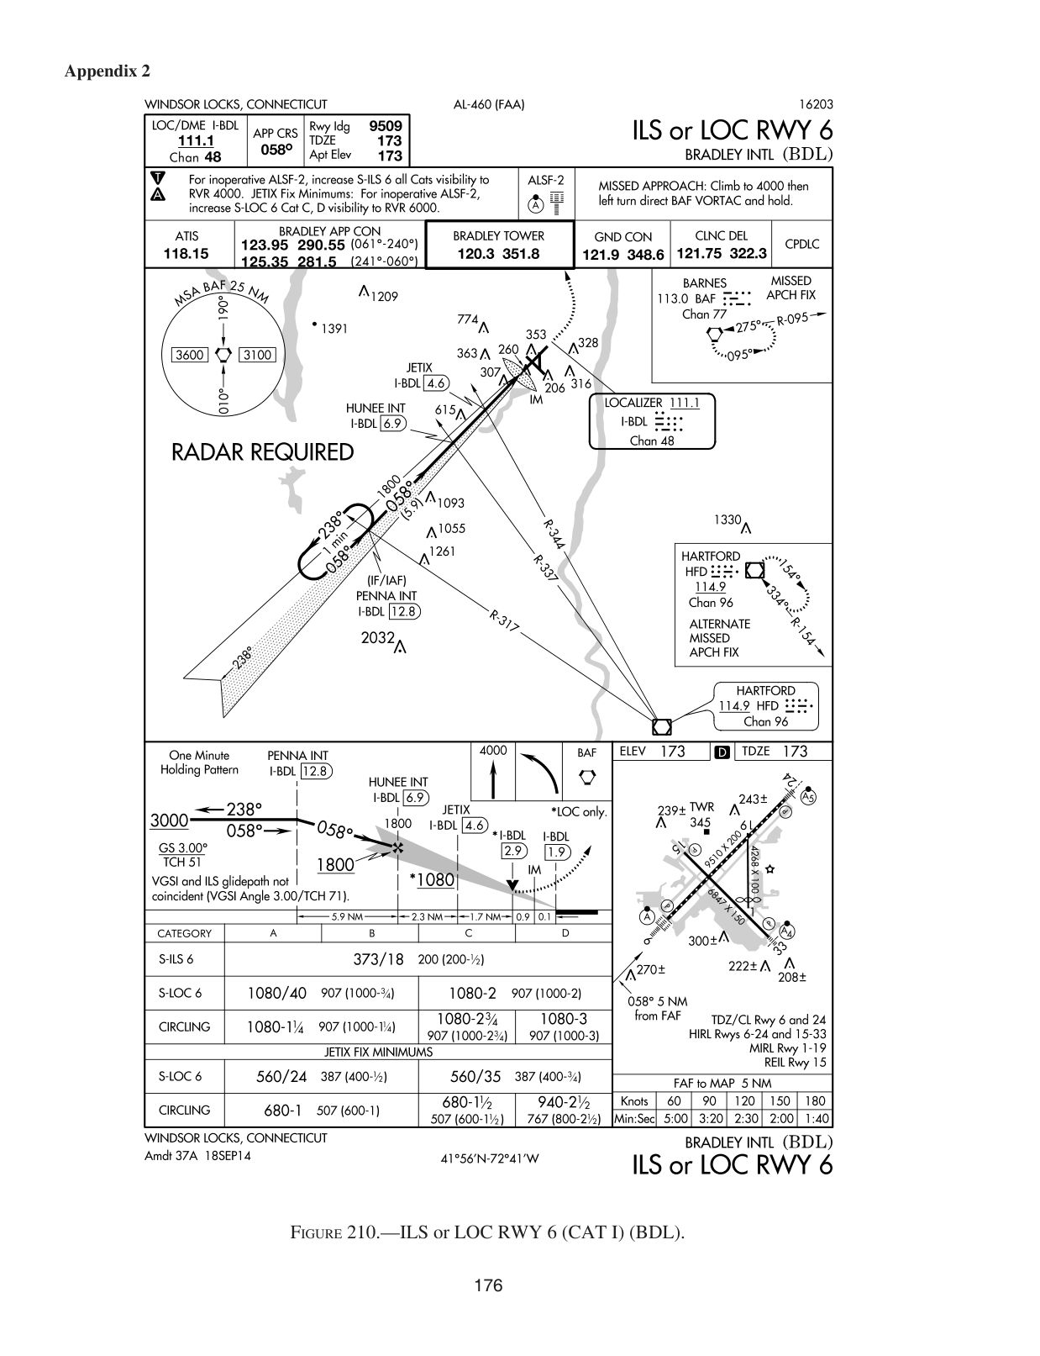
Correction (leave blank if correct): __________
────────────────────────────────────────────────────────────
Question 9 (ID: 2604) → Currently: Figure 240
Topic: Topic 6. Holding and Instrument Approaches
What type entry is recommended for the missed approach holding pattern depicted on the VOR/DME RWY 36 approach chart for Price/Carbon County Airport?
- A. Direct only.
- B. Teardrop only.
- C. Parallel only.
Correct answer: C
Explanation:
DISCUSSION: On the missed approach to VOR/DME RWY 36, the pilot makes a climbing right turn to 10,000 ft. via heading 200° and PUC VOR/DME R-164 to FOSOV/12 DME. Since the aircraft will be approaching FOSOV from the north, a parallel entry will be appropriate. Answer (A) is incorrect. A direct entry would only be appropriate if coming in from the south. Answer (B) is incorrect. A teardrop entry would be appropriate only if coming in from the northwest.
↓ Currently shown Figure 240:
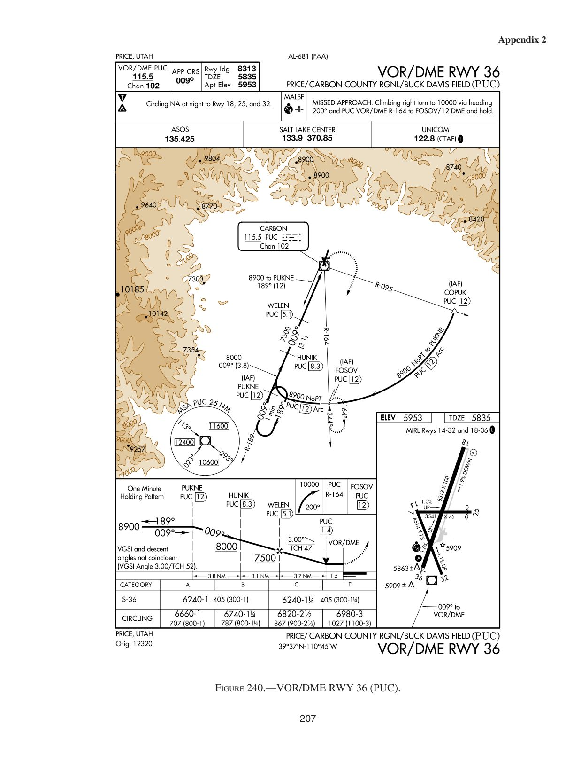
Correction (leave blank if correct): __________
────────────────────────────────────────────────────────────
Question 10 (ID: 2605) → Currently: Figure 240
Topic: Topic 6. Holding and Instrument Approaches
At which points may you initiate a descent to the next lower minimum altitude when cleared for the VOR/DME RWY 36 approach, from the PUC R-095 IAF [DME operative]?
- A. Start descent from 8,900 when established on final, from 7,500 when at the 5.1 DME fix, and from 6,240 when landing requirements are met.
- B. Start descent from 8,900 when established on the PUC R-189 from 8,000 at the 8.3 DME fix, from 7,500 at the 5.1 DME fix, and from 6,240 when landing requirements are met.
- C. Start descent from 8,900 at the R-095, from 8,000 at the LR-164, from 7,500 at the 5.1 DME fix.
Correct answer: B
Explanation:
DISCUSSION: When cleared for the VOR/DME RWY 36 approach, maintain 8,900 ft. on the 12 DME arc until established on R-189, when you may begin descent to 8,000 ft. At the 8.3 DME fix, you may descend from 8,000 ft. to 7,500 ft. At the 5.1 DME fix you may descend to 6,240 ft., which is the MDA. With the runway environment in sight, at or before the MAP, you may descend below 6,240 ft. Answer (A) is incorrect. This approach does not consider the step down from 8,900 ft. to 8,000 ft. at the 8.3 DME fix. Answer (C) is incorrect. You may start your descent from 8,900 ft. when established on R-189, not R-095, from 8,000 ft. only with the runway environment in sight, at or before the MAP.
↓ Currently shown Figure 240:

Correction (leave blank if correct): __________
────────────────────────────────────────────────────────────
Question 11 (ID: 2852) → Currently: Figure 24
Topic: Topic 10. IFR En Route
Military training routes (MTR) above 1,500 feet are depicted on
- A. IFR Planning Charts.
- B. IFR Low Altitude En Route Charts.
- C. IFR High Altitude En Route Charts.
Correct answer: B
Explanation:
DISCUSSION: IFR En Route Low-Altitude Charts depict all IFR and VFR MTRs (IR and VR routes) that accommodate operations above 1,500 feet AGL. Answer (A) is incorrect. The U.S. IFR/VFR Planning Chart does not depict MTRs. The DOD Area Planning Chart depicts all MTRs, not only those above 1,500 feet AGL. Answer (C) is incorrect. IFR En Route High-Altitude Charts cover altitudes at and above 18,000 feet MSL; generally, MTRs are established below 10,000 feet MSL.
↓ Currently shown Figure 24:
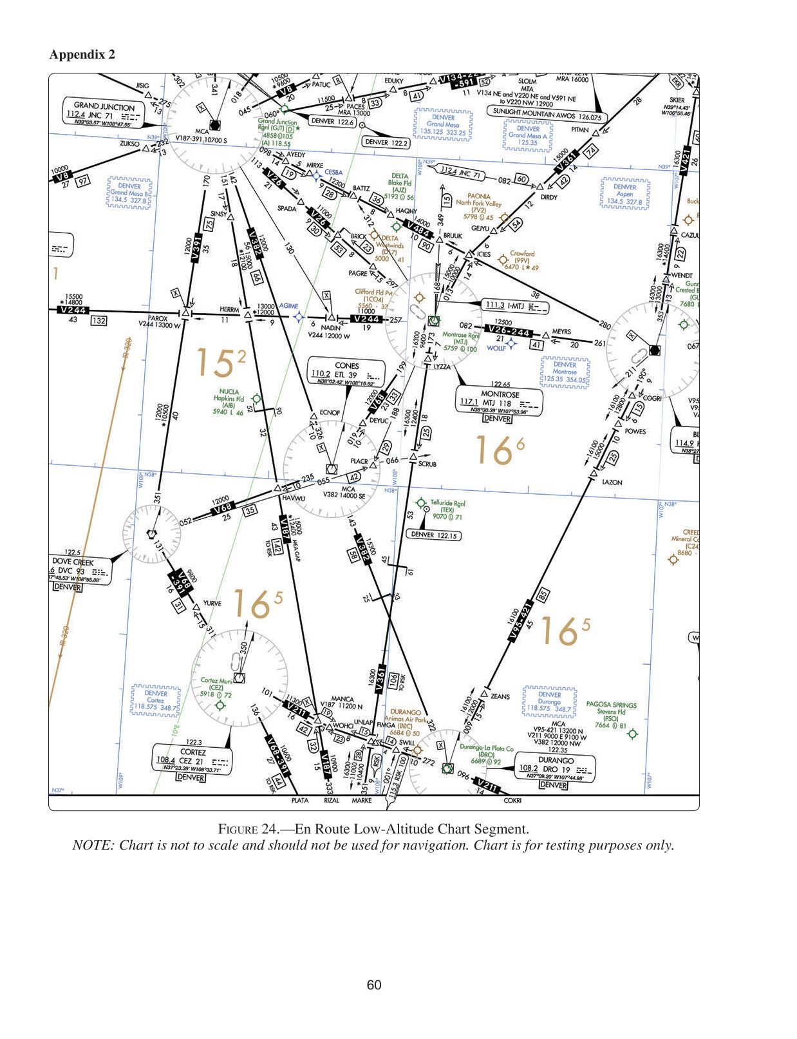
Correction (leave blank if correct): __________
────────────────────────────────────────────────────────────
Question 12 (ID: 2890) → Currently: Figure 24
Topic: Topic 10. IFR En Route
What are the oxygen requirements for an IFR flight northeast bound from Bryce Canyon on V382 at the lowest appropriate altitude in an unpressurized aircraft?
- A. The required minimum crew must be provided and use supplemental oxygen for that part of the flight of more than 30 minutes
- B. The required minimum crew must be provided and use supplemental oxygen for that part of the flight of more than 30 minutes, and the passengers must be provided supplemental oxygen
- C. The required minimum crew must be provided and use supplemental oxygen, and all occupants must be provided supplemental oxygen for the entire flight above 15,000 feet
Correct answer: C
Explanation:
DISCUSSION: At cabin pressure altitudes above 14,000 feet MSL, the required minimum flight crew must be provided with and use supplemental oxygen during the entire flight time at those altitudes. Additionally, each occupant must be provided with supplemental oxygen at cabin pressure altitudes above 15,000 feet MSL. The MEA for V382 is 16,000 feet MSL. Answer (A) is incorrect. The requirement that the required minimum crew be provided with and use supplemental oxygen for that part of the flight of more than 30 minutes describes the oxygen requirements when at cabin pressure altitudes above 12,500 feet MSL up to and including 14,000 feet MSL, not at 16,000 feet MSL. Answer (B) is incorrect. The requirement that the required minimum crew be provided with and use supplemental oxygen for that part of the flight of more than 30 minutes describes the oxygen requirements when at cabin pressure altitudes above 12,500 feet MSL up to and including 14,000 feet MSL, not at 16,000 feet MSL.
↓ Currently shown Figure 24:

Correction (leave blank if correct): __________
────────────────────────────────────────────────────────────
Question 13 (ID: 2891) → Currently: Figure 71
Topic: Topic 10. IFR En Route
What is the ARTCC discrete frequency at the COP on V208 southwest bound from HVE to PGA VOR/DME?
- A. 122.1
- B. 122.4
- C. 133.6
Correct answer: C
Explanation:
DISCUSSION: The COP on V208 southwest bound to PGA VOR/DME from HVE VORTAC is indicated by the symbol "↓", and the mileages are given to each VOR station. The COP is 61 NM northeast of PGA and 35 NM southwest of HVE. Notice the ragged line (see Legend 34 on page 340) south of HVE VORTAC, which is the symbol that divides Salt Lake City ARTCC to the north and Denver ARTCC to the south. Thus, the COP is in Salt Lake City ARTCC airspace. To the right of HVE VORTAC is a box indicating that Salt Lake City ARTCC uses an RCO at Hanksville on a discrete frequency of 133.6. Answer (A) is incorrect. This frequency is shown above the communications boxes at MLF, HVE, and PGA VORs and is used for communicating with FSS, not the ARTCC. Answer (B) is incorrect. This frequency is shown in the remote communications outlet (RCO) boxes at Bullfrog Basin and Cal Black Memorial Airports and is used for communicating with Cedar City FSS, not the ARTCC.
↓ Currently shown Figure 71:
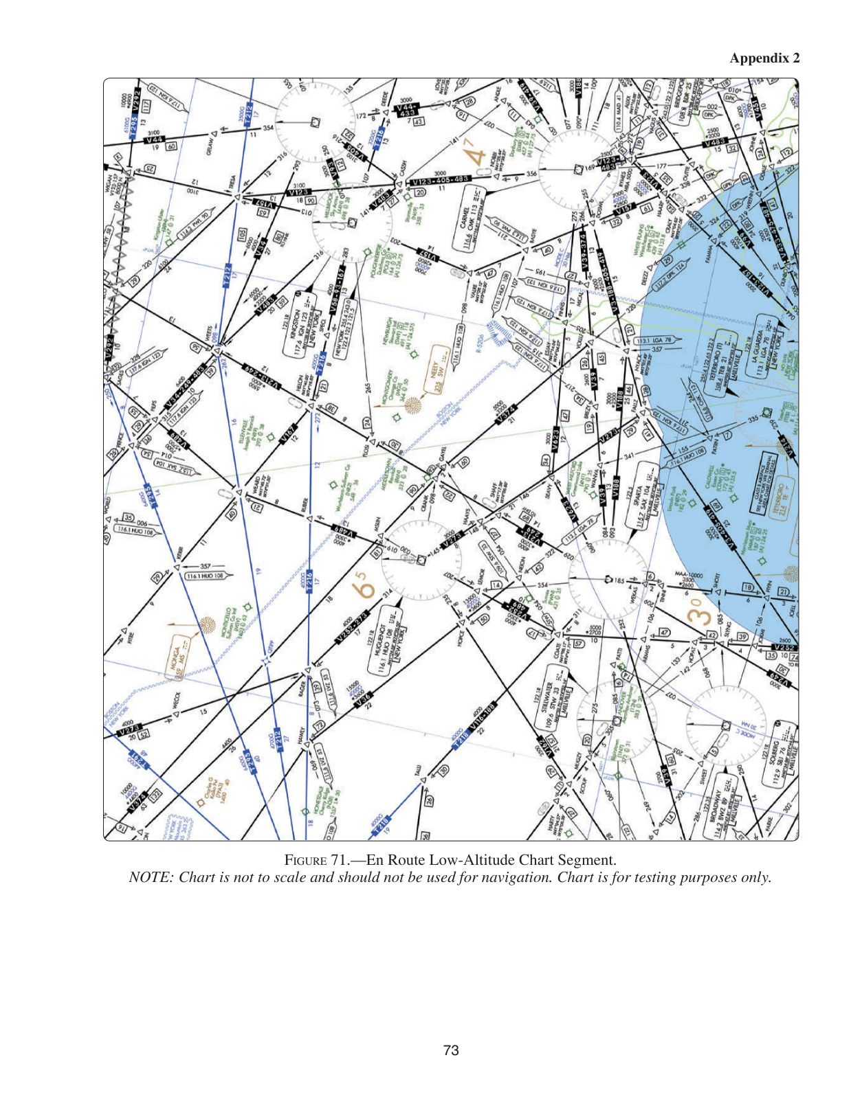
Correction (leave blank if correct): __________
────────────────────────────────────────────────────────────
Question 14 (ID: 2892) → Currently: Figure 31
Topic: Topic 10. IFR En Route
What type airspace exists above Bryce Canyon Airport from the surface to 1,200 feet AGL?
- A. Class D.
- B. Class E.
- C. Class G.
Correct answer: C
Explanation:
Answer (C) is correct. (ACL, AIM Para 3-3-1) DISCUSSION: Bryce Canyon Airport symbol is brown in color, which means it does not have a published IAP. The airport is not indicated to be in Class B or C airspace but does lie below a federal airway (the white area to either side of and along V8). Federal airways are Class E airspace and, unless otherwise specified, extend upward from 1,200 feet AGL to, but not including, 18,000 feet MSL. Bryce Canyon is not a Class D airport (indicated by D following the airport name). Class E surface areas are not shown on En Route Low-Altitude Charts. However, since Bryce Canyon has no IAP, we can assume that no Class E surface area is associated with the airport. Therefore, Class G airspace extends from the surface upward to 1,200 feet AGL, the floor of the federal airway. Answer (A) is incorrect. Class D airports are indicated by a D following the airport name. Answer (B) is incorrect. Federal airways normally extend upward from 1,200 feet AGL, not from the surface.
↓ Currently shown Figure 31:
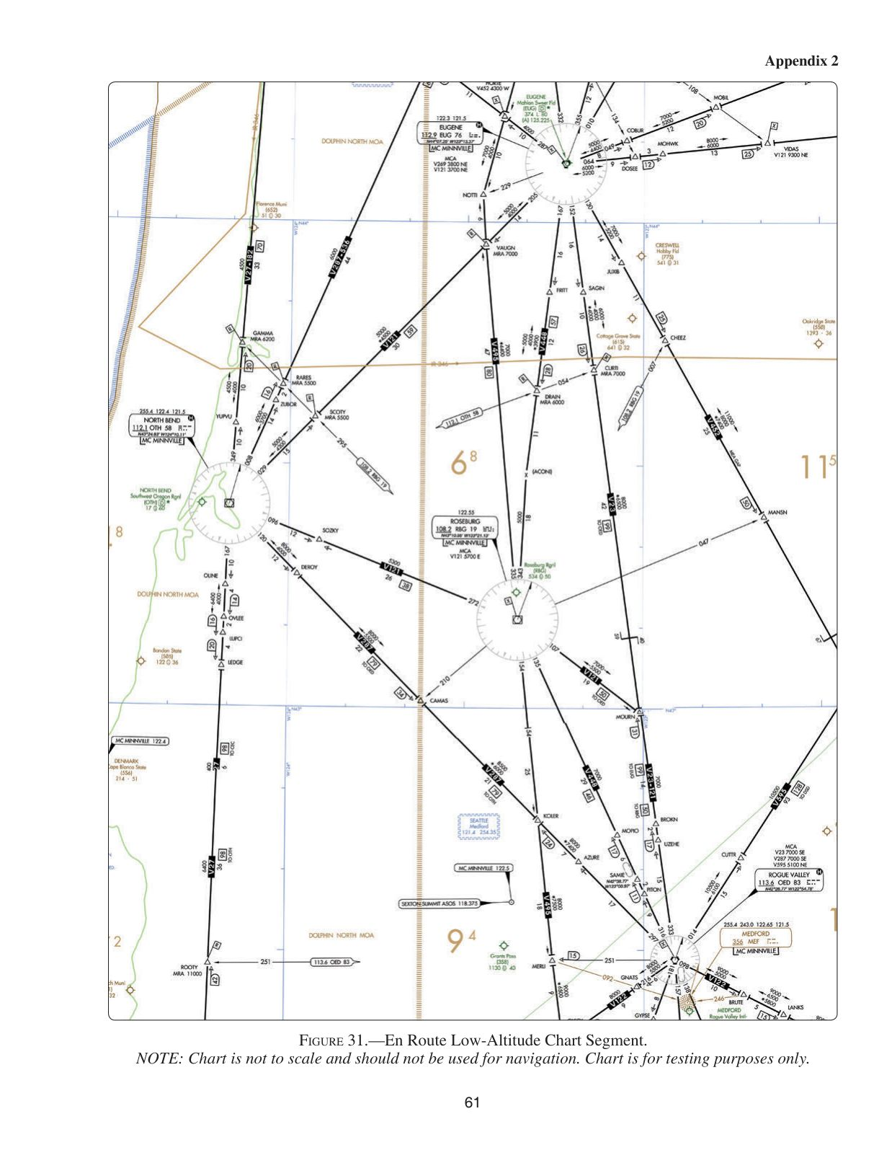
Correction (leave blank if correct): __________
────────────────────────────────────────────────────────────
Question 15 (ID: 2896) → Currently: Figure 257
Topic: Topic 10. IFR En Route
Southbound on V257, at what time should you arrive at DBS VORTAC if you crossed CPN VORTAC at 0850 and over DIVID intersection at 0854?
- A. 0939
- B. 0943
- C. 0947
Correct answer: B
Explanation:
CPN VORTAC is on the left side of the chart about 1 1/2 in. down from the top. Going south on V257, DIVID INT is 9 NM from CPN VORTAC. Use your flight computer to determine the groundspeed. Locate 9 on the outer scale and place 4 on the minute scale under the 9. The groundspeed is read over the index, which is 135 kt. From DIVID to DLN VORTAC is 39 NM; then from DLN VORTAC to DBS VORTAC is 71 NM, or a total of 110 NM. To determine the time, place 135 knots over the index of your flight computer and locate 110 NM on the outer scale; the time is read below on the minute scale, which is 49 minutes from DIVID INT to DBS VORTAC. Thus, your ETA at DBS VORTAC is 0943 (0854 + 49). Answer (A) is incorrect. The 49 minutes is added to the time you crossed DIVID INT (0854), not the time you crossed CPN VORTAC (0850). Answer (C) is incorrect. The distance from CPN VORTAC to DIVID INT (9 NM) must be subtracted from the 48 NM between CPN VORTAC and DLN VORTAC.
↓ Currently shown Figure 257:
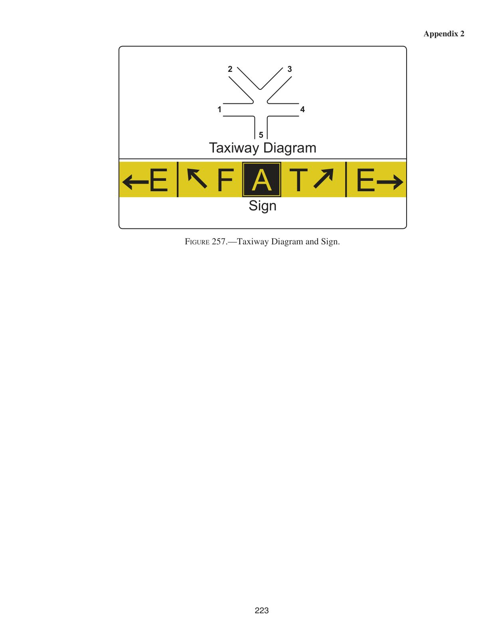
Correction (leave blank if correct): __________
────────────────────────────────────────────────────────────
Question 16 (ID: 2910) → Currently: Figure 24
Topic: Topic 11. IFR Flights
What is the MOCA between JNC and MANCA intersection on V187?
- A. 10,900 feet MSL.
- B. 15,000 feet MSL.
- C. 12,400 feet MSL.
Correct answer: C
Explanation:
The MOCA (minimum obstruction clearance altitude) appears with an asterisk under the MEA on V187. It is 12,400 ft. MSL. Answer (A) is incorrect. This is the MEA, not MOCA, between MANCA and RIZAL intersections. Answer (B) is incorrect. This is the MEA, not MOCA, between JNC and MANCA INT.
↓ Currently shown Figure 24:

Correction (leave blank if correct): __________
────────────────────────────────────────────────────────────
Question 17 (ID: 2911) → Currently: Figure 24
Topic: Topic 11. IFR Flights
At what point should a VOR changeover be made from JNC VOR to MANCA intersection southbound on V187?
- A. 36 NM south of JNC.
- B. 52 NM south of JNC.
- C. 74 NM south of JNC.
Correct answer: B
Explanation:
The VOR changeover point is depicted on V187, south of HERRM INT. and depicts the mileage between the VORTAC stations. It shows the COP as being 52 NM south of JNC. Answer (A) is incorrect. The COP is depicted as 52 NM, not 36 NM, south of JNC. Answer (C) is incorrect. The COP is depicted as 52 NM, not 74 NM, south of JNC.
↓ Currently shown Figure 24:

Correction (leave blank if correct): __________
────────────────────────────────────────────────────────────
Question 18 (ID: 2912) → Currently: Figure 47
Topic: 11.2 MFR to EUG
What minimum navigation equipment is required en route on V448 to identify MOPIO?
- A. One VOR receiver.
- B. Two VOR receivers and DME.
- C. One VOR receiver and DME.
Correct answer: C
Explanation:
MOPIO is located on the OED 316° radial at 17 NM DME. An operational VOR receiver and DME would be required to identify MOPIO. Answer (A) is incorrect. An operational DME would also be required, in addition to an operational VOR receiver, to identify MOPIO. Answer (B) is incorrect. Only one VOR receiver is required to identify MOPIO.
↓ Currently shown Figure 47:
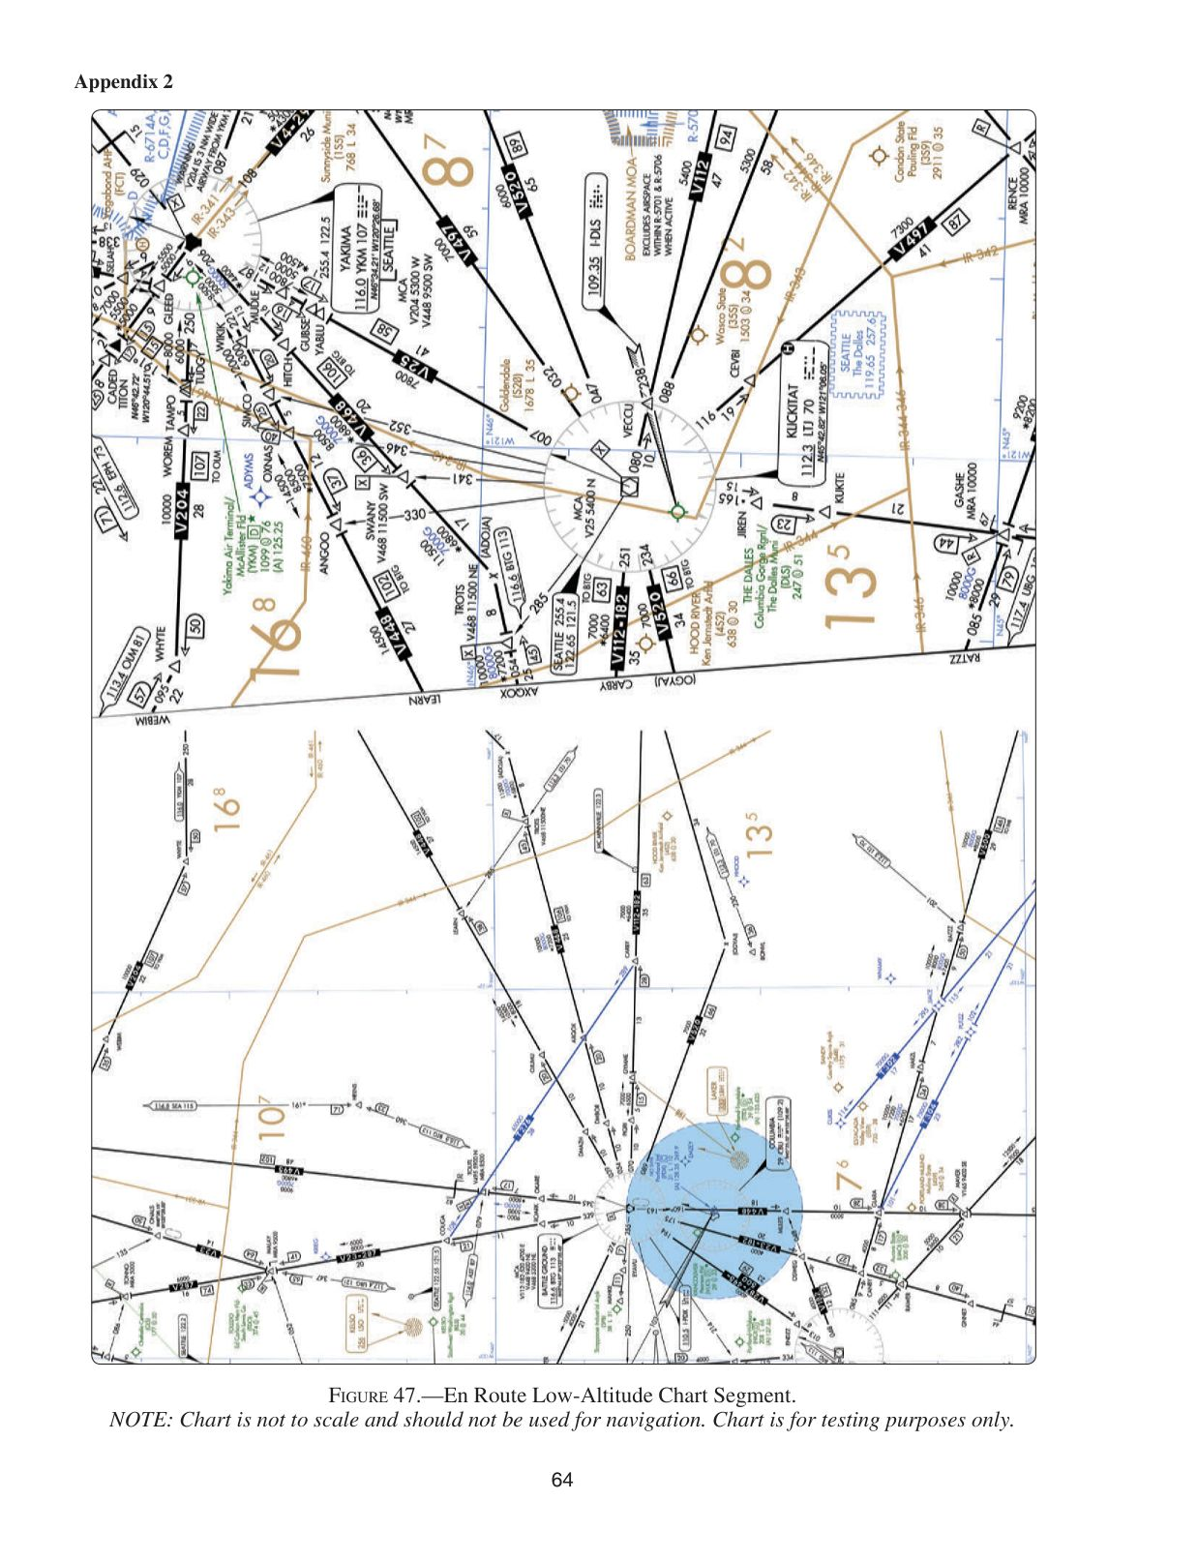
Correction (leave blank if correct): __________
────────────────────────────────────────────────────────────
Question 19 (ID: 2913) → Currently: Figure 161
Topic: 11.2 MFR to EUG
What is the TDZE elevation for RWY 16R on Eugene/Mahlon Sweet Field?
- A. 363 feet MSL.
- B. 374 feet MSL.
- C. 396 feet MSL.
Correct answer: A
Explanation:
On the IAP chart, the TDZE is shown in the airport diagram. The TDZE for RWY 16R at EUG is 363 ft. Answer (B) is incorrect. This is the airport elevation. Answer (C) is incorrect. This is the height of an obstacle to the right of RWY 16R.
↓ Currently shown Figure 161:
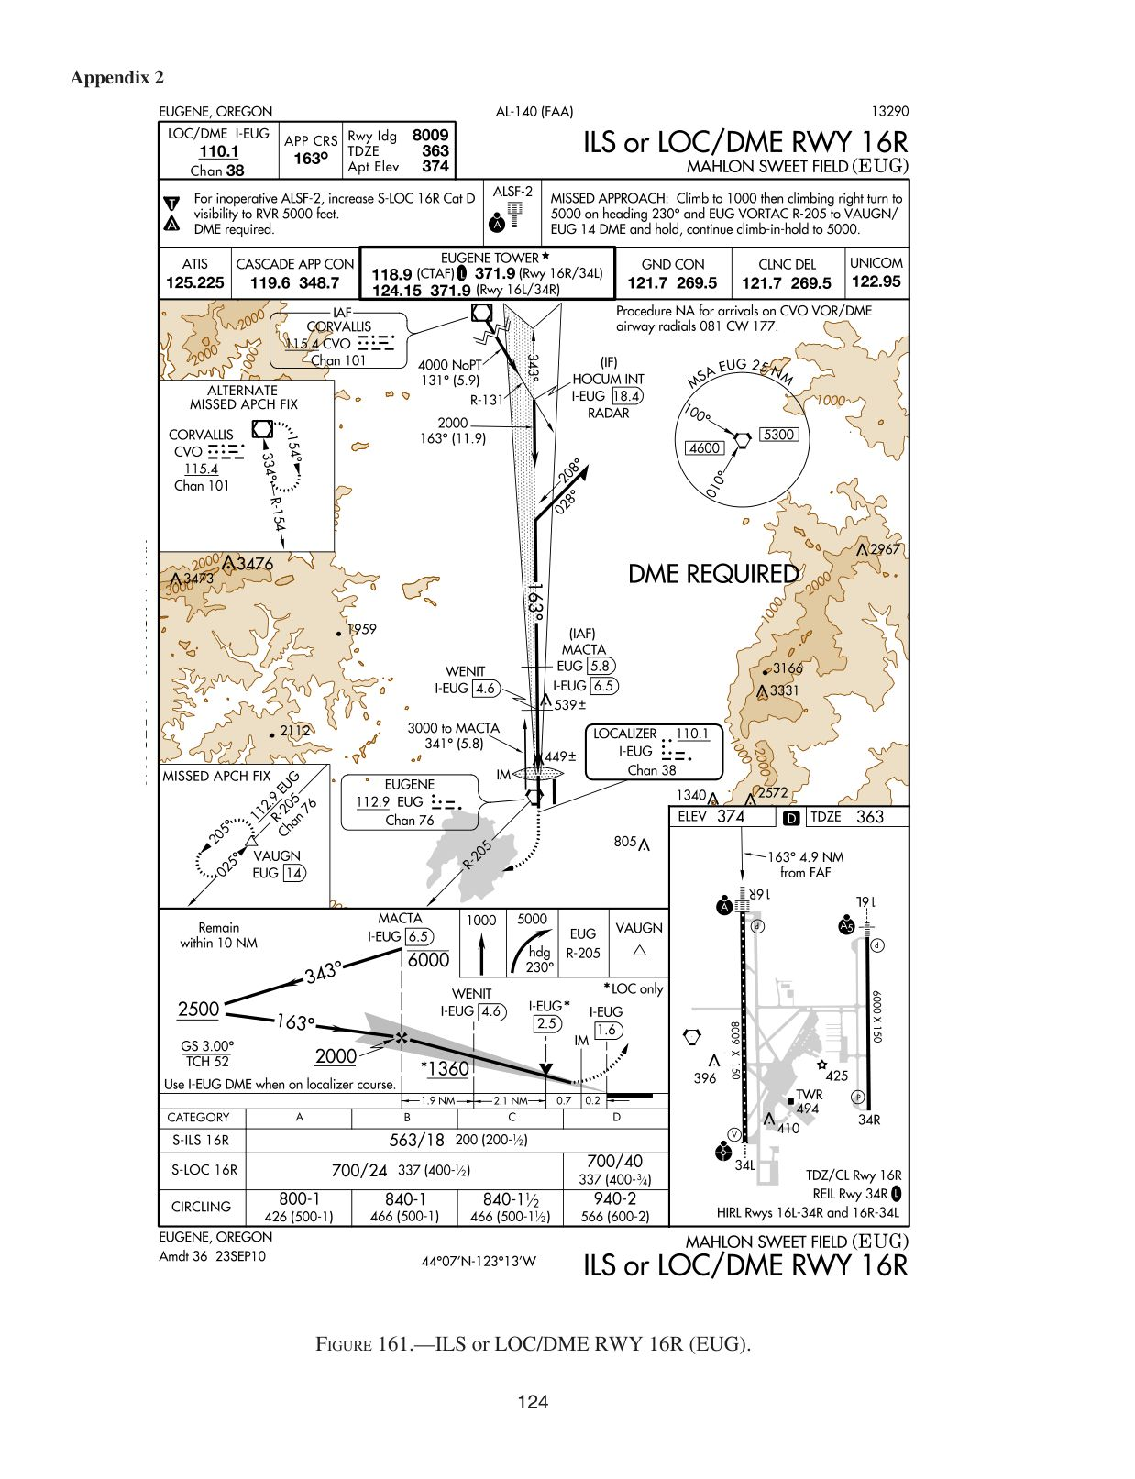
Correction (leave blank if correct): __________
────────────────────────────────────────────────────────────
Question 20 (ID: 2938) → Currently: Figure 34
Topic: 11.5 HOT to ADS
For planning purposes, what is the highest usable altitude for an IFR flight on V573 from the HOT VORTAC to the TXK VORTAC?
- A. 16,000 feet MSL.
- B. 14,500 feet MSL.
- C. 13,999 feet MSL.
Correct answer: A
Explanation:
Answer (A) is correct. (AIM Para 3-2-6) DISCUSSION: The VOR airway system consists of airways designated from 1,200 ft. AGL up to, but not including, 18,000 ft. MSL. Flying on V573 from HOT to TXK is a generally westerly course which requires an even-thousands altitude. Thus, 16,000 ft. MSL is the highest usable altitude. Answer (B) is incorrect. This is a VFR, not IFR, cruising altitude from 180° to 359°. Answer (C) is incorrect. IFR altitudes are even or odd thousands of feet.
↓ Currently shown Figure 34:
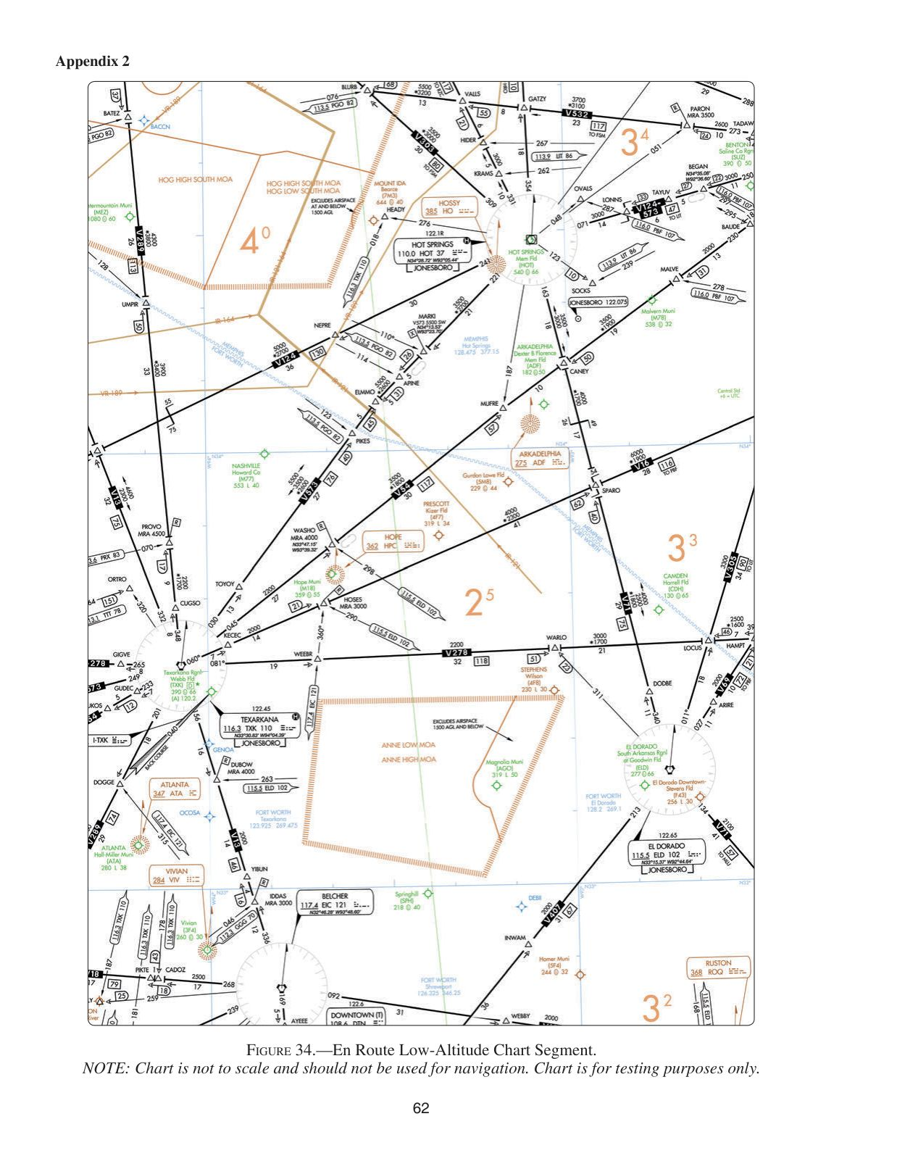
Correction (leave blank if correct): __________
────────────────────────────────────────────────────────────
Question 21 (ID: 2940) → Currently: Figure 171
Topic: 11.5 HOT to ADS
Under which condition should the missed approach procedure for the RNAV(GPS) RWY 33 approach be initiated?
- A. When passage of the MAP waypoint is shown on the ambiguity indicator.
- B. After the MDA is reached and 1.8 DME fix from the MAP waypoint.
- C. Immediately upon reaching 4.1 DME from the FAF.
Correct answer: A
Explanation:
Answer (A) is correct. (AIM Para 1-1-18) DISCUSSION: If a missed approach is necessary, the ambiguity indicator will show arrival and passage of the Missed Approach Waypoint (MAWP). Answer (B) is incorrect. There is no requirement to continue past the Missed Approach Waypoint (MAWP) by 1.8 DME before initiating the missed approach. The ambiguity indicator will show arrival and passage of the MAWP. It is at that point a missed approach can be initiated. Answer (C) is incorrect. Although the missed approach point is 4.1 DME from the FAF (POIRPTS), it is the ambiguity indicator's display of arrival and passage of the missed approach waypoint that establishes the position where the missed approach should be initiated.
↓ Currently shown Figure 171:
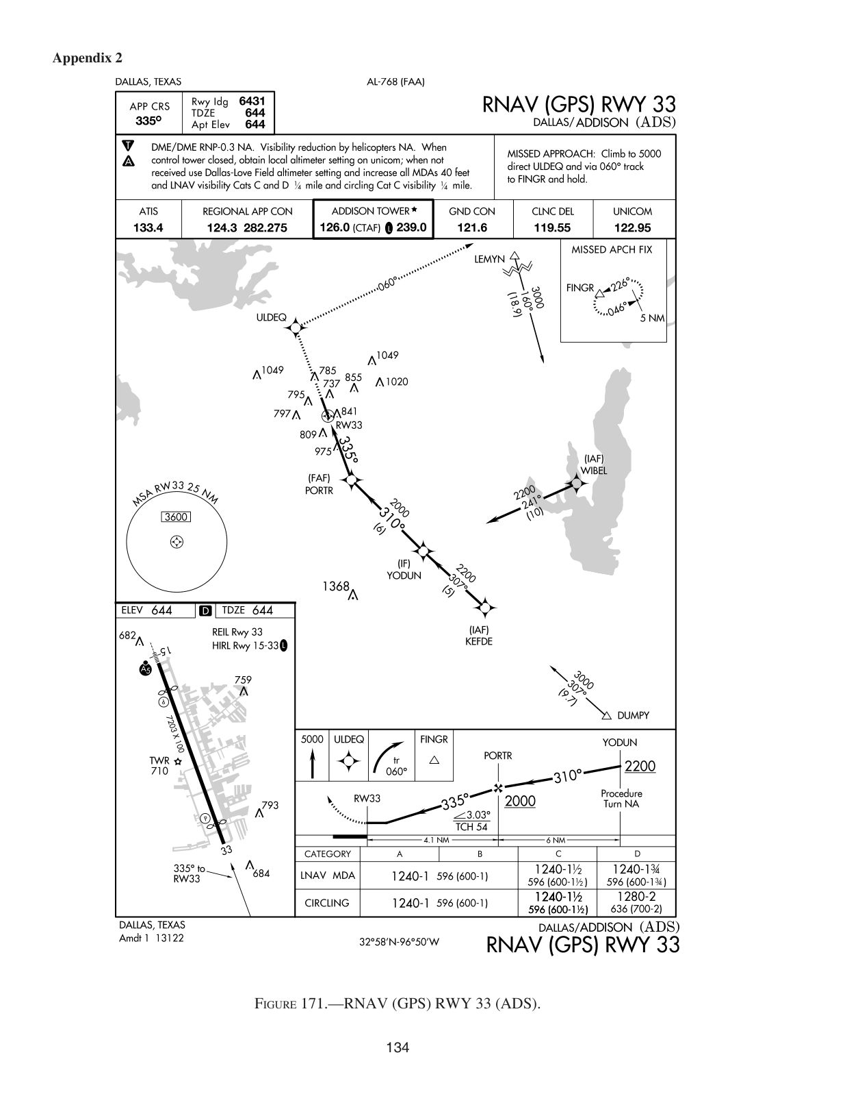
Correction (leave blank if correct): __________
────────────────────────────────────────────────────────────
Question 22 (ID: 2941) → Currently: Figure 170
Topic: 11.5 HOT to ADS
What is the MDA and visibility criteria respectively for the circling approach procedure?
- A. 1,240 feet MSL; 1/2 SM.
- B. 1,240 feet MSL; 1 SM.
- C. 1,280 feet MSL; 1 and 1/4 SM.
Correct answer: B
Explanation:
Answer (B) is correct. (ACL) DISCUSSION: The MDA and visibility criteria are found in the minimums section of the RNAV (GPS) RWY 33 approach chart. The circling MDA and visibility criteria for Category A and B aircraft are 1,240 ft. MSL and 1 SM, respectively (note that the question does not specify the aircraft category). Answer (A) is incorrect. The minimum visibility is not shown to be 1/2 SM for any category of aircraft using the circling RNAV (GPS) RWY 33 approach into ADS. Answer (C) is incorrect. The minimum visibility is not shown to be 1 and 1/4 SM for any category of aircraft using the circling RNAV (GPS) RWY 33 approach into ADS.
↓ Currently shown Figure 170:
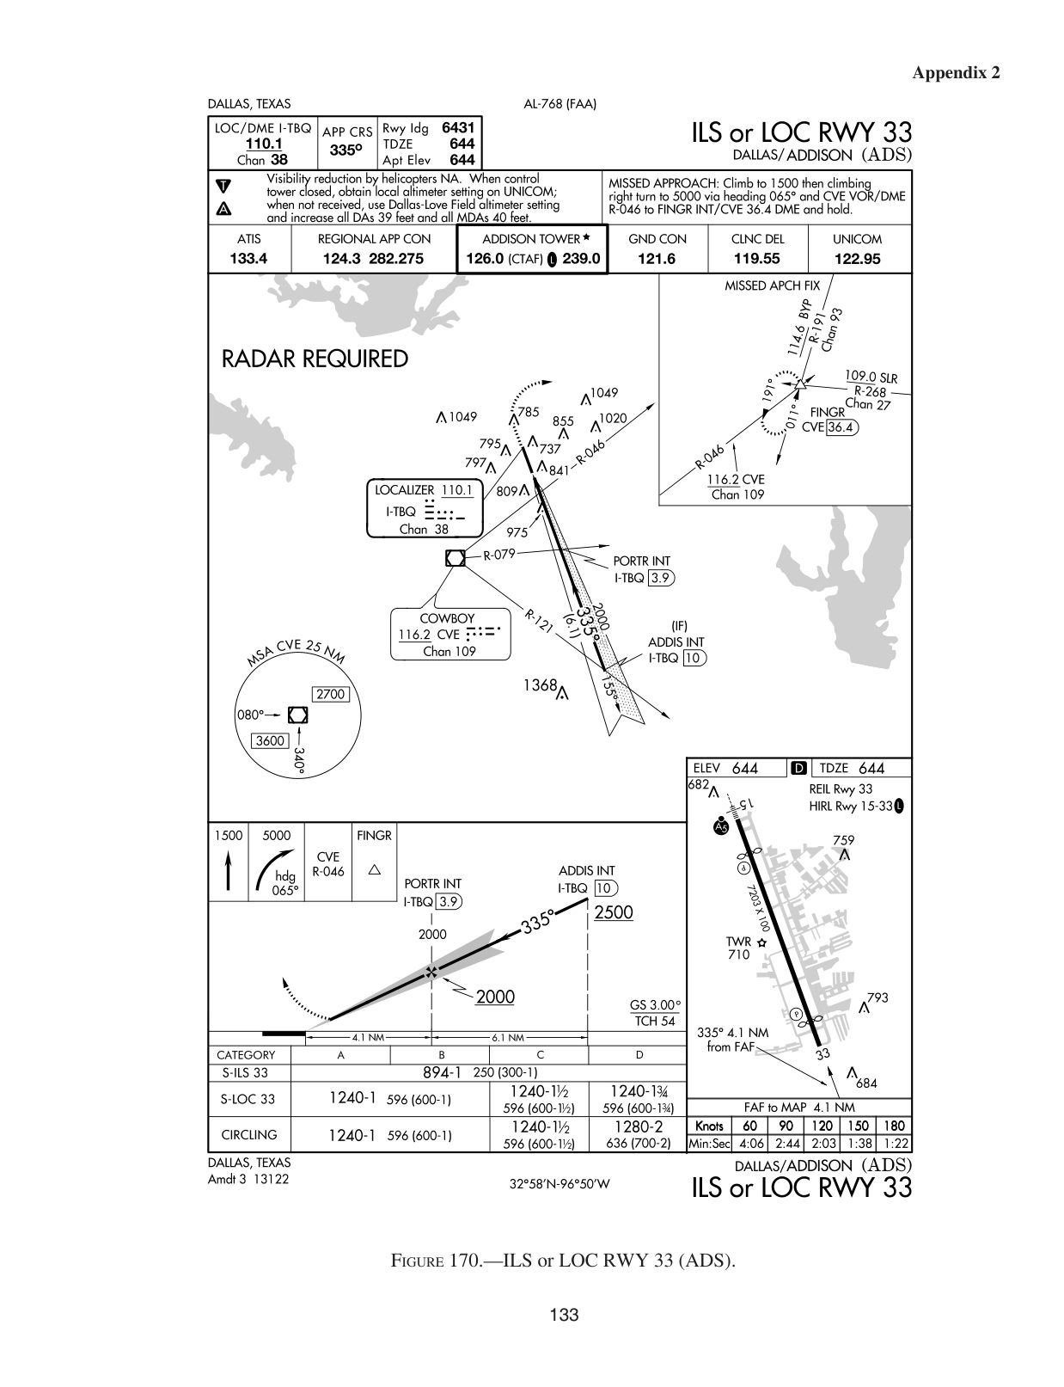
Correction (leave blank if correct): __________
────────────────────────────────────────────────────────────
Question 23 (ID: 2943) → Currently: Figure 47
Topic: 11.6 21XS to DFW
For planning purposes, what is the highest usable altitude for an IFR flight on V16 from the BGS VORTAC to ABI VORTAC?
- A. 17,000 feet MSL.
- B. 18,000 feet MSL.
- C. 6,500 feet MSL.
Correct answer: A
Explanation:
The VOR airway system consists of airways designated from 1,200 ft. AGL up to, but not including, 18,000 ft. MSL. Answer (B) is incorrect. Victor airways go up through 17,999 ft. but do not include 18,000 ft. Answer (C) is incorrect. The altitude of 6,500 ft. is the MRA at LORAN intersection.
↓ Currently shown Figure 47:

Correction (leave blank if correct): __________
────────────────────────────────────────────────────────────
Question 24 (ID: 2950) → Currently: Figure 71
Topic: 11.7 4N1 to BDL
What is your position relative to the FLOSI intersection northbound on V213 airway?
- A. West of V213 and approaching the FLOSI intersection.
- B. East of V213 and approaching the FLOSI intersection.
- C. West of V213 and past the FLOSI intersection.
Correct answer: A
Explanation:
Answer (A) is correct. (FAA-H-8083-15B Chap 9) DISCUSSION: VOR-1 is tuned to CDI VORTAC (117.6) with an OBS setting of 265°. The FROM indication and right needle deflection indicate you are south of the CDI and thus approaching it. VOR-2 is tuned to SAX VORTAC (115.7) with an OBS setting of 029°. The FROM indication and right needle deflection indicate you are to the left or west of the SAX R-029. Answer (B) is incorrect. A left, not right, needle deflection in VOR-2 would indicate right or east of the V213. Answer (C) is incorrect. A left, not right, needle deflection in VOR-1 would indicate that you have passed FLOSI intersection.
↓ Currently shown Figure 71:

Correction (leave blank if correct): __________
────────────────────────────────────────────────────────────
Question 25 (ID: 2952) → Currently: Figure 210
Topic: Topic 11. IFR Flights
What is the minimum altitude at which you should intercept the glide slope on the ILS RWY 6 approach procedure?
- A. 3,000 feet MSL.
- B. 1,800 feet MSL.
- C. 1,080 feet MSL.
Correct answer: B
Explanation:
In the profile section of the IAP chart, there is an 1800 with a lightning bolt pointing to the glide slope. This is the glide slope intercept altitude and the approach fix for precision approaches. Thus, here, one should not intercept below 1,800 feet MSL. Answer (A) is incorrect. This is the minimum altitude in the holding pattern at PENNA INT. Answer (C) is incorrect. This is the minimum altitude at which you will cross JET1X when descending on the glide slope.
↓ Currently shown Figure 210:

Correction (leave blank if correct): __________
────────────────────────────────────────────────────────────
Question 26 (ID: 2953) → Currently: Figure 210
Topic: Topic 11. IFR Flights
What is the touchdown zone elevation for RWY 6?
- A. 173 feet MSL.
- B. 200 feet AGL.
- C. 270 feet MSL.
Correct answer: A
Explanation:
The IAP chart shows the TDZE in the airport diagram. The TDZE is 173 feet MSL. Answer (B) is incorrect. This is the HAT (height above touchdown) at the DH on the ILS. Answer (C) is incorrect. This is the height of an obstruction near the approach end of RWY 6.
↓ Currently shown Figure 210:

Correction (leave blank if correct): __________
────────────────────────────────────────────────────────────
Question 27 (ID: 2954) → Currently: Figure 210
Topic: Topic 11. IFR Flights
Using an average ground speed of 90 knots on the final approach segment, at what rate of descent should the aircraft be descended initially to establish the glidepath for the ILS RWY 6 approach procedure?
- A. 395 feet per minute.
- B. 480 feet per minute.
- C. 555 feet per minute.
Correct answer: B
Explanation:
The profile view of the IAP chart shows a glide slope angle of 3.00°. Legend 27 gives rates of descent based on various glide slope angles and groundspeeds. Find the 3.0° angle of descent on the left margin and move right to the 90-knot groundspeed column to determine a rate of descent of 480 feet per minute. Answer (A) is incorrect. This is the required rate of descent at 75 knots, not 90 knots. Answer (C) is incorrect. This is the required rate of descent at a groundspeed of 105 knots, not 90 knots.
↓ Currently shown Figure 210:

Correction (leave blank if correct): __________
────────────────────────────────────────────────────────────
Question 28 (ID: 2956) → Currently: Figure 210
Topic: Topic 11. IFR Flights
After pushing the OM, Bradley Approach Control advises you that the MM on the ILS RWY 6 approach is inoperative. Under these circumstances, what adjustments, if any, are required to be made to the DH and visibility?
- A. DH 424/24.
- B. No adjustments are required.
- C. DH 374/24.
Correct answer: B
Explanation:
Refer to Legend 32, Inoperative Components or Visual Aids Table. Since the MM is not listed in the table, no adjustments are required. Answer (A) is incorrect. No adjustments are required due to an inoperative MM. Answer (C) is incorrect. No adjustments are required due to an inoperative MM.
↓ Currently shown Figure 210:

Correction (leave blank if correct): __________
────────────────────────────────────────────────────────────

