

Project Title: RoadGuard: Real-Time Roadside Emergency Dispatch Platform
Group Name: Team Void
Group Member
1. Iftakhar Majumder- 0112230783
2. Md. Nazmul Hossain Sakib- 0112230965

Course Code: CSE 2118
Section: B
Trimester: SUMMER 26
Submitted To: Mahmudul Hasan

RoadGuard
1. Introduction
RoadGuard is a web platform that connects drivers with nearby mechanics when their cars break down. A driver can share the car’s location, describe the problem, and upload a photo. The system finds nearby mechanics who are online, offers them the job, and assigns it to the first mechanic who accepts. The driver can then track the mechanic on a live map, chat with them, and rate the service after the job is completed.
The main challenge was making the system work reliably when multiple things happen at the same time. For example, several mechanics might accept the same job, a mechanic might disconnect during a job, or there may be no available mechanic nearby. RoadGuard handles these cases using multithreading, synchronization, socket programming, collections, file I/O, serialization, and database persistence. Browsers communicate through HTTP and WebSocket, while a separate TCP gateway allows devices to connect using raw sockets, with both using the same dispatch system.
a.Objective
- To get a stranded driver to a suitable mechanic quickly, with the driver choosing what is wrong and the system doing the matching by skill, distance and rating
- To make sure exactly one mechanic gets each job even when many accept at the same moment, and to recover automatically when a mechanic drops off or nobody answers
- To show live information to the driver without refreshing: the mechanic's position, the route, the estimated arrival, the job status and a chat
- To use an AI model to read a photo of the problem, judge how urgent it is and give safety advice, while still working normally when the AI is slow or unavailable
- To build a raw TCP device gateway and a fleet simulator, so that the hard cases can be demonstrated and tested instead of just explained
- To record every job so it can be replayed afterwards, using file I/O and object serialization

b. Background and Motivation
Anyone who has been stuck on a Dhaka road with a flat tyre or an overheating engine knows the problem. You do not know which garage is open, you do not know who is close, and you end up phoning shops one by one while the car blocks traffic. Ride-hailing apps solved something similar for taxis, where a request goes out to nearby drivers and the first to accept gets the trip. We wanted to see what it takes to build that idea for roadside repairs, where the right person also has to have the right skill.
We were also more interested in the engineering than in the screens. A dispatch system is a good place to meet concurrency problems for real, because a wrong answer is easy to see: two mechanics are sent to the same car. Getting that right, and proving it with tests, is what motivated most of the work.

2. Project Description
RoadGuard has three kinds of users, a driver, a mechanic and an administrator, and a dispatch engine that works between them. The features below are grouped by who uses them and what they do.
a. For the driver
- Accounts and roles: Anyone can register as a driver or a mechanic. Passwords are stored as BCrypt hashes and each login returns a signed token. A driver can reset a forgotten password with a six-digit code. The server checks the role and the owner on every request, so a driver can only see their own jobs.
- Reporting a breakdown: The driver drags a pin to where the car is, or searches for a place by name, or types coordinates. The coordinates update live as the pin moves. They then choose the problem from a list (flat tyre, dead battery, engine trouble, electrical, brakes, out of fuel, overheating, locked out, towing, or something else), write a short note, and optionally attach a photo.
- Photo check with AI: If there is a photo, it is sent to Google's Gemini vision model, which answers with a fault category, an urgency level and a short safety instruction. In our test the model read a photo of a steaming engine as "Engine Overheating and Steam Leak", marked it critical, and told the driver not to open the radiator cap. The driver's own choice still decides which kind of mechanic is called, because a photo of an open bonnet looks much the same whether the tank is empty or the engine is hot. The photo only sets the urgency and the advice. If the AI times out or is down, the request carries on with a safe default, which happened once during our own testing.
- Seeing who is around: The driver's map shows mechanics who are online within fifteen kilometres as green pins, refreshed every few seconds, and a legend says how many there are. Mechanics who have set up a shop appear as orange pins, dimmed when the shop is closed, and tapping one shows its phone number, address, skills and rating. The pin colours are the same everywhere in the app: blue is you, green is a mechanic, orange is a shop, red is the search area.
- Waiting and tracking: After the request is sent, the search area is drawn on the map as a circle. When a mechanic accepts, the driver sees their name, a route along the real roads, the distance and the estimated time, and the mechanic's pin moves as their position updates. The driver can cancel at any point before the job is finished.
- Chat: Driver and mechanic can message each other during a job, including sending a picture. Messages are saved, so the conversation is still there if either side reloads the page. The chat can be minimised so it does not cover the map.
- Rating and replay: When the job is completed the driver can give one to five stars and a comment, once per job. Afterwards the whole job can be replayed on a map.
b. For the mechanic
- Console: A mechanic goes on duty with one switch and lists what they can fix (tyres, battery, engine, electrical, brakes, fuel, towing, general). The skills can be changed at any time. Their location is set the same ways the driver sets theirs: a pin, a place search, coordinates, or the device's GPS.
- Offers: A nearby job arrives as a card with the driver's photo, the fault, the urgency, the note and a countdown. The mechanic accepts or declines. If they ignore it, the offer expires and is passed on.
- Working a job: An accepted job shows a four-stage tracker: on my way, arrived, working, done. Each press updates the driver's screen immediately. A mechanic who is on a job is marked busy and receives no new offers.
- Shop profile: A mechanic can also register a shop with a name, type, phone number, address, picture and map position. Drivers see it on their map, with an open or closed state that follows the mechanic's availability.
c. For the administrator
- Dashboard: The admin sees the number of active requests, online mechanics, drivers and mechanics, how many jobs are waiting in the dispatch queue and how many offer rounds have gone out. It refreshes itself and shows a live activity feed. A live map shows every request and every mechanic, coloured by state: green available, amber busy, grey offline. Mechanics who have never set a location cannot be drawn, so the page names them underneath.
- The accept lock switch: The administrator can turn the accept lock off. Then several mechanics can be told they won the same job, which shows exactly why the lock exists. Turning it back on makes it one winner again. A setting can forbid turning it off outside demonstrations.
- Re-dispatch and replay: Any open job can be pushed back into the queue from the list, and any finished job has a Replay button.
d. The fleet simulator
To test and demonstrate the engine we needed many mechanics at once, which nobody can do by hand. The fleet simulator starts any number of pretend mechanics, each with its own real socket to the gateway. They are registered like any other mechanic, report their positions, and answer offers. When one wins a job it drives to the driver, reports each stage with status, and finishes the job. It can run from the admin page with one button, or as a separate command-line program, which shows it is a genuinely separate client. The admin card narrates what is happening in plain sentences, with the raw protocol line beside each one, so the race can be watched (Figure 16 and 17). There is also a race mode where every mechanic who was offered a job answers at the same instant, and a switch that makes the winner vanish mid-job to show the automatic reassignment.

Key Screenshots
Fig 1: Sign in
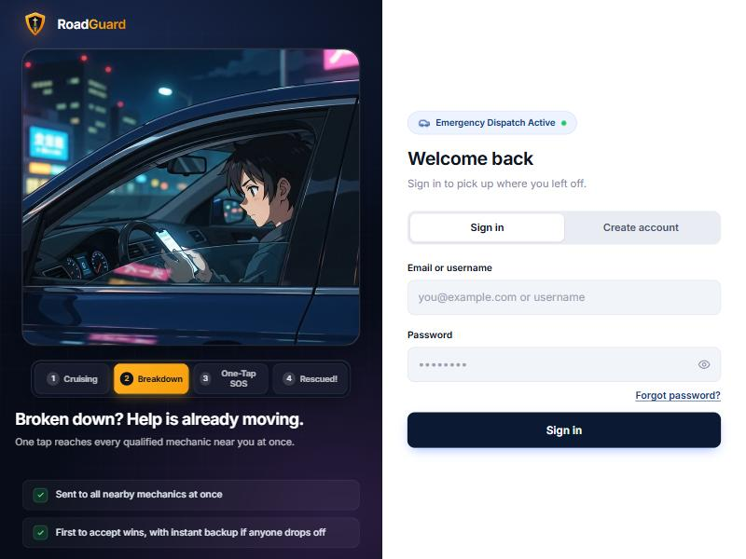

Fig 2: Registration with a role, here as a driver
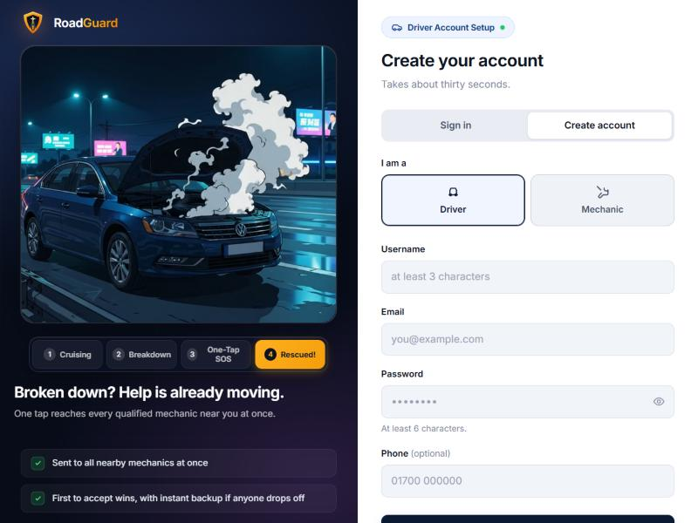
Fig 3: Mechanic registration with the skills picker
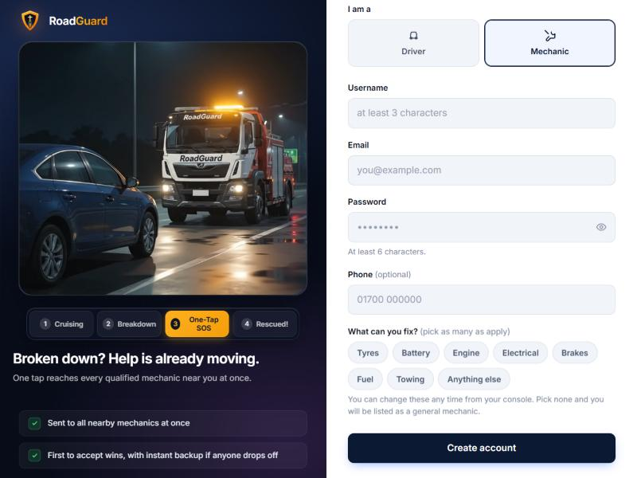

Fig 4: Driver home: the report form, a shop's details, and how many mechanics are online nearby
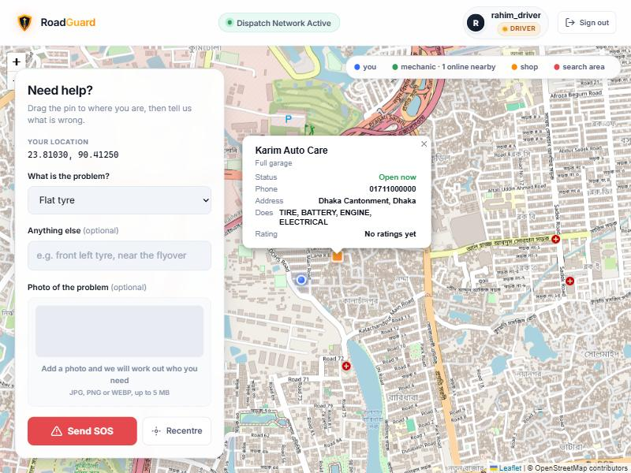
Fig 5: A request is created and the problem is being checked
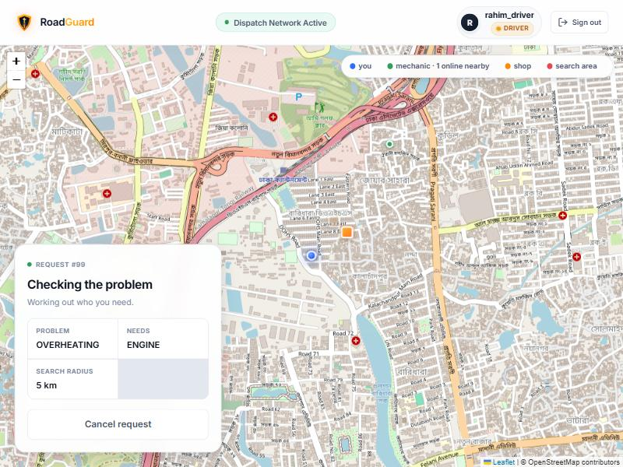

Fig 6: AI photo check: critical engine fault with safety advice
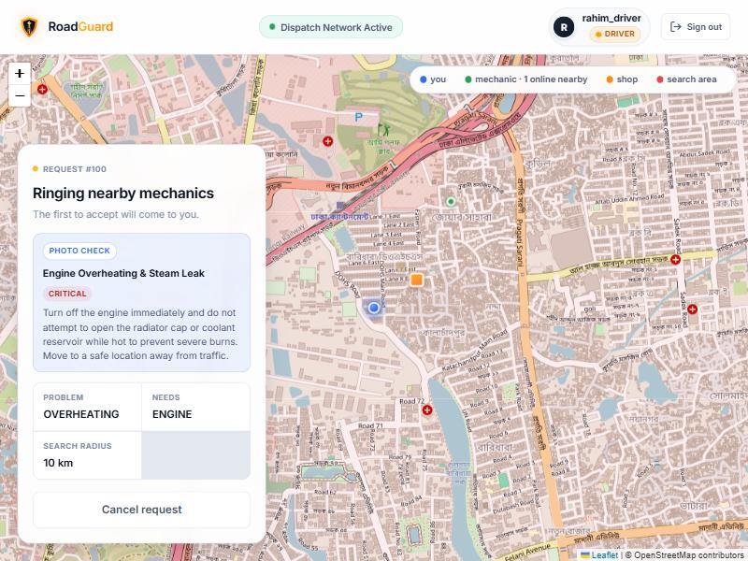
Fig 7: Searching: the search area is drawn on the map
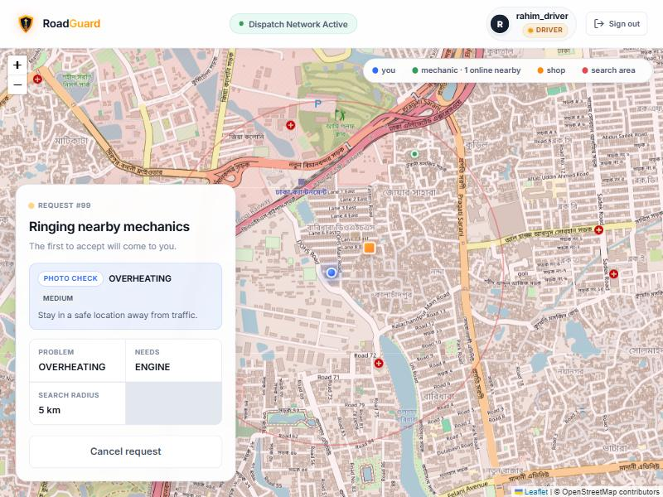

Fig 8: Mechanic console: on duty, skills and location tools
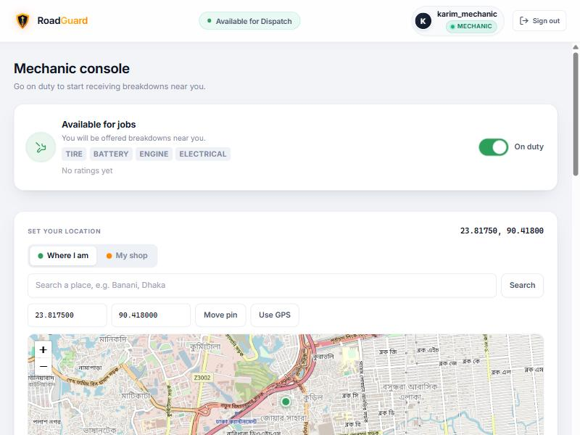

Fig 9: An incoming job offer with the driver's photo and a countdown
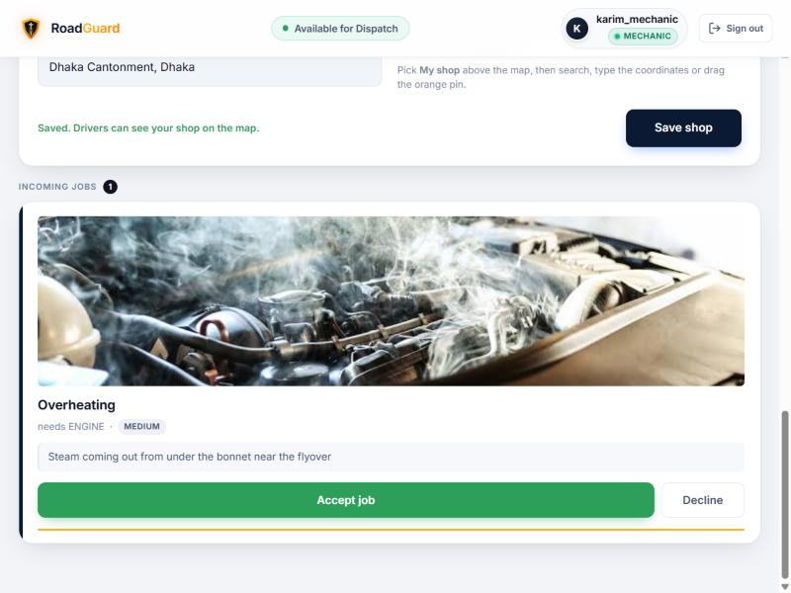
Fig 10: The accepted job with its four stages and live chat
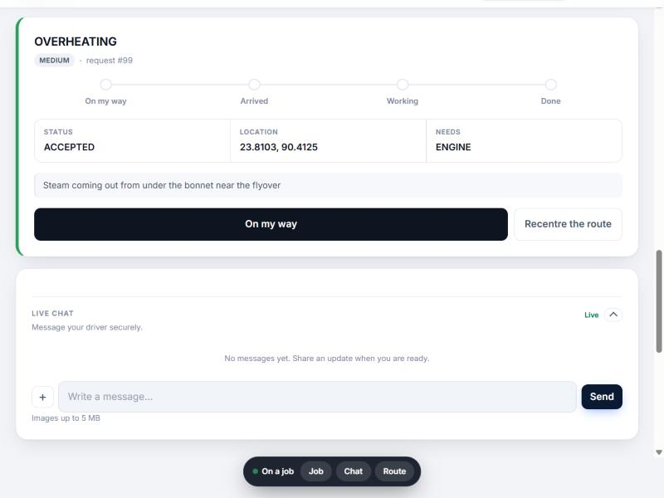

Fig 11: Live tracking: the mechanic's route, distance and estimated time
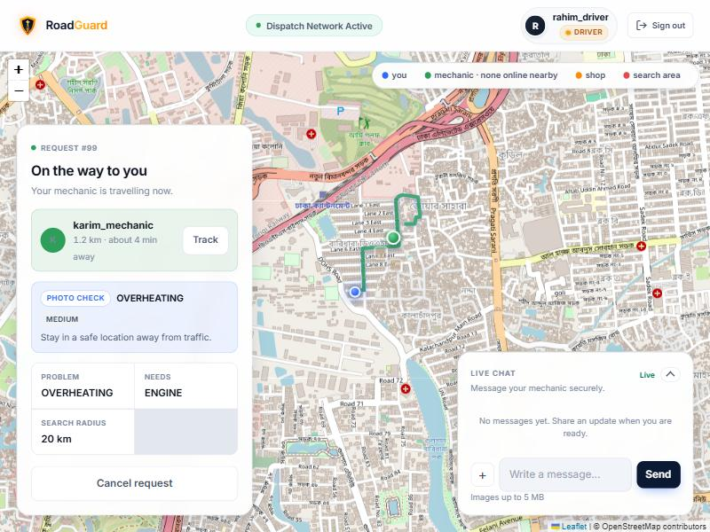

Fig 12: Driver and mechanic chat during the job, seen by the mechanic
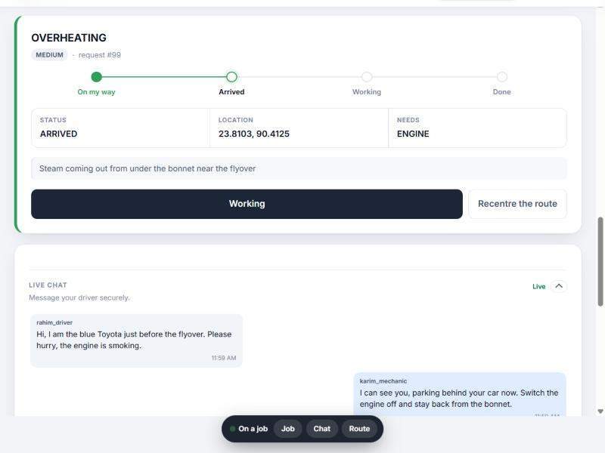

Fig 13: Rating the mechanic after the job is completed
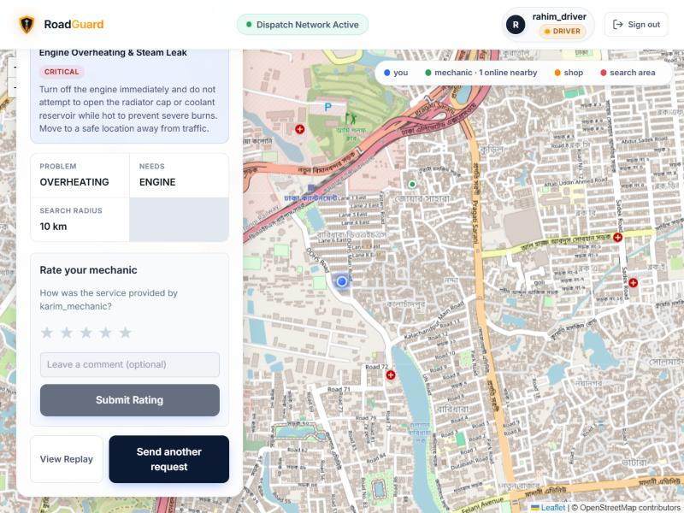

Fig 14: Replay of a finished job on the map
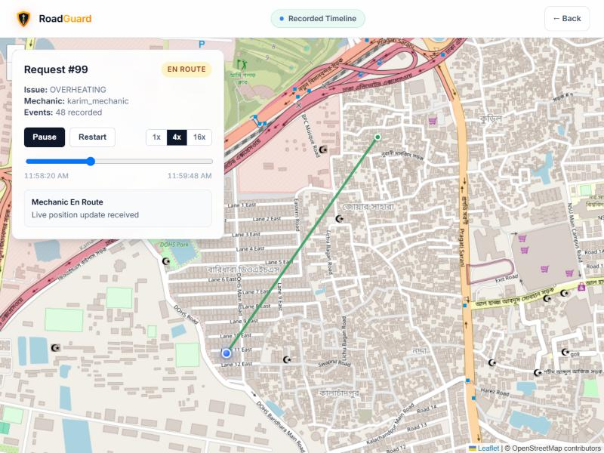

Fig 15: Admin dashboard with the dispatch queue and the accept lock
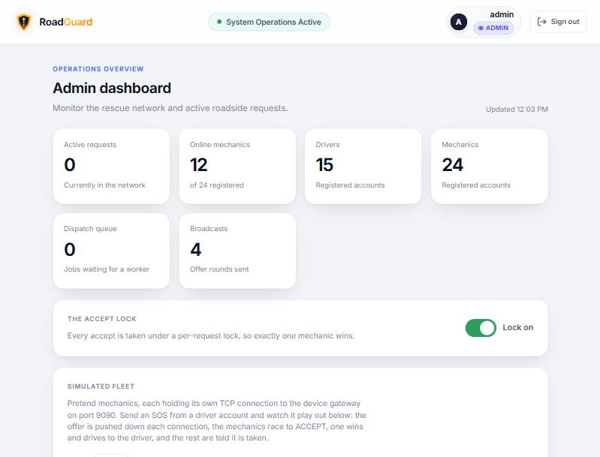

Fig 16: Fleet simulator: one mechanic wins, nine lose, with the raw protocol lines
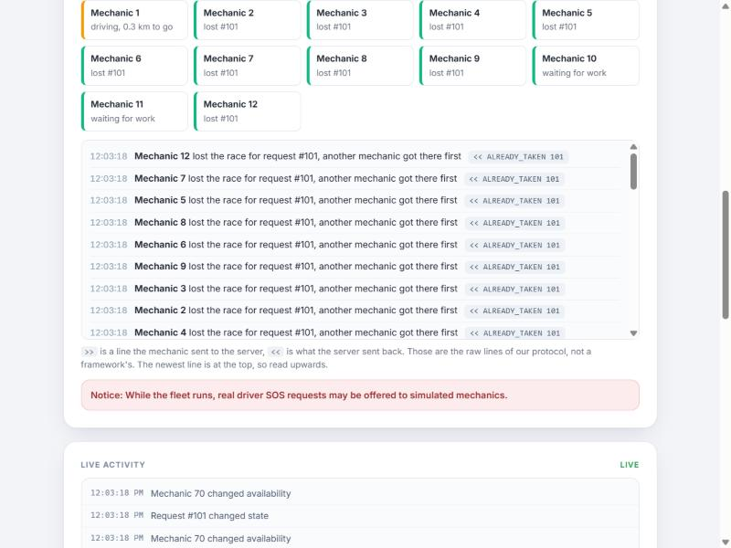

Fig 17: Accept lock switched off: ten mechanics are all told they won the same job
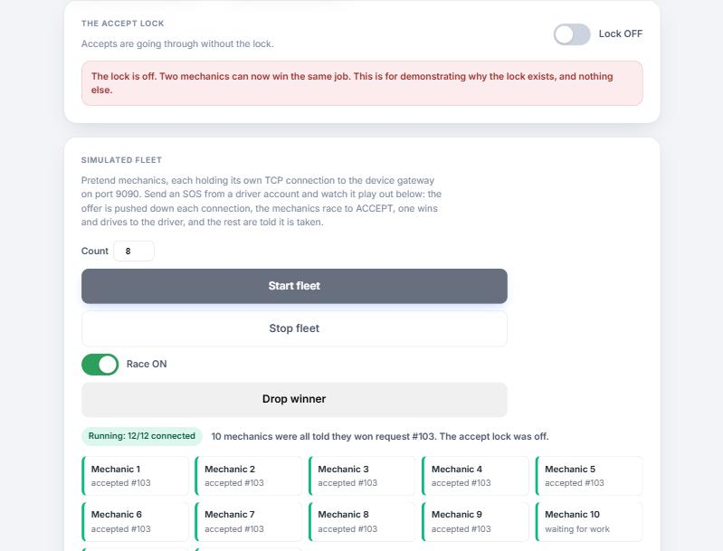

Fig 18: Admin live map: request, busy mechanic, available and offline mechanics
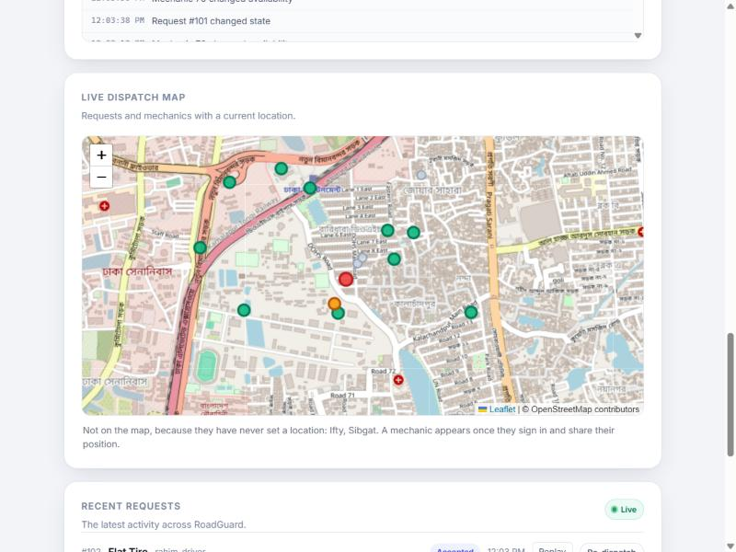

3. Future Works
We had a limited amount of time, so there are things we could not do. These are the ones we would pick up next.
- Native mobile apps with push notifications and GPS that keeps working in the background, so a mechanic does not need to keep a browser tab open
- Online payment and receipts for a finished job
- Mechanic working hours and breaks, so shops can be shown as opening and closing on a schedule
- A mechanic queue of several jobs, and coordination between a repair mechanic and a tow truck for the same car
- Bangla language support in the interface
- Reports for the administrator, such as average time to accept, busiest areas and the best-rated mechanics
- Stronger account protection, such as two-factor sign-in for administrators and limits on repeated login attempts
4. Conclusion
RoadGuard takes a driver from a broken-down car to a mechanic on the way, and keeps working when things go wrong: two mechanics accepting at once, a mechanic going silent, or nobody being nearby. The accept lock, the heartbeat sweep, the offer timeouts and the state machine are all covered by automated tests, and the fleet simulator lets us show those cases live instead of describing them.
Building it taught us how easy it is for concurrent code to look correct and still be wrong. Several of the problems we fixed were found only because we measured them, for example a result counter that added up winners across different jobs, and a map that opened zoomed in on nothing. It is still a part of what a real service would need, and the list above shows where we would go next, but the core of it works and can be demonstrated end to end.

