ECE 4122 Final Report

Group members: Christopher Chen

Yee Aung

Nick Landi

Mohammad Karim

Nathan Olivares

**We did the extra credit part where we implemented c-make for all three methods in one text file.**

Runtimes for Cuda, MPI, and Multi-thread implementations.

Implementation output pictures:

1. Cthreads Tower256

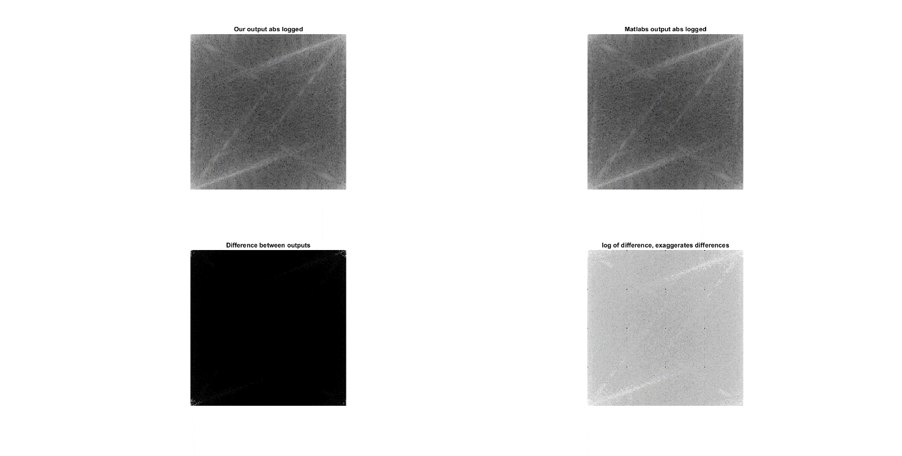

1. Mpi Tower256

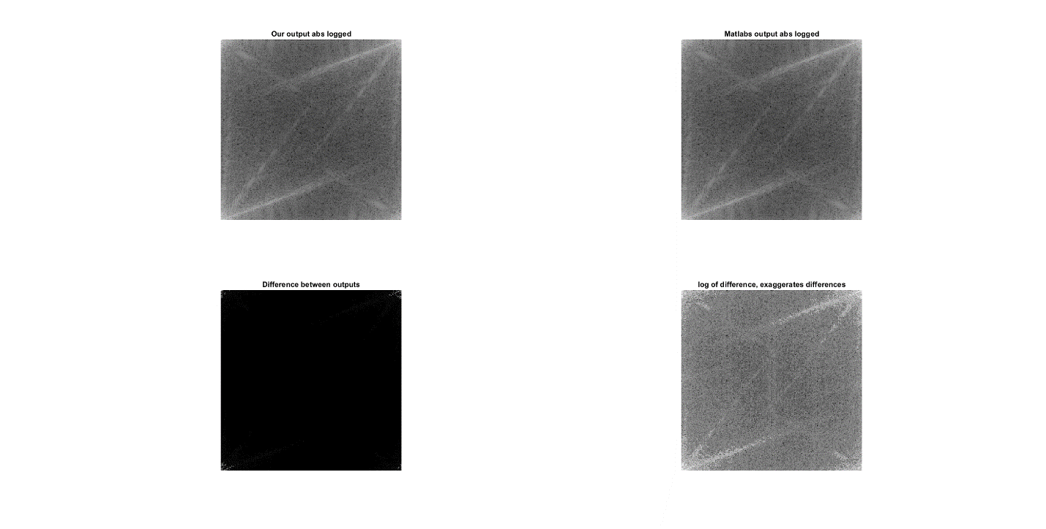

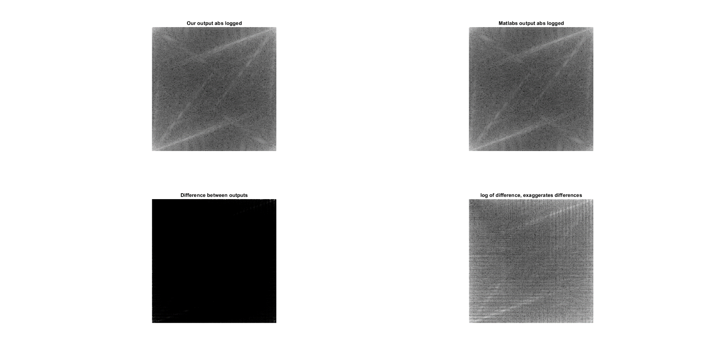3)Cuda Tower256

