ITC 353 Project 1 Worksheet
NYC 311 Service Request Delay Prediction
Name: NYC 311 Analytics Student
Run NYC311_Analysis.R from this folder before running the question examples. Each numbered question below includes its answers, an executable R example, and output from the completed R run. The full script reproduces every table, chart, model, and metric. Original source files are preserved. All results describe the supplied April 2025 sample.
The R examples share objects created by the full script; run them in numerical order in the same R session. Full tables are in analysis/tables. Name is a permitted placeholder. Review the learning reflection in your own voice before submission.

Part 1: Business Understanding

1. Business Problem
In your own words, describe the business problem your team is trying to solve.
Response:
City operations leaders need to identify incoming requests that may take longer to close so they can plan follow-up and allocate limited attention. This project estimates recorded closure time and screens for unusually slow requests within comparable problem types. Recorded closure is an administrative outcome and does not establish that the underlying issue was fixed. The supplied sample contains only records marked Closed, which limits its representativeness for new incoming requests.

R code for question 1
cat("Goal: anticipate recorded closure delays at initial submission.\n")

Executed R output
Goal: anticipate recorded closure delays at initial submission.

2. Prediction Goal
What are you trying to predict in this project?
Linear regression model:
Predict log(1 + resolution_hours), where resolution_hours is the elapsed time from creation to recorded closure. Report validation RMSE on this transformed scale and separately check predictions converted to hours.
Logistic regression model:
Predict the probability that a request exceeds the training-set 75th percentile of closure time for its original problem type. The outcome is 1 for slow and 0 otherwise; small or unseen types use a global training threshold.

R code for question 2
print(business_goal)

Executed R output
model target
1 Linear regression log(1 + hours to recorded closure)
2 Logistic regression Above training problem-specific 75th percentile

3. Business Use
How could city operations leaders use these predictions?
Response:
Use estimates to plan monitoring and follow-up queues, alongside urgency, service commitments, and staff judgment. The weak slow-request model should be evaluated in a monitored pilot before operational use. Its predictions should not determine which residents receive service.

R code for question 3
cat("Use: reviewed follow-up planning; validate before operational triage.\n")

Executed R output
Use: reviewed follow-up planning; validate before operational triage.

Part 2: Data Understanding and Exploratory Data Analysis
Before building models, explore the dataset carefully. Your goal in this section is to understand what the data contains, what problems need to be addressed, and which variables may be useful for prediction.

4. Initial Data Review
Record the basic structure of your dataset. You may not be able to complete the bottom half of the table right away. Return to it after you have finished inspecting the data, making cleaning decisions, and selecting the variables you will use for modeling.
Item | Answer
Number of rows before cleaning | 40,000
Number of columns before cleaning | 16
Number of rows after removing unusable records | 39,668
Number of columns after selecting/creating variables for modeling | 8 (6 predictors + 2 outcomes)

Briefly explain any major changes in the number of rows or columns.
Response:
The CSV has 40,000 data records and 16 columns; 40,001 counts the header as a row. Removing 332 records without closed timestamps leaves 39,668. No duplicate keys, invalid created timestamps, negative durations, or out-of-April created dates were removed. The exported model datasets have eight columns: six predictors and two outcomes. Categorical predictors expand into multiple regression coefficients.

R code for question 4
print(split_summary)

Executed R output
item value
1 Raw rows 40000
2 Raw columns 16
3 Eligible rows 39668
4 Training rows 27767
5 Validation rows 11901
6 Seed 353
7 Predictor variables 6
8 Model columns including two outcomes 8

5. Missing Values and Data Quality
Create a missing values summary table for all columns. Note: this may be an iterative process. Recommendation: fill in the first three columns first, then complete the rest of the data exploration before making final decisions about removal or recoding.
Variable | Number Missing | Percent Missing | Decision | Reason
unique_key | 0 | 0.000% | Remove predictor | Identifier; retain for audit
created_date | 0 | 0.000% | Derive features | Known at submission
closed_date | 332 | 0.830% | Target only | 332 absent; exclude these rows
agency | 0 | 0.000% | Remove predictor | Largely determined by problem
problem | 0 | 0.000% | Keep and group | Pool rare training categories
problem_detail | 429 | 1.073% | Remove predictor | High cardinality and overlap
additional_details | 22,528 | 56.320% | Remove predictor | Incomplete free text
status | 0 | 0.000% | Remove predictor | Post-submission; all Closed
location_type | 4,532 | 11.330% | Remove predictor | Exact overlap with some problems
incident_zip | 373 | 0.932% | Remove predictor | Use borough for parsimony
borough | 0 | 0.000% | Keep | Five complete categories
community_board | 0 | 0.000% | Remove predictor | Geographic overlap; many levels
open_data_channel_type | 0 | 0.000% | Keep and recode | Rare level to training mode
due_date | 39,766 | 99.415% | Remove predictor | 99.415% missing; timing uncertain
resolution_description | 148 | 0.370% | Remove predictor | Post-submission information
resolution_action_updated_date | 0 | 0.000% | Remove predictor | Post-submission information

Based on your missing values summary, answer the following:
Which variables have the most missing data?
due_date is missing for 39,766 records (99.415%); additional_details for 22,528 (56.320%); location_type for 4,532 (11.330%). All 16 columns appear in the table.
Are any variables too incomplete to be useful? Explain.
due_date is almost entirely absent and its availability at initial submission is not established, so it is excluded. additional_details is an incomplete free-text field and is omitted from this introductory model. Missing location_type could be encoded, but the field is ultimately excluded because some levels exactly duplicate problem types in the training design matrix.
Are there missing values that could be meaningful? For example, does a blank value sometimes mean “not applicable” rather than an error?
A blank detail or location field may reflect an issue for which that field is not applicable, or inconsistent collection. The file cannot distinguish these explanations. Missing closed_date does not mean zero hours: 332 such records are labeled Closed, but their duration cannot be computed.

R code for question 5
print(missingness, row.names = FALSE)

Executed R output
variable missing percent
unique_key 0 0.0000
created_date 0 0.0000
closed_date 332 0.8300
agency 0 0.0000
problem 0 0.0000
problem_detail 429 1.0725
additional_details 22528 56.3200
status 0 0.0000
location_type 4532 11.3300
incident_zip 373 0.9325
borough 0 0.0000
community_board 0 0.0000
open_data_channel_type 0 0.0000
due_date 39766 99.4150
resolution_description 148 0.3700
resolution_action_updated_date 0 0.0000

6. Categorical Variable Distributions
Create frequency tables or bar charts for the following variables: agency, problem, problem_detail, location_type, borough, community_board, and open_data_channel_type. For each variable, focus on the most common categories.
Variable | Most common categories | Rare categories under 100 | Modeling decision
agency | NYPD (18,997); HPD (7,445); DSNY (4,331) | 2 of 14 | Remove predictor
problem | Illegal Parking (7,088); Noise - Residential (4,194); HEAT/HOT WATER (2,479) | 84 of 142 | Keep and group
problem_detail | Loud Music/Party (4,519); Blocked Hydrant (2,079); ENTIRE BUILDING (1,672) | 529 of 598 | Remove predictor
location_type | Street/Sidewalk (13,365); RESIDENTIAL BUILDING (7,445); Residential Building/House (4,623) | 66 of 83 | Remove predictor
borough | BROOKLYN (12,603); QUEENS (9,692); MANHATTAN (8,557) | 0 of 5 | Keep
community_board | 12 MANHATTAN (1,168); 01 BROOKLYN (1,078); 12 BRONX (1,044) | 13 of 75 | Remove predictor
open_data_channel_type | ONLINE (17,113); PHONE (11,166); MOBILE (8,627) | 1 of 5 | Keep and recode

Which categorical variables seem most useful for predicting resolution time? Why?
Problem type should capture differences in agency workflow and task complexity. Borough, submission channel, and creation time may add context. Agency is descriptively informative but is largely determined by problem type, making separate causal interpretations inappropriate.
Which categorical variables may be difficult to use because they have too many categories or too many rare values?
There are 142 problem types and 598 problem-detail categories including Missing; 84 and 529 respectively have fewer than 100 observations. Location type has 83 categories and community board 75. Sparse categories increase instability and make unseen validation levels difficult.
Did your team decide to group, remove, or simplify any categorical variables? Explain.
Problem categories with fewer than 100 training records are pooled as Other. Borough is retained. The single rare channel is mapped to the training modal channel ONLINE because its combined rare group is too small to estimate. Future unseen levels use the saved training mapping. Agency, problem_detail, location_type, community_board, and ZIP are omitted for redundancy, sparsity, or parsimony. All mappings are learned on training rows only.

R code for question 6
print(category_summary, row.names = FALSE)
for (v in cats) {
cat("\n", v, "\n")
print(head(sort(table(raw[[v]], useNA="ifany"),
decreasing=TRUE), 3))
}

Executed R output
variable levels rare_under_100
agency 14 2
problem 142 84
problem_detail 598 529
location_type 83 66
borough 5 0
community_board 75 13
open_data_channel_type 5 1

agency

NYPD HPD DSNY
18997 7445 4331

problem

Illegal Parking Noise - Residential HEAT/HOT WATER
7088 4194 2479

problem_detail

Loud Music/Party Blocked Hydrant ENTIRE BUILDING
4519 2079 1672

location_type

Street/Sidewalk RESIDENTIAL BUILDING
13365 7445
Residential Building/House
4623

borough

BROOKLYN QUEENS MANHATTAN
12603 9692 8557

community_board

12 MANHATTAN 01 BROOKLYN 12 BRONX
1168 1078 1044

open_data_channel_type

ONLINE PHONE MOBILE
17113 11166 8627

7. Date and Time Patterns
Use created_date to explore when service requests were submitted. Create at least two of the following:
- Requests by day of the month
- Requests by day of week
- Requests by hour of day
- Requests on weekdays versus weekends
Are service requests evenly distributed across the month?
Counts are uneven: April 25 has 1,541 records, April 30 only 361, and April 1 has 959. This is a supplied sample, not a verified complete month of city demand. The boundary-day differences may reflect sample coverage and should not be interpreted as actual citywide demand changes.
Do requests appear more common on certain days of the week or times of day?
Tuesday has the most total records (6,770), but April contains five Tuesdays. After dividing by calendar-day counts, Thursday averages 1,429.75 requests per day and Wednesday 1,244.80. The peak hour is 09:00 with 2,325 requests; 04:00 has 453. These are descriptive sample patterns.
What date/time features did your team create for modeling? Why might they be useful?
Created weekday is a seven-level factor. Hour is encoded by sine and cosine so 23:00 and 00:00 remain adjacent. Day of month and weekend are also created for EDA. They are not final predictors: weekday already expresses weekend membership, and a single-month day trend may not generalize.

R code for question 7
print(read.csv("analysis/tables/weekday_adjusted.csv"))
print(range(table(d$day)))
print(sort(table(d$hour), decreasing=TRUE)[c(1,24)])

Executed R output
weekday requests calendar_days per_day
1 Mon 5667 4 1416.75
2 Tue 6770 5 1354.00
3 Wed 6224 5 1244.80
4 Thu 5719 4 1429.75
5 Fri 5581 4 1395.25
6 Sat 5013 4 1253.25
7 Sun 5026 4 1256.50
[1] 361 1541

9 4
2325 453
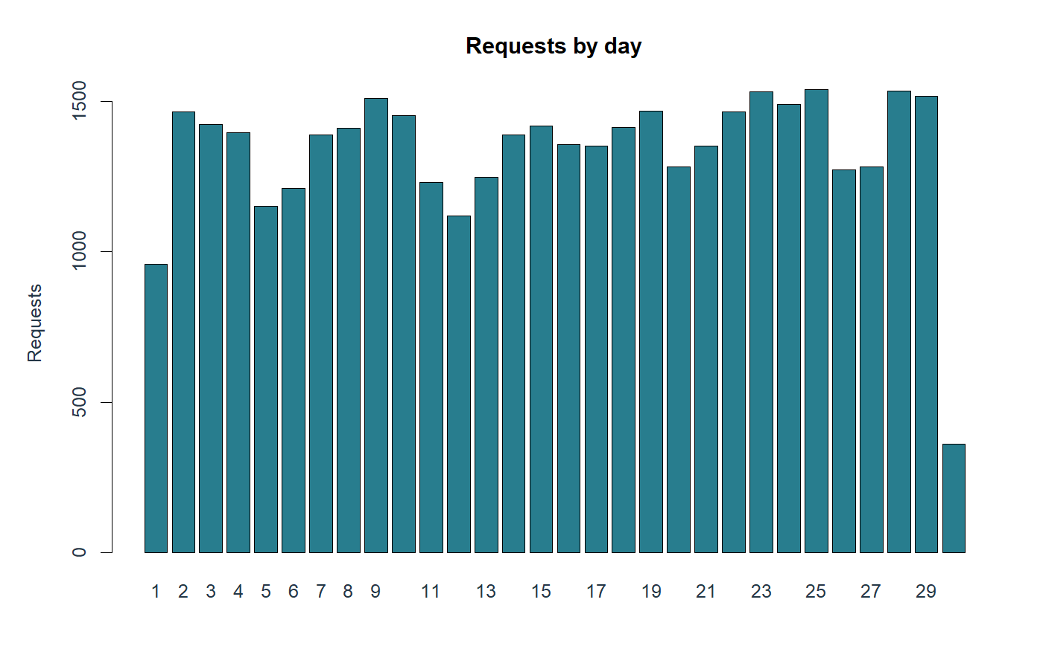
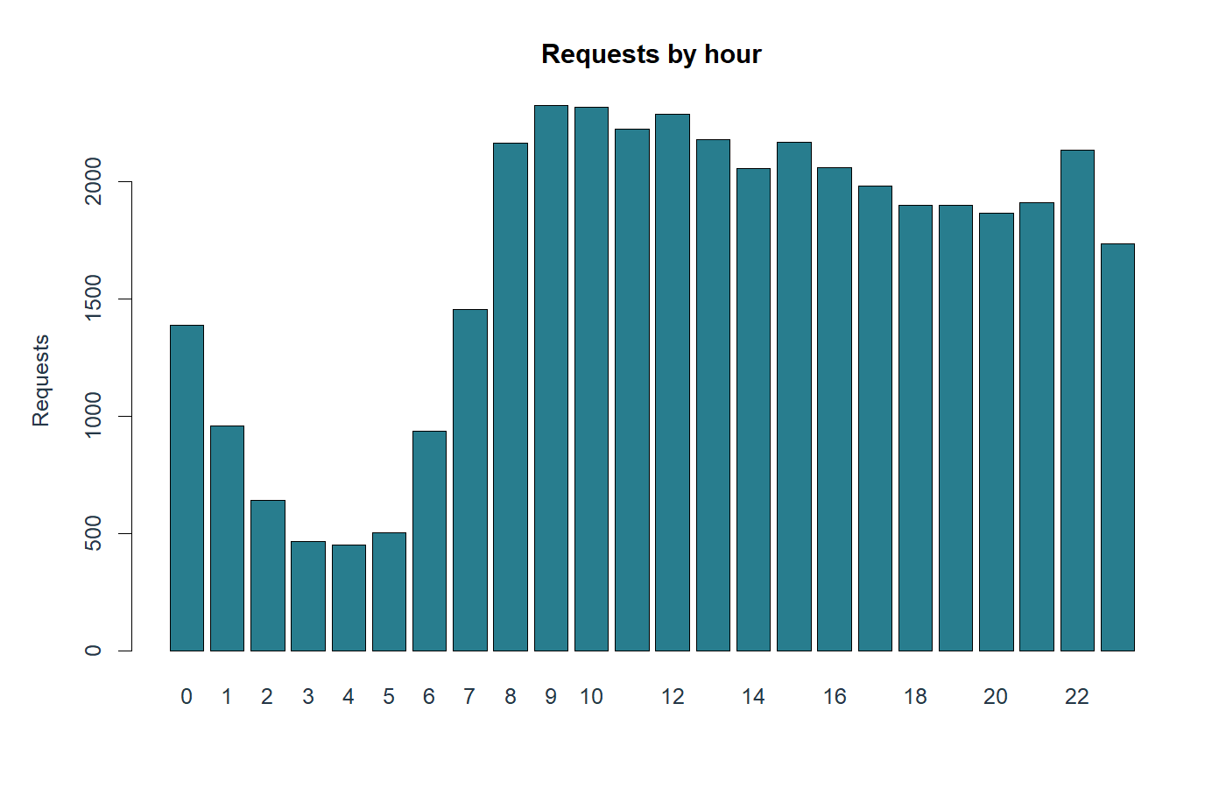

8. Resolution Time Distribution
Create a resolution_hours variable using created_date and closed_date. Then create the following:
- A summary table for resolution_hours
- A histogram of resolution_hours
- A histogram of log_resolution_hours
Use this table to record your summary statistics.
Statistic | Value in hours unless count
Minimum | 0
Mean | 251.3556
Median | 6.6817
75th percentile | 66.0012
90th percentile | 437.4729
95th percentile | 1,251.4371
Maximum | 9,888.1831
Zero hours | 677
Over 30 days | 2,930

What does the histogram of raw resolution_hours show?
The raw distribution is strongly right-skewed: median 6.68 hours versus mean 251.36 hours. A small fraction of very long cases stretches the horizontal axis. The 95th percentile is 1,251.44 hours and the maximum 9,888.18 hours.
Why might log_resolution_hours be useful for the linear regression model?
log1p(resolution_hours) compresses the upper tail and retains valid zero-hour records. Linear regression then minimizes squared error in log(1 + hours), emphasizing relative differences. Better log-scale fit does not guarantee accurate hour-scale forecasts.
Are there very short or very long resolution times? How did your team decide to handle them?
There are 677 zero-hour records and 2,930 records over 30 days. Both are retained because equal timestamps and long durations are possible and cannot be proven erroneous from this file. Their interpretation requires caution. The log transformation reduces their leverage; negative durations would be excluded, but none occur.

R code for question 8
print(duration_summary, row.names=FALSE)
hist(clean$resolution_hours, breaks=60)
hist(clean$log_resolution_hours, breaks=50)

Executed R output
statistic value
Minimum 0.00000
Mean 251.35559
Median 6.68167
75th percentile 66.00118
90th percentile 437.47289
95th percentile 1251.43711
Maximum 9888.18306
Zero hours 677.00000
Over 30 days 2930.00000
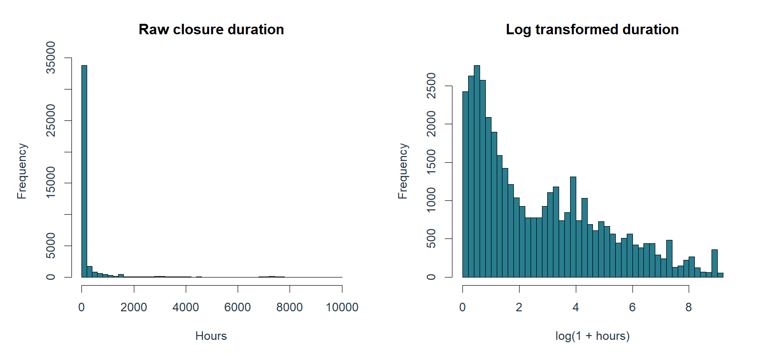

9. Resolution Time by Key Variables
Explore how resolution time differs across important categories. Create at least three of the following:
- Median resolution time by agency
- Median resolution time by problem
- Median resolution time by borough
- Median resolution time by open_data_channel_type
- Boxplot of resolution time by agency
- Boxplot of resolution time by borough
Record key findings below.
Variable | Comparison | Pattern | Model implication
agency | Eligible group medians | EDC 7,254.84 h; NYPD 1.43 h | Large case-mix differences
problem | Eligible types with n >= 100 | Helicopter 7,254.84 h; Rodent 0 h | Retain problem; interpret closure cautiously
borough | Median duration | Staten Island 13.07 h; Bronx 10.82 h | Context, not causal ranking
channel | Median duration | UNKNOWN 45.02 h; PHONE 25.97 h | May reflect different issue mix

Which agencies or problem types tend to have longer resolution times?
Among agencies with at least 100 eligible records, EDC has median 7,254.84 hours (n = 251), TLC 1,213.84 (n = 409), and DOB 293.82 (n = 1,202). Noise - Helicopter has median 7,254.84 hours and Building/Use 2,488.14 hours. These are recorded closure patterns, not an agency performance ranking adjusted for case mix.
Which agencies or problem types tend to be resolved quickly?
NYPD has median 1.43 hours across 18,997 requests. Rodent has median zero hours across 450 records; that is a timestamp observation, not evidence of instantaneous pest removal. Small categories are not used to establish reliable rankings.
Why might it be unfair to use one single definition of “slow” for every type of service request?
Different problem types require different actions and have different recorded workflows. A universal threshold would label naturally lengthy work slow even when it is typical for that problem. A within-problem percentile creates a relative comparison, although it is not an official service-level deadline.

R code for question 9
for (v in c("agency", "problem", "borough",
"open_data_channel_type")) {
z <- read.csv(paste0("analysis/tables/duration_by_",v,".csv"))
cat("\n",v," (n >= 100)\n")
print(head(z[z$n >= 100,], 4), row.names=FALSE)
}

Executed R output

agency (n >= 100)
category n median mean
EDC 251 7254.840 7271.468
TLC 409 1213.840 1585.513
DOB 1202 293.822 1477.036
DPR 990 116.717 929.056

problem (n >= 100)
category n median mean
Noise - Helicopter 251 7254.84 7271.47
Building/Use 240 2488.14 3507.83
Taxi Complaint 106 1923.03 2256.51
Food Establishment 158 1447.96 1431.80

borough (n >= 100)
category n median mean
STATEN ISLAND 1505 13.07333 266.573
BRONX 7623 10.82361 188.017
MANHATTAN 8316 9.16472 369.333
BROOKLYN 12552 5.08722 206.019

open_data_channel_type (n >= 100)
category n median mean
UNKNOWN 3093 45.01667 732.5458
PHONE 11098 25.96667 244.2106
ONLINE 17015 5.21111 263.4668
MOBILE 8461 2.25000 60.4951
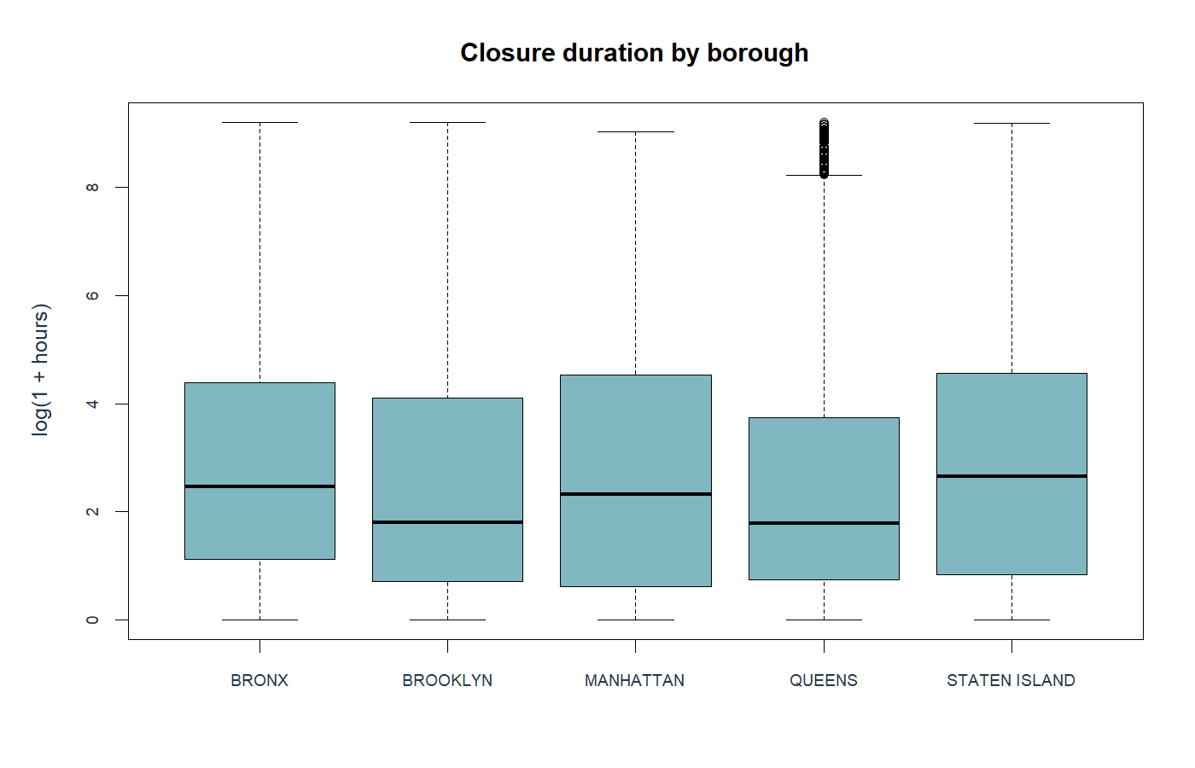

10. Relationships Between Important Variables
Create at least two cross-tabulations to explore relationships between categorical variables. Recommended cross-tabs: agency by problem, problem by borough, problem by open_data_channel_type, and borough by open_data_channel_type.
Cross-tab | Relationship | Finding
Agency by problem | Routing of problem types | 138 of 142 types occur within one agency
Borough by channel | Within-borough channel shares | Phone: Bronx 34.66%, Manhattan 24.37%
Problem by borough | Request mix across geography | Full counts and row percentages exported

Are some problem types handled mostly by specific agencies?
Yes. In the supplied sample, 138 of 142 problem types occur entirely within one agency. The full agency-by-problem table is saved, and a compact excerpt is included below. Agency and problem should therefore not be interpreted as independent drivers.
Do some types of requests appear more common in certain boroughs or submission channels?
Submission channel mix differs by borough. Phone accounts for 34.66% of Bronx records versus 24.37% of Manhattan records; online accounts for 36.69% versus 46.98%. These proportions describe recorded users and request mix, not all residents or access needs. The problem-by-borough table is also saved for inspection.
How could these relationships affect your model results or interpretation?
Correlated predictors can make individual coefficients unstable or redundant. Channel and borough associations may reflect differences in problem mix and reporting behavior. I retain problem but omit agency; I also remove location_type after its training-only design check finds exact redundancy. Model coefficients are associations, not causal effects.

R code for question 10
ap <- table(raw$problem,raw$agency)
cat("Single-agency problem types:",
sum(rowSums(ap>0)==1), "of", nrow(ap), "\n")
print(table(raw$agency,raw$problem)[
c("NYPD","HPD","EDC"),
c("Illegal Parking","HEAT/HOT WATER","Noise - Helicopter")])
print(round(100*prop.table(
table(raw$borough,raw$open_data_channel_type),1),2))

Executed R output
Single-agency problem types: 138 of 142

Illegal Parking HEAT/HOT WATER Noise - Helicopter
NYPD 7088 0 0
HPD 0 2479 0
EDC 0 0 251

MOBILE ONLINE OTHER PHONE UNKNOWN
BRONX 23.38 36.69 0.00 34.66 5.27
BROOKLYN 22.30 42.74 0.00 26.83 8.13
MANHATTAN 21.50 46.98 0.01 24.37 7.14
QUEENS 20.69 43.58 0.00 26.97 8.76
STATEN ISLAND 12.27 45.09 0.00 29.05 13.59

11. EDA Summary
Based on your exploratory analysis, summarize the most important things your team learned before modeling.
Key EDA finding | Why it matters
Strongly skewed duration | Median 6.68 h; mean 251.36 h. Use log1p and separate hour metrics.
332 missing closed dates | Cannot calculate an observed target; exclude without imputation.
Problem overlaps agency and location | Use a parsimonious predictor set; check training design rank.

Which variables do you expect to be most useful for prediction? Explain.
Problem is expected to be most informative for absolute closure duration; borough, channel, weekday, and cyclic hour may add information. For relative slow status, the problem-based definition removes much of the between-problem signal, so good duration prediction need not imply good slow-request classification.
What is one data issue your team will need to address before modeling?
The 332 Closed records without closed_date cannot provide a target. They are removed without inventing outcomes. More broadly, all statuses are Closed, so the sample may exclude still-open requests and underestimate delays among all incoming requests.

R code for question 11
cat("Median hours:",median(clean$resolution_hours),"\n")
cat("Mean hours:",mean(clean$resolution_hours),"\n")
cat("Closed status without closed_date:",
sum(raw$status=="Closed" & is.na(raw$closed_date)),"\n")

Executed R output
Median hours: 6.68167
Mean hours: 251.356
Closed status without closed_date: 332

Part 3: Data Preparation

12. Resolution Time
How did your team calculate resolution time?
Formula or explanation:
Parse created_date and closed_date as NYC local timestamps, then calculate as.numeric(difftime(closed, created, units = "hours")). April has no daylight-saving transition. This measures time to recorded closure; it is not a direct measure of resident satisfaction or confirmed problem resolution.
What unit did you use?
[ ] Minutes [X] Hours [ ] Days [ ] Other

R code for question 12
resolution_hours <- as.numeric(difftime(
d$closed,d$created,units="hours"))
print(head(resolution_hours))

Executed R output
[1] 0.646111 0.592778 3811.809167 22.127500 8.215833 4.956667

13. Records Removed
What records did your team remove before modeling?
Records removed | Reason
332 with missing closed_date | Cannot compute observed closure duration
0 duplicate keys | No repeated unique_key values
0 invalid created dates, negative durations, or outside-April rows | Checks implemented; no additional exclusions

R code for question 13
print(table(reason))
cat("Duplicate keys:",sum(duplicated(raw$unique_key)),"\n")
cat("Negative durations:",
sum(d$resolution_hours<0,na.rm=TRUE),"\n")

Executed R output
reason
Missing or invalid closed date Retained
332 39668
Duplicate keys: 0
Negative durations: 0

14. New Variables Created
List the new variables your team created.
New variable | How created | Purpose
created, closed | Parse local timestamp strings | Calculate elapsed time
resolution_hours | difftime(closed, created), hours | Raw target and EDA
log_resolution_hours | log1p(resolution_hours) | Linear regression outcome
day, hour, weekday | Extract creation components | EDA and time features
weekend | Saturday or Sunday indicator | EDA only; redundant with weekday
hour_sin, hour_cos | sin/cos(2*pi*hour/24) | Cyclic hourly predictors
slow | Hours exceed frozen training threshold | Binary logistic outcome
Grouped categorical values | Training counts and saved mapping | Stable sparse-level handling

R code for question 14
print(head(clean[,c("day","hour","weekday","weekend",
"hour_sin","hour_cos","resolution_hours",
"log_resolution_hours")]),row.names=FALSE)

Executed R output
day hour weekday weekend hour_sin hour_cos resolution_hours
26 22 Sat 1 -0.500000 8.66025e-01 0.646111
20 18 Sun 1 -1.000000 -1.83691e-16 0.592778
27 15 Sun 1 -0.707107 -7.07107e-01 3811.809167
2 15 Wed 0 -0.707107 -7.07107e-01 22.127500
27 22 Sun 1 -0.500000 8.66025e-01 8.215833
11 21 Fri 0 -0.707107 7.07107e-01 4.956667
log_resolution_hours
0.498416
0.465480
8.246122
3.141022
2.220923
1.784511

15. Missing Values
How did your team handle missing values?
Field | Decision | Reason
closed_date | Remove 332 rows | Do not impute the target
location_type | Explore as Missing; omit predictor | Exact training-design redundancy
problem_detail, additional_details, incident_zip, due_date | Omit these predictors | Sparsity, complexity, geography overlap, or timing
Final model predictors | No missing values after mappings | Verified in R

R code for question 15
cat("Missing final training predictors:",
sum(is.na(train[,predictors])),"\n")
cat("Missing final validation predictors:",
sum(is.na(validation[,predictors])),"\n")

Executed R output
Missing final training predictors: 0
Missing final validation predictors: 0

16. Categorical Variables
Which categorical variables did your team use in the models?
Categorical variable | Handling | Reason
problem | Training n < 100 pooled as Other | Limit sparse coefficients
borough | Retain all five levels | Coarse location context
open_data_channel_type | Keep common levels; rare/unseen to saved fallback | Single rare channel cannot support its own effect
weekday | Seven-level factor, Monday reference | Allow weekday differences

R code for question 16
for (v in c("problem","borough","open_data_channel_type",
"weekday")) {
cat(v,":",nlevels(train[[v]]),"model levels\n")
}
print(maps$open_data_channel_type)

Executed R output
problem : 47 model levels
borough : 5 model levels
open_data_channel_type : 4 model levels
weekday : 7 model levels
$keep
[1] "MOBILE" "ONLINE" "PHONE" "UNKNOWN"

$levels
[1] "ONLINE" "MOBILE" "PHONE" "UNKNOWN"

$fallback
[1] "ONLINE"

Part 4: Data Leakage Check
A model should only use information that would be available when the service request is first submitted.

17. Leakage Variables
Identify any variables that should not be used as predictors because they would create data leakage.
Variable | Why excluded from predictors
closed_date | Unknown when a request first arrives
status | Snapshot reflects later progress; all Closed here
resolution_description | Records agency action after submission
resolution_action_updated_date | Timestamp of later action
resolution_hours, log_resolution_hours, slow | Outcomes derived from future closure; never predictors
due_date | Availability at submission unverified; almost entirely missing

R code for question 17
leakage <- c("closed_date","status","resolution_description",
"resolution_action_updated_date","resolution_hours",
"log_resolution_hours","slow")
stopifnot(!any(predictors %in% leakage))
cat("Leakage predictor check passed.\n")

Executed R output
Leakage predictor check passed.

18. Final Predictor Set
List the variables your team used as predictors in your final models.
Predictor | Linear | Logistic | Reason
problem | Yes | Yes | Issue/workflow context
borough | Yes | Yes | Coarse geography
open_data_channel_type | Yes | Yes | Submission context
weekday | Yes | Yes | Day-of-week patterns
hour_sin | Yes | Yes | Cyclic time of submission
hour_cos | Yes | Yes | Completes cyclic representation

R code for question 18
print(predictors)
print(formula(linear))
print(formula(logistic))

Executed R output
[1] "problem" "borough" "open_data_channel_type"
[4] "weekday" "hour_sin" "hour_cos"
log_resolution_hours ~ problem + borough + open_data_channel_type +
weekday + hour_sin + hour_cos
slow ~ problem + borough + open_data_channel_type + weekday +
hour_sin + hour_cos

Part 5: Holdout Validation

19. Training and Validation Split
In this project, you will use the holdout method to evaluate your models. The holdout method divides the data into two independent parts:
- The training set is used to build the model.
- The validation set is used to evaluate how well the model predicts new, unseen observations.
Record how your team split the data.
Item | Answer
Percent used for training | 70% (27,767 / 39,668)
Percent used for validation | 30% (11,901 / 39,668)
Training observations | 27,767
Validation observations | 11,901
Random seed | 353

Why did your team use this split?
A reproducible 70/30 random holdout provides 27,767 training rows and 11,901 validation rows, using seed 353. It leaves enough examples for estimating categorical effects and a substantial unseen evaluation set. The split is performed before rare-level mappings and slow thresholds are estimated.
Why is it important to evaluate model performance on the validation set instead of only using the training set?
Training performance is optimistic because the same observations estimated the coefficients. Validation measures performance on held-out records. This random within-April split still does not test future months or dependence between related requests; a later-month test is needed before deployment.

R code for question 19
print(table(ifelse(seq_len(nrow(clean)) %in% train_id,
"Training","Validation")))
cat("Seed: 353; training fraction:",
nrow(train)/nrow(clean),"\n")
stopifnot(!any(train$unique_key %in% validation$unique_key))

Executed R output

Training Validation
27767 11901
Seed: 353; training fraction: 0.699985

Part 6: Linear Regression Model

20. Linear Regression Outcome
What outcome variable did you use for the linear regression model?
log_resolution_hours = log1p(resolution_hours).
Did you transform the outcome variable?
[ ] No [X] Yes - explain the transformation:
Yes. I used the natural logarithm of 1 plus hours, which is defined at zero and reduces the influence of the long upper tail.
Why was this outcome appropriate for predicting resolution time?
Closure duration is nonnegative and extremely skewed. The transformation supports modeling broad relative duration patterns while keeping zero-hour records. I also evaluate a training-residual smearing conversion to hours to avoid presenting transformed performance as an hour-scale error.

R code for question 20
train$log_resolution_hours <- log1p(train$resolution_hours)
print(summary(train$log_resolution_hours))

Executed R output
Min. 1st Qu. Median Mean 3rd Qu. Max.
0.000 0.758 2.023 2.692 4.217 9.177

21. Linear Regression Validation Performance
Build the linear regression model using the training set. Then use the model to predict the outcome for the validation set.
Record your model performance.
Metric on log1p-hours scale | Training | Validation
RMSE | 1.2938 | 1.3089
MAE | 0.9156 | 0.9278
R_squared | 0.6699 | 0.6582

Use RMSE as your primary performance measure. A lower RMSE means the model’s predictions are closer to the actual values.
What does the validation RMSE tell you about the model’s predictive performance?
Validation RMSE is 1.3089 log1p-hours versus 2.2388 for predicting the training mean log duration. Validation MAE is 0.9278 and predictive R-squared is 0.6582. RMSE is not 1.31 hours. On the hour scale, smearing-adjusted RMSE is 1,373.18 hours, worse than the training-mean baseline of 970.97 hours.
Is there a large difference between the training RMSE and validation RMSE? What might that suggest?
Training RMSE is 1.2938 and validation RMSE is 1.3089, a small increase of 0.0151. This does not suggest a large overfitting gap on this split, but it does not establish future-month reliability or eliminate sampling bias.

R code for question 21
linear <- lm(reformulate(predictors,
"log_resolution_hours"), data=train)
pred_valid <- predict(linear, newdata=validation)
sqrt(mean((validation$log_resolution_hours-pred_valid)^2))
print(linear_metrics,row.names=FALSE)
print(hours_metrics,row.names=FALSE)

Executed R output
set RMSE MAE R_squared
Training 1.2938 0.915567 0.669945
Validation 1.3089 0.927796 0.658189
model RMSE MAE R_squared
Smearing adjusted linear 1373.178 316.646 -1.00009e+00
Training mean baseline 970.967 392.307 -1.31544e-05
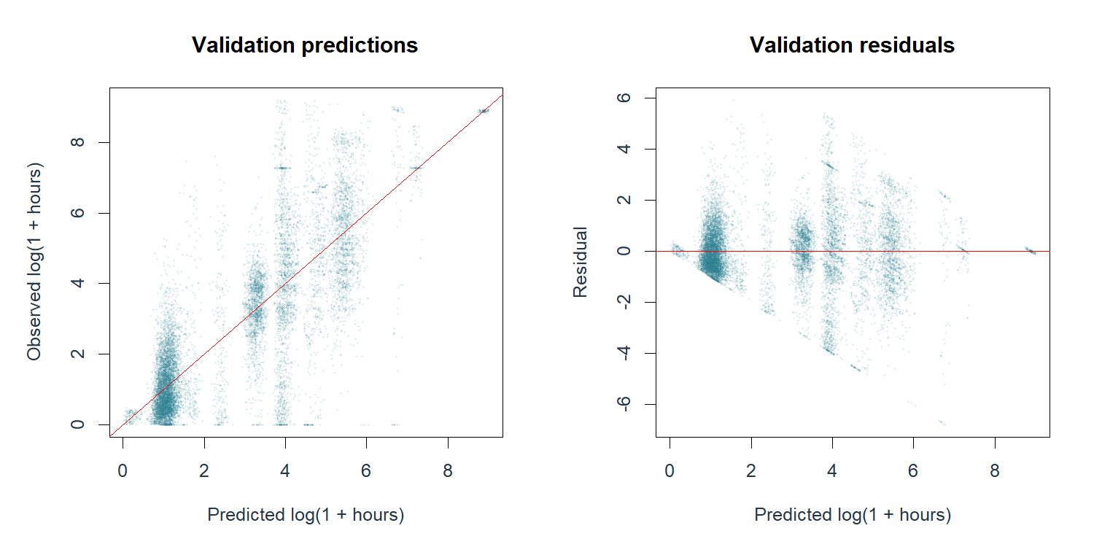

22. Linear Regression Interpretation
What did the linear regression model tell you?
The model explains substantial variation on the transformed scale using problem type and submission context. Validation predictive R-squared is 0.6582, and log-scale RMSE improves over the intercept-only baseline. Coefficients and residual plots are saved for review; the residual spread and hour-scale errors show substantial remaining uncertainty.
Was the model useful from a business perspective? Why or why not?
It may support broad planning about relative closure duration, but it is not reliable for individual completion-time promises. The smearing-adjusted hour-scale RMSE is worse than a simple mean baseline, even though hour-scale MAE improves from 392.31 to 316.65 hours. Large cases dominate squared error.

R code for question 22
print(read.csv("analysis/tables/linear_baseline_log.csv"))
cat("Training residual smearing factor:",smearing,"\n")

Executed R output
RMSE MAE R_squared
1 2.2388 1.88367 -5.65145e-06
Training residual smearing factor: 2.96069

Part 7: Logistic Regression Model

23. Defining a Slow Request
For the logistic regression model, the response variable should be binary:
- 1 = slow request, the target class
- 0 = not slow request, the nontarget class
How did your team define a “slow” service request?
A request is slow if its duration is strictly greater than the training-set 75th percentile for its original problem type (R quantile type 7). If a problem has fewer than 30 training records or was unseen in training, use the global training 75th percentile. Validation labels use these frozen training thresholds; ties are not slow.
Why is this definition reasonable for the business problem?
This compares requests with broadly similar work and uses only training data to set benchmarks. The threshold is a relative historical benchmark, not an official SLA. Ties and the global fallback mean the slow fraction is not exactly 25%: training is 25.21% and validation 26.17%. Small categories have a less comparable fallback.

R code for question 23
print(head(read.csv("analysis/tables/slow_thresholds.csv")))
cat("Global training q75 hours:",global_q75,"\n")
cat("Training slow rate:",mean(train$slow),"\n")
cat("Validation slow rate:",mean(validation$slow),"\n")

Executed R output
problem training_n threshold_hours fallback
1 AHV Inspection Unit 1 66.86236 TRUE
2 APPLIANCE 156 887.23875 FALSE
3 Abandoned Bike 24 66.86236 TRUE
4 Abandoned Vehicle 576 5.45194 FALSE
5 Air Quality 76 69.66667 FALSE
6 Animal in a Park 61 4.15667 FALSE
Global training q75 hours: 66.8624
Training slow rate: 0.252062
Validation slow rate: 0.261743

24. Logistic Regression Validation Performance
Build the logistic regression model using the training set. Then use the model to predict slow requests in the validation set.
What probability cutoff did your team use to classify requests as slow?
[ ] 0.50 [X] Other cutoff: 0.25
If you used a cutoff other than 0.50, explain why.
The 0.25 cutoff was set before fitting as a screening-oriented choice for an outcome near 25% prevalence. It is not an optimized business cutoff because error costs and queue capacity are unknown. The 0.50 comparison flags no records, so its 73.83% accuracy hides zero recall. At 0.25, 44.99% of validation requests are flagged.
Complete the confusion matrix for your validation set.
 | Predicted Not Slow | Predicted Slow
Actually Not Slow | 4,997 (TN) | 3,789 (FP)
Actually Slow | 1,550 (FN) | 1,565 (TP)

Record your classification performance measures.
Metric | Validation value at 0.25
Accuracy | 55.14%
Sensitivity / Recall | 50.24%
Specificity | 56.87%
Precision | 29.23%
F1 | 0.3696
ROC AUC | 0.5542
Flagged share | 44.99%

Accuracy measures the overall percentage of correctly classified requests. Sensitivity measures the percentage of actual slow requests that were correctly flagged. Specificity measures the percentage of actual not-slow requests that were correctly identified.
Which performance measure is most important for this business problem? Explain.
Sensitivity is important because missed slow requests lose an opportunity for early follow-up. It is 50.24%, so about half are still missed. Precision (29.23%) and flag volume are also essential: 3,789 false alerts create workload. Accuracy alone is misleading; AUC is only 0.5542, indicating weak ranking ability.

R code for question 24
logistic <- glm(reformulate(predictors,"slow"),
data=train, family=binomial())
prob <- predict(logistic, newdata=validation,
type="response")
print(classification_metrics,row.names=FALSE)
cat("Validation AUC:",auc,"\n")

Executed R output
cutoff TN FP FN TP accuracy sensitivity specificity precision
0.25 4997 3789 1550 1565 0.551382 0.502408 0.568746 0.292305
0.50 8786 0 3115 0 0.738257 0.000000 1.000000 NaN
F1 flag_rate
0.369583 0.449878
0.000000 0.000000
Validation AUC: 0.554211

25. Logistic Regression Interpretation
What types of requests were more likely to be classified as slow?
At cutoff 0.25, 99.43% of Bronx validation requests are flagged, compared with 20.94% in Brooklyn and 1.17% in Staten Island. Phone submissions are flagged 50.70% versus 39.03% online. These are model flag rates, not causal effects or proof of fair treatment. The borough imbalance is a major reason to avoid automatic triage.
Which error is more concerning for this business problem?
[ ] Predicting slow when not slow [X] Predicting not slow when actually slow
Explain your answer.
A false negative is more concerning for the screening objective because an actually slow request receives no early flag. There are 1,550 false negatives. However, the 3,789 false positives would divert staff time, so false-positive costs and capacity must also shape any future cutoff.

R code for question 25
print(read.csv("analysis/tables/validation_risk_borough.csv"),
row.names=FALSE)
print(read.csv(
"analysis/tables/validation_risk_open_data_channel_type.csv"),
row.names=FALSE)

Executed R output
category n actual_slow mean_probability flag_rate
BROOKLYN 3748 0.224653 0.228750 0.2094450
BRONX 2288 0.335664 0.313694 0.9943182
MANHATTAN 2480 0.247984 0.243244 0.3737903
QUEENS 2958 0.269777 0.249097 0.4604462
STATEN ISLAND 427 0.215457 0.196246 0.0117096
category n actual_slow mean_probability flag_rate
ONLINE 5081 0.256446 0.245057 0.390278
MOBILE 2534 0.267956 0.257378 0.482242
PHONE 3361 0.271050 0.257890 0.506992
UNKNOWN 925 0.240000 0.253899 0.481081

Part 8: Business Recommendation

26. Main Findings
Summarize your three most important findings.
Finding | Evidence
Duration varies widely | Median 6.68 h versus mean 251.36 h; problem/agency differences
Log fit does not ensure hour accuracy | Log RMSE 1.3089; hour RMSE 1,373.18 versus baseline 970.97
Slow classification is weak | AUC 0.5542; 50.24% recall, 29.23% precision; large borough imbalance

R code for question 26
cat("Median/mean hours:",median(y),mean(y),"\n")
print(linear_metrics[2,],row.names=FALSE)
print(classification_metrics[1,],row.names=FALSE)

Executed R output
Median/mean hours: 6.68167 251.356
set RMSE MAE R_squared
Validation 1.3089 0.927796 0.658189
cutoff TN FP FN TP accuracy sensitivity specificity precision
0.25 4997 3789 1550 1565 0.551382 0.502408 0.568746 0.292305
F1 flag_rate
0.369583 0.449878

27. Recommendation
What should city operations leaders do based on your analysis?
Do not deploy the current classifier for automatic prioritization. Use the descriptive results to investigate long recorded closure workflows and missing timestamps. If predictions are piloted, run them in shadow mode with staff review, compare against simple operational rules, and test a later-month sample including open requests. Set a review-capacity limit and explicit costs before selecting a cutoff.

R code for question 27
cat("Flags per 1000:",round(1000*mean(prob>=.25)),"\n")
cat("Correct flags per 1000:",
round(1000*sum(prob>=.25 & validation$slow==1)/
nrow(validation)),"\n")

Executed R output
Flags per 1000: 450
Correct flags per 1000: 132

28. Responsible Use
What should leaders be careful about if they use this model?
A slow prediction does not measure urgency, harm, or service eligibility. Keep safety and established service obligations ahead of the model. Monitor recall, false-positive rates, and workload by borough and problem type. Closure timestamps may reflect administrative practices. Do not infer that borough causes delays or that closed means the problem was fixed.

R code for question 28
print(read.csv("analysis/tables/optional_borough_monitor.csv")[,
c("borough","n","sensitivity","specificity","flag_rate")],
row.names=FALSE)

Executed R output
borough n sensitivity specificity flag_rate
BROOKLYN 3748 0.2232779 0.79456297 0.2094450
BRONX 2288 0.9934896 0.00526316 0.9943182
MANHATTAN 2480 0.3707317 0.62520107 0.3737903
QUEENS 2958 0.4824561 0.54768519 0.4604462
STATEN ISLAND 427 0.0108696 0.98805970 0.0117096

29. Limitations
Identify at least two limitations of your analysis.
Limitation | Why it matters
One supplied month and unknown sampling method | Cannot generalize to other months or all city requests; boundary counts uneven
All records marked Closed | Still-open requests may be absent; 332 lack closure timestamps
Random within-month holdout | Does not test future periods or correlated related requests
Administrative closure outcome | Does not demonstrate issue resolution or resident satisfaction
Relative threshold and sparse-type fallback | Not an SLA; some rare types use a less comparable global cutoff
Weak classification and geographic imbalance | Automatic prioritization could allocate attention poorly

R code for question 29
print(table(raw$status))
print(range(d$created))
cat("Excluded unlabeled durations:",sum(reason!="Retained"),"\n")

Executed R output

Closed
40000
[1] "2025-04-01 09:43:16 EDT" "2025-04-30 09:40:54 EDT"
Excluded unlabeled durations: 332

Part 9: AI and Tool Use Reflection

30. Tool Use
Did you use AI or other tools to support your work?
[ ] No [X] Yes
If yes, briefly describe how you used the tool and how you checked the output.
Yes. Codex AI helped inspect the assignment, draft base-R code, interpret outputs, and assemble the worksheet and presentation. The analysis was executed in R 4.6.1. Automated checks verified nonoverlapping splits, valid targets, complete predictions, full model rank, logistic convergence, and confusion-matrix totals. All numeric results come from saved R outputs; document assembly used Python. The student should rerun the script and review the interpretations before submission.

R code for question 30
cat(R.version.string,"\n")
cat(readLines("analysis/verification.txt"),sep="\n")

Executed R output
R version 4.6.1 (2026-06-24 ucrt)
All R invariants passed.
Input MD5: e83fa732cededd45cf760884b1a8f0a1
Linear model rank: 62
Logistic converged: TRUE

31. Learning Reflection

What is one data preparation or modeling decision you understand better after completing this project?
A key modeling lesson is that a transformation changes what prediction error means. log1p kept zero-hour observations and improved prediction on the transformed scale, but converting predictions back to hours did not beat the mean baseline on RMSE. This shows why I need to connect evaluation units to the business decision, rather than treating a good transformed R-squared as a promise of accurate completion times.

R code for question 31
print(hours_metrics,row.names=FALSE)
cat("Compare errors on the scale needed for the decision.\n")

Executed R output
model RMSE MAE R_squared
Smearing adjusted linear 1373.178 316.646 -1.00009e+00
Training mean baseline 970.967 392.307 -1.31544e-05
Compare errors on the scale needed for the decision.
Reminder: Your worksheet should explain your reasoning. Do not simply paste code output without interpreting what it means for the project.

Optional LinkedIn Article Analysis
Question: How does the probability cutoff change detection and staff workload, and does the same cutoff behave similarly across boroughs?
R code: run the Optional LinkedIn Article Analysis section of NYC311_Analysis.R. The following examples inspect its executed results.
read.csv("analysis/tables/optional_threshold_tradeoff.csv")
read.csv("analysis/tables/optional_borough_monitor.csv")
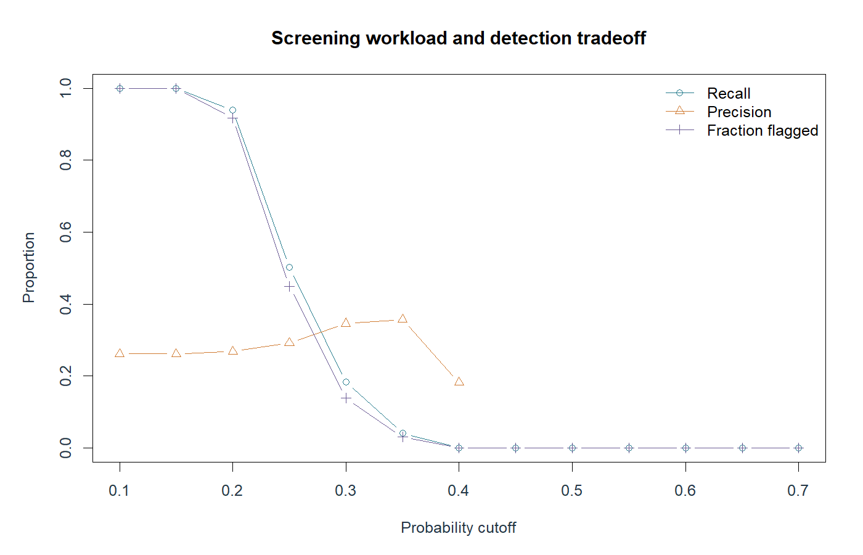
At 0.25, the model flags approximately 450 of every 1,000 requests, with about 132 correct flags. It misses about half of actual slow requests. At 0.50 it flags none. A lower cutoff can increase recall while creating more review work; no optimal cutoff can be claimed without costs and capacity. These validation comparisons are exploratory, not an independent test of a tuned policy.
The same cutoff flags 99.43% of Bronx validation requests but only 1.17% in Staten Island. Recall is 99.35% and 1.09%, respectively. Different request mix and group calibration may contribute; these results do not establish discrimination, causality, or operational fairness. They show why a model can require subgroup review even when its overall metrics are available.

Sources and data definitions
Supplied sources: Project Overview- NYC 311 Service Requests.pdf; Project 1 Student Worksheet.docx; NYC311_April2025_RawSample.csv. No separate data dictionary or lecture script was included. The field-use table in question 5 documents the operational interpretation used for this analysis.
NYC 311 Reporting FAQ: https://www.nyc.gov/site/311reporting/faq/faq.page (accessed September 26, 2026). Defines the duration as time between receipt and agency-recorded closure.
NYC311 Service Requests: https://portal.311.nyc.gov/article/?kanumber=KA-03116 (accessed September 26, 2026). A closed service request may still have an unresolved underlying issue.
NYC Open Data dataset and column definitions: https://data.cityofnewyork.us/Social-Services/311-Service-Requests-from-2020-to-Present/erm2-nwe9 (accessed September 26, 2026). The supplied sample is the analysis input; the live dataset was not substituted.

