**Auto HQ Git**

When you edit one of the files in a repo you will immediately see there is a file to be committed:

Click on the word ‘Commit’ and the Commit window will open. Here you can select the files that you want to ‘stage’:

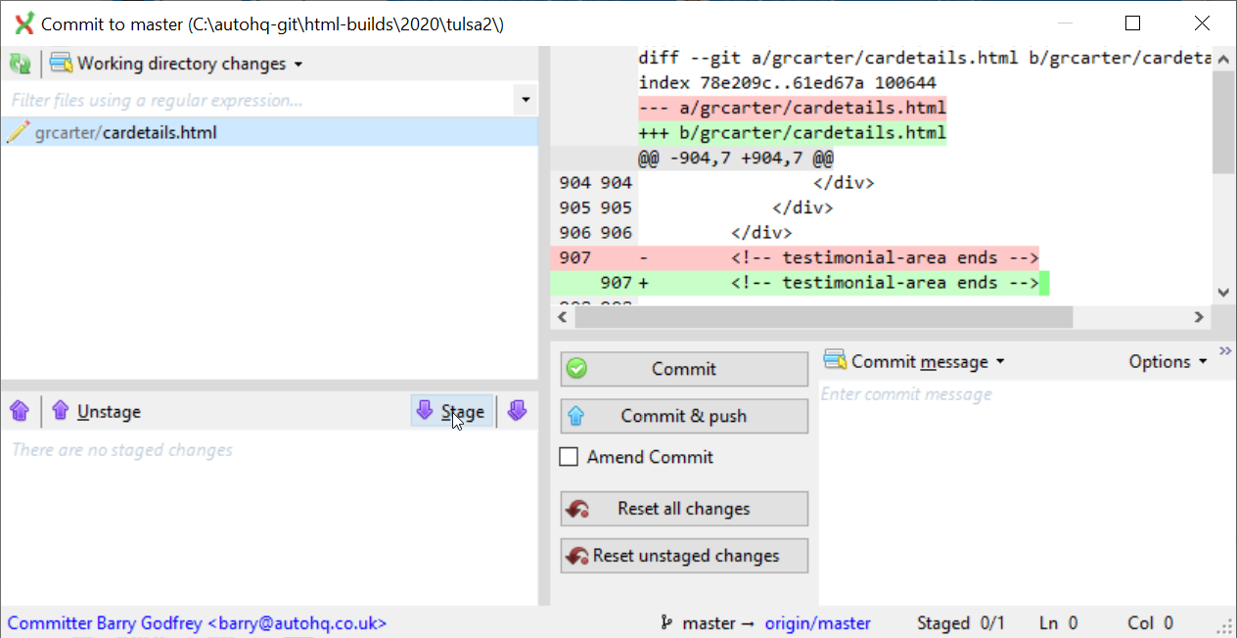

Add a title for the commit, and then click the Commit button:

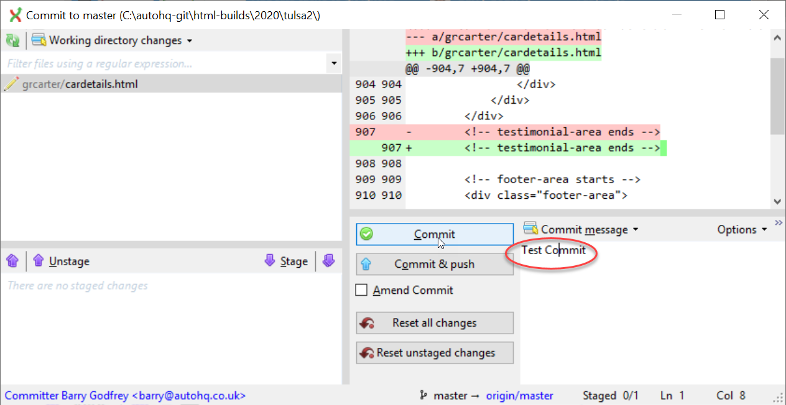

Your changes will be shown in the list of commits, but the green ‘origin’ tag will still be showing on the previous commit. This is because the changes have not been pushed to the repository on Bitbucket:

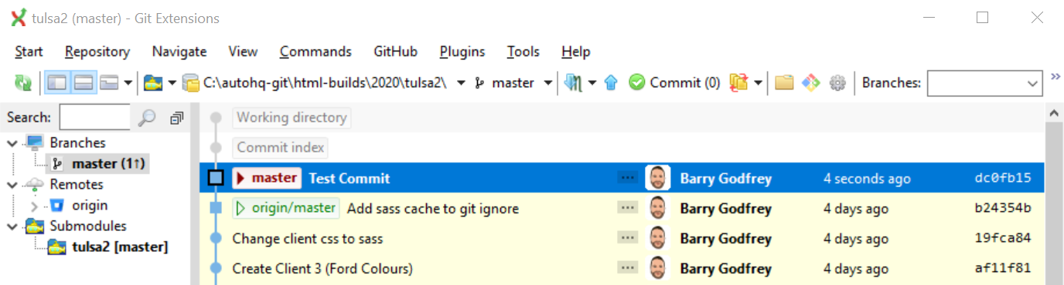

However, **before** you push your changes, you should always **pull** in case there are other changes from other users. If you don’t remember this important check there is a chance of getting a merge conflict.

**Summary:**

Its important to remember to carry out the following process when you need to save changes to the repository:

1 - Commit your changes

2 - Pull from the origin to make sure there are no pending changes from other users

3 - Push your changes to the origin