**Name: Iftekhar E Mahbub Zeeon**

**ID: 1805038**

**Course: CSE204**

**Offline on Sorting Algorithm(Quick Sort and Merge Sort)**

**Data Table:**

*Table:* ***Average time*** *for sorting* ***n integers*** *in different* ***input orders***

|  |  |  |  |  |  |  |  |
| --- | --- | --- | --- | --- | --- | --- | --- |
| **Input Order** | **N =** | **10** | **100** | **1000** | **10000** | **100000** | **1000000** |
| **Sorting Algorithm** |
| Ascending | Merge | 1.3748 | 1.522 | 3.3293 | 51.5911 | 1534.1331 | 115294.3992 |
| Quick | 0.0173 | 0.2358 | 6.585 | 23.6454 | 398.3575 | 5209.8398 |
| Descending | Merge | 1.3873 | 1.5386 | 3.8572 | 55.4266 | 1384.2887 | 114251.592 |
| Quick | 0.0198 | 0.405 | 6.1934 | 37.8165 | 154.1828 | 356.4776 |
| Random | Merge | 1.2995 | 1.48 | 3.2975 | 53.9234 | 1380.8468 | 122381.9985 |
| Quick | 0.0183 | 0.0754 | 0.4676 | 1.9392 | 16.217 | 128.8368 |

**Complexity Analysis Graphs:**

*Time vs N graph for* ***Both Algorithm***

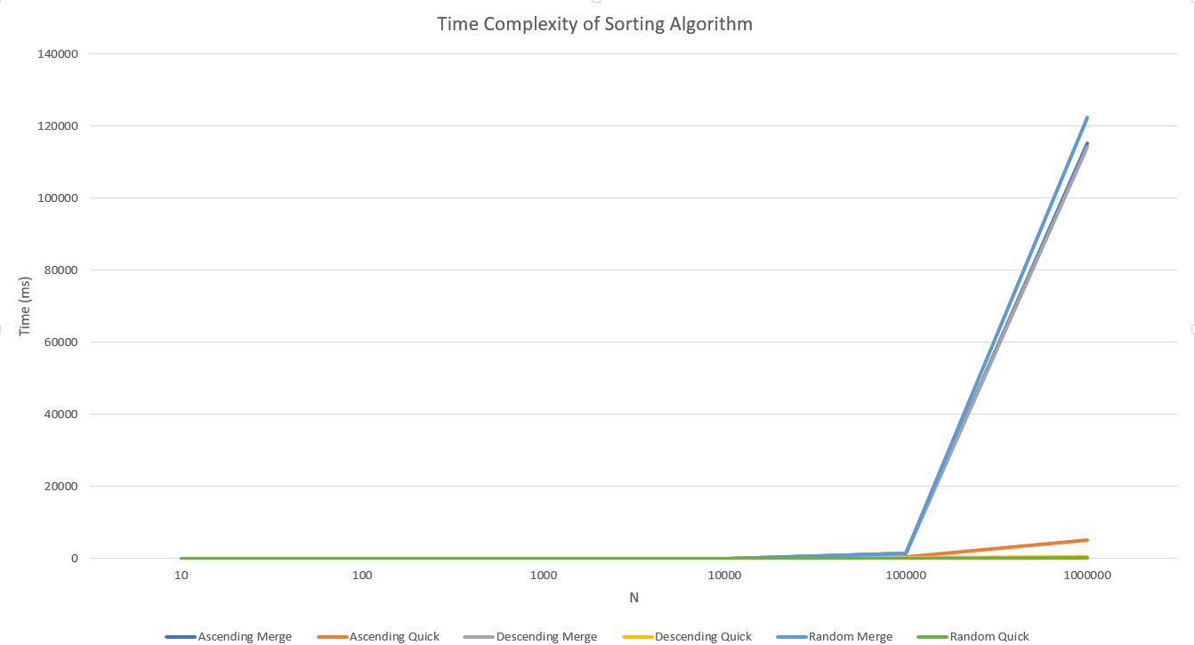

*Time vs N graph for* ***Ascending*** *input order*

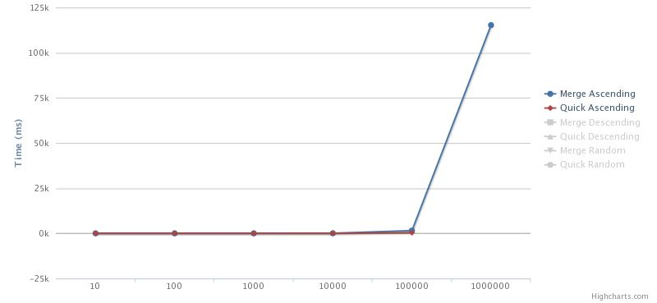

*Time vs N graph for* ***Descending*** *input order*

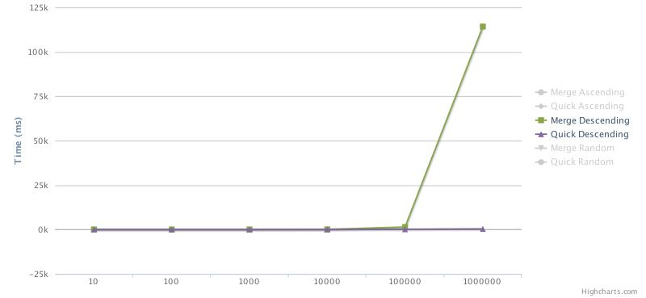

*Time vs N graph for* ***Random*** *input order*

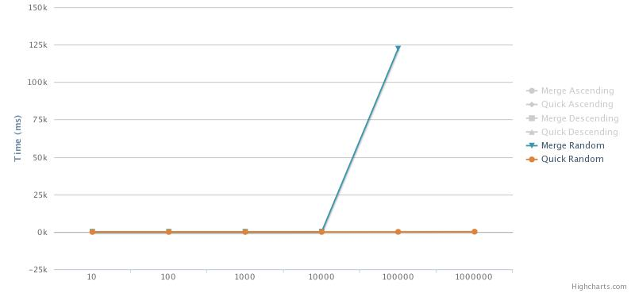

*Time vs N graph for* ***QuickSort in Different*** *input order*

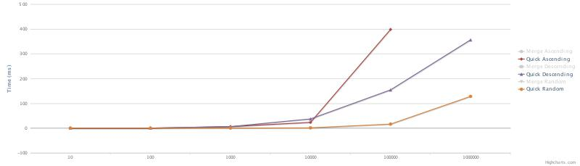

*Time vs N graph for* ***MergeSort in Different*** *input order*

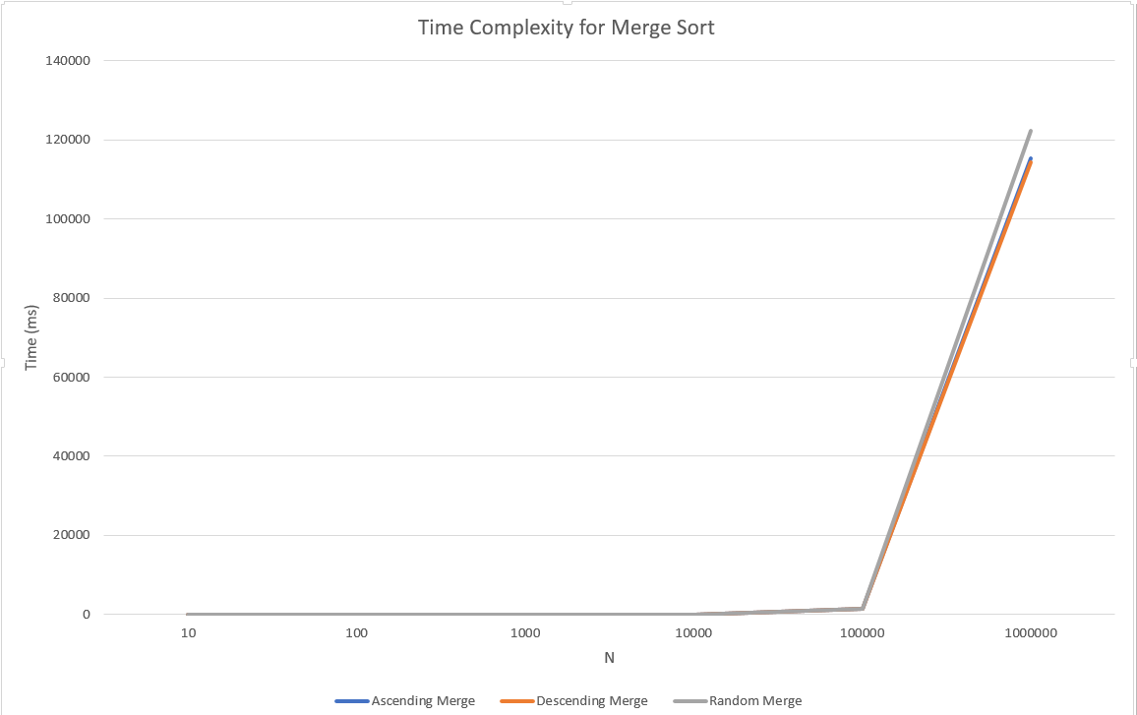

**Analysis Table:**

| **Basis for comparison** | **Quick Sort** | **Merge Sort** |
| --- | --- | --- |
| **Ascending** | In our algorithm the pivot element was the last element. As the algorithm was implemented on the ascending order, same order as input was the worst case for it. Normally quicksort takes less time than merge sort. However it is not stable and varies from machine to machine.  Here as the input data increases, the time difference between the random and ascending is noticeable. For random the complexity was O(nlogn), but in case of ascending, it became O(n2).  In case of 106 data as inputs, as the recursion goes so deep, stack overflow error occurs sometimes. | In the merge sort, the array is always parted into just 2 halves (i.e. n/2). So the complexity usually remains consistent for any size of data and any sort of order.  The complexity for merge sort is O(nlogn), and since it takes more space than quicksort, usually it is less sufficient than quicksort.  Since it remains consistent, the execution time doesn’t change much for ascending, descending or random. |
| **Descending** | Input as descending order is considered as worst case for quicksort when pivot element is fixed. However, in here for large amount data even though descending order takes more time than random order, but it doesn’t take as much time as ascending. However, in case of 106 data, it still causes stack over flow error sometimes. | As explained earlier, merge sort is more consistent regarding execution time. It doesn’t vary much whether the input array is in descending or ascending. As the input size increases, it follows it’s normal complexity form. |
| **Random** | Random order is considered as the average case for quicksort. In case of random order, pivot element randomly divides the array into different parts when in case of ascending or descending, usually array is not divided into small parts at the beginning, so execution time is very high. But for random case, the complexity is O(nlogn). Even for large data size, it is seen that it is more efficient than ascending and descending. | Random order doesn’t change the working procedure of merge sort. From the table it is seen that whether it is random or ascending or descending, the behavior is same. |

From the analysis, it is clear that quicksort is more unstable than merge sort and mainly depends on the configuration of the machine. Here the machine configuration that was used to implement these algorithms is given below.

**Machine Configuration:**

* Ram: **8 GB**
* Processor: **Intel(R) Core(TM) i7-8550U CPU @ 1.80GHz 1.99 GHz**
* System Type: **64-bit operating system**
* OS: **Windows 10**
* Storage: **512GB SSD**
* IDE Used: **IntelliJ**
* Approx. Heap Memory Used for IntelliJ: **1.5GB**