Setting up a test user on SQL Server

I needed to set up a test user for some specific demonstrations. I created the login and then the user assigning it to dbo and the role of public and db_datareader.

When I attempted to login I received the following error. Microsoft SQL Server, Error 18456.

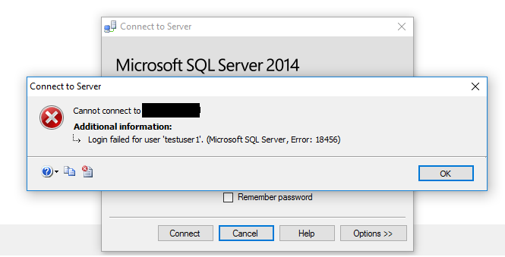

I checked the specific information and then the event viewer to see what the error was being caused by.

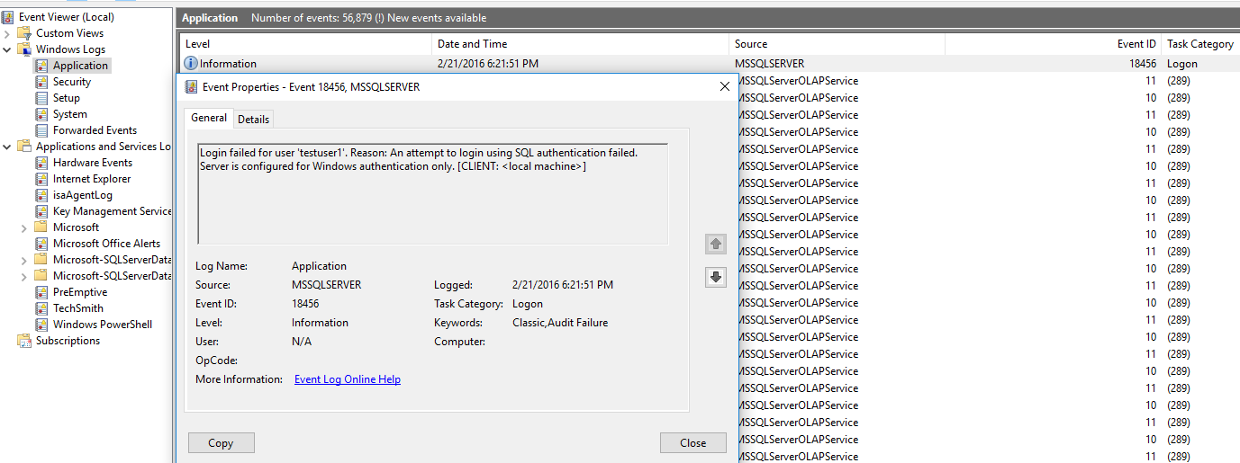

This error appeared under task category logon and was very straightforward stating that the SQL instance isn’t configured to allow for SQL and Windows Authentication.

The fix was just to change the properties for the instance to allow for both types of connections

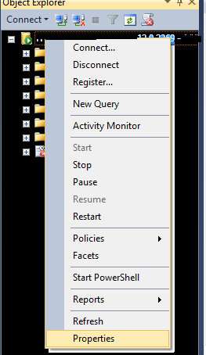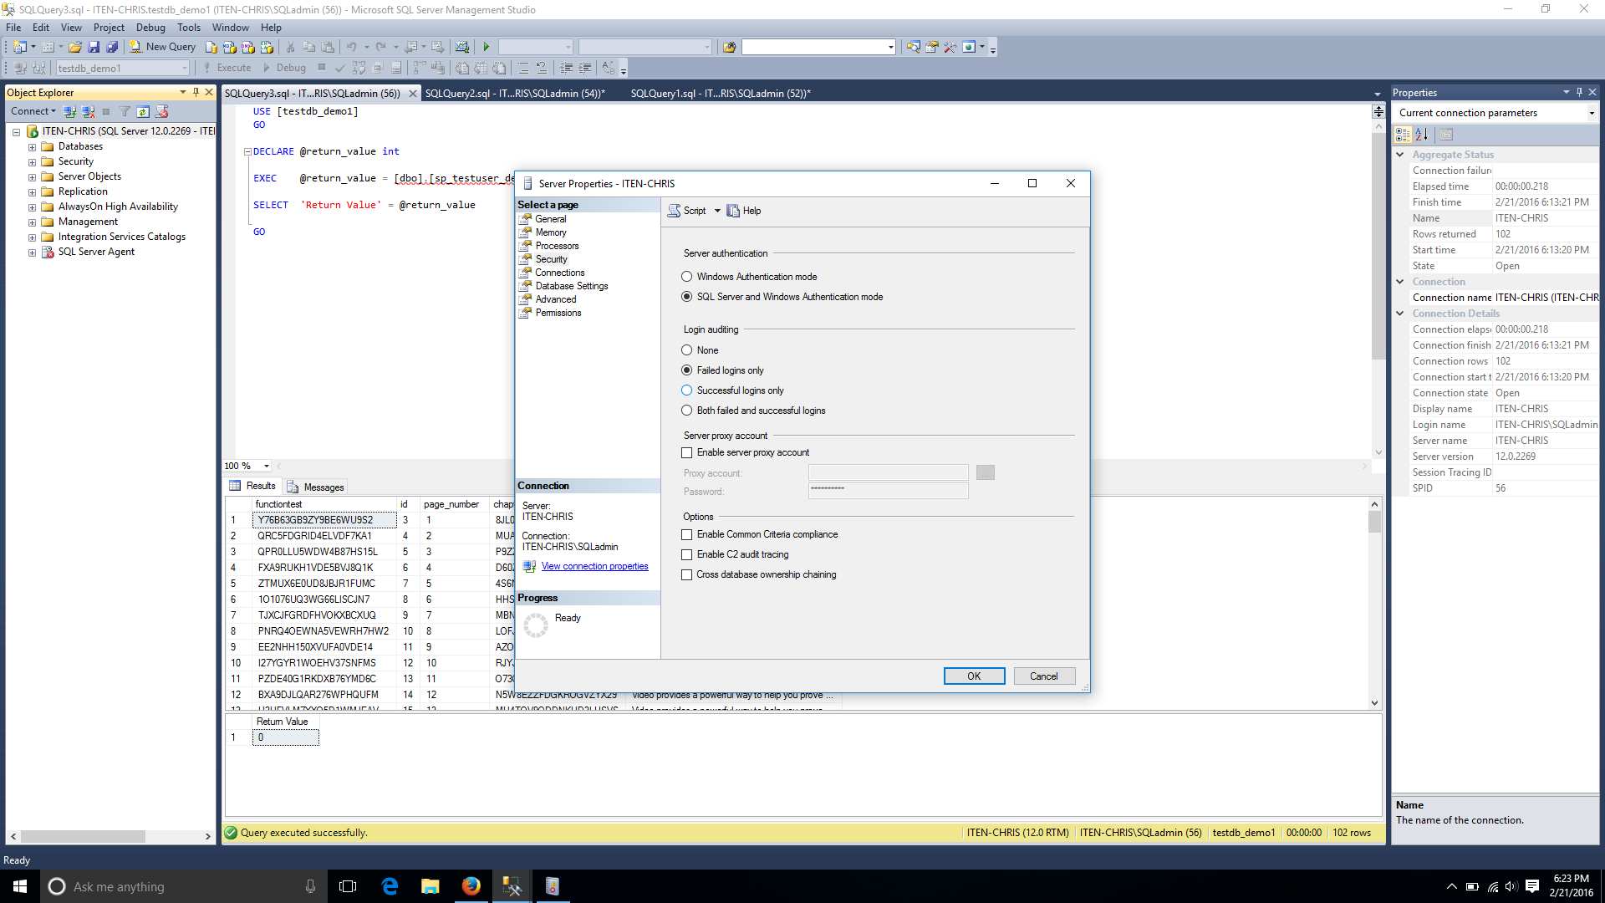

Just restart the SQLServer service and you’re good to go.

Microsoft. (n.d.). Change Server Authentication Mode. Retrieved February 21, 2016, from https://msdn.microsoft.com/en-us/library/ms188670.aspx?f=255&MSPPError=-2147217396