HORMUUD UNIVERSITY
NATIONAL TRAINING WEEK
Training Management System – Functional Summary
Theme 2026: Artificial Intelligence for National Transformation
Item | Description
Organizer | Hormuud University, Mogadishu
Event Type | Annual National Training Week
2026 Program | 6 days × 3 training sessions per day (18 sessions in total)
Audience | General public, professionals, university students and developers, and fresh high-school graduates
Delivery | Primarily virtual, with registration required
System Purpose | Manage the full training lifecycle from publication and registration through attendance, certification, recordings, and reporting

1. System overview
The National Training Week Management System will be the central platform used by Hormuud University to organize and operate the annual National Training Week. The system will bring public information, participant registration, training enrollment, trainer and moderator coordination, online meeting management, invitations, reminders, attendance, feedback, certificates, recorded sessions, and administrative reporting into one platform. Trainers/Speakers are managed as invited training profiles and do not require a system login by default.
The platform is designed to support the 2026 Artificial Intelligence program and future editions without rebuilding the system each year. Each annual edition will contain event days, and each day will contain individual training sessions. Participants will register for the sessions they want to attend, administrators will assign a Trainer/Speaker profile and a Moderator to each session, and the Moderator will manage meeting access and operational communication.
2. People who use the system
User | Main responsibility
Public Visitor | View the public website: Home, About, Program, Trainings, Training Details, Recordings, Certificate Verification, Contact, Sign In, and Sign Up.
Participant | Create an account, browse image-based trainings, register for sessions, receive invitations and reminders, attend sessions, submit feedback, and download eligible certificates through a vertical learning/event portal.
Trainer / Speaker | Managed Trainer/Speaker profile. No login is required by default; receives the meeting invitation from the Moderator and joins the online session directly.
Moderator | Authenticated operational user who coordinates assigned sessions, meeting details, Trainer/Speaker and participant invitations, reminders, QR/manual attendance, and attendance updates.
Administrator | Manage the complete event, users, trainings, assignments, registrations, communications, attendance, certificates, recordings, and reports.
3. Public pages
• Home – introduction to National Training Week, current theme, important dates, featured trainings with cover images, program highlights, and registration access.
• About – background, objectives, target participants, organizer information, and purpose of the annual program.
• Program – the six-day schedule, daily themes, dates, times, trainers, and individual sessions.
• Trainings – published sessions with cover images and filters such as day, category, date, audience, level, and trainer.
• Training Details – training cover image, full description, trainer, moderator, schedule, audience, learning outcomes, and registration action.
• Recorded Sessions – published recordings from completed sessions as a free public learning library.
• Certificate Verification – public verification using a certificate ID or QR code.
• Contact Us – public inquiries and official program contact information.
• Sign In – account access for authenticated Participant, Moderator, and Administrator users.
• Sign Up – participant account registration.
4. Participant
• Registration form and account creation.
• Login, logout, forgot password, and password reset.
• Participant portal/dashboard presented as a vertical, content-first learning experience showing upcoming trainings, registered trainings, recommended/open trainings, attendance, certificates, notifications, and profile access.
• Browse published trainings using image-based training cards and open the full training details.
• Register for one or more trainings.
• View registration status for each training.
• View meeting information after the registration is approved and the meeting is released.
• Receive invitation, reminder, schedule-change, and cancellation messages.
• View attendance records.
• Submit training feedback after attendance.
• Download eligible certificates.
• Update personal profile and password.

Participant profile information
Information | Use
Full Name | Participant identity and certificate name
Email | Login and official communication
Phone | Contact information
Gender | Optional demographic reporting if required
Region | National participation reporting
Organization / University / School | Institutional affiliation
Profession / Occupation | Audience analysis
Participant Type | General Public, Professional, University Student, Developer/IT, High-School Graduate, or Other
Profile Photo | Optional profile identification

Registration and attendance must be stored separately.
Area | Statuses
Registration | Pending, Approved, Rejected, Cancelled
Attendance | Not Marked, Present, Absent, Late

5. Trainer / Speaker
• Trainer/Speaker login is not required by default.
• Administrator creates and maintains the Trainer/Speaker profile, including name, email, phone, title, organization, biography, photo, and expertise where required.
• Administrator assigns the Trainer/Speaker profile to one or more training sessions.
• Moderator creates or confirms the meeting details for the assigned training and sends the meeting invitation to the Trainer/Speaker.
• Trainer/Speaker receives the invitation by email and joins the online meeting directly using the provided meeting link.
• After delivering the session, the Trainer/Speaker can leave the meeting without performing any required action inside the platform.
• Optional system access may be enabled later for a Trainer/Speaker who needs a dashboard, materials, schedule, or feedback access, but this is not required for the first production version.
• Trainer/Speaker profile information may be shown publicly on training details where Hormuud University approves publication.

6. Moderator
• Login and logout.
• Dashboard with assigned and upcoming trainings.
• View My Trainings and approved participant lists.
• Create, update, or remove meeting details for assigned sessions when authorized.
• Send meeting invitations to the assigned Trainer/Speaker, all approved participants, or selected participants.
• Send reminders, schedule changes, and cancellation messages to the relevant Trainer/Speaker and participants.
• Open QR attendance for a training.
• Record attendance manually when needed.
• Review and update attendance records.
• View training feedback.
• Update personal profile.
Meeting information
Field | Description
Platform | Zoom, Google Meet, Microsoft Teams, or Other
Meeting Link | Online joining link
Meeting ID | Optional meeting identifier
Passcode | Optional passcode
Start / End Time | Scheduled meeting period
Notes | Optional joining instructions

7. Administrator
• Dashboard with participant, training, trainer, moderator, attendance, registration, and certificate statistics.
• Create and manage annual Event / Edition records.
• Create and manage Event Days.
• Create, view, update, and delete Categories.
• Create, view, update, and manage Trainer/Speaker profiles; create, update, activate, or deactivate Moderator accounts.
• Create, view, update, publish, close, complete, or cancel Trainings.
• Assign a Trainer/Speaker profile and Moderator to a training.
• Manage participant accounts and training registrations.
• Approve, reject, or cancel participant registrations.
• Manage training meetings and communication history, including Trainer/Speaker and participant invitations.
• Create announcements and send reminders.
• Manage QR and manual attendance.
• Generate, issue, reissue, or revoke certificates.
• Manage recorded training sessions and publication status.
• Review participant feedback and training evaluations.
• Generate operational and post-event reports.
• Review Contact Us messages.
Annual event / edition information
Field | Example / purpose
Event Name | Hormuud University National Training Week 2026
Theme | Artificial Intelligence for National Transformation
Year | 2026
Start / End Date | Defines the event period
Registration Start / Deadline | Controls the registration period
Description | Edition-specific information
Status | Draft, Registration Open, Registration Closed, Ongoing, Completed

2026 event days
Day | Theme
Day 1 | AI Literacy Day
Day 2 | AI for Education Day
Day 3 | AI for Business and Entrepreneurship Day
Day 4 | AI for Community & Health Day
Day 5 | AI for Graduates Day
Day 6 | AI and Innovation Day

Training information
Field | Purpose
Title | Official session title
Description | Session description
Cover Image / Thumbnail | Optional 16:9 training cover image used on public training cards, featured sections, program views, training details, and related visual listings. Recommended size: 1200 × 675 px. If no image is uploaded, the system uses a branded default placeholder.
Event / Edition | Annual edition that owns the session
Event Day | The day containing the session
Category | Training classification
Trainer | Assigned trainer or speaker
Moderator | Assigned session moderator
Date / Time | Scheduled period
Audience | Intended participant group
Level | General, Beginner, Intermediate, or Advanced
Language | For example Somali or English
Capacity | Optional participant limit
Registration Required | Controls whether enrollment is required
Status | Draft, Published, Registration Open, Registration Closed, Ongoing, Completed, Cancelled

8. Attendance
Attendance will support both QR check-in and manual entry. The QR process must verify the participant account, confirm registration for the correct training, and prevent duplicate check-ins. The moderator or administrator can review the attendance list and correct an entry when authorized. Each attendance record should keep the participant, training, status, check-in time, attendance method, and the user who made or changed the record.
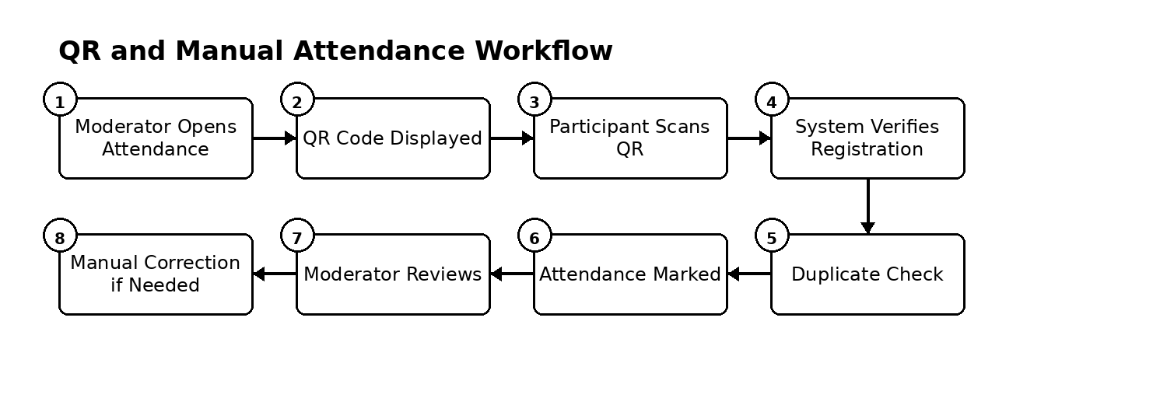
Figure 1. Attendance workflow
9. Certificates
Certificates should be issued only after the training is completed and the participant satisfies the approved eligibility rule. The recommended rule is: approved registration, attendance marked Present, and training status Completed. Each certificate should contain the participant name, training title, event name, date, certificate ID, and a verification QR code.
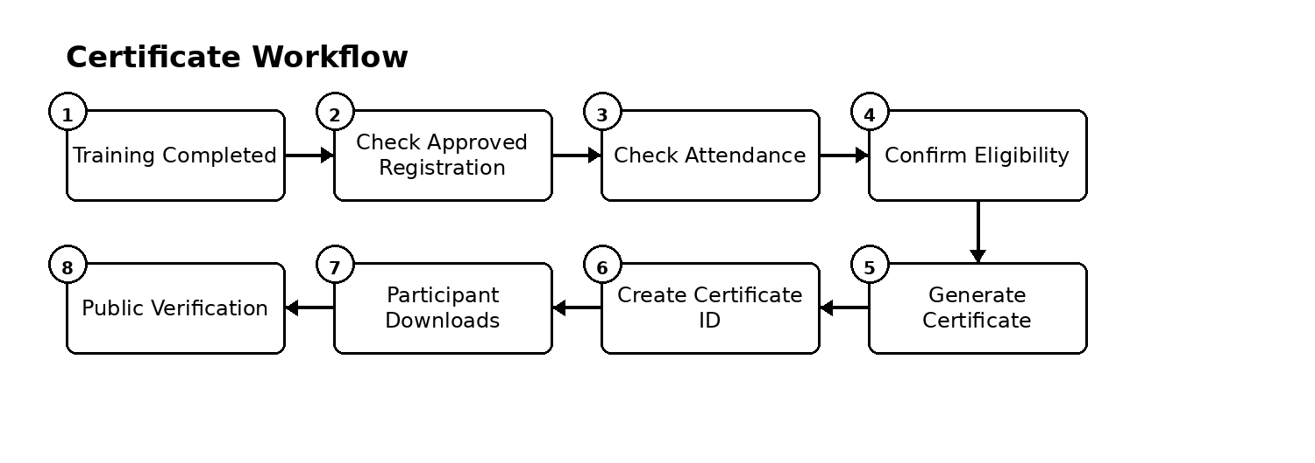
Figure 2. Certificate workflow

10. Recorded sessions and feedback
• A completed training can have a recording containing the video title, URL, description, thumbnail, related training, and publication status.
• Only published recordings appear on the public Recorded Sessions page.
• Participants who attended can submit a training evaluation.
• Feedback can include content rating, trainer rating, organization rating, comments, and suggestions.
• Feedback, attendance records, and other event statistics will support the post-event report.
11. Reports
• Participant registration report.
• Training enrollment report.
• Attendance report and attendance percentage.
• Certificates issued report.
• Feedback and evaluation report.
• Participants by region.
• Participants by participant type or profession.
• Daily attendance summary.
• Training/session performance summary.
• Overall National Training Week report.
12. Main system records
Record | Purpose
Users | Authenticated accounts for Administrator, Moderator, and Participant. Trainer/Speaker does not require an account by default.
Events | Annual National Training Week editions
Event Days | Themed days belonging to an event
Categories | Reusable training classifications
Trainings | Individual sessions
Assignments | Trainer/Speaker profile and Moderator assignments to trainings
Registrations | Participant enrollment in trainings
Meetings | Online meeting information
Communications | Invitations, reminders, announcements, and history
Attendance | Participant attendance per training
Feedback | Participant evaluation per training
Certificates | Issued and verified certificates
Recordings | Published session recordings
Contact Messages | Public inquiries

13. Important operating rules
• A participant may register for multiple trainings, but cannot register twice for the same training.
• Only published/open trainings can accept public registration.
• Trainer/Speaker and Moderator assignments are separate from participant registrations. Trainer/Speaker is normally a managed profile rather than an authenticated system user.
• Only authorized Admin or Moderator users can manage attendance.
• QR attendance must verify the correct training, participant identity, registration, and duplicate check-in.
• Certificates are issued only when the configured eligibility rule is satisfied.
• Recordings are normally published after the related training is completed.
• Each role can only view or modify information permitted for that role.
• Each annual edition remains separate so that future event data does not overwrite previous years.
14. Overall system workflow
The platform follows one continuous operational process from event preparation to post-event reporting. The operational sequence is: publish event and trainings, participant registration and approval, create meeting, invite Trainer/Speaker and approved participants, send reminders, deliver the session, record attendance, collect feedback, issue certificates, publish the recording, and complete reporting. This workflow should guide the database structure, user interface, and API design.
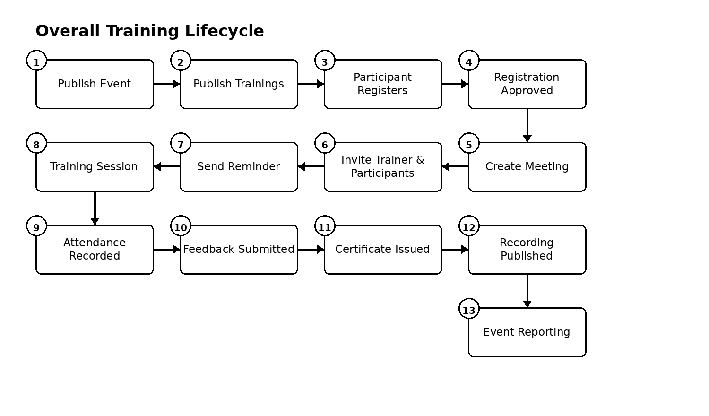
Figure 3. Overall training lifecycle

15. Development scope
The first production version should concentrate on the core National Training Week workflow: event and session publication, participant registration, approval, Trainer/Speaker invitation, meeting communication, attendance, feedback, certificates, recordings, and reporting. Trainer/Speaker login is not required in the first production version. The Participant interface should be a content-first learning/event portal, while Moderator and Administrator interfaces remain operational management dashboards.
This functional summary should be approved before database design, interface design, API development, and implementation begin. The proposed structure allows the same platform to support the 2026 event and future annual editions without redesigning the core system.

