# Title

Review of biophysical modelling in investigating connectivity patterns in marine species with a pelagic larval stage.

# Introduction

Biophysical modelling has been used to investigate marine larvae dispersal patterns for nearly 30 years (Bartsch 1988). Biophysical connectivity models typically focus on marine species with distinct sedentary adult and a pelagic larval life stage. Biophysical models produce potential patterns of connectivity using a physical (i.e. oceanographic) model coupled with a model of the known biology of the larval stage. Biophysical models are powerful research tools, allowing us to investigate these potential connectivity patterns over large spatial scales (Andrello et al. 2013, Treml et al. 2015) and over long temporal scales

(Berglund et al. 2012, Richar et al. 2014), scales that empirical studies cannot capture. These models also provide us the ability to investigate how different early-life history traits (e.g. mortality, swimming ability, and orientation) affect the patterns found in connectivity studies

(Staaterman et al. 2012). questions which would require largely intractable *in situ* experiments due to the inherent difficulties of studying the larval phase of marine species.

There is an evolution in complexity and realism within the world of biophysical transport modelling driven in part by greater computing power and improved oceanographic flow models (CITE?) but also by empirical research which is increasingly demonstrating the exception ability of larvae to affect their own fate via a variety of behaviours (CITES). This trend was clear in Miller’s (2009) review of ichthyoplankton biophysical transport modelling where…INSET FINDINGS FROM THAT STUDY ABOUT THE USE OF BIO PARAMS IN MODELS. This increased focus on the importance of the biology of these transport models had led to a variety of insights as to the importance of various behavioural parameters. For instance …HERE I WOULD GIVE BACKGROUND ON WHAT WE KNEW AT THAT TIME ABOUT THE IMPORTANCE OF SWIMMING (VERT AND HORZ), SENSORY ABILITY AND SETTLEMENT FROM INDIVIDUAL STUDIES.

This previous work has made it clear that the biological components of transport models can strongly affect connectivity patterns. And this emphasis has been recognized in the ICES pub… which recommends their inclusion and provides guidance for how to do this. And freely available tools for BPTM (biophy transport modelling…maybe sue this throughout?) like Connie and Clair Paris tool also include them. But despite this increasing attention paid to the inclusion of bio in BPTM there remains little consensus on the relative importance of different params. This is perhaps understandable given the potentially for these to be context dependent. For instance, the importance of horizontal swimming may depend upon the length of the larval period. Or the ability of horizontal swimming to affect connectivity may depend on the local geography of the modeled environment and the strength of vertical flow gradients.

BPTMs typically feature a high number of parameters and there is often little info with which to determine realistic values. As a result, researchers must often make decisions about which to include. The objective of this study was to review existing BPTM studies to evaluate progress in the field in the inclusion of bio params and provide insight into the relative importance of different params as well as any context dependence of these. Specifically we aim to…COULD REPEAT BELOW SLIGHTLY EDITED.

We know physical patterns are the driving force in moving ichthyoplankton around the world's oceans, however, it is now well understood that biological factors also influence where these larvae settle. This intended aim was to understand what biological parameters people were implementing in their biophysical models, i.e. was there a consensus of the most important, and how these biological parameters influence the connectivity patterns as measured through common metrics. If we can ascertain the importance of biological parameters in influencing these patterns, we can then ensure we target collecting the empirical data on these traits and behaviours. In addition, an inherent challenge in connectivity modelling is the difficulty in verifying the output as proportional to the spatial and temporal scales used in the model. Progression in the field requires that we have a degree of confidence in the accuracy and precision of the modelled patterns especially where it is difficult to empirically replicate the results. Therefore, understanding what input parameters are required to maximise model accuracy (with well understood trade-offs such as execution time) that allow us to infer compelling conclusions is another aim of this review.

The last major review in the area of ichthyoplankton biophysical modelling was undertaken a decade ago

(Miller 2007). We wanted to see if the biological processes found in this review were still relevant in recently published models, even though our focus was on connectivity models. For example, had emergent processes like growth become standard in models now or was there a new consensus of parameters to implement? In addition to this review, the International Council for the Exploration of the Sea (ICES) published a comprehensive and well defined manual on the recommended practices for modelling connectivity in 2009 (North et al. 2009). High-performance computing has also become more accessible to researchers in the last decade, with researchers becoming more programming literate and the decreasing start-up costs of high-performance computing. Therefore, it is hypothesised that models will become more common in the recent literature and that these models will have a higher inherent complexity, as the tools and knowledge to construct these models are more ubiquitous. Whilst our research interest lies in the connectivity patterns of ichthyoplankton, we reviewed studies of a variety of marine species with a pelagic larval stage, owing to negligible differences in input parameterisation.

The second major aim of the review was see how different behaviours affected the connectivity patterns using a meta-analysis. By understanding which parameters had greater effects on the output will allow us to concentrate on correctly parameterising these to produce better quality models. It also allows us to focus our efforts on collecting the empirical data on these behaviours if we can identify an overall trend.

[Talk about wanting to look at the influence of different modelling choices on metrics]

The scope of this review therefore was to understand the parameters used in these models and how these input parameters effect the dispersal patterns generated.

## Review aims:

1. To identify the suite of parameters, both physical and biological, that recently published biophysical models are using, along with the metrics used to measure the output of these models.
2. To compare the effects of implemented larval behaviours on the connectivity patterns generated by biophysical models, as measured using common metrics.

## What is not covered?

E.g. Discuss that the accuracy of individual models was not added for effect.

# Methods

## Literature search

Our review used the keywords connectivity, model* and marine, querying the online search engines ISI Web of Knowledge and SCOPUS. Seventy-six studies matching these criteria, published in 34 different journals, were found (the full list of references and the data extracted is provided as part of the Supplementary materials). Our review search was limited to publications from 2009 as this was when a manual had been published, recommending the way forward for biophysical connectivity models (North et al. 2009) and also close to the date the last review in this area had been conducted

(Miller 2007).

## Data classification

Most studies performed simulations using multiple variations of their main model, involving different input values for one or more parameters. This was done to test the effect of different parameters (representing different species/taxa or just variations in behaviours of the same species/taxa) on resulting connectivity patterns. In this review we separately identify each of these scenarios within a study and refer to each as a model.. Many studies consisted of only one or a few models though one had 99..

Each model run within a study was characterized according to a variety of traits which are broadly grouped under four themes. The first theme was general information about the study, such as study motivation, location, model species, and whether the system tropical or temperate. Study motivations were classified based on the broad aim of the study: climate change, marine park connectivity, dispersal & settlement, and theoretical. Climate change objectives identified temporal and spatial changes in larval connectivity patterns with increases in ocean temperatures. Marine park connectivity studies determined the extent of connectedness of either existing or potential marine parks for various species. Dispersal and settlement approaches were interested in the dispersal or settlement of a species using known input parameters. Theoretical approaches to connectivity studies investigated how different larval parameters effected the patterns of connectivity. The second theme focused on the inputs used to parametrise the physical model. Assessing the physical model included details such as the oceanographic model used, the particle tracking software, diffusion methods and the model time-step. The third theme considered the input parameters of the biological model, recording the traits such as the pelagic larval duration and spawning times and the behaviours implemented, e.g. mortality, vertical migration and growth. The fourth and final theme recorded what metrics were used to measure the output of the model, which consisted of both common and rare metrics. The metrics used varied considerably, with in-excess of 25 different metrics used to describe the patterns of connectivity. These metrics ranged from common metrics such as dispersal kernels and connectivity matrices to metrics unique to the study (Table 1). These metrics can be broadly categorised into two related classes. The first is purely dispersal, which using the dispersal kernel andprovided metrics of spread, distance and direction travelled. The second class described the settlement of larvae, using measures such as self-recruitment, local retention and settlement success (defined in Table 1).

To compare how the input parameters of these biophysical models, physical and biological, affected the output, the metrics found to be most prevalent were used. Metric data was averaged for each model execution, e.g. the self-recruitment values across all X sites were averaged to get a single parameter. Linear regressions (*and Kruskall-Wallace tests*) were used to test for sensitivity of parameters to output metrics.

## Statistics and data

Data was derived from figures where possible, using the free software package GraphClick (version 3.0.3; http://www.arizona-software.ch/graphclick/). Data analysis was conducted using the R programming language version 3.3.2 {RAlanguageanden:wf}, using the package *tidyverse* to manipulate the data (Wickham 2016) and the package *ggplot2* to produce the figures (Wickham 2009). Correlations were tested using the base R packages.

*Should there be more in this list?*

Table 1: The definitions used of terms used in biophysical connectivity papers that are referred to in this review

|  |  |
| --- | --- |
| Term | Definition |
| Self-recruitment | The percentage of recruits to a site (regardless of their site of origin), that were natal to that site {Burgess:2014cf} |
| Local retention | The percentage of the larvae natal to a site that recruited back to that site {Burgess:2014cf} |
| Settlement success | The percentage of recruits natal to a site that successfully recruited to anysite |
| Dispersal kernel | The probability density function of the dispersal distance for the larvae released in the system |
| Connectivity matrix | A matrix with columns specifying natal sites and rows specifying settlement sites, showing the probability that a larva is born in one site and settles at another {Burgess:2014cf} |

# Current trends in biophysical connectivity modelling

Of the study motivations classified, the overwhelming motivation for using a connectivity biophysical model was to answer questions about dispersal and settlement (68.0%; Figure 1). Dispersal models without settlement (13.3%) and studies motivated by investigating marine park connectivity (12.0%) occurred in almost equal frequencies. Theoretical (4.0%) and climate change (2.67%) were motivations used only occasionally amongst these review papers. Understandably, climate change models are not that common, as predicting connectivity patterns in 50-100 years, using current hydrodynamic modelling has inherent predictive complications. Interestingly, there were few studies using a purely theoretical approach to understanding the biology that influences connectivity, although many studies indirectly accomplished this within some other more applied context, e.g. using multiple species in a study that have varied behaviours or traits.

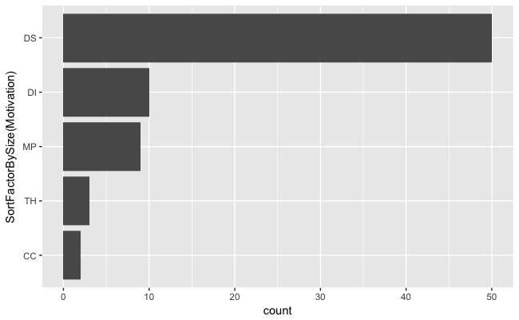

Figure 1: The number of studies within each of e five major categories of motivation identified in the review (DS = dispersal and settlement; DI = dispersal; MP = marine park connectivity; TH = theoretical; CC = climate change) used for the studies reviewed

The studies in this review used hydrodynamic models covering 20 oceanographic regions across the world, two studies even investigated connectivity patterns at a global scale (Figure 2). Similar to patterns observed in Miller's (2007) review, the modelling effort was concentrated in highly industrialised fishing regions, such as the North-East Atlantic and the Mediterranean Sea. Most studies were in temperate waters (64.9%), however unlike Miller's (2007) review, there was a noticeable increase in the number of tropical studies, up from 4% of studies to 32.4% of studies.

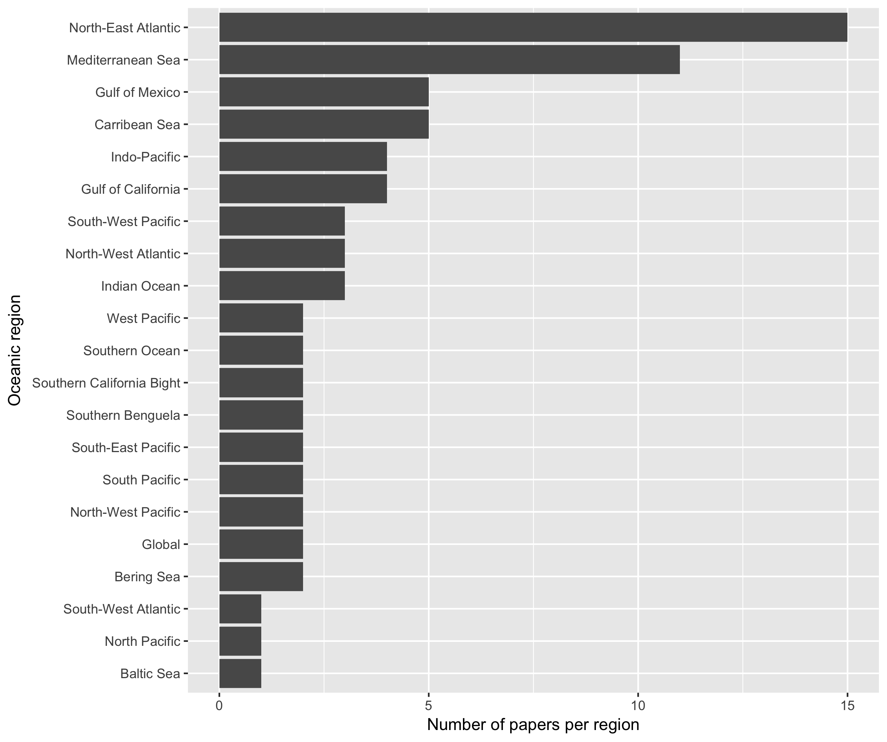

Figure 2: The oceanographic regions modelled in the studies used in the review.

Almost all studies used an established biophysical connectivity model (82.6%), only 16% of studies constructed a new biophysical model for their connectivity study. The three most popular biophysical models used amongst the reviewed studies were Ichthyop ((Lett et al. 2008);18.67%), Connectivity Modelling System ((Paris et al. 2013);12.0%) & MGET ((Roberts et al. 2010);8.0%). Overall, it was determined that 21 different biophysical models (ignoring version numbers) were used amongst the studies, although we were unable to identify the exact particle tracking model used for nearly one quarter of the papers (22.7%). The studies used forecasting models to run their connectivity studies, with one exception - a hindcast solution whereby the larvae are initially tracked from settlement sites to determine their natal sites (Wren & Kobayashi 2016).

## How connectivity studies are parametrising the physical models

The choice of oceanographic model depended upon the study region The two most common ocean circulation models used were the Regional Ocean Modelling System (ROMS; 25.3%) and the Hybrid Coordinate Ocean Model (HYCOM; 17.3%). Nested circulation models were used in the more complex particle trackers to bypass issues of low resolution in modelling. The largest resolution used in these connectivity models was 5.6km^2, with extremes ranging from a precise 50m^2 (Brennan et al. 2014) to broader 33km^2 (Crochelet et al. 2013). As seen in Miller's 2007 review, there was no trend over time towards high resolution models.

The time particles updated in the system (environmental forcing) were either fixed time-steps or varied per other factors. The median time-step was one hour, and ranged between 60 seconds (Moritz et al. 2013) and 24 hours

(Mora et al. 2012). The time-step used was not reported in 37.3% of the papers. The choice of time-step is determined by both the physical model and computational choices, and no rational was given for the decision in those studies. There was no relationship betweentime-step choice and the metrics of dispersal or settlement, therefore it is integral to be accurate when resolving oceanographic forcing. The models used different time-scales of oceanographic data depending on the trends of interest (inter- or intra-annual). Studies trended towards running the biophysical model using only the time-scale of a few years (median = 3 years) (Figure 3) with the majority using only a single year in their connectivity study. Only one study used the average of several years input data to interpret mean connectivity patterns (Feutry et al. 2013). Other outliers included studies investigating climate change scenarios, which used periods of 60 years (Aiken et al. 2011) and 130 years (Andrello et al. 2014). In these studies, the earliest year modelled was 1950, and the latest year modelled was 2100 (using ocean current data based on past averages). The average of the dates modelled was a start date of 2001 with an end date of 2008. Although not all models used continuous years as input choosing rather to use only used specific years. As high powered computing becomes more available and with the known variability between consecutive years in hydrodynamic modelling, the trend for biophysical models should hopefully be towards using longer periods of ocean data as input though there is little evidence for this trend over the past X years based on Miller and this review. It's important to move in this direction as the use of more years also allows for inter-annual comparisons in connectivity patterns.

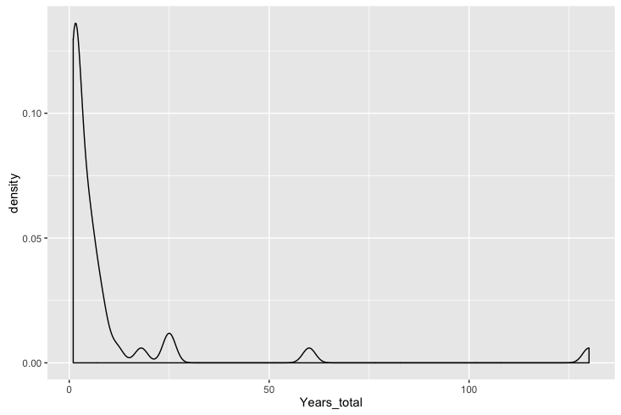

Figure 3: Density plot of the total years modelled in each of the model runs

## How connectivity studies are parametrising the biological models

In the papers we reviewed, biophysical connectivity modelling has been a regular research tool for understanding connectivity patterns. Ten specific and one generic marine taxonomic groupswere identified in the studies we reviewed (Figure 4). The generic taxonomic group was used by studies that defined a suite of biological parameters that could potentially apply to multiple species, e.g. many species of reef fish most likely have a pelagic larval duration of 20 days. Generic species were used in 40.2% of the total executed model runs evaluated though one study included 99 model runs (x % of the total evaluated in the review) using a suite of generic parameters (Treml et al. 2015). The 10 known taxonomic groups were comprised from 47 species and another seven where the modelled biological group was specified at the family level, e.g. Labridae or Sparidae. The two most common taxa modelled were fish (39%) and bivalves (10%).

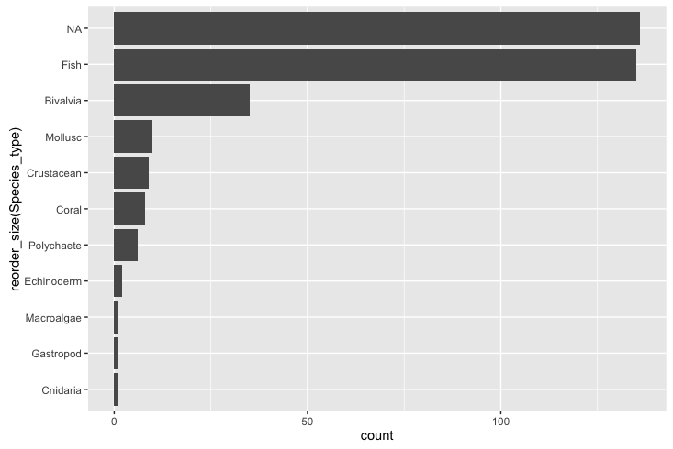

Figure 4: The different taxanomic groups that were used to parameterise the biological models in the reviewed connectivity papers

The biological parameters implemented were generally not consistent across studies. The only biological parameters that were consistent and implemented across nearly each study in this review were the trait of pelagic larval duration (100%) and the spawning behaviour (98.3%; as mentioned previously there was a single hindcast study). It is not abundantly clear why there is no consistency in the traits and behaviours captured by the biological models. The possible reasons could be that researchers do not agree that biology has much influence on connectivity patterns, that certain traits and behaviours are species specific, or that there is not enough empirical evidence to parametrise the model with confidence.

Table 2: The behaviours that have been implemented in the modelled connectivity studies. Note that multiple behaviours can be implemented in the one model

|  |  |
| --- | --- |
| Functionality | Implemented(%) |
| Pelagic larval duration | 100.0 |
| Settlement competency window | 48.3 |
| Spawning strategies | 98.3 |
| Mortality | 41.0 |
| Growth | 6.7 |
| Sensory ability | 58.3 |
| Orientation | 2.6 |
| Swimming behaviours | 25.7 |

*Planktonic larval duration*

Information on the length of time an organism will spend in the pelagic environment prior to settlement at a site is fundamental to any attempt at transport modelling. As such, this period, often termed the pelagic larval duration (PLD) is a core parameter found in every study we reviewed (Table 2). The studies we reviewed exhibited two different approaches when implementing the pelagic larval duration. The standard approach (92.4% of models) was to make the PLD value fixed for each larva. If the individual larva reaches this time, it either must settle (if possible) or it is considered dead. The other approach was to implement some variability in the PLD (5.6% of models), either using a Gaussian distribution (based on knowledge of the population) or instead of using time, make the PLD dependent on ocean temperature. The fixed PLD values ranged from 2-420 days, with a median value of 30 days (Figure 5). The PLDs were, in general, taken from known ranges found in the literature, with the highest values modelled for invertebrate species e.g. the long duration (~400 days) of the phyllosoma stage of some lobster larvae (Butler et al. 2011, Kough et al. 2013).

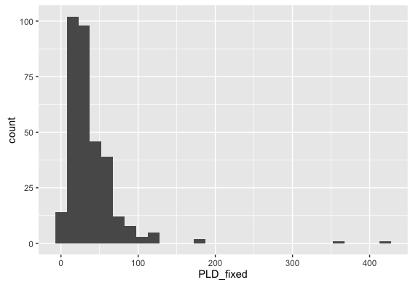

Figure 5: The range of fixed PLD values implemented in the reviewed models (n=318)

PLDs were often used in conjunction with a settlement competency window (48.7%). The settlement competency window gives the marine larvae a period in which they can settle before they reach the end of their pelagic larval duration. It is generally based on their known biology, incorporating the idea that most species with a pelagic larval phase must develop sufficiently before the pelagic stage can finish. The range of start dates for this window were 0-152 days, with a median start date of 9 days when the larvae were considered developed enough to settle.

*Spawning*

A second fundamental element, included by necessity, in every study in our review was some sort of spawning strategy which determined how the larvae were released in the model. The spawning strategy was typically dependent on the biology of the modelled taxa and included pelagic eggs, demersal eggs, or brooding. In order to implement these different strategies, studies changed depth for the release of the larvae, e.g. demersal eggs were released on the bottom of the natal reef and pelagic eggs were released higher up the water column. The two strategies for releasing the particles at depth were either to use a fixed depth (37.5%), or to randomly release the larvae over a range of depth values (60.8%), i.e release larvae in in the 0-20 m range of the water column. The timing of when larvae were released varied from hourly intervals (Jacobi et al. 2012), daily (Kough et al. 2013), monthly

(Staaterman et al. 2012), on lunar cycles (Davies et al. 2014) or just a one-off spawning event (Herbert et al. 2011). The spawning windows relied on the known biology and what times of year the species is known to produce larvae. In general, spawning events were pre-determined, but several studies used temperature as a spawning initiation (Rochette et al. 2012, Andrello et al. 2014) or even wave height was used to release abalone larvae in one model (Miyake et al. 2011). In general, the release and settlement sites were the same. However, several studies (X percent) used a limited set of focal release sites with many more available settlement sites. The larvae spawned at each site ranged from only 10 larvae to 10,000,000, with a median of 6800. The overall larvae tracked in the system (spawning site x number of sites x number of releases) had a similarly large range, from 328 to 610,000,000 larvae, with a median total of 3.2 million. To get around tracking these large numbers of larvae in the system, five studies (15.6%) used the concept of a super-individual, whereby a single larvae in the system represents a larger number of larvae with a normalised collection of attributes. There are large computational benefits to this approach, especially in models that use a continuous space. The caveat is that you have to consider how much individual variation you are willing to lose by modelling these super-individuals.

*WILLS COMMENT: Would it be possible to give the average number of larvae released from a site that were used to make one connectivity matrix? This would differentiate situations where, for instance they released 100,000 larvae from each site, ran them out and made a matrix and they did this every week…so one matrix per week. As compared to another study which may have released 100000 ever week for a month and then used all this info to make one matrix. The idea would be to give some sort of guidance on the amount of larvae people seem to think is enough to generate a single estimate of connectivity.* *STEVES COMMENT: I would have to go back and check this out, mostly they provided one connectivity matrix or perhaps one per month or year. Will take me half a day to comb through all the papers again, but I can do it. I'll wait to see if there are other things I need to look for as well*

*Mortality and growth*

Larval mortality was implemented in only 41% of the models (Table 2). However, the implementation of mortality varied across the models, the most common mortality function used was a linear function (82.2%), whereby a fixed percentage of the larvae were killed each day. The daily mortality rate in these studies varied from 1.7% to 30.0% with an average of 19.4%. Other mortality implementations were to kill the larvae based on a known temperature or salinity threshold (7.9%), using a decay function that decreased mortality based on age (7.9%) or using a Weibull function (2.1%). Unlike in Miller's 2007 review, where growth was implemented in one-third of the studies, only 6% of the models reviewed had the ability for larvae to grow built in (Table 2). The rationale is that the models used in this review are solely investigating connectivity, where growth is not considered such an important factor affecting the strength of connectivity amongst sites, unless it is co-implemented with a sinking velocity dependent on mass.

*Behaviour*

The degree to which larvae can behave, specifically sense, orient and swim directionally (vertically or horizontally) is a fundamental concern in broader field of larval biology which has potentially important ramifications for connectivity. As discussed previously, this has been recognized in the world of BPTM with general support for the inclusion of such behaviors in models. Miller (2007) observed… In this review we classified models according to which of the four the major larval behaviours they implemented; no movement (passive movement), movement (e.g. horizontal or vertical swimming), orientation (ability to orientate towards a reef using cues) and settlement (settle at a site using a sensory buffer or sticky zones).

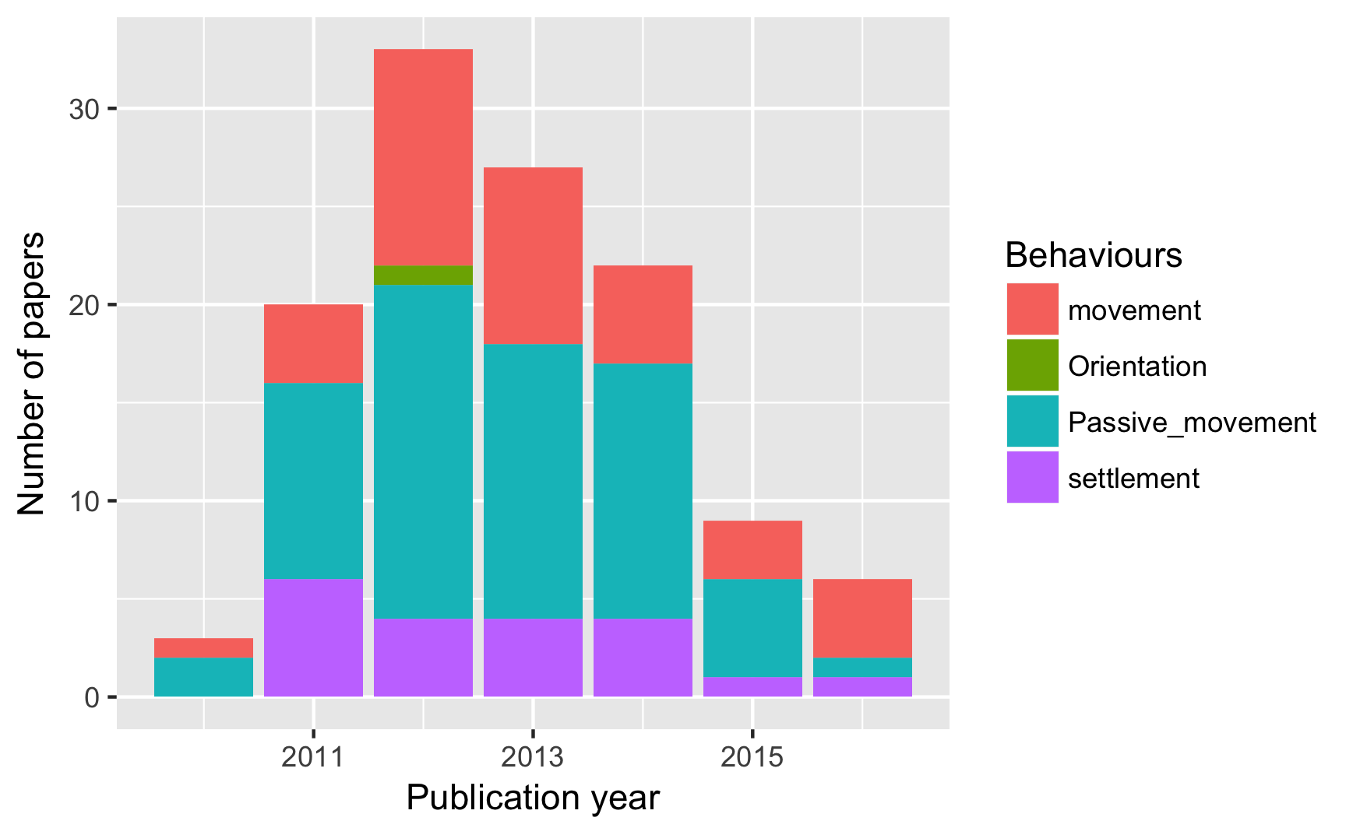

Figure 6: The years studies in the review were published

Larvae were given the ability to move in 26% of the models, conversely in 74% of the models the larvae were assumed to be passive and moved by the physical model (Figure 6). Of the behaviours classified as movement, diel vertical migration was the most commonly implemented behaviour (45.4%; Table 3). Ontogenetic vertical migration, the idea that marine species change their vertical position in the water column as a factor of their ontogeny, was used in 27.2% of the models. Horizontal swimming was implemented in 12.5% of the models, although it must be mentioned that random movement to mimic turbulence does capture an extent of undirected horizontal swimming. A smaller number implemented vertical swimming in the larvae (4.5%). Other movements included in models were prompted by environmental conditions such as tides (circatidal migration 5.7%,), salinity (halocline migration; 1.1%) or following the pynocline (6.8%). Another movement implementation, as mentioned above, was using sinking velocity (3.4%) in conjunction with growth, e.g. the heavier the larvae the faster it sinks. The last strategy involved giving the pelagic eggs a buoyancy (4.5%) based on the salinity level in the water column, thus they can float at different vertical migrations.

Table 3: The percentage of ichthyoplankton models in this review which implemented different swimming behaviours. Note the percentages sum to greater than 1 because multiple swimming behaviours can be implemented in a single model.

|  |  |
| --- | --- |
| Swimming behaviour | Implemented(%) |
| Horizontal swimming | 12.5 |
| Vertical swimming | 4.5 |
| Ontogenetic vertical swimming | 27.2 |
| Diel vertical migration | 45.4 |
| Halocline migration | 1.1 |
| Circatidal migration | 5.7 |
| Pynocline migration | 6.8 |
| Sinking velocity | 3.4 |
| Egg buoyancy | 4.5 |

The ability of the marine larvae to sense settlement habitat was implemented in 50.9% of the models. Of these, 95.4% opted for a buffer implementation, where each settlement habitat has a buffer zone added around it. The average size of the buffer zone around the potential settlement sites was 8.18 km (SD = 5.2 km). The other implementation, which essentially works on similar principles, was to give the larvae a detection distance, which was relative to the centre of the settlement site

(Staaterman et al. 2012). This settlement cue was used to allow the larvae to orientate towards the reef if the larvae was within the cue distance ranging between 1-10km (median distance was X km), with a combination of early and late onset orientating abilities. Giving the larvae the ability to orientate early improved their chances of settling, and also increased self-recruitment.

For the studies modelling fish, the implemention of only passive movement decreased over the reviewed period. In 2015, for the first time, there were more studies using movement behaviours than other forms of behaviour (Figure 7). The yearly totals of fish based biophysical models are similar to the totals found in the previous review

(Miller 2007). Implementation of settlement sensory strategies seem to have remained constant over the published time period. Interestingly, the ability of fish to orientate towards settlement sites was only found to be implemented in one study in 2012. This is despite the increasing body of research in the last decade regarding the ability of reef fish larvae to orientate towards natal reefs using olfactory mechanisms (Gerlach et al. 2007), celestial cues (Leis et al. 2014, Faillettaz et al. 2015) and a magnetic compass (Bottesch et al. 2016). For invertebrates, there appears to be no real real change over time in the pattern of implemented behaviours (Figure 8).

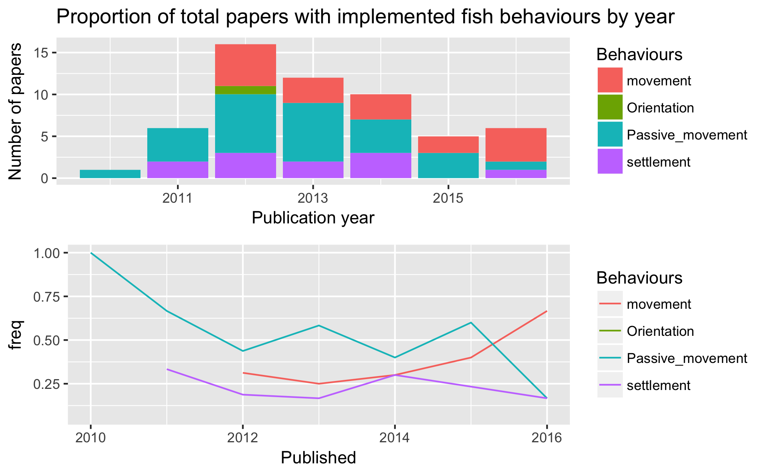

Figure 7: The proportion of behaviours in the published fish studies by year

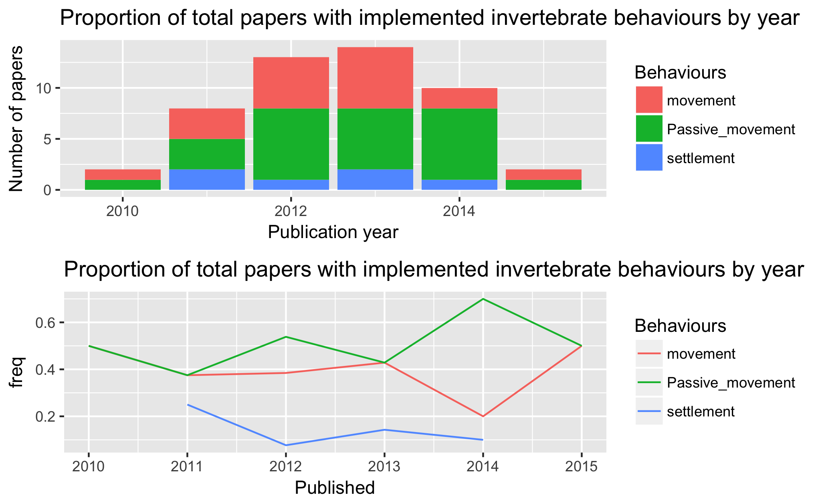

Figure 8: The proportion of behaviours in the published invertebrate studies by year

This finding is extremely interesting from a biological viewpoint, as the empirical knowledge of fish behaviour influencing the outcome of connectivity

(Leis 2006, Cowen & Sponaugle 2009), many biophysical modelling showing how connectivity changes with behaviour, and papers suggesting the way forward is to include behaviour (North et al. 2009, Staaterman & Paris 2014), there are still many studies including models with no implemented behaviour at all - passive larvae were used in 75% of model configurations. There is also a well established body of empirical literature which highlights the often extensive swimming abilities of ichthyoplankton

(Leis 2006, 2010). Even where horizontal swimming may not be important, many larvae have diel vertical migration patterns to below the mixed layer to escape predators during the day. Indeed, several studies in the review showed that vertical migration (either diel or ontogenetic) increased self-recruitment and limit the overall dispersal kernel (Aiken et al. 2011, Young et al. 2012). One reason for not implementing movement could be that the complete (or even partial) early life history is often unknown for many species, and researchers might be trying to avoid any behavioural assumptions. Fish larval behaviour is known to be species specific, yet many models are limited to using known data from the Family taxonomic level due to the lack of species specific knowledge. Such an approach for large taxonomic families like Labridae, potentially masks a large variation of behavioural traits. The lack of species specific knowledge poses the question, can we only model species where we fully understand the early life history, or is there some level of assumptions that are deemed to still be scientifically valid?

## The metrics used to describe connectivity

There was a lot of variation in the metrics used to describe the results of connectivity studies. There were more than 25 different measures used to describe the patterns of dispersal and settlement. The common approaches were to use combinations of dispersal kernels (64.0%) and connectivity matrices (57.2%) (defined in Table X). Less common measures of model output were larval centre of mass (average geographical position of the larvae; 2.6%) (Miyake et al. 2011, Lacroix et al. 2013), isotropy (describes the inertia around the centre of mass; 1.3%) (Ayata et al. 2010), positive area (number of areas that had larvae in them, 1.3%) (Puckett et al. 2014), and proportion of sites settled (1.3%) (Robins et al. 2013).

The trend in biophysical modelling is to present data using visual techniques such as heat maps, which while being effective tools for visually communicating complex patterns qualitatively, make it difficult to pull out quantified data points. The most common connectivity values reported in the the reviewed studies were self-recruitment, local retention and overall settlement success of larvae (all defined in Table X). However, while these response metrics were explicitly described, we were only able to extract actual values from X, Y, Z% of the studies in which they were described for SR, LR and SS respectively.

Based on the extracted datathere was a large spread of the mean self-recruitment amongst the models, ranging from 0-98%, depending on the study, with a median self-recruitment value of 13.0%. Most people only reported potential connectivity models (potential is the probability of settlement, where realised is a more accurate measure offset by biological processes such as egg production and mortality). Mean local retention ranged from 0.3-46.0%, with a median value of 6.0%. Overall mean settlement success of the larvae ranged from 0.1-80% with a median of 26.8%.

The large range in these three metrics, especially settlement success, causes some concern about the maturity of these models. It was expected that the settlement success would be extremely low, even if mortality is not included in the system. The complicated suite of input parameters makes it difficult to tease out why the range is so large, whether it be the shape and size of the study site, high vs low resolution ocean models, area of settlement sites, larval mortality rate, length of PLDs etc.

# Influence of modelling decision on connectivity values

As indicated above, much of the variation observed in connectivity values and patterns across the reviewed study will be driven by modeling environments and especially parameterization decision. Below we attempt to use the body of reviewed literature to assess the impact of various model and parameter choices on resulting connectivity values. As indicated in the methods section above, we have restricted consideration to only those model characteristics/input parameters and output connectivity metrics that were shared amongst the majority of studies. Specifically we look at the impact two modelling environment characteristics (system choice) and four biological parameterization decisions (larval duration, competency window, larval mortality and movement behavior) on three key metrics of connectivity (self-recruitment, local retention, settlement success). Note there are situations where there were not enough studies to make valid comparison of specific connectivity metrics.

## Discuss the common metrics used for comparison

Each parameter was tested, where possible, against the common metrics of mean- self-recruitment, local retention, settlement success and distance travelled. It was difficult to get measures to compare amongst the papers due to the different metrics used for measuring model outputs. When there were common approaches of connectivity matrices, visual tools such as heat maps often hid the underlying data points, impeding meta-analysis. A consistent approach, including providing underlying data would assist in progressing the field for future comparisons, allowing us to understand why there is so much variation amongst reported measures such as self-recruitment and transport success.

To test the effect of physical parameter choice on connectivity metrics, we considered....

### Modelling environment

### System choice

To see if there was an effect of the modelled geographical area on settlement, the regions were broadly categorised into open (coastal, island) or closed (bay or inland sea). There was no evidence that the geographic openness of the modeled system was consistently affecting the connectivity results derived from the models. While both self-recruitment and settlement success were greater in closed system (13% and 7%) respectively, the difference was not significant (SR: t = , df = , p>0.05; SS: t =, df = , p>0.05). a This results is somewhat unexpected given the presumably much elevated rates of larval loss in open systems but it should be note the samples sizes here are small. Of course this lack of a difference could also be indicative of researchers appropriately choosing the boundaries of the modeled systems based on the biology of the modeled taxa. In this case, even apparantely open systems may in fact be demographically more similar to geographically (and thus also demographically) closed ones.

### Model resolution

There was no apparent relationship between model resolution and self-recruitment (r2=0.07, p > 0.05) or settlement success (r^2=0.01, p > 0.05). This was unexpected given that sub-mesoscale processes are expected to be more accurately captured in the hydrodynamic model as the resolution increases, as would the connectivity patterns of the modelled larvae, e.g. increasing self-recruitment as small eddies trap larvae close to natal reefs. Self-recruitment was significantly smaller (X% or A vs B) when nested models were used (t=6.45, df=44.1, p<0.05), however, caution has to used when evaluating this result due to the large unbalance between the groups (only X models had nested designs versus Y which did not). There was no significant difference in the mean settlement success when using nested models.

Other ideas for comparison which I need to quickly explore - Choice of physical model? (correlated with location obviously) - Choice of particle model? Do some models settle more than others? - Years model was run? Was there a difference in multiple run years

## Biological parameterisation

### Pelagic larval duration

Local retention was positively correlated with the the length of the pelagic larval periods (r=0.75, df=16, p<0.05) when pelagic larval durations greater than 150 days were removed. The pelagic larval duration was not significantly correlated with the other the three metrics. Again it must be noted local retention had the lowest data points compared to the other metrics. Interestingly pelagic larval duration was not correlated with dispersal distance. Logically, longer dispersal times would theoretically lead to longer dispersal distances. This result has been seen in other studies (CITES).

### Settlement competency window

The length of the settlement competency window determined as the time period between the first age of settlement competency and the end of the pelagic larval duration. The settlement competency window was negatively correlated with local retention (r=-0.86, p<0.05) and positively correlated with self-recruitment (r=0.52, df = , p<0.05). The was no significant correlation with settlement success. (Need to think about why LR would go down and SR would go up. LR goes down because longer window so means can settle further away, but why would SR go up - seems counter intuitive)

### Mortality included (need to compare size of linear mortality as well?)

Models which included mortality had higher levels ofself-recruitment than those that didn’t (Figure 9, stats…assuming this was significant?). The inclusion of mortality didn’t have a strong effect on the mean overall settlement success, however there was much lower variability when mortality was included (stats…do a comparison of variation?) (Figure 10). Including mortality also seemed to increase the mean distance travelled of the larvae, which is the opposite of what is expected (Figure 11).

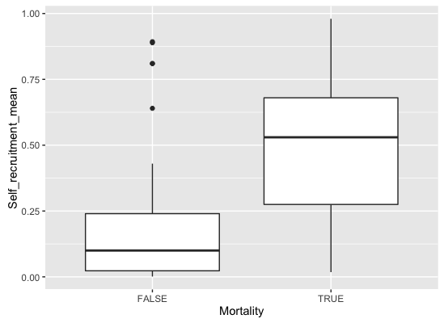

Figure 9: Comparison of the mean self-recruitment values with mortality included implemented in the model

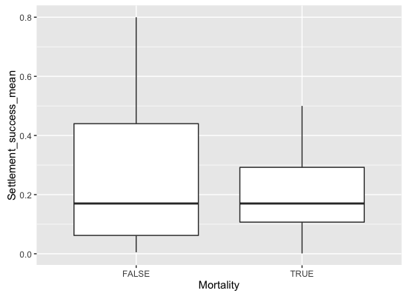

Figure 10: Comparison of the mean settlement success values with mortality included implemented in the model

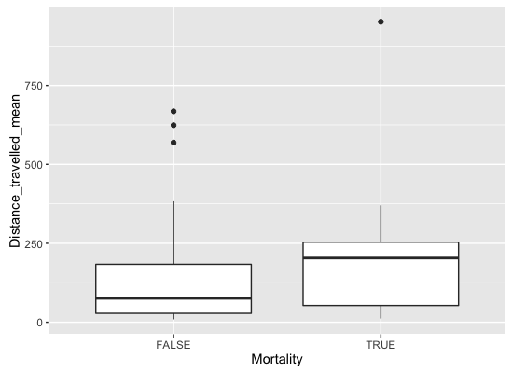

Figure 11: Comparison of the mean distance travelled with mortality included implemented in the model

### Movement behaviours

Models which included movement or settlement sensory abilities had overall lower mean self-recruitment levels than those which did not (Figure 12, **INCLUDE STATS**). This is an unexpected result, considering the overriding consensus is that self-recruitment is increased through behavioural implementations in the model

(Werner et al. 1993, Paris & Cowen 2004).

While the maximum values for mean self-recruitment are higher with behaviour, other model parameters specific to the studies could be influencing this trend. If both these behaviours were included, then self-recruitment increased, although there are fewer data points for comparison. The large spread of values for self-recruitment, ranging from close to 100% down to almost none, also suggest that the is a mix of parameters influencing the self-recruitment seen in models.

The opposite trend appears to occur for settlement success (Figure 13). The highest settlement success occurred when multiple behaviours of movement & settlement or movement & orientation & settlement were all included in the model. Unfortunately there were not many studies that included orientation to draw meaningful comparisons about the influence of orientation on connectivity patterns, but the strong assumption is that it would also increase settlement success, as shown in individual studies

(Staaterman et al. 2012).

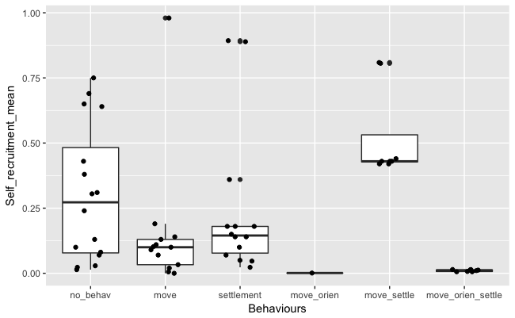

Figure 12: The effect of larval behaviour (movement, orientation & settlement sensory) on the mean self-recruitment in connectivity studies

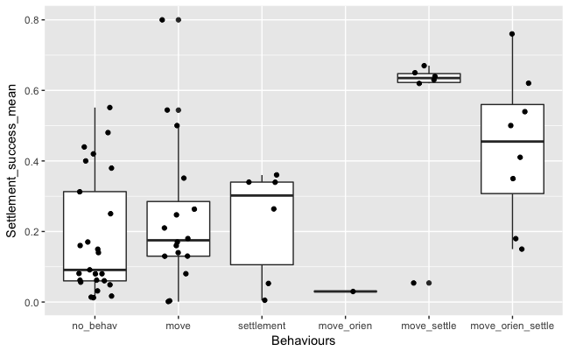

Figure 13: The effect of larval behaviour (movement, orientation & settlement sensory) on the mean settlement success of larvae in connectivity studies

# Conclusion and recommendations

The other interesting outcome was the large spread of values reported for these studies. The common measures of self-recruitment, local-retention and settlement success all reported huge variations amongst studies. Seemingly obvious explanations such as open/closed systems did not explain the variance. These are inherently complex systems and teasing out the differences between studies is not a trivial task. The other key driver is the variability of the oceanographic currents, which change within and between years. Therefore it was interesting there were still many studies that only looked at dispersal patterns over one or two year periods, arguably not allowing the model to capture enough natural variation.

*WILLS COMMENT: You can’t just throw this in as a sentence. What did you do, what does this mean? Need to show that you actually looked at this in some objective manner so your argument that it can be dismissed will be accepted.You can’t just throw this in as a sentence. What did you do, what does this mean? Need to show that you actually looked at this in some objective manner so your argument that it can be dismissed will be accepted.*

The first caveat to such an approach is that comparisons such are difficult because of the number of parameters used to configure these biophysical models that could all have an influence on the results. This is a complicated issue to resolve. Comparing a large number of studies should cancel out some of the noise surrounding all the parameters. A future direction would be to determine a way to normalise the data based on the input parameters, allowing for more effective comparisons. Otherwise perhaps it is only prudent to compare studies that occur in the same oceanic region, at the same time, using the same physical models and perhaps the same particle disperser for consistency.

The current state of the field feels like is not moving forward as coherently it should be. Studies have been calling for behaviour to be implemented for nearly a decade, yet the majority of studies are still not including larval behavioural traits. This is despite the evidence that behaviours do change the described connectivity patterns. Perhaps we cannot move forward until these models, which include behaviour, are empirically validated. However, we would argue that the first priority should be to start including both movement and settlement sensory abilities for species where this is applicable and known in the literature. The second priority to is provide clarity in metrics so we can meaningfully compare the outcomes of connectivity studies and progress the field further.

Aiken CM, Navarrete SA, Pelegrí JL (2011) Potential changes in larval dispersal and alongshore connectivity on the central Chilean coast due to an altered wind climate. J Geophys Res 116:G04026

Andrello M, Mouillot D, Beuvier J, Albouy C, Thuiller W, Manel S (2013) Low connectivity between mediterranean marine protected areas: a biophysical modeling approach for the dusky grouper *Epinephelus marginatus* (JG Hiddink, Ed.). PLoS ONE 8:e68564

Andrello M, Mouillot D, Somot S, Thuiller W, Manel S (2014) Additive effects of climate change on connectivity between marine protected areas and larval supply to fished areas (M Bode, Ed.). Diversity and Distributions 21:139–150

Ayata S-D, Lazure P, Thiébaut E (2010) How does the connectivity between populations mediate range limits of marine invertebrates? A case study of larval dispersal between the Bay of Biscay and the English Channel (North-East Atlantic). Prog Oceanogr 87:18–36

Bartsch J (1988) Numerical-simulation of the advection of vertically migrating herring larvae in the north-sea. Meeresforschung-Reports on Marine Research 32:30–45

Berglund M, Jacobi MN, Jonsson PR (2012) Optimal selection of marine protected areas based on connectivity and habitat quality. Ecological Modelling 240:105–112

Bottesch M, Gerlach G, Halbach M, Bally A, Kingsford MJ, Mouritsen H (2016) A magnetic compass that might help coral reef fish larvae return to their natal reef. Curr Biol 26:R1266–R1267

Brennan G, Kregting L, Beatty GE, Cole C, Elsasser B, Savidge G, Provan J (2014) Understanding macroalgal dispersal in a complex hydrodynamic environment: a combined population genetic and physical modelling approach. Journal of The Royal Society Interface 11:20140197

Burgess SC, Nickols KJ, Griesemer CD, Barnett LAK, Dedrick AG, Satterthwaite EV, Yamane L, Morgan SG, White JW, Botsford LW (2014) Beyond connectivity: how empirical methods can quantify population persistence to improve marine protected-area design. Ecological Applications 24:257–270

Butler MJ IV, Paris CB, Goldstein JS, Matsuda H, Cowen RK (2011) Behavior constrains the dispersal of long-lived spiny lobster larvae. Mar Ecol Prog Ser 422:223–237

Cowen RK, Sponaugle S (2009) Larval Dispersal and Marine Population Connectivity. Annual Review of Marine Science 1:443–466

Crochelet E, Chabanet P, Pothin K, Lagabrielle E, Roberts JJ, Pennober G, Lecomte-Finiger R, Petit M (2013) Validation of a fish larvae dispersal model with otolith data in the Western Indian Ocean and implications for marine spatial planning in data-poor regions. Ocean and Coastal Management 86:13–21

Davies SW, Treml EA, Kenkel CD, Matz MV (2014) Exploring the role of Micronesian islands in the maintenance of coral genetic diversity in the Pacific Ocean. Mol Ecol 24:70–82

Faillettaz R, Blandin A, Paris CB, Koubbi P, Irisson J-O (2015) Sun-Compass Orientation in Mediterranean Fish Larvae (HM Patterson, Ed.). PLoS ONE 10:e0135213

Feutry P, Vergnes A, Broderick D, Lambourdière J, Keith P, Ovenden JR (2013) Stretched to the limit; can a short pelagic larval duration connect adult populations of an Indo-Pacific diadromous fish (*Kuhlia rupestris*)? Mol Ecol 22:1518–1530

Gerlach G, Atema J, Kingsford MJ, Black KP, Miller-Sims V (2007) Smelling home can prevent dispersal of reef fish larvae. PNAS 104:858–863

Herbert RJH, Willis J, Jones E, Ross K, Hübner R, Humphreys J, Jensen A, Baugh J (2011) Invasion in tidal zones on complex coastlines: modelling larvae of the non-native Manila clam, Ruditapes philippinarum, in the UK. Journal of Biogeography 39:585–599

Jacobi MN, André C, Döös K, Jonsson PR (2012) Identification of subpopulations from connectivity matrices. Ecography 35:1004–1016

Kough AS, Paris CB, Butler MJ IV (2013) Larval connectivity and the international management of fisheries (H Browman, Ed.). PLoS ONE 8:e64970

Lacroix G, Maes GE, Bolle LJ, Volckaert FAM (2013) Modelling dispersal dynamics of the early life stages of a marine flatfish (*Solea solea* L.). Journal of Sea Research 84:13–25

Leis JM (2006) Are larvae of demersal fishes plankton or nekton? In: Southward AJ, Sims DW (eds) Advances in Marine Biology, Vol 51. Academic Press Ltd-Elsevier Science Ltd, London, p 57–141

Leis JM (2010) Ontogeny of behaviour in larvae of marine demersal fishes. Ichthyological Research 57:325–342

Leis JM, Paris CB, Irisson J-O, Yerman MN, Siebeck UE (2014) Orientation of fish larvae in situ is consistent among locations, years and methods, but varies with time of day. Mar Ecol Prog Ser 505:193–208

Lett C, Verley P, MULLON C, Parada C, Brochier T, PENVEN P, BLANKE B (2008) A Lagrangian tool for modelling ichthyoplankton dynamics. Environmental Modelling and Software 23:1210–1214

Miller TJ (2007) Contribution of individual-based coupled physical-biological models to understanding recruitment in marine fish populations. Mar Ecol Prog Ser 347:127–138

Miyake Y, Kimura S, Kawamura T, Kitagawa T, Takahashi T, Takami H (2011) Population connectivity of Ezo abalone on the northern Pacific coast of Japan in relation to the establishment of harvest refugia. Mar Ecol Prog Ser 440:137–150

Mora C, Treml EA, Roberts JJ, Crosby K, Roy D, Tittensor DP (2012) High connectivity among habitats precludes the relationship between dispersal and range size in tropical reef fishes. Ecography 35:89–96

Moritz C, Meynard CN, Devictor V, Guizien K, Labrune C, Guarini JM, Mouquet N (2013) Disentangling the role of connectivity, environmental filtering, and spatial structure on metacommunity dynamics. Oikos 122:1401–1410

North EW, Gallego A, Petitgas P (Eds) (2009) Manual of recommended practices for modelling physical-biological interactions during fish early life.

Paris CB, Cowen RK (2004) Direct evidence of a biophysical retention mechanism for coral reef fish larvae. Limnol Oceanogr 49:1964–1979

Paris CB, Helgers J, van Sebille E, Srinivasan A (2013) Connectivity Modeling System: A probabilistic modeling tool for the multi-scale tracking of biotic and abiotic variability in the ocean. Environmental Modelling and Software 42:47–54

Puckett BJ, Eggleston DB, Kerr PC, Luettich RA Jr (2014) Larval dispersal and population connectivity among a network of marine reserves. Fisheries Oceanography 23:342–361

Richar JI, Kruse GH, Curchitser EN, Hermann AJ (2014) Patterns in connectivity and retention of simulated tanner crab (*Chionoecetes bairdi*) larvae in the eastern Bering Sea. Prog Oceanogr 138:475–485

Roberts JJ, Best BD, Dunn DC, Treml EA, Halpin PN (2010) Marine Geospatial Ecology Tools: An integrated framework for ecological geoprocessing with ArcGIS, Python, R, MATLAB, and C. Environmental Modelling and Software 25:1197–1207

Robins PE, Neill SP, Giménez L, Jenkins SR, Malham SK (2013) Physical and biological controls on larval dispersal and connectivity in a highly energetic shelf sea. Limnol Oceanogr 58:505–524

Rochette S, Huret M, Rivot E, Le Pape O (2012) Coupling hydrodynamic and individual-based models to simulate long-term larval supply to coastal nursery areas. Fisheries Oceanography 21:229–242

Staaterman E, Paris CB (2014) Modelling larval fish navigation: the way forward. Ices Journal of Marine Science 71:918–924

Staaterman E, Paris CB, Helgers J (2012) Orientation behavior in fish larvae: A missing piece to Hjort's critical period hypothesis. Journal of Theoretical Biology 304:188–196

Treml EA, Roberts JJ, Halpin PN, Possingham HP, Riginos C (2015) The emergent geography of biophysical dispersal barriers across the Indo-West Pacific (R Cowie, Ed.). Diversity and Distributions 21:465–476

Werner FE, PAGE FH, Lynch DR, LODER JW, LOUGH RG, PERRY RI, Greenberg DA, SINCLAIR MM (1993) Influences of mean advection and simple behavior on the distribution of cod and haddock early life stages on Georges Bank. Fisheries Oceanography 2:43–64

Wickham H (2009) ggplot2: Elegant Graphics for Data Analysis. Springer-Verlag New York

Wickham H (2016) tidyverse: Easily Install and Load “Tidyverse” Packages, 1st edn.

Wren JLK, Kobayashi DR (2016) Exploration of the “larval pool”: development and ground-truthing of a larval transport model off leeward Hawai‘i. PeerJ 4:e1636

Young EF, Rock J, Meredith MP, Belchier M, Murphy EJ, Carvalho GR (2012) Physical and behavioural influences on larval fish retention: contrasting patterns in two Antarctic fishes. Mar Ecol Prog Ser 465:201–215