Ayesha Habib



** PURPOSE/OBJECTIVE**

I am Seeking for a platform where I can prove and further polish my abilities, which a gained from work experience. The platform I am looking for must have maximum chances of grooming and learning.

** CONTACT**

Faisalabad  0309-8013614

□

**ABOUT ME**



Father's Name: Habib Ahmad Siddiqi Date of Birth: 12 July 2004

CNIC: 3310**2-2279444-2**

Nationality: Pakistan

Religion: Islam

Domicile Faisalabad

Marital Status Single

Gender Female

# EDUCATION

Matric (Science) 1st Division 2018 FSD Board. Intermediate (ICS) 2nd Division 2020 FSD Board Graduation (IS) 2nd Division 2022 Punjab Universty FSD

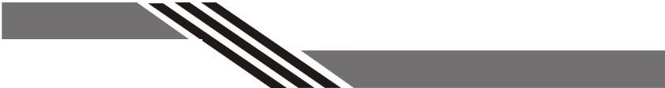

 **REFRENCES REFERENCES**

Would be furnished on demand.

# LANGUAGES

English (very good Knowledge) Urdu (Native language)

  **ACTIVITIES**

Reading News Paper & Islamic Book Computer Designing