# **Snake’s Masterplan**

## Iftime Adrian-Dumitru

## < Faculty of Automatic Control and Computer Engineering, Iasi>

## email: <iftimeadrian99@yahoo.ro>,

## academic year: <2019-2020>

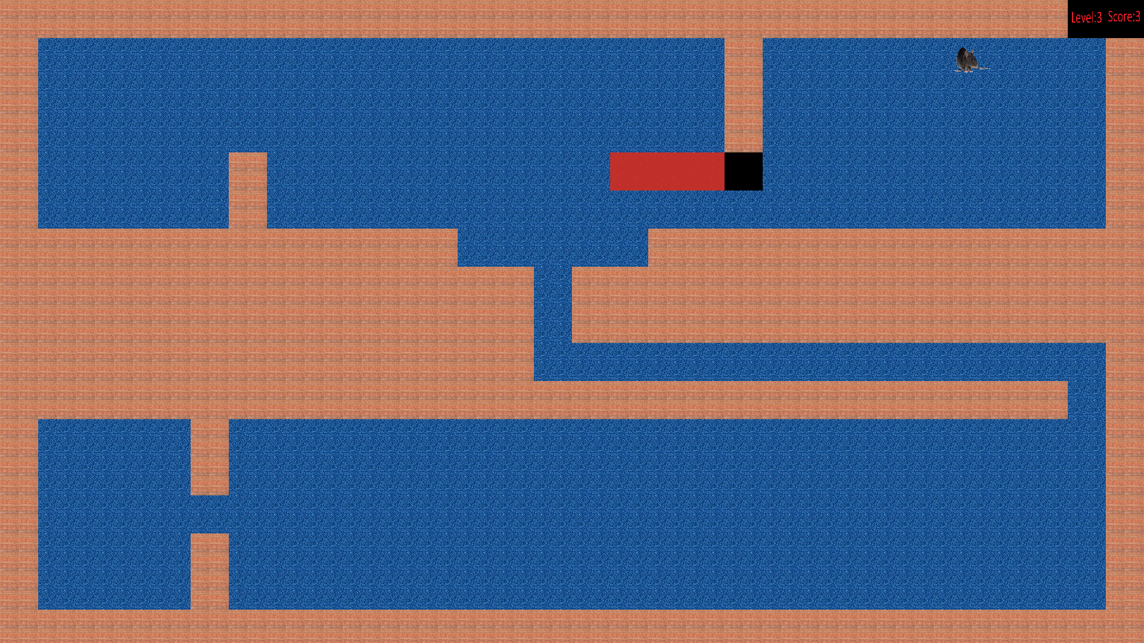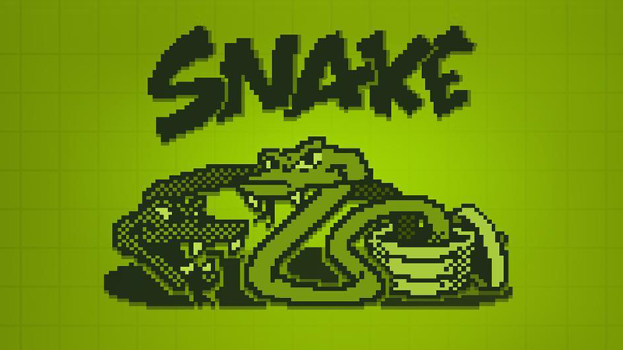

* **Gameplay**: The player controls a small snake. The snake attempts to eat the food by running into them with his head. Each item eaten makes the snake longer, so controlling is progressively more difficult. The player loses when the snake runs into the screen border, other obstacle, or itself.
* **Plot**: The 3 small snakes are sick of being bullied by humans and other animals so they came up with a plan: To become the head of the food-chain but first they have to grow as big as they can so nobody will make fun of them anymore.
* **Characters**: The 3 snakes are the ​ main characters and player-characters. They are a strange type because unlike other snakes they also like to eat fruits: apples (maybe he was the snake from the Eden Garden) and strawberries but their favorite meals are the rats that are living in the neighbor’s house.
* **Mechanics**: movement, score, uniquely designed levels, snakes, food and terrain, cannibalism