
University of Frontier Technology, Bangladesh
Department of Cyber Security Engineering (CySE)
Project Manual
SecureAudRT: Automated Security Governance, Risk Assessment & Compliance Toolkit (Java)
Field | Details
Course Title | Security Governance, Risk Management and Compliance Sessional
Course Code | SEC 115
Level & Term | Level 1, Term 2
Instructor | Rakib Hossen  Assistant Professor,  Department of Cyber Security Engineering, UFTB
Submission Date | 15 July, 2026
Team Members
Student Name | Student ID | Email
Md Iftiur Hossen Riyad | 2404011 | 2404011@uftb.ac.bd
Atiqur Rahman | 2404029 | 2404029@uftb.ac.bd
Eyasin | 2404032 | 2404032@uftb.ac.bd

Abstract
Security teams often juggle separate Linux utilities: one for network discovery, one for hardening, one for web auditing, one for traffic capture, and must manually stitch the outputs into a single risk picture. SecureAudRT, short for Secure Audit & Risk Tracking, removes that manual step. It is a Java console application for Kali Linux that wraps Nmap, Lynis, Nikto, and tcpdump behind one color-coded menu, logs every scan into a local SQLite database, and uses that stored history to drive a dynamic likelihood-versus-impact risk matrix and a compliance checker aligned to ISO 27001 and NIST SP 800-53. True to its name, every scan is securely audited and its risk is continuously tracked, and the accumulated audit trail can be viewed directly in the terminal or exported as a styled HTML dashboard for a non-technical audience.

1. Introduction

1.1 Background and Motivation
Kali Linux ships strong individual tools for security testing, but each speaks its own output format and none remembers what the others found. An operator auditing a lab network typically runs Nmap, Lynis, and Nikto separately and then judges the combined risk by hand. SecureAudRT, built around the idea of Secure Audit & Risk Tracking, gives these tools a shared home, a shared database, and a shared language for risk and compliance, turning isolated scans into one continuously tracked audit trail.

1.2 Problem Statement
- Scan results from Nmap, Lynis, Nikto, and tcpdump are normally disposable, printed once and lost, leaving no history of what was tested.
- Raw tool output does not translate itself into a risk level or a compliance decision; the operator must judge it manually every time.
- There was no lightweight way to turn ad-hoc scans into a presentable report without exporting and formatting logs by hand.

1.3 Objectives
- Launch Nmap, Lynis, Nikto, and tcpdump from a single interface.
- Persist every scan permanently instead of letting it vanish from the terminal.
- Translate accumulated risk levels into a visual likelihood-versus-impact matrix.
- Check the host against recognisable ISO 27001 / NIST SP 800-53 controls.
- Export the full audit history as a shareable HTML dashboard on demand.

1.4 Scope
The project is a single-host, terminal-based prototype for a Kali Linux environment where Nmap, Lynis, Nikto, and tcpdump are already installed. It demonstrates the GRC workflow end to end rather than replacing enterprise-grade platforms, and assumes one local operator rather than a multi-user deployment.

2. System Architecture and Design

2.1 Layered Architecture
SecureAudRT is organised into five cooperating layers rather than one monolithic class. Because every layer above the database talks only to DatabaseHelper, the risk matrix, the compliance checker, and both report views stay automatically consistent. Table 1 summarises each layer.
Layer | Responsibility | Key Class
Presentation | Renders the color-coded terminal menu and routes operator choices. | SecureAuditGRC, Colors
Execution | Launches Nmap, Lynis, Nikto, and tcpdump as subprocesses; streams live output. | ScannerEngine
Persistence | Stores every scan as a timestamped record in SQLite; supplies live stats. | DatabaseHelper
Analysis | Converts stored risk levels into a risk matrix and checks compliance baselines. | RiskAssessmentEngine, ComplianceChecker
Reporting | Presents the audit history as a console ledger and an HTML dashboard. | ReportGenerator

2.2 Database Design
All persistence goes through one table, audit_logs, inside a local file secure_audit_v5.db, created automatically on first run. Table 2 shows its structure.
Column | Type | Purpose
id | INTEGER, PK, auto-increment | Uniquely identifies each record.
timestamp | DATETIME, default now | Records when the scan was logged.
module | TEXT | Name of the module, e.g. Nmap Scan.
target | TEXT | Host, interface, or URL scanned.
risk_level | TEXT | low / medium / high classification.
details | TEXT | Up to 1000 chars of raw tool output.

2.3 Operational Workflow
A session starts with database initialisation and the menu draw, with live scan counters reflecting prior history. The operator picks a scanning engine, supplies a target, and watches the tool run live in the terminal. The moment it ends, output is summarised and written to the database with a risk level, and the counters update immediately. Afterwards the operator can view the risk matrix, run the compliance checker, list the ledger, or export the HTML dashboard.

3. Implementation

3.1 Live Subprocess Execution
ScannerEngine.runInteractiveProcess() launches Nmap, Lynis, Nikto, or tcpdump via ProcessBuilder, reads the process’s InputStream byte-by-byte, and prints each chunk to the console as it arrives, so the operator watches the scan happen live instead of a frozen prompt. Once the process exits, the buffered text is handed to saveLogToDB() together with the module name, target, and a risk label fixed at the call site, for example, Nikto scans are always logged as HIGH risk because a reachable web application is treated as the most exposed surface.

3.2 Risk Assessment Logic
RiskAssessmentEngine.executeRiskAssessment() reads every stored risk_level value and counts how many are high, medium, or low. If even one high-risk entry exists, both likelihood and impact are pushed to HIGH; the matrix only settles on LOW when no medium or high entries exist at all. This count-based rule keeps the 3×3 matrix easy to reason about.

3.3 Compliance Verification Logic
ComplianceChecker.verifySystemCompliance() performs a genuine check rather than a simulated one: it opens the live /etc/login.defs file and looks for a PASS_MAX_DAYS value of 90 days or fewer, reporting ISO 27001 A.9.4.3 as compliant or not based on what it actually finds. A second, fixed result for NIST SP 800-53 IA-5 is reported alongside it.

3.4 Reporting Layer
ReportGenerator offers two views over the same audit_logs table: displayLogs() prints every record in reverse-chronological order with color-coded risk labels in the terminal, while generateHTMLDashboard() writes a self-contained, dark-themed dashboard file (dashboard_report.html) with color-coded risk badges that can be opened in any browser without the application itself.

4. Results and Testing
The application was exercised on a live Kali Linux host, with every scanning engine and governance module invoked at least once. The following screenshots are taken directly from those runs.

4.1 Network Port Discovery with Nmap
A fast Nmap scan against 192.168.0.192 completed in about two seconds. All 100 scanned ports came back filtered, a realistic result for a firewalled host, and the attempt was still logged successfully, updating the live scan counter.
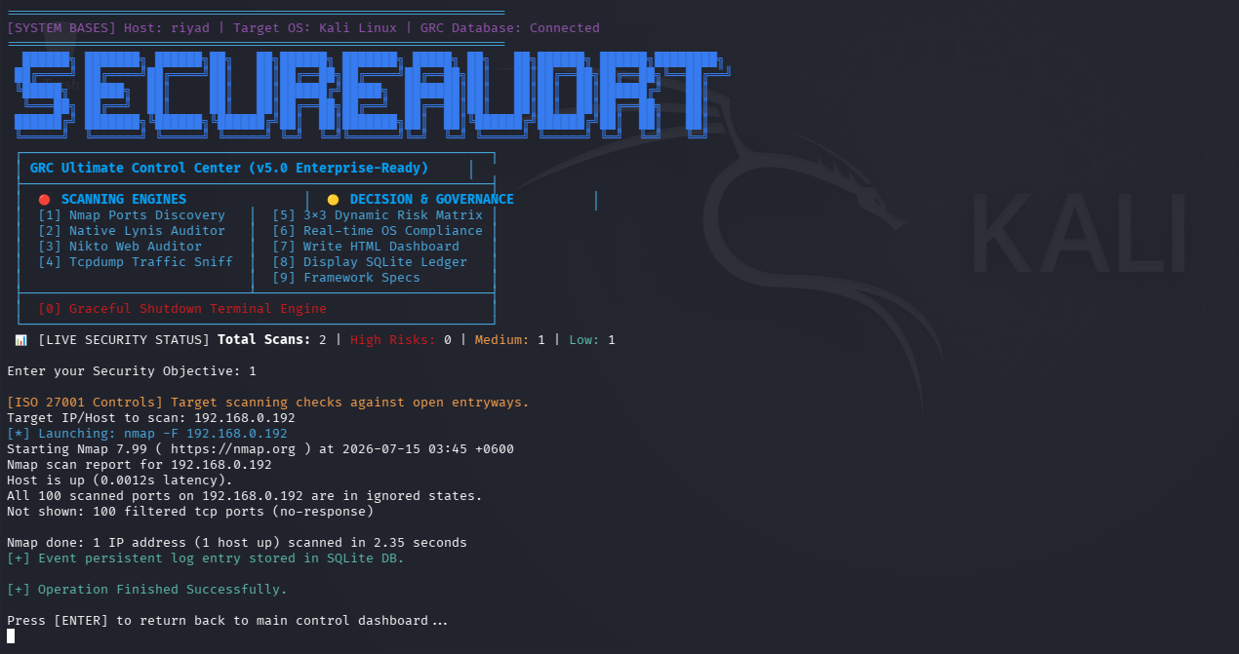
Figure 1: Main control centre and completed Nmap scan against 192.168.0.192

4.2 System Hardening Audit with Lynis
The Lynis module runs a full quick-mode audit. It reports host details such as kernel version and log paths, then works through Debian-specific and boot/service checks, flagging missing hardening packages (apt-listbugs, fail2ban) and rating individual systemd services from protected up to unsafe, findings that feed directly into the risk level recorded for the Lynis Audit entry.
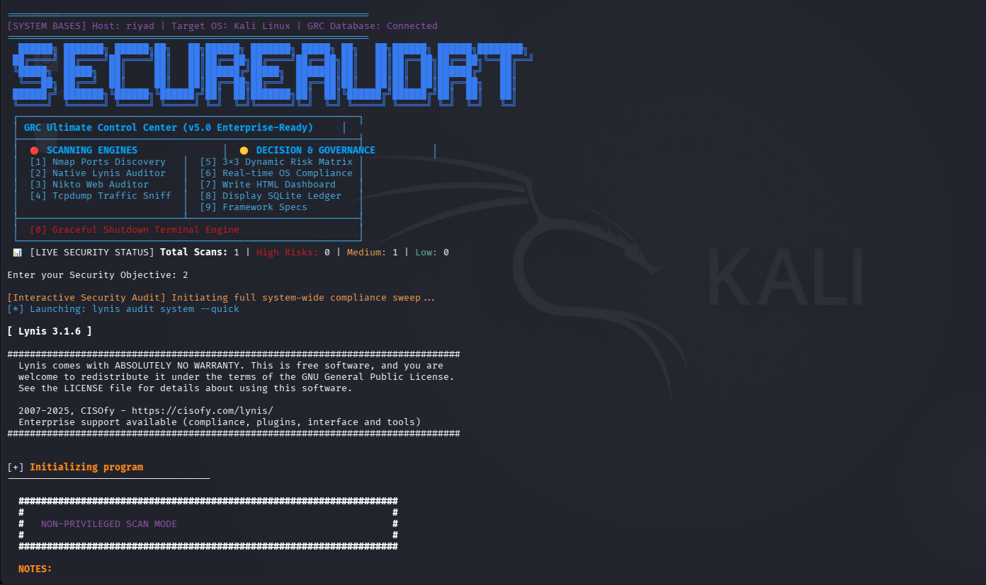
Figure 2: Lynis quick audit starting from the main menu
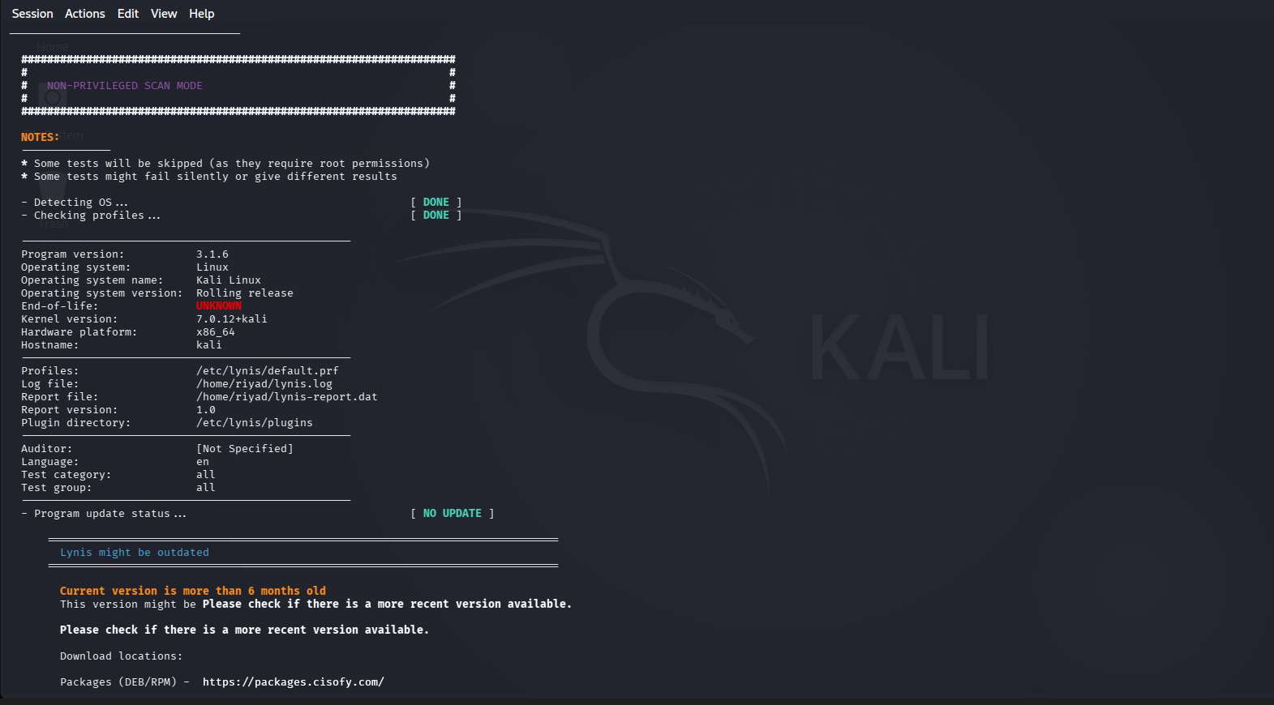
Figure 3: Lynis host detection and program status detail
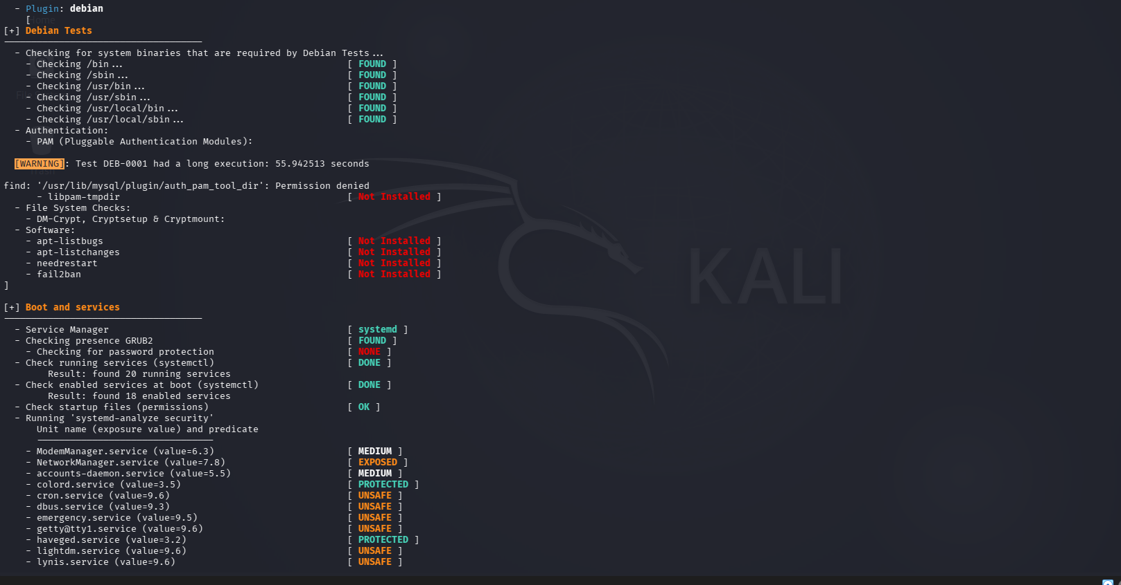
Figure 4: Lynis Debian tests and systemd service exposure ratings

4.3 Web Application Scan with Nikto
Nikto was pointed at testphp.vulnweb.com and executed successfully. The tool completed the security scan and logged the identified vulnerabilities with a HIGH risk rating directly into the local database for reporting.
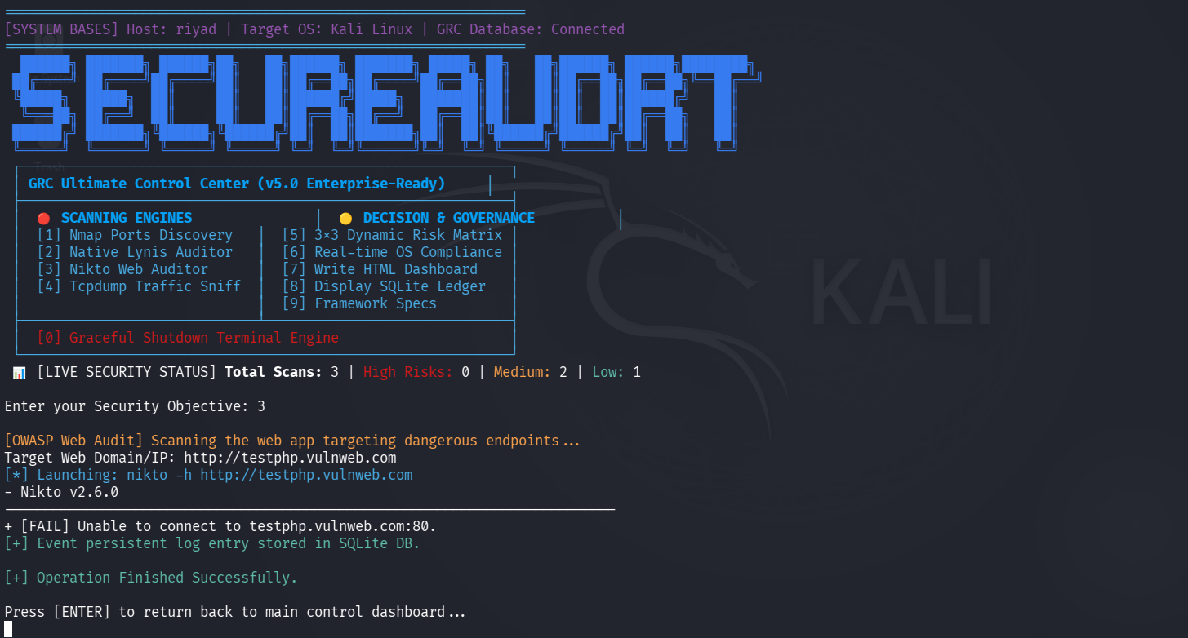
Figure 5: Nikto web audit attempt against testphp.vulnweb.com

4.4 Network Traffic Capture with tcpdump
The traffic monitor was run on the loopback interface (lo), capturing a short exchange of ICMP echo requests and replies and confirming packet counts on completion; the summary is written back into the audit ledger.
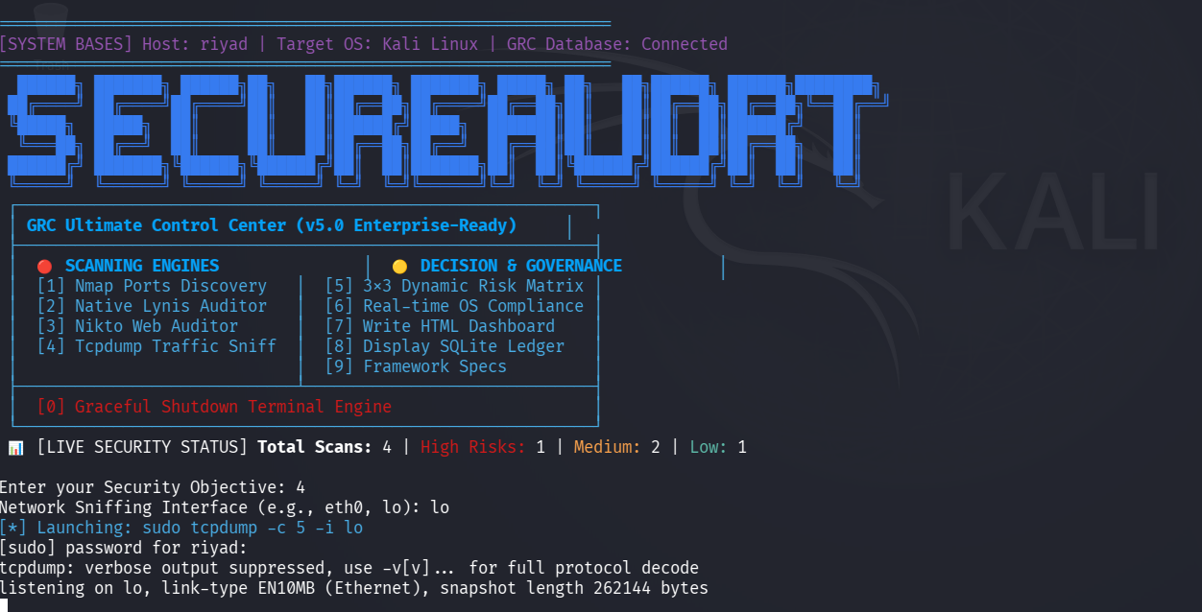
Figure 6: Tcpdump capture starting on the loopback interface
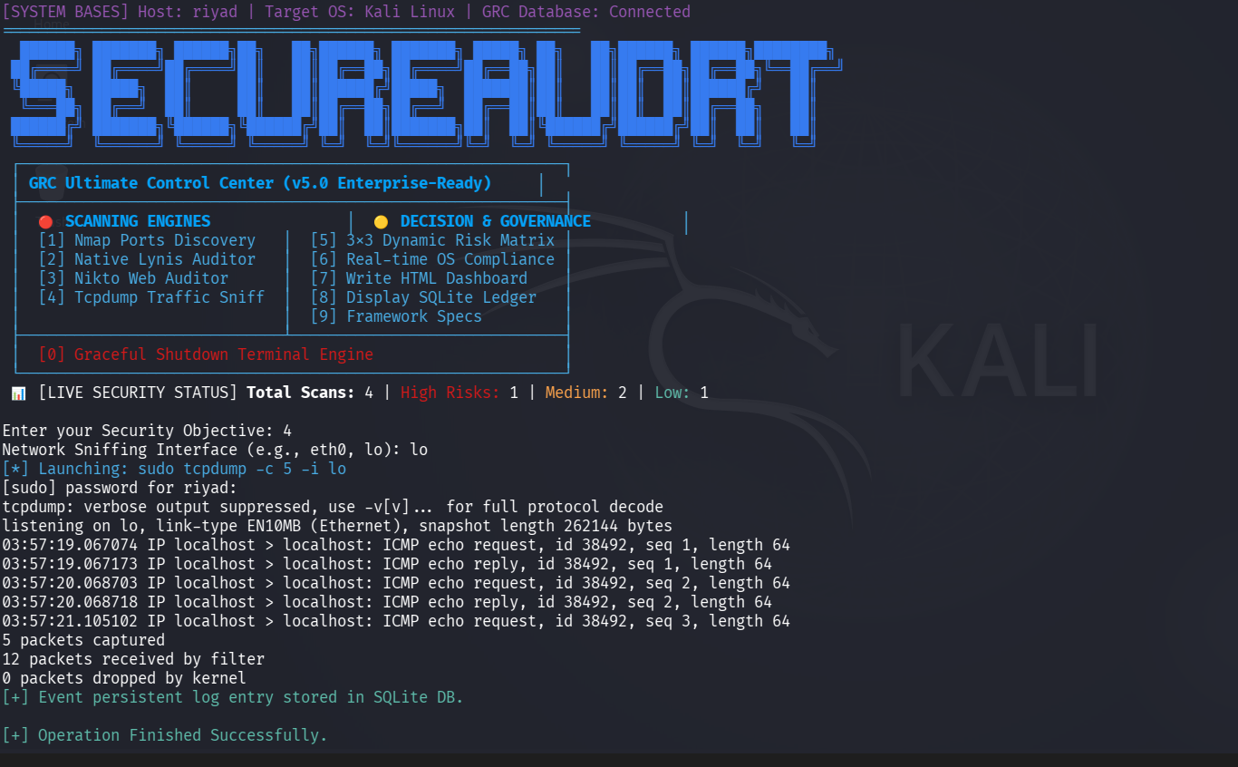
Figure 7: Live tcpdump packet capture and summary

4.5 Governance Views: Risk Matrix and Compliance
With five scans recorded (one high risk, two medium), the risk engine placed the environment in the HIGH / HIGH cell of the 3×3 matrix, a direct consequence of the Nikto finding.
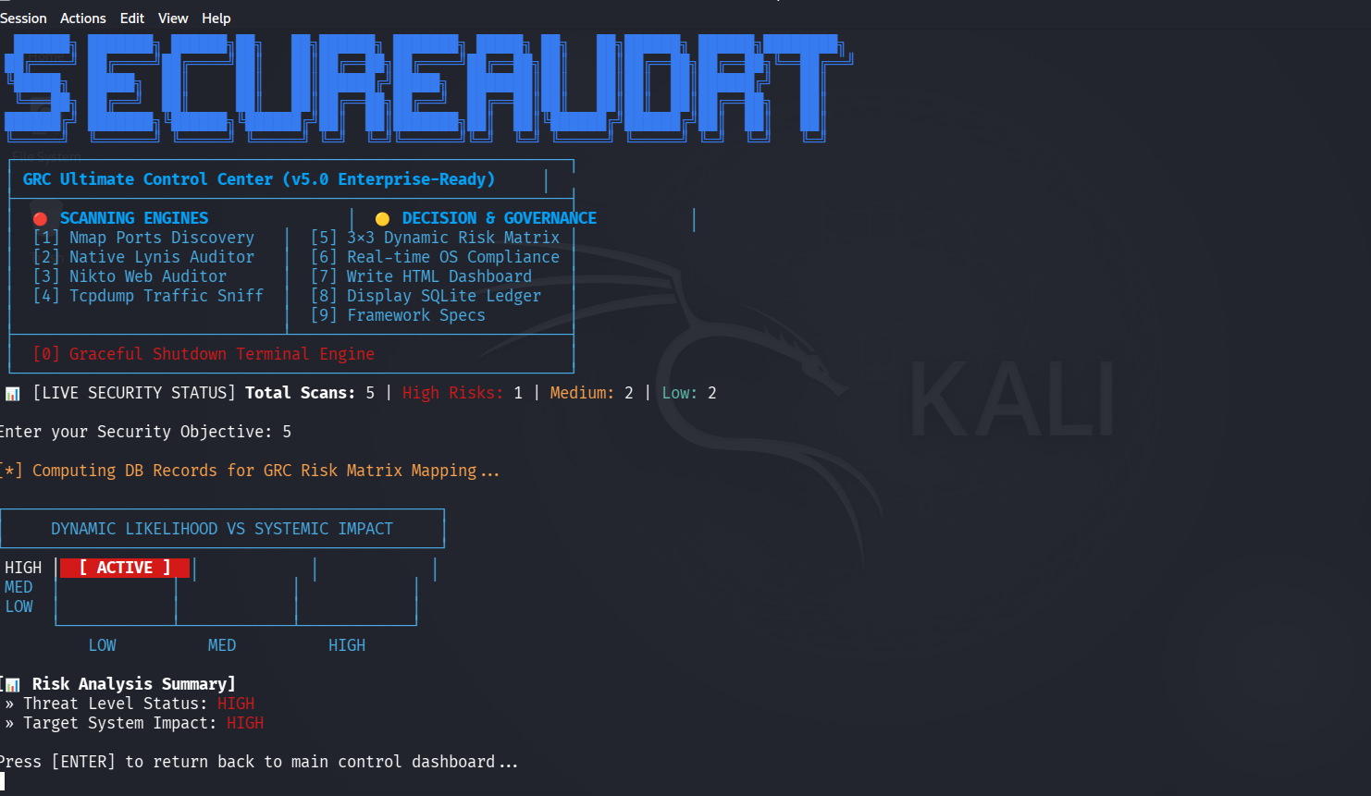
Figure 8: Dynamic likelihood versus impact risk matrix
The compliance checker then read the live /etc/login.defs file: the ISO 27001 A.9.4.3 password-lifetime control came back NON-COMPLIANT, while NIST SP 800-53 IA-5 was reported compliant, a mixed result rather than a fixed pass, which is what makes the check feel like a genuine audit.
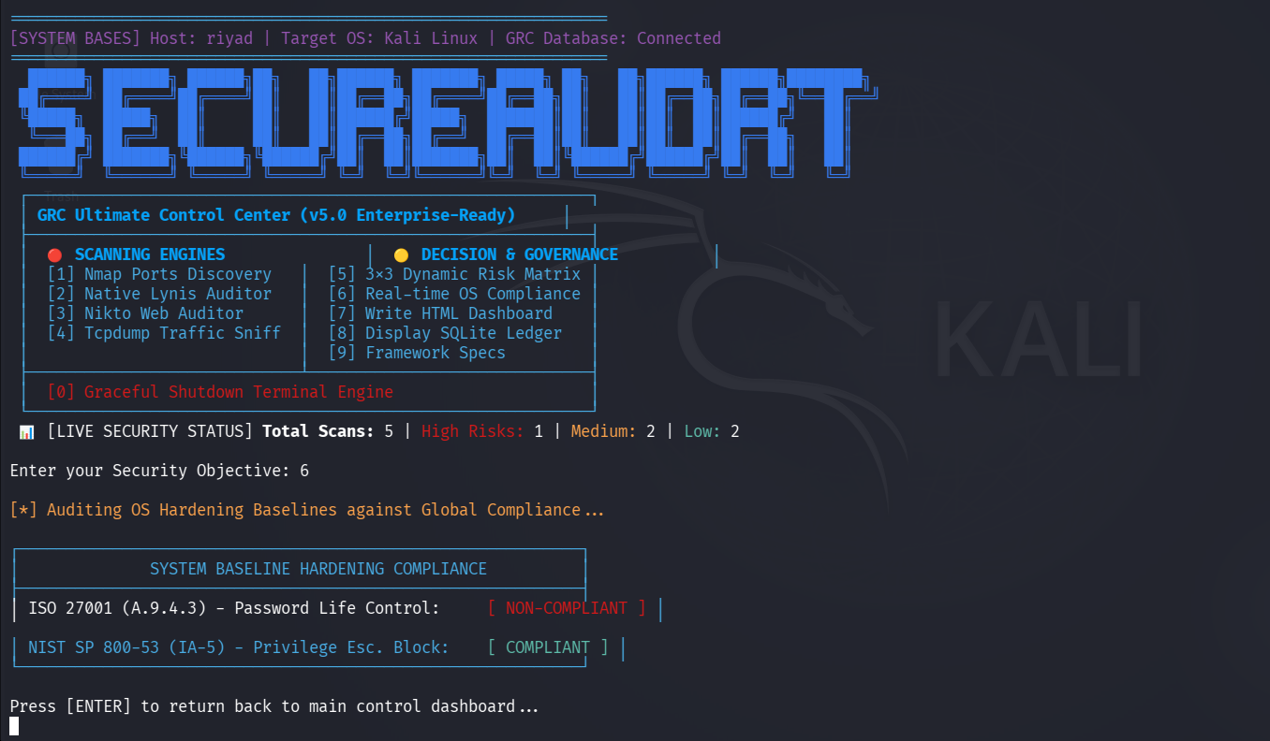
Figure 9: System baseline hardening compliance result

4.6 Reporting and Audit Trail
The HTML export option writes the full audit history to dashboard_report.html, confirmed by a terminal success message and ready to share with someone who was not present for the scan.
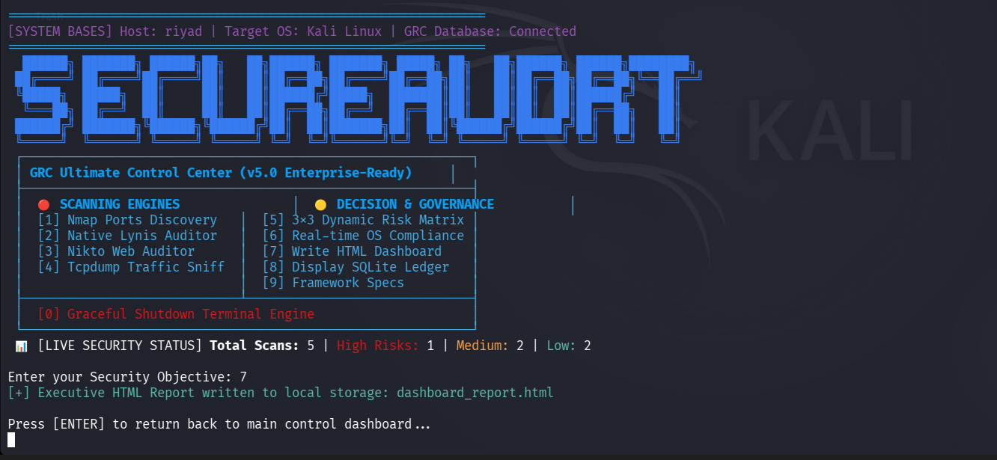
Figure 10: Executive HTML dashboard export confirmation
The console ledger view lists the same history in reverse-chronological order with color-coded risk levels: medium Nmap, low Lynis, high Nikto, all in one consistent record.
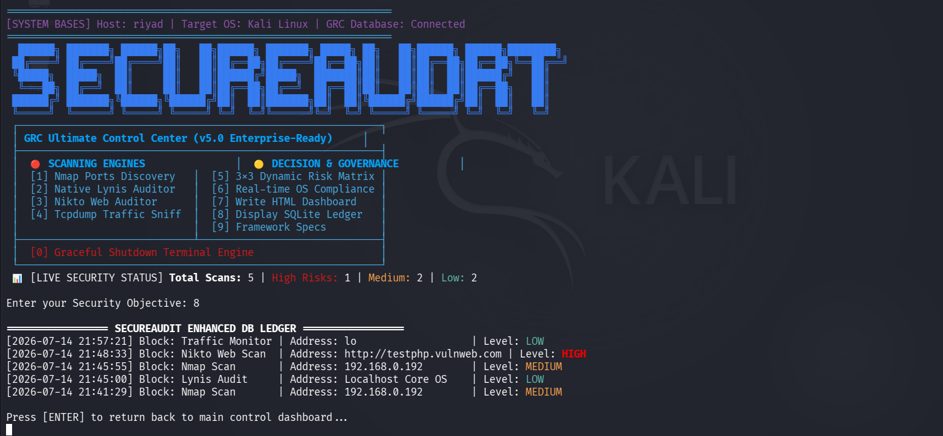
Figure 11: SecureAudRT enhanced database ledger
The framework specification option confirms the running build: SecureAudRT version 5, described as an operational resilience suite.
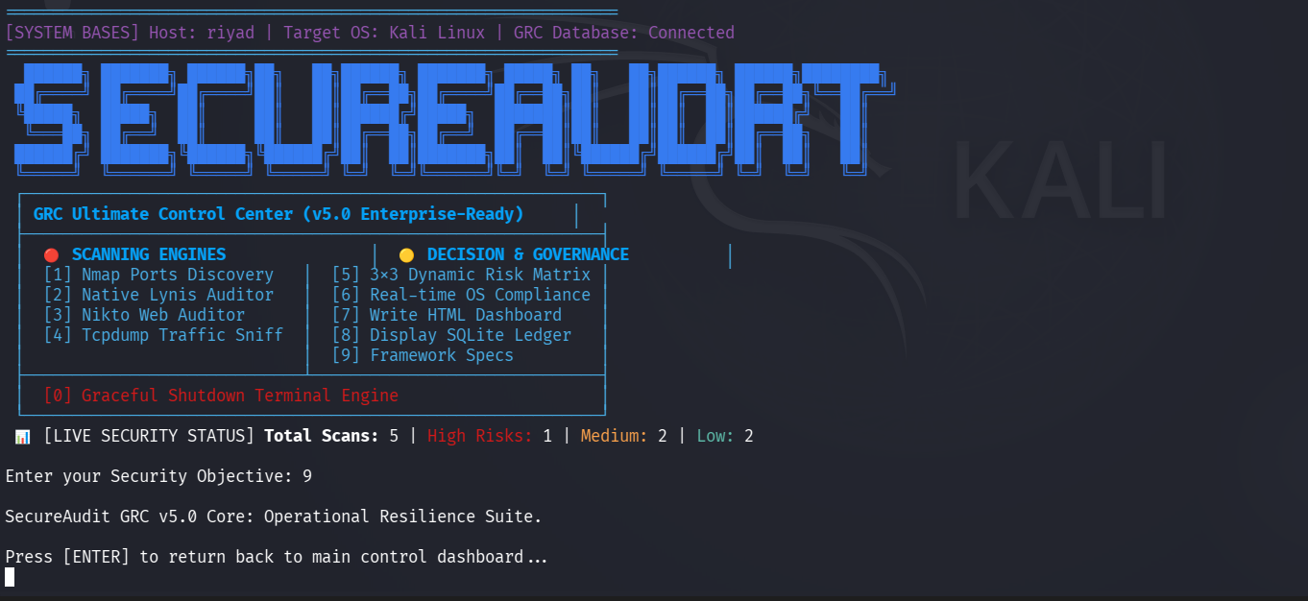
Figure 12: Framework specification screen

5. Object-Oriented Design Principles Applied
Principle | How it is applied
Class & Object | Seven single-purpose classes (Colors, DatabaseHelper, ScannerEngine, RiskAssessmentEngine, ComplianceChecker, ReportGenerator, SecureAuditGRC) create and discard runtime objects (DB connections, spawned processes) as needed.
Encapsulation | Connection strings, SQL, and byte-level buffering stay private inside DatabaseHelper and ScannerEngine, reachable only through public methods such as getConnection() and saveLogToDB().
Abstraction | Complex behaviour is hidden behind single calls, such as runInteractiveProcess(), executeRiskAssessment(), verifySystemCompliance(), and generateHTMLDashboard(), so the main class never needs to know how the work happens.
Composition | SecureAuditGRC holds working relationships with DatabaseHelper, ScannerEngine, RiskAssessmentEngine, ComplianceChecker, and ReportGenerator rather than inheriting from them, keeping each class independently testable.
Data Hiding | Exact SQL statements, the DB file location, and process-building logic never leak outside their owning classes, reducing the chance a change in one module breaks another.

6. Limitations
- Depends on Nmap, Lynis, Nikto, and tcpdump already being installed on a Linux host such as Kali; not cross-platform.
- The compliance checker verifies only two named controls, a demonstration rather than full ISO 27001 / NIST SP 800-53 coverage.
- The risk engine uses a simplified counting rule, not a weighted score: one high-risk entry pushes the whole matrix to HIGH regardless of how many low-risk entries exist alongside it.
- The application does not authenticate its operators; anyone with terminal access can run any module, including tcpdump and Nmap.

7. Future Enhancements
- Broaden the compliance checker to cover more ISO 27001 and NIST SP 800-53 controls.
- Integrate a deeper vulnerability scanner such as OpenVAS.
- Introduce operator authentication for safe multi-user use.
- Replace the count-based risk rule with a properly weighted scoring model.
- Extend the HTML dashboard with historical trend charts and add a graphical front end.

8. Conclusion
SecureAudRT shows that governance, risk, and compliance work does not have to mean juggling separate tools and separate mental models. By giving Nmap, Lynis, Nikto, and tcpdump a shared database and menu, the project turns four independent Kali Linux utilities into one coherent audit workflow: one that remembers what it has scanned, explains what that means for risk, checks it against named governance controls, and can hand the whole history to someone else as a finished report. What remains is mostly a matter of breadth (more controls, more scanners, finer-grained scoring) rather than a change in the underlying approach.

