Latest Robustness Evidence Checklist
  - CW2 Formal Portfolio Analysis Report | Formal baseline run 6905e84b-9e16-4106-8c0f-cd9ecce56728
Status confirmation
Part 1 to Part 5 have been generated from the formal slim data package. The evidence index contains 17 report rows, and the centralized formal NAV reference figure exists at outputs/robustness/report_evidence/shared/formal_baseline_nav_reference.png. The run is quarterly target generation and quarterly execution, with monthly holding-period performance records.

1. Formal Baseline Reference
Item | Latest formal reading
Formal portfolio | cw2_formal_20260420_fund_ra3_s30_t50
Formal run id | 6905e84b-9e16-4106-8c0f-cd9ecce56728
Cadence | Quarterly target generation and quarterly rebalance; monthly performance measurement.
Total return | 74.12%
Annualized return | 11.94%
Annualized volatility | 15.82%
Sharpe / Sortino / IR | 0.582 / 0.917 / 0.126
Max drawdown | 17.13%
Turnover and cost | Avg monthly recorded turnover 15.35%; annualized one-way turnover 184.23%; total cost drag 0.55%.

Revision note versus the older PDF
The new formal baseline is lower than the earlier report version: annualized return is about 11.94%, Sharpe is 0.582, and max drawdown is about 17.13%. The report should therefore avoid over-claiming a high-Sharpe profile and should frame the result as positive but equity-like.

2. Part 1 - Deterministic Sensitivity Checklist
Checklist item | Latest scenario | Latest metric reading | Report implication
Test 1 Cost sensitivity | cost_25bps | Ann. return 11.57%; Sharpe 0.561; MDD 17.35%; Excess vs Universe EW 2.21%. | Still passes the cost-survival logic, but the margin is thinner than in the old report.
Test 2 Backtest window | window_minus_6m | Ann. return 10.78%; Sharpe 0.554; MDD 17.13%; Excess vs Universe EW 1.42%. | Return and Sharpe remain positive across date shifts; use as a stability check, not as the main headline.
Test 3 Concentration | concentration_tighter | Ann. return 11.09%; Sharpe 0.528; MDD 19.57%; Excess vs Universe EW 1.73%. | The conclusion is now that the signal is not dependent on one exact holding count; tighter is slightly better in this run.
Test 4 Factor weights | factor_value_up_5pct | Ann. return 12.94%; Sharpe 0.636; MDD 15.70%; Excess vs Universe EW 3.58%. | The most informative key scenario suggests value tilt helps; do not reuse old full factor-removal numbers unless rerun.
Test 5 Regime threshold | regime_mainline | Ann. return 10.85%; Sharpe 0.515; MDD 19.57%; Excess vs Universe EW 1.49%. | Regime switching still improves the disabled case, but the absolute level is lower than the old PDF.
Test 6 Drawdown brake | brake_off | Ann. return 11.94%; Sharpe 0.582; MDD 17.13%; Excess vs Universe EW 2.58%. | Drawdown brakes trade return for lower drawdown; the formal mainline should be described as no active brake effect.
Test 7 Incumbent band | band_medium | Ann. return 11.19%; Sharpe 0.537; MDD 18.52%; Excess vs Universe EW 1.83%. | Band settings are moderately stable; avoid the old claim that no band is clearly strongest.
Test 8 Trade constraints | trade_constraint_strong | Ann. return 10.94%; Sharpe 0.519; MDD 19.58%; Excess vs Universe EW 1.58%. | Trade constraints are not the source of the return; the variants stay close to one another.

3. Part 2 - Ablation Checklist
Checklist item | Latest scenario | Latest metric reading | Report implication
Regime switch ablation | no_regime_switch | Ann. return 9.00%; Sharpe 0.424; MDD 17.66%; Excess vs Universe EW -0.37%. | The regime switch remains a meaningful contributor because disabling it weakens return and Sharpe.
Risk overlay ablation | no_risk_overlay | Ann. return 16.49%; Sharpe 0.762; MDD 20.20%; Excess vs Universe EW 7.12%. | Removing the overlay raises return but also raises drawdown; present the overlay as defensive risk control, not pure return maximization.
Sector constraint ablation | no_sector_constraint | Ann. return 10.85%; Sharpe 0.514; MDD 19.57%; Excess vs Universe EW 1.48%. | Sector constraints are mildly useful in the formal setup; removing them weakens the latest result.
Inactive implementation toggles | no_intraday_trigger | Ann. return 11.94%; Sharpe 0.582; MDD 17.13%; Excess vs Universe EW 2.58%. | Intraday trigger and liquidity clipping are effectively non-binding in the formal baseline; do not make them major evidence claims.

Scope caution
The latest formal fast run completed Block B module ablations. The older PDF's value-factor removal ablation should be treated as obsolete unless that exact ablation is rerun on the formal slim baseline.

4. Part 3 - Subperiod and Regime Checklist
Checklist item | Comparator | Latest reading | Report implication
Normal regime | static_baseline / universe_ew | Strategy ann. return 17.08%; excess vs static 5.43%; excess vs Universe EW 2.21%. | Keep the positive normal-regime language.
Stress regime | static_baseline / universe_ew | Strategy ann. return -15.91%; excess vs static -1.03%; excess vs Universe EW 4.10%. | This is the largest logic change: avoid claiming stress outperformance against every benchmark.
All-period regime summary | static_baseline / universe_ew | Strategy ann. return 11.94%; excess vs static 4.32%; excess vs Universe EW 2.58%. | Use this as the bridge between the baseline result and the regime-specific caveat.
2022 Bear window | SPY / static / universe | Ann. return 1.49%; Sharpe 0.075; MDD 17.13%; excess vs SPY 9.70%. | Absolute return is weak, but benchmark-relative protection is positive.
2024 Bull window | SPY / static / universe | Ann. return 36.07%; Sharpe 2.650; MDD 4.97%; excess vs SPY 2.82%. | Strongest absolute window; useful as upside-participation evidence.
2025-2026 Recent window | SPY / static / universe | Ann. return 7.59%; Sharpe 0.530; MDD 7.65%; excess vs SPY -0.18%. | Recent performance is acceptable but not a clean relative win; write this with restraint.

5. Part 4 - Stochastic Robustness Checklist
Checklist item | Latest scenario | Latest metric reading | Report implication
Test 9 Stationary bootstrap | stationary_block_bootstrap | P50 ann. return 12.51%; P50 Sharpe 0.788; P50 MDD 15.50%; positive-return probability 98.95%. | Still supports a positive-return distribution, but at a lower median return and Sharpe than the old PDF.
Test 10 Cost perturbation | flat_extra_25bps | P50 ann. return 11.45%; P50 Sharpe 0.712; P50 MDD 17.71%; positive-return probability 100.00%. | Execution-cost stress remains positive; use it as transaction-cost resilience evidence.
Test 11 Factor-neighbourhood | tight / medium / loose | loose: ann. return 10.81%, Sharpe 0.519; medium: ann. return 11.58%, Sharpe 0.563; tight: ann. return 10.54%, Sharpe 0.501 | Use as local factor-weight robustness only because each band has a small rerun count.
Test 12 Rolling OOS | rolling_24p_is_1p_oos | OOS ann. return 16.62%; OOS Sharpe 1.100; OOS hit rate 48.48%; OOS excess -0.06%. | Absolute OOS performance is good, but benchmark-relative OOS excess is near flat; avoid overstating OOS alpha.
Test 13 Empirical MC | empirical_mean_covariance | P50 ann. return 12.37%; P50 Sharpe 0.768; P50 MDD 18.54%; positive-return probability 94.45%. | Distributional stress remains broadly supportive and should sit behind the deterministic evidence.

6. Part 5 - Packaging, Acceptance, and Scorecard
Criterion | Definition | Latest status | Evidence note
1 | Positive long-run excess return vs primary benchmark | Pass | Primary-benchmark excess return is +0.84% annualized.
2 | Lower stress max drawdown than static baseline | Fail | Stress max drawdown is 13.18% versus 11.78% for the static baseline.
3 | At least two of Sharpe, Sortino, IR beat static baseline | Pass | Sharpe, Sortino, and IR all beat the static baseline.
4 | Excess return survives 25 bps cost robustness | Pass | The 25 bps cost scenario keeps +2.21% annualized excess, 11.57% annualized return, and 0.561 Sharpe.
5 | Positive stress-period excess return vs static baseline | Fail | Stress-period excess versus static baseline is -1.03%.

Overall Part 5 reading
The latest scorecard is 3 out of 5 pass. The formal story is therefore not 'robust in every stress test'. A better wording is: the strategy has a positive active-return case, survives transaction-cost stress, and shows useful risk-adjusted evidence, but stress-period performance versus the static baseline should be treated as a weakness.

7. Recommended Report Edits
- Replace the older headline metrics with the formal baseline: total return 74.12%, annualized return 11.94%, Sharpe 0.582, IR 0.126, and max drawdown 17.13%.
- Describe cadence precisely: quarterly target generation and quarterly execution, while monthly rows are holding-period performance records.
- Keep transaction-cost sensitivity, but lower the confidence tone: 25 bps remains acceptable, 40 bps still positive but visibly weaker.
- Move from a broad 'stress robustness' claim to a benchmark-specific claim: stress performance is better versus Universe EW but weaker versus static baseline.
- Do not reuse the old value-factor-removal ablation as formal evidence unless it is rerun on the 6905 formal slim baseline.
- Use the centralized formal NAV reference figure for report packaging when fast-mode per-scenario charts are intentionally not regenerated.

8. Centralized Formal Figure
The formal evidence pack contains a centralized NAV reference figure for report packaging.
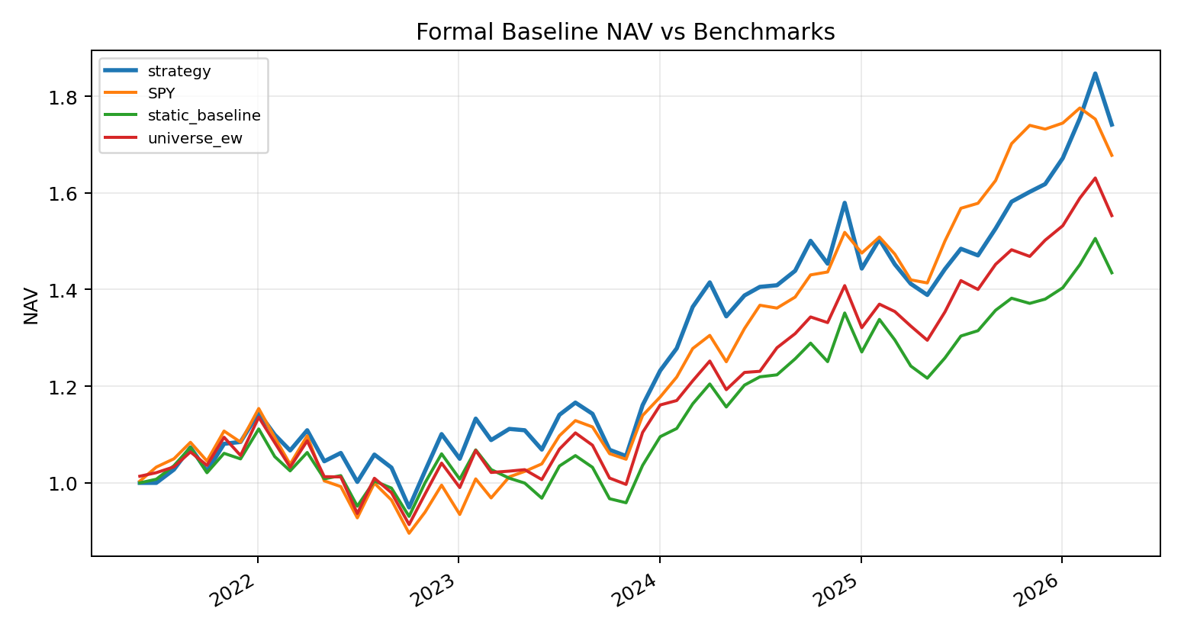
Figure: formal_baseline_nav_reference.png

