Purpose of document
Discuss how The Co-ordinator, REA, CMMN, VDML can be used together to provide an operational model for an online collaborative community, layered on top of each other.

Speech Act Theory
Searle (1975) identified five fundamental illocutionary points -- things you can do with an utterance:

Assertive: Commit the speaker (in varying degrees) to something being the case -- to the truth of the expressed proposition.
Directive: Attempt (in varying degrees) to get the hearer to do something. These include both questions (which can direct the hearer to make an assertive speech act in response) and commands (which direct the hearer to carry out some linguistic or non-linguistic act).
Commissive: Commit the speaker (again in varying degrees) to some future course of action.
Declaration: Bring about the correspondence between the propositional content of the speech act and reality (e.g., pronouncing a couple married).
Expressive: Express a psychological state about a state of affairs (e.g., apologizing and praising).
Conversation for Action
described in Winograd and Flores (1986).

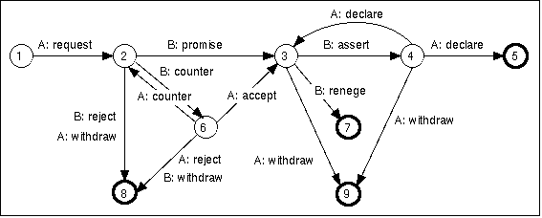
http://www.pluralisticnetworks.com/?q=history
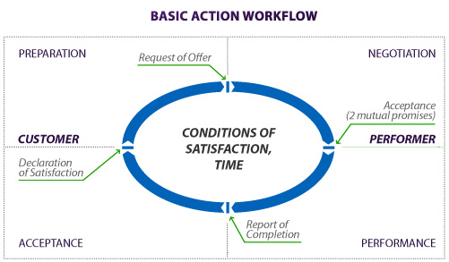
REA
An ontology for framing an individual economic exchange as a reciprocal flow of value between two agents
http://reatechnology.com/what-is-rea.html
Good for definining a contract up front, and a balance sheet afterwards.

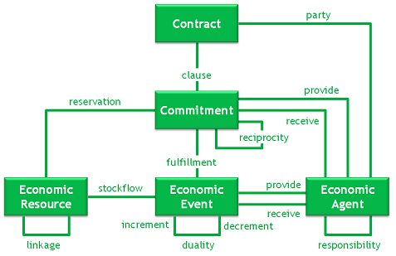
When looking at economic collaborations, REA is useful in breaking down the collaboration into atomic economic events. It thus provides a perspective at the most granular level.
A=Initiating Economic Agent
B=Responding Economic Agent
REA refers to the Agent's enduring role in the economic exchange as “party”, and the resulting relationship between the two agents by virtue of their position in the contract as “responsibility”
Preparation
The process of defining the nature of the need/request. Out of scope for REA. Assumed to precede the economic exchange.
A: Request
A defines need

Negotiation
The process of agreeing on both the providing and receiving commitments. Culminates in establishing a contract. Again, REA does not guide or restrict the details of this process, but documents its conclusion.
B: Reject
B walks away
A: Withdraw
A walks away, e.g. too expensive, quality prospects not acceptable.
B:Counter
A:Counter
Part o negotiation
B:Promise,A:Accept
This is where the two economic agents agree on the quantity the value of the two reciprocal commitments. We now have a contract. At this point, a reservation is placed on the economic resource/value to be exchanged. As a tangible, measurable resource (or resource time), the committed amount should be “reserved” in the agents stockpile/calendar. The system should prevent either party from over committing. Could freeze funds, allocate time on calendar, freeze stock.

Performance
REA does not explicitly dictate how the performance of an individual economic exchange happens, or how it is monitored. However, very possible that REA could be used to break a coarse grained exchange down into smaller, individual exchanges, in which case the completion of these individual “line items” would result in a solid measuring stick for progress.

B:Assert
Claim that the value promised by B is available/ready for consumption. Not recorded in REA.

Acceptance
This is the process of agreeing/negotiating the exact quantities of the value that has been provided
A:Declare (disagree)
Disagreement about the exact value – expecting the recriprocal value to either be reduced, or the provided value to be increased.
B:Renege
Exactly that- renege on the contract – not worth it.
A:Withdraw
Provided value not enough.
A:Declare (agree)
Agreement by A that the value committed to is indeed available. At this point REA can be used to record the resulting flow of value to A, and the reciprocal flow of value to B, the relation between the two flows/events is called “duality”

(http://www.jeffsutherland.org/oopsla2000/mccarthy/mccarthy.htm).

CMMN
Not an accounting ontology, nor a measurement methodology, therefore does not necessarily answer questions regarding quantities, resources or money. It focuses more
1. on the business entities users operate on and significant events they generate.
2. human activity an the events it generates.
3. planning and co-ordinating human activities in response to events.

One could use CMMN to model conversations for action, but that would lower the level of abstraction of models resulting in extremely verbose models. Fortunately, the concept of “planning” in CMMN leaves a significant opportunity to implement conversations for actions in every task. Planning could determine the inputs of a task, who gets to perform a task and what the terms of its completion are (due date, completion criteria, etc).

It would be fair to say the a conversation for action is a style of planning.
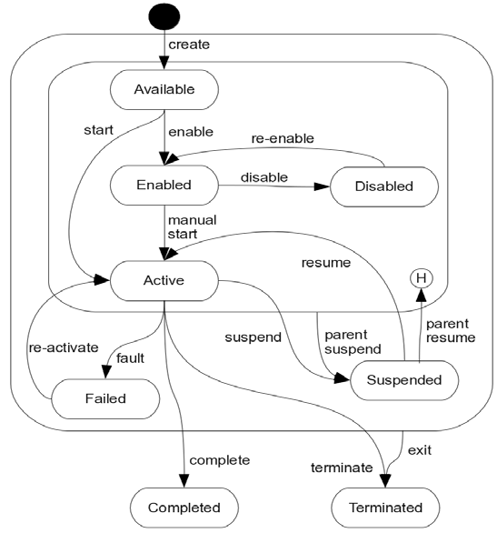

A is the case owner, the planner.
B is the performer of the task or potentially the owner of the “subcase”

Preparation
The process of defining the nature of task required. In CMMN, this would involve setting up business entities required in the task to a sufficient level of detail. In the process, potential tasks will be created/deleted as events occur in the business entity. This is very much a planning exercise.
A: Request
A indicates to the CMMN engine that all the potential tasks within the scope of planning are ready to be reviewed by potential performers. Whether this request will be sent out to a pool of potential performers or one specific potential performer depends on how the task was assigned.

Negotiation
The process of agreeing on both the inputs and outputs of the tasks, as well as the conditions for its completion such as . Still very much within the domain of planning. At this point a Human Task is created, but could be placed in a Suspended state to ensure that no activity takes place against the task. In fact, the various negotiation states could be considered “substates” of a kind of specialized planning Suspended state, but it may be easier to separate the two lifecycles.

B: Reject
B either ignores the request if it was sent to a pool of potential performers, or declines it if B was the only potential performer. B would not be liable for any losses incurred by A in the negotiation process. A needs to keep this in mind when preparing the request, gather just the right balance of information to construct the request, and also making sure that there is redundency in the choice of potential performers.
A: Withdraw
A decides the task should not be performed and disables the task. Withdrawal represents a pre-contractual breakdown. At this point, A is not liable for any losses that B has incurred, and B needs to keep that in mind when dedicating time and resources for a promise or a counter.

B :Counter
A:Counter
Counter proposals are expressed in terms of the business entities that are in scope for the task, and the attributes of the task itself, e.g. due date. This would form part of the planning activity. Since a counter proposal could become actual commitments, once could use the REA ontology to represent counters as “provisional” commitments. Commitments only become binding when A has accepted.

B:Promise
One small deviation is perhaps in order here. In CMMN, there will always be a broader planning context from which the conversation for action takes place. The planner needs to be comfortable with the entire picture before the commitments become binding. The promise from B would therefore still have to be a “provisional” commitment, as A may need to withdraw due to factors outside of the context of the conversation. Another task in the CMMN case may turn out to be so costly, that the task which is the topic of the current conversation needs to be withdrawn. In order to protect B, an expiration date needs to be placed on the promise.

A:Accept
This is where A agrees to the counter or promise from B, and commits to compensate B appropriately. A cannot Accept an expired promise or counter, and would need to reopen the negotiation if the promise has expired. At this point, the Commitments from both parties become binding.

Performance
In CMMN, a Human Task would be an atomic activity performed by a single participant. The task is either complete or it is not. Individual implementations may want to track progress, but this has limited value from the perspective of the conversation, as A would have to take B's word for feedback regarding the level of completion. Obviously if the task takes to long, A may withdraw, or it may be considered as B reneging on his/her commitment. This would constitute post-contractual breakdown

B:Assert
B notifies A that B considers the task to be completed. The required output has been produced, and is ready for A to assess. In CMMN, the task would still be Active, but A would have an opportunity to provide feedback.

Acceptance
This is the process where the Case owner/planner and performer negotiate on whether the task was completed successfully, and what needs to be done to get it to that point. The task remains Active in CMMN whilst the acceptance stage takes place. During acceptance, A would review the output of the task and either accept the task as completed or instruct B to do continue work on the task.

A:Declare Adequate
A this point, the task is considered complete. In CMMN the Task moves to the Complete state, which is a final state.
B:Renege
B decides not to continue with the Task. This is a contractual breakdown with possible liabilities. Some legal process may possibly follow. In CMMN this task moves to the Fault state, which is not a final state. Due to negotiations outside the current scope the parties may decide to terminate the task or reactivated it.
A:Withdraw
A declares that he/she is not willing to compensate B for the Task. Reasons could be failure of B, or changes in requirements in A. Again, the CMMN task is moved to the Fault state and legal processes may follow.
A:Declare Inadequate
A declares that the task needs some more work, but the conversation is still salvageable. The CMMN task remains in the Active state.

VDML
Up to now, we have only looked at Assertive, Commissive
Intangibles=Expressive
Expressives can be recorded throughout the conversation.
Before Committed only intangibles/expressives
Two levels to be negotiated: operational and meta level
Operational level, VDML does not assume any details of how the conversation takes place.
DeclareAdequate would result in the tangible value flows being recorded.
The negotiation process could involve intangibles as well, which could result in a transformation of intangible to intangible. Intangibles however, by definition, cannot be legally binding. Nevertheless, the measurement of intangibles will take place. The exchange of intangibles will form the basis of a personal trust relationship, and are essential for the conversation.
Counters follow Value Propositions and Resource Use
ResourceUse is an economic event, contractually agreed upon during Negotiation, Could be input into Task
CapabilityOffers could be used to determine who to have the conversation with.
The “Pay” Activity may not be represented at all in CMMN

Example
Building Case
Case Owner: Home Owner
Roles: Foundation Layer, Brick Layer, Plasterer, Painter, Carpenter, Trusses Supplier, Tiler, Electrician, Plumber.
Stores: Foundation Mix, Cement, Bricks, Tiles, Roof tiles/sheets, Paint, Bonding liquid, Plaster Sand, Building Sand, Doors,
Step 1:
Lay foundation.
Input Documents: House Plan, Bill of Materials for Foundation with pre-agreed quantities
Input Resources: Foundation Mix, Water, Money, Compaction Hammer, Fuel for the Compaction Hammer.
Output Documents: House Progress Report, Updated Bill of Materials, Assessment of Foundation by inspector
Output Resources: Foundation
Events:
Money from Home Owner for Labour by Foundation Layer,
Money from Home Owner for Compaction Hammer
Foundation mix, Converted to Foundation.
Water converted to Foundation
Fuel Consumed by the Compaction Hammer
Money to equipment supplier for Hammer

Searle, J. R. (1975). A taxonomy of illocutionary acts. In K. Gunderson (Ed.), Language, Mind and Knowledge, 344-369. Minneapolis: University of Minnesota Press.

Winograd, Terry, and Fernando Flores. 1986. Understanding computers and cognition: A new foundation for design. Norwood, N.J.: Ablex Pub. Corp.

