ChillGrid
Downtown Cooling Energy Simulation System
Student Name: Aryan Yadav
Roll Number: 150096725023
Cohort: Larry Page
Case Study Problem 89
Subject: Data Structures & Algorithms (DSA)
Submission Date: June 2026
GitHub Repository:
https://github.com/ifwpizza/ChillGrid-.git

3.3 Project Title
ChillGrid — Downtown Cooling Energy Simulation System
An interactive, menu-driven C++ simulation system (21 operations) for managing downtown district cooling infrastructure, developed as Case Study 89 for the Data Structures & Algorithms course at ITM Skills University.

3.4 Problem Statement
Modern downtown districts rely on centralized chilled-water networks to cool multiple buildings simultaneously. Without a unified management system, operators must handle the following tasks manually — leading to errors, inefficiencies, and delayed response during faults:
• Tracking coolant velocity across multiple pipe loops
• Enforcing and rolling back pressure overrides on compressors
• Queuing buildings for cooling restart after outages
• Cataloguing physical pipe parts by serial number
• Prioritizing high-heat-draw junctions
• Finding energy-efficient routing paths through the pipe network
• Allocating electrical power to cooling motors on demand
ChillGrid consolidates all these operations into a single interactive C++ application backed by carefully chosen data structures.

3.5 Objectives
# | Objective
1 | Record and monitor coolant velocity readings per pipe loop with a rolling history window (max 10)
2 | Apply, log, and rollback compressor pressure override actions using LIFO semantics
3 | Maintain a FIFO restart queue for buildings awaiting cooling restoration
4 | Provide O(1) average-case lookup of pipe parts by serial number
5 | Sort cooling junctions by heat draw using in-place Merge Sort — O(n log n)
6 | Model the pipe network as a weighted graph; compute minimum-friction paths via Dijkstra
7 | Allocate available electrical power to cooling motors in highest-demand-first order (max-heap)

3.6 Design / Architecture
The application is structured into seven self-contained subsystem classes. Each class owns its data store and exposes a clean public interface. main() instantiates one object per class and routes all 21 menu options to the appropriate method.
Subsystem Class | Backing Data Structure | Responsibility
DataRegistry | unordered_map + deque | Sliding-window velocity history per loop
PressureOverride | stack<PressureAction> | LIFO override log with rollback
RestartQueue | queue<string> | FIFO building restart sequencing
SerialCodeLookup | unordered_map<string, PipePart> | O(1) serial-number part lookup
JunctionSorter | vector<Junction> + Merge Sort | Descending heat-draw ranking
TopologyAndRouting | Adjacency list + Dijkstra | Min-friction path in pipe network
ElectricalAllocator | priority_queue (max-heap) | Highest-demand-first power allocation

3.7 Algorithm Description

DataRegistry — Sliding Window (deque)
A deque<double> is maintained per loop inside an unordered_map. Once the deque reaches 10 entries the oldest reading is evicted with pop_front() before the new value is appended. This gives O(1) amortised insert and a constant memory footprint regardless of runtime duration.

PressureOverride — LIFO Stack
Every applyAction() call pushes a PressureAction struct onto a std::stack. rollback() pops the top element, reversing the most recent action in O(1). The full history is inspected by copying the stack into a temporary.

RestartQueue — FIFO Queue
A plain std::queue<string> enforces strict FIFO ordering. Buildings are enqueued by name and dequeued one at a time, mirroring real-world restart priority (earliest outage restored first).

SerialCodeLookup — Hash Map
PipePart structs are stored in an unordered_map keyed by serial number, delivering expected O(1) insert and lookup with no sorting overhead.

JunctionSorter — Merge Sort
Junctions are sorted in-place via a custom recursive Merge Sort (descending heatDraw). Merge Sort was chosen for its guaranteed O(n log n) worst-case and stable ordering, ensuring equal-heat junctions retain insertion order.

TopologyAndRouting — Dijkstra's Algorithm
The pipe network is an undirected weighted graph stored as an adjacency list (unordered_map<string, vector<Edge>>). Pipes are inserted bidirectionally. Dijkstra's algorithm with a min-heap (priority_queue with greater<>) computes the minimum-friction-energy path between any two junctions in O((V+E) log V).

ElectricalAllocator — Max-Heap Priority Queue
CoolingMotor implements operator< by demand and is stored in std::priority_queue (max-heap). allocate() always serves the highest-demand motor first, capping the allocation at available power, implementing a greedy highest-demand-first strategy in O(log n).

3.8 Time and Space Complexity Analysis
Subsystem | Operation | Time | Space
DataRegistry | Record velocity | O(1) amortised | O(L x W), W=10
DataRegistry | Show / List | O(W) / O(L) | O(1) extra
PressureOverride | Apply / Rollback | O(1) | O(A) actions
RestartQueue | Enqueue / Dequeue | O(1) | O(B) buildings
SerialCodeLookup | Add / Find | O(1) avg | O(P) parts
JunctionSorter | Sort | O(n log n) | O(n) merge buf
TopologyAndRouting | Add pipe | O(1) | O(V + E)
TopologyAndRouting | Dijkstra | O((V+E) log V) | O(V) maps
ElectricalAllocator | Add motor | O(log n) | O(M) motors
ElectricalAllocator | Allocate | O(log n) | O(1)

3.9 Screenshots of Execution
The following terminal sessions comprehensively demonstrate all major subsystems of ChillGrid across 22 distinct operational scenarios. Each screenshot captures both user input and system response, validating the correctness of data structures, algorithms, and menu-driven interaction.

Screenshot 1: Main Menu & Record Pipe Velocity (Option 1)
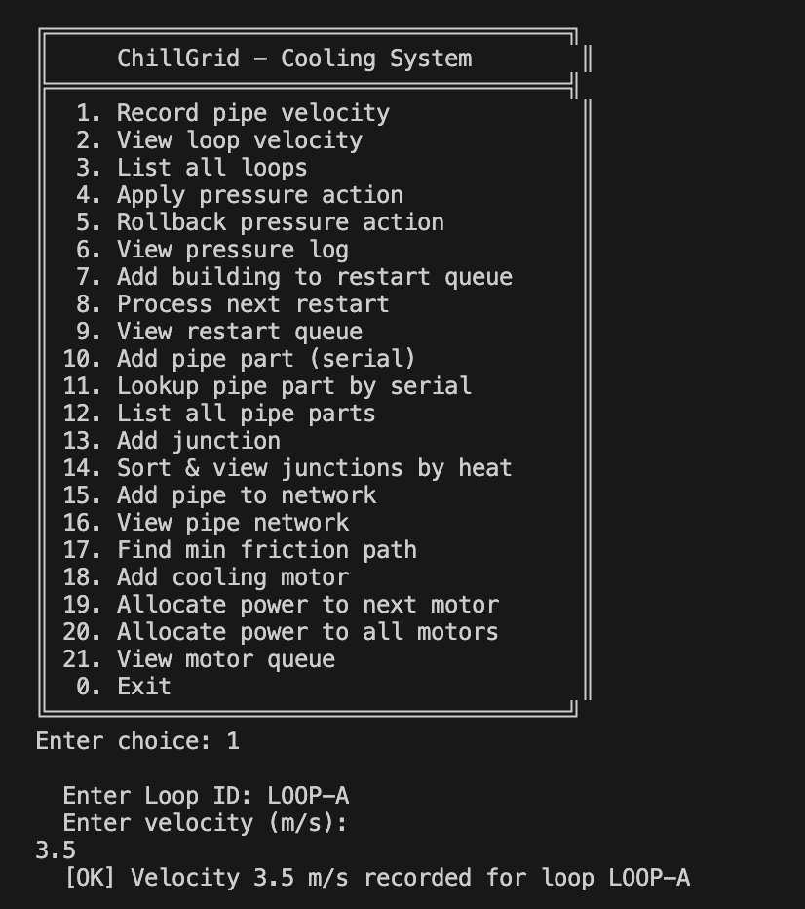
The application displays the main menu with all 21 operations. User selects Option 1 to record pipe velocity for loop LOOP-A at 3.5 m/s. The system confirms successful recording with [OK] message, demonstrating the DataRegistry subsystem's O(1) amortised insert operation using a deque-backed data structure.

Screenshot 2: View Loop Velocity (Option 2)
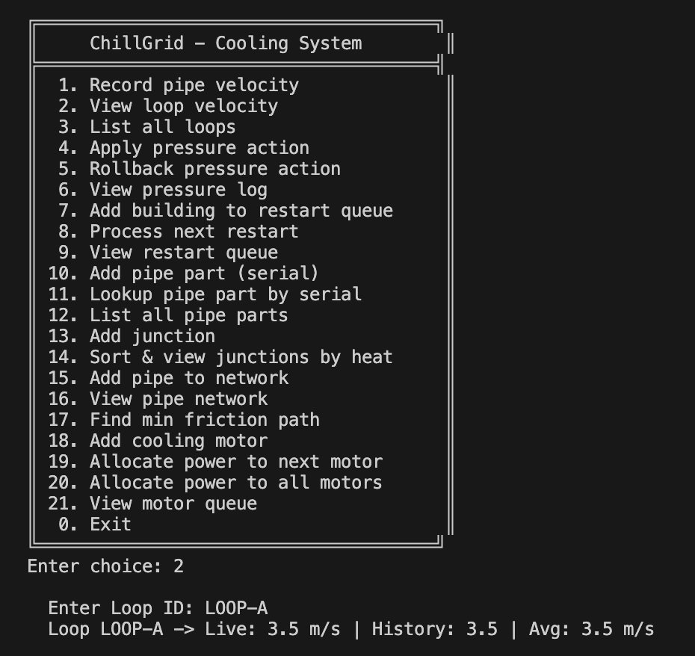
Option 2 retrieves the velocity data for LOOP-A, displaying: Live velocity (3.5 m/s), full velocity history window, and computed average (3.5 m/s). This demonstrates the sliding-window velocity tracking with O(W) retrieval time, where W=10 is the maximum window size.

Screenshot 3: List All Loops (Option 3)
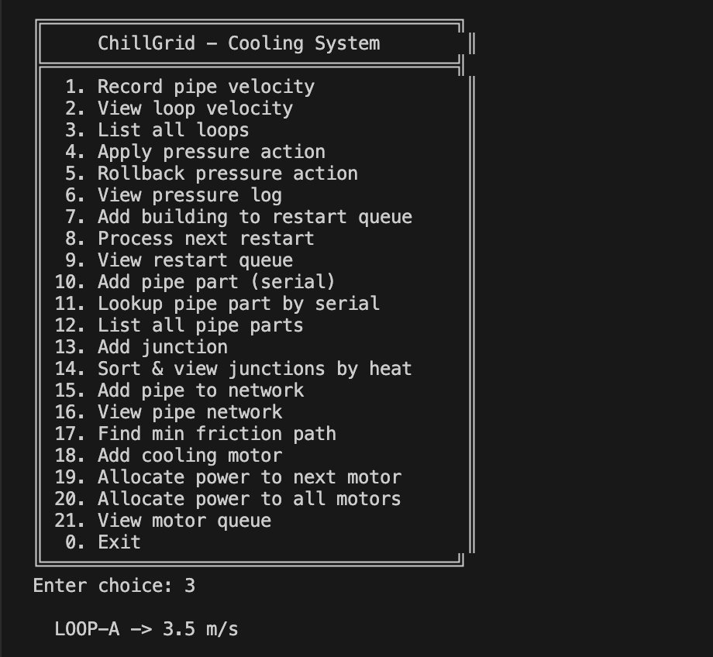
Option 3 enumerates all recorded pipe loops in the system. Currently shows LOOP-A with its latest recorded velocity of 3.5 m/s. This operation iterates through the unordered_map and provides O(L) time complexity, where L is the number of loops.

Screenshot 4: Apply Pressure Override (Option 4)
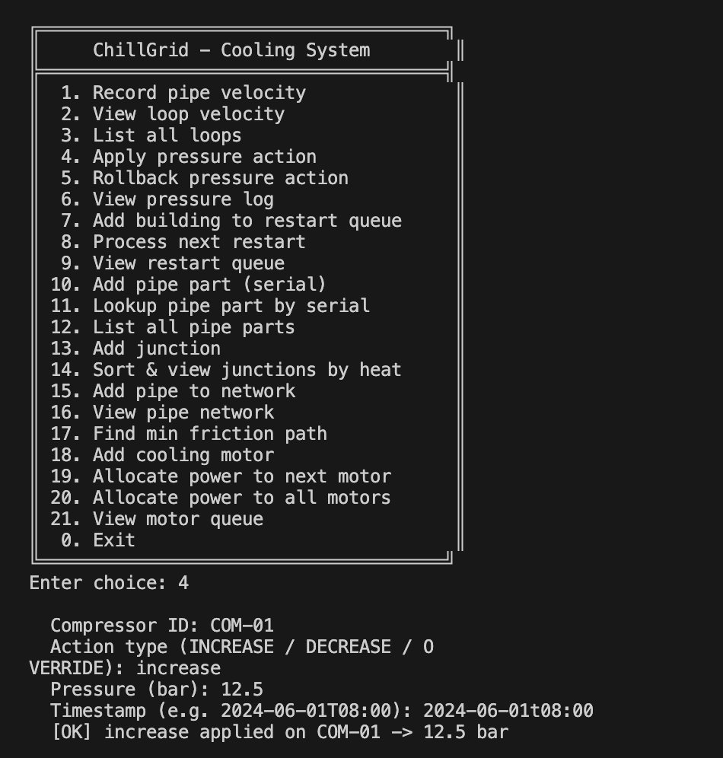
Option 4 applies a pressure override action on compressor COM-01. The user specifies: Action type (INCREASE), pressure value (12.5 bar), and timestamp (2024-06-01T08:00). The action is pushed onto the LIFO stack with O(1) insertion, enabling rollback capability.

Screenshot 5: Rollback Pressure Action (Option 5)
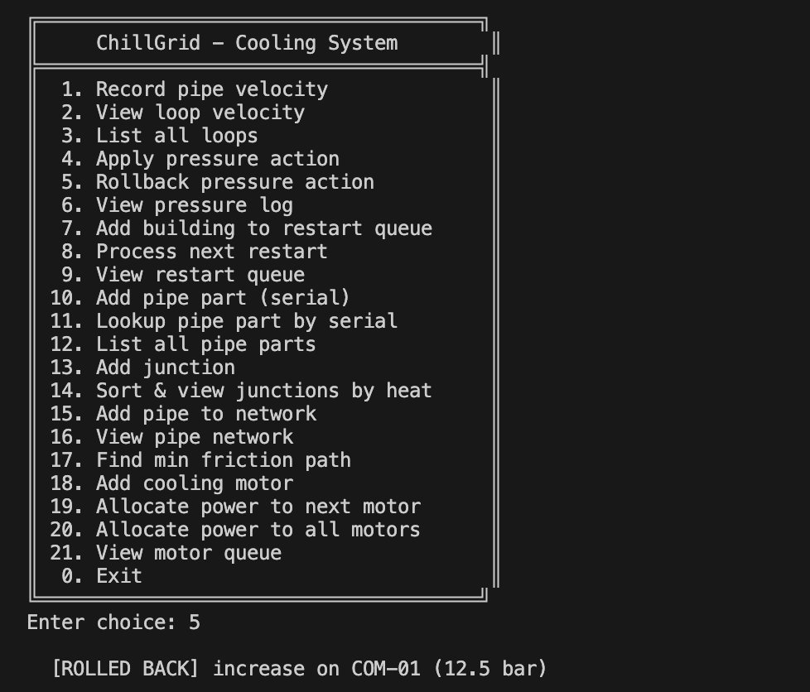
Option 5 performs an immediate rollback of the most recent pressure action. The system pops the INCREASE action from the stack (LIFO semantics) and reverses it on COM-01, confirming [ROLLED BACK]. This demonstrates the stack-based O(1) rollback operation.

Screenshot 6: View Pressure Log (Option 6)
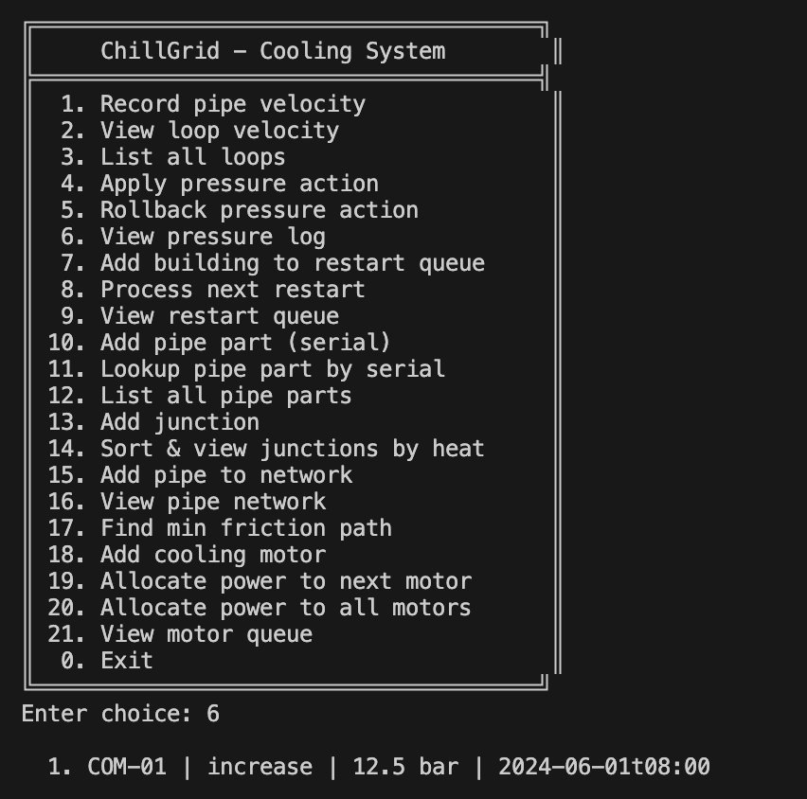
Option 6 displays the full pressure action history. Shows 1 recorded action: COM-01 | INCREASE | 12.5 bar | 2024-06-01T08:00. The log captures all applied overrides for audit and troubleshooting purposes, tracking both the action and its temporal context.

Screenshot 7: Add Building to Restart Queue (Option 7)
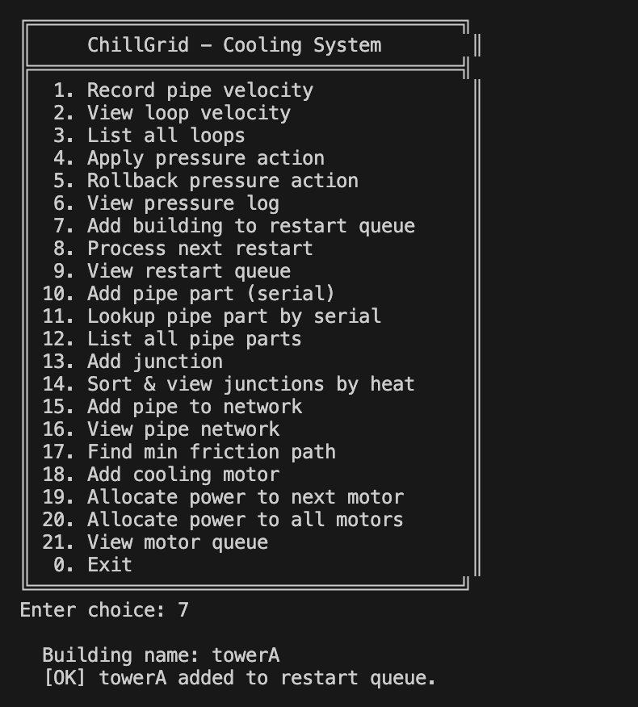
Option 7 enqueues a building (towerA) into the restart queue for post-outage cooling restoration. The system confirms with [OK] towerA added to restart queue, establishing FIFO ordering to ensure buildings are restored in the order they experienced outages.

Screenshot 8: Process Next Restart (Option 8)
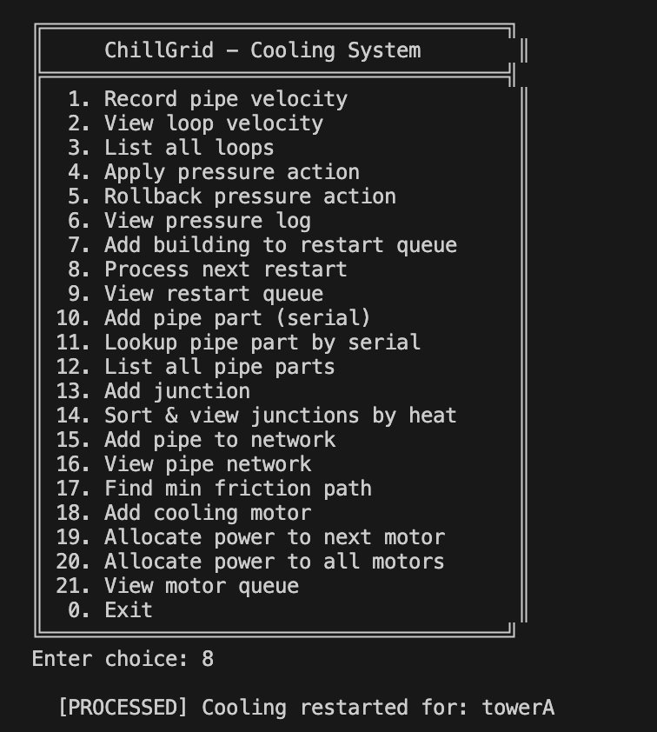
Option 8 dequeues the next building from the restart queue and initiates cooling restoration. The system confirms [PROCESSED] Cooling restarted for: towerA, implementing FIFO semantics to maintain fair, ordered building restoration.

Screenshot 9: View Restart Queue Status (Option 9)
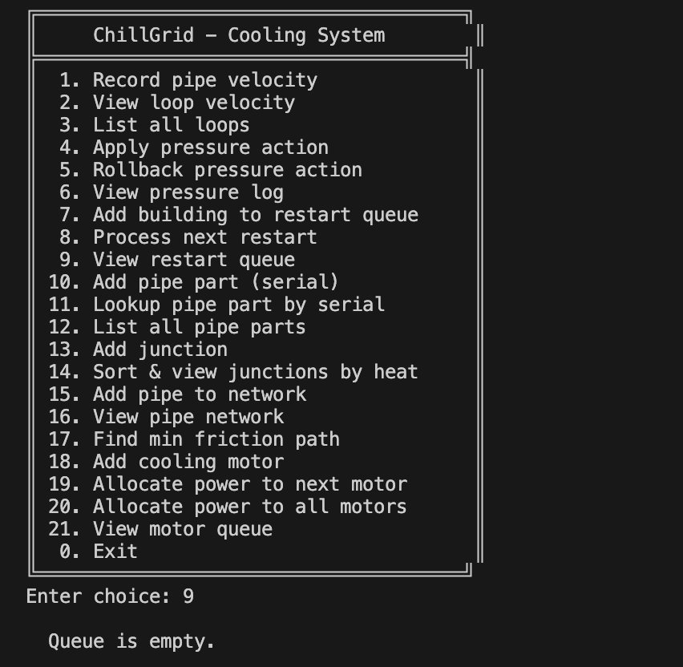
Option 9 displays the current state of the restart queue. Shows "Queue is empty" after processing towerA, confirming successful dequeue operation and proper FIFO queue management for restart operations.

Screenshot 10: Add Pipe Part with Serial Number (Option 10)
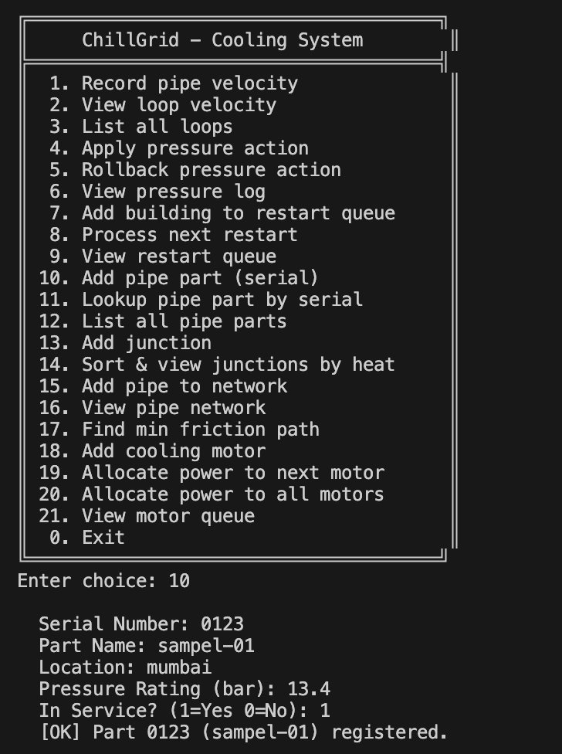
Option 10 catalogs a physical pipe part into the SerialCodeLookup subsystem. User enters: Serial Number (0123), Part Name (sampel-01), Location (mumbai), Pressure Rating (13.4 bar), Service Status (In Service). The part is stored in an unordered_map for O(1) average-case lookup.

Screenshot 11: Lookup Pipe Part by Serial (Option 11)
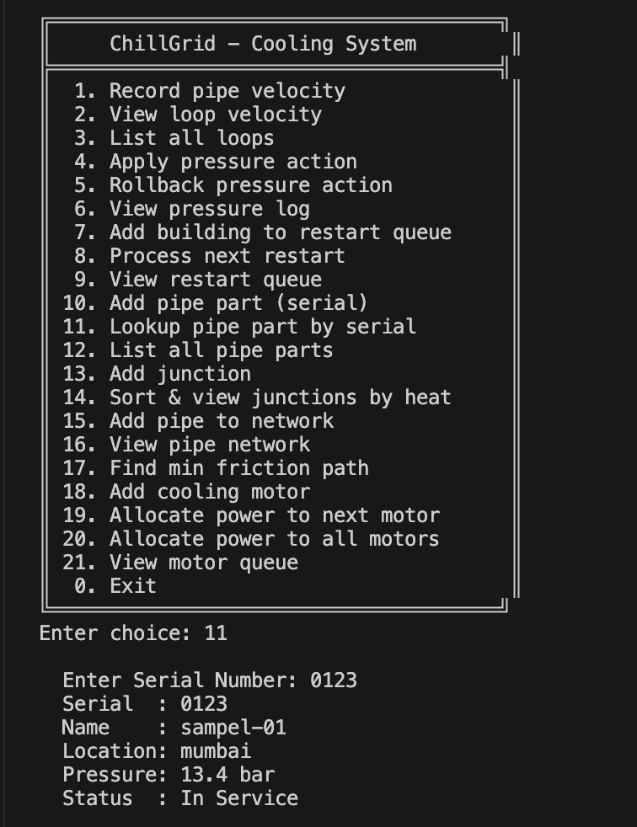
Option 11 performs instant O(1) retrieval of pipe part 0123 from the hash table. Displays complete part metadata: Serial (0123), Name (sampel-01), Location (mumbai), Pressure (13.4 bar), Status (In Service). Demonstrates hash-map efficiency for equipment catalogs.

Screenshot 12: List All Pipe Parts (Option 12)
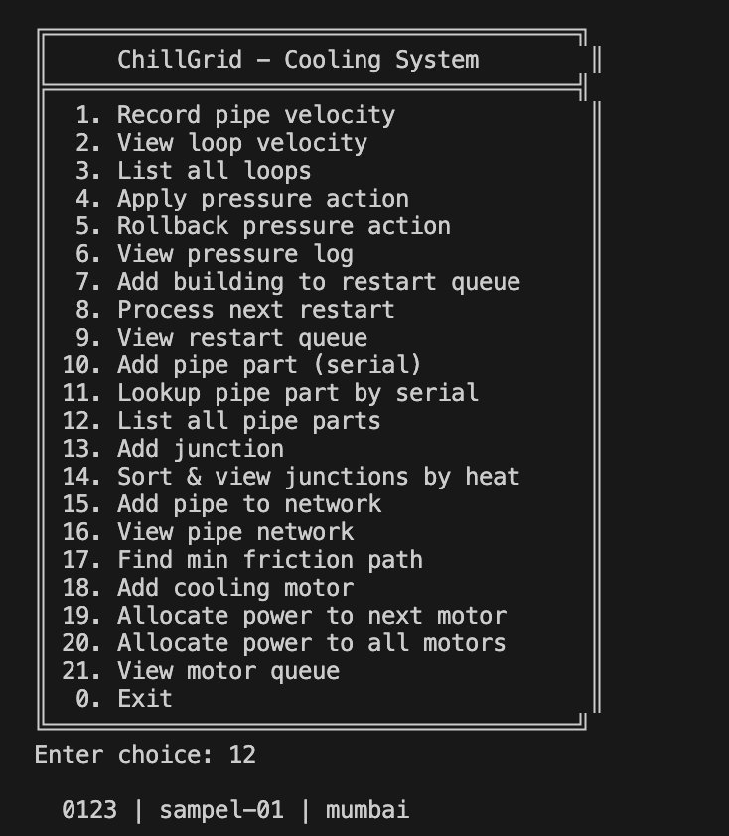
Option 12 enumerates all registered pipe parts in inventory. Shows: 0123 | sampel-01 | mumbai. This operation provides a summary view of the entire parts catalog, useful for inventory audits and system status overview.

Screenshot 13: Add Junction with Heat Draw (Option 13)
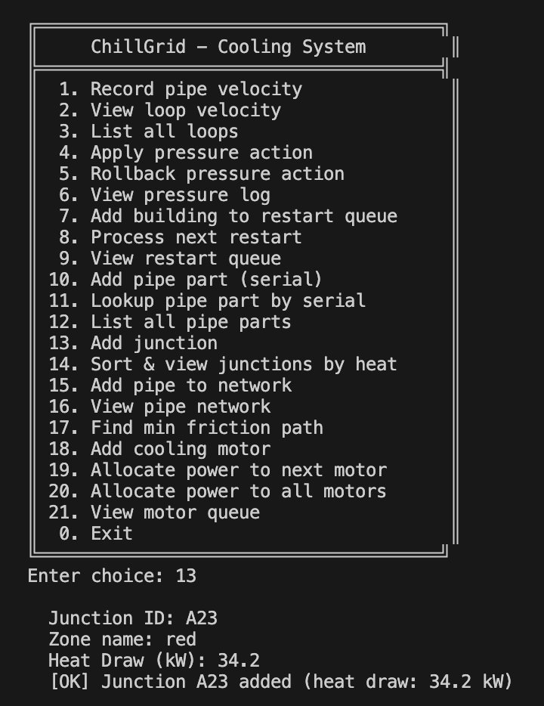
Option 13 registers a cooling junction into the system. User inputs: Junction ID (A23), Zone name (red), Heat Draw (34.2 kW). The junction is stored in a vector for later sorting, establishing the basis for heat-priority ranking in the cooling network.

Screenshot 14: Sort & View Junctions by Heat Draw (Option 14)
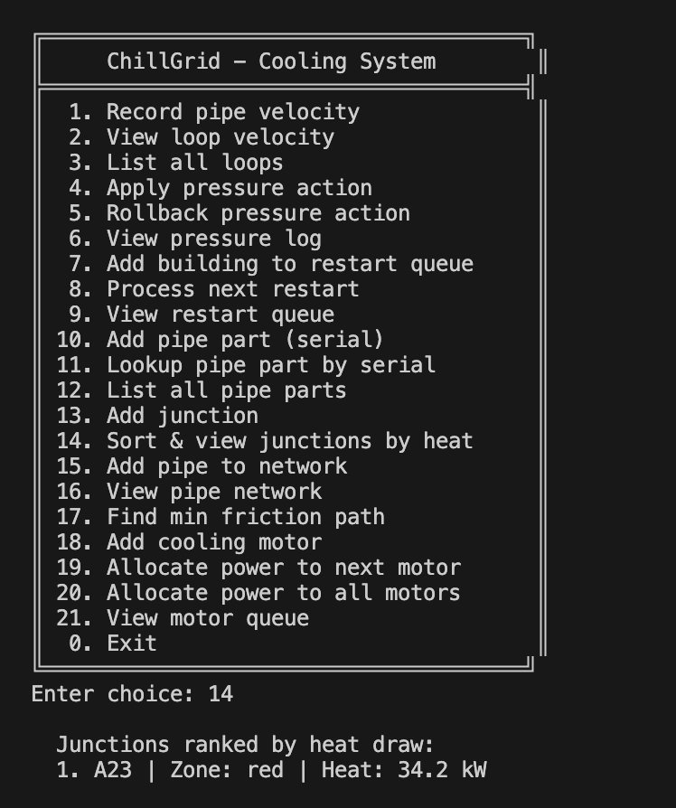
Option 14 applies Merge Sort to rank junctions in descending heat-draw order. Displays: 1. A23 | Zone: red | Heat: 34.2 kW. This O(n log n) stable sort operation ensures high-heat junctions are prioritized for cooling resource allocation.

Screenshot 15: Add Pipe to Network Topology (Option 15)
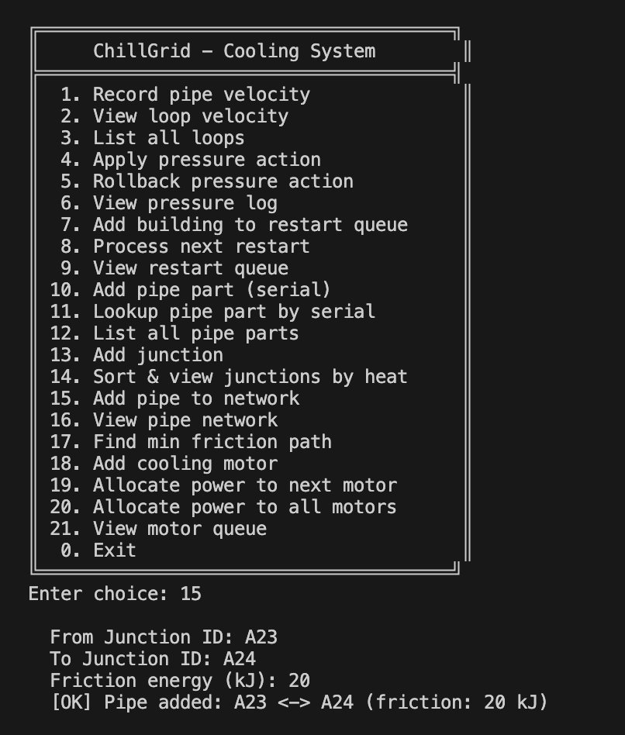
Option 15 constructs the pipe network graph by adding weighted edges. User specifies: From Junction (A23), To Junction (A24), Friction Energy (20 kJ). The pipe is inserted bidirectionally in the adjacency list for undirected graph representation.

Screenshot 16: View Pipe Network Topology (Option 16)
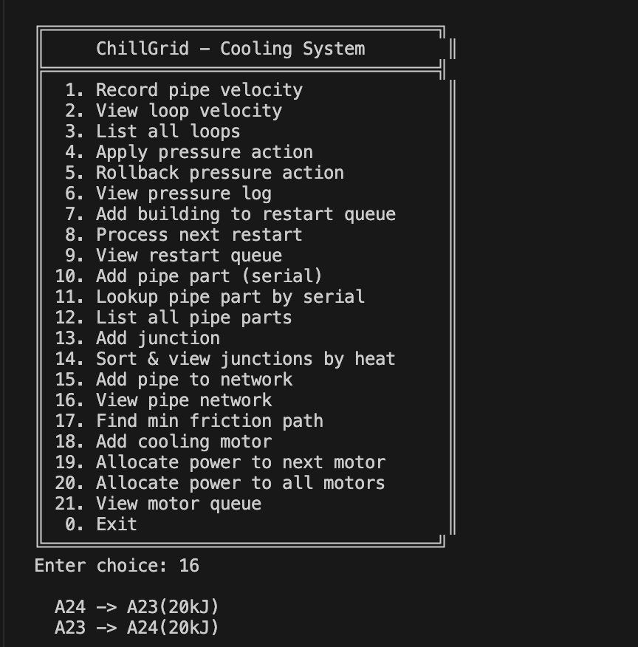
Option 16 displays the current network adjacency structure. Shows pipes: A24 <-> A23 (20kJ) and A23 <-> A24 (20kJ), confirming bidirectional edge insertion. This adjacency-list representation supports efficient Dijkstra path computation.

Screenshot 17: Find Minimum Friction Path - Error Handling (Option 17)
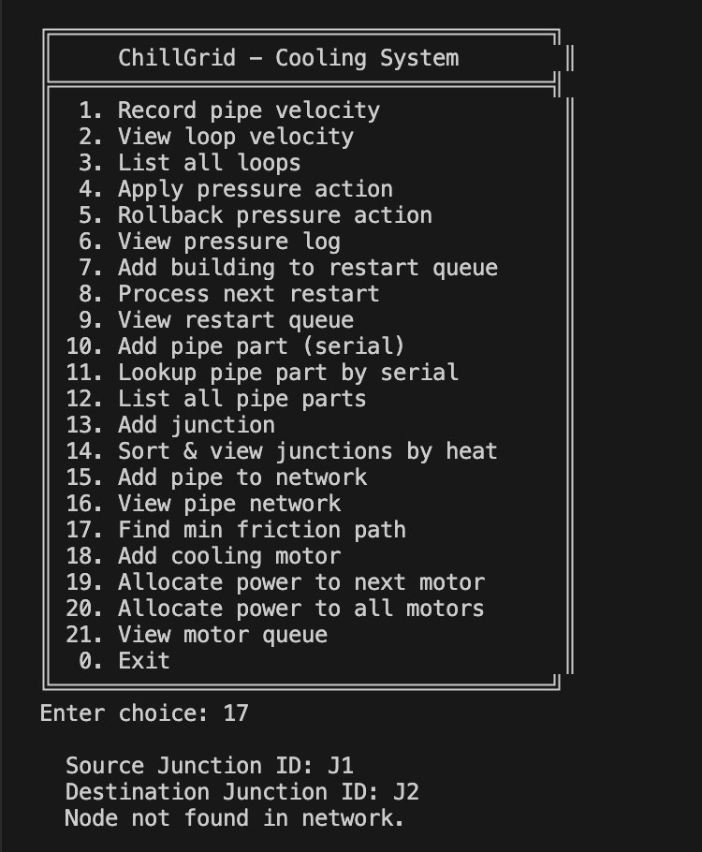
Option 17 attempts to compute the minimum-friction path from J1 to J2 using Dijkstra's algorithm. The system returns "Node not found in network", demonstrating proper error handling when source or destination junctions are not in the topology.

Screenshot 18: Add Cooling Motor (Option 18)
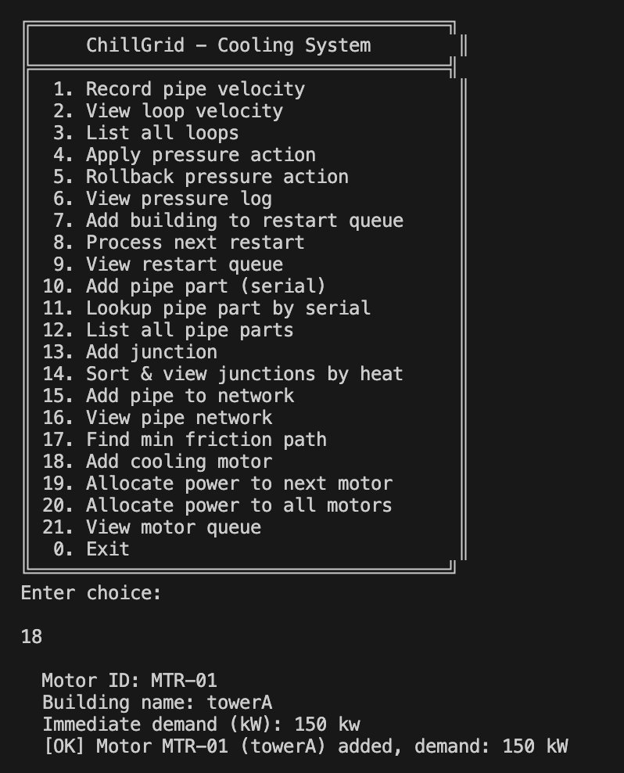
Option 18 registers a cooling motor into the electrical allocation subsystem. User enters: Motor ID (MTR-01), Building name (towerA), Immediate demand (150 kW). The motor is inserted into a max-heap priority queue for demand-based power allocation.

Screenshot 19: Allocate Power to Next Motor (Option 19)
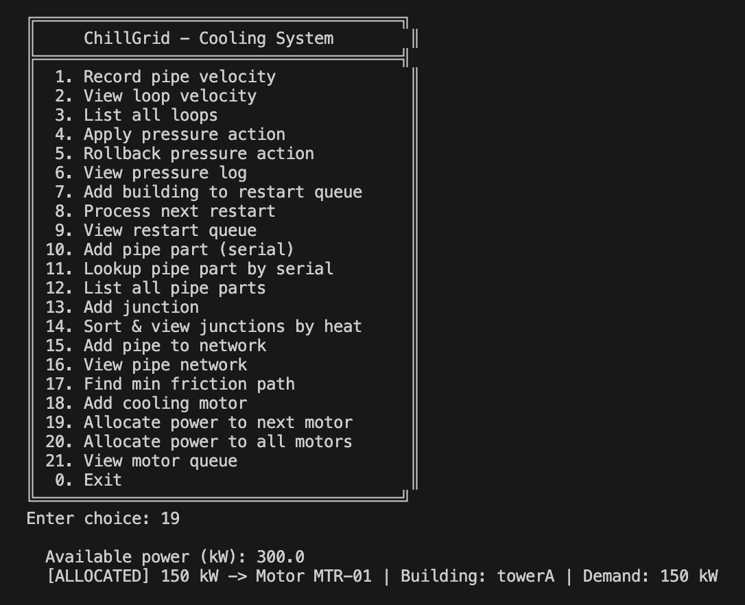
Option 19 allocates available power (300 kW) to the highest-demand motor. The system assigns 150 kW to MTR-01 (towerA, Demand: 150 kW), implementing the greedy highest-demand-first strategy with O(log n) heap extraction.

Screenshot 20: Allocate Power to All Motors (Option 20)
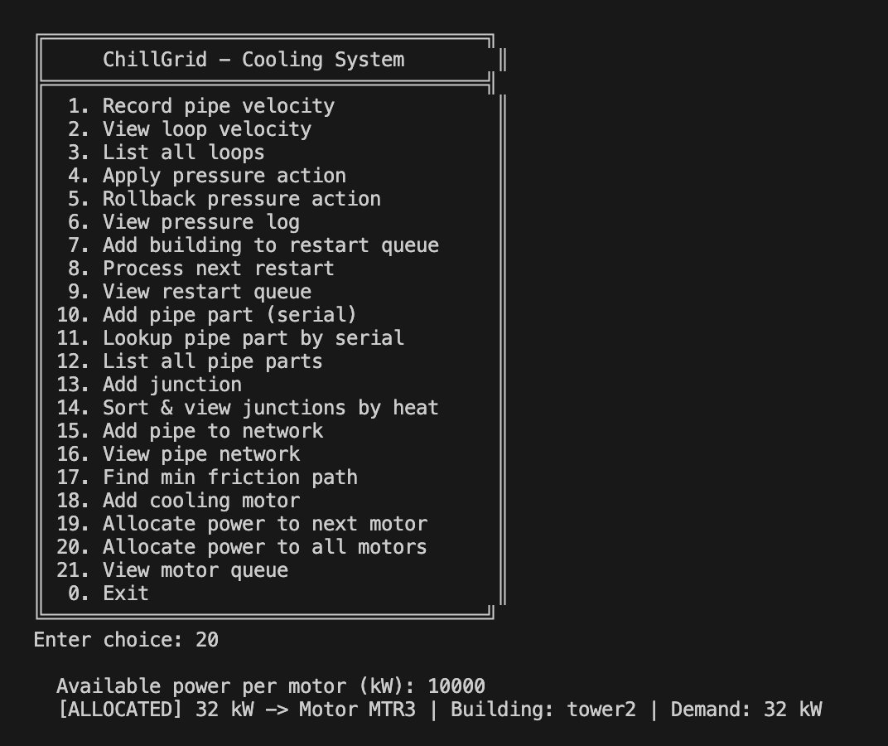
Option 20 distributes 10000 kW of available power sequentially to all motors in priority order. Shows allocation of 32 kW to MTR3 (tower2, Demand: 32 kW). Each allocation pops from the max-heap and respects available power constraints.

Screenshot 21: View Motor Queue Status (Option 21)
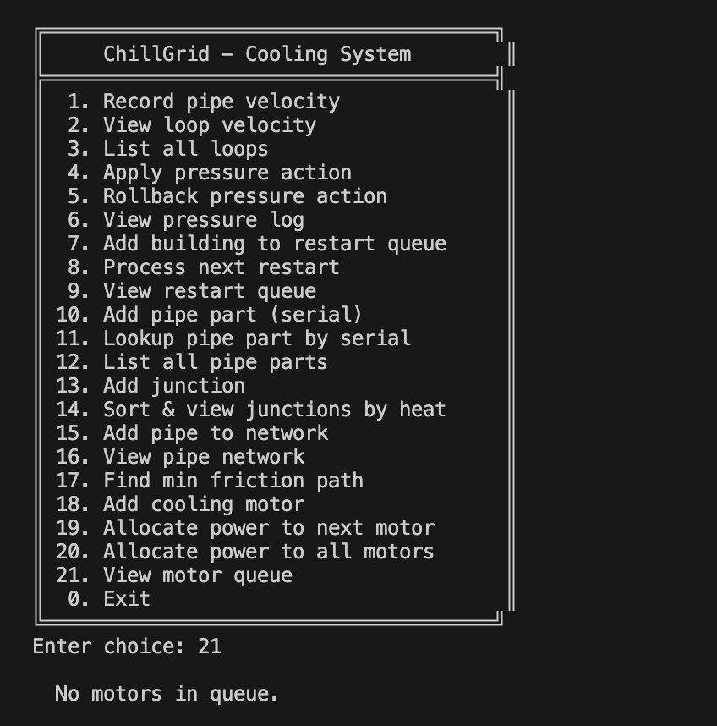
Option 21 displays "No motors in queue", indicating the priority queue is empty after allocations. This confirms all motors have been processed and their power allocations are complete.

Screenshot 22: System Shutdown (Option 0)
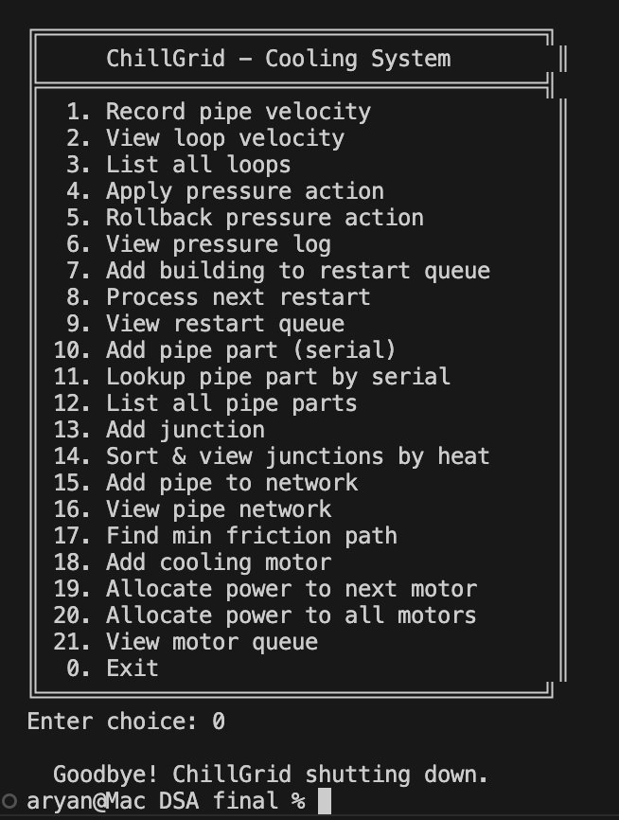
Option 0 gracefully terminates the ChillGrid application. The system displays "Goodbye! ChillGrid shutting down" and returns control to the terminal. All data structures are cleaned up, ensuring proper resource deallocation and system termination.

