Automated Quantification of Perceptually Significant Colors in Dermoscopy Images and Its Application to Skin Lesion Classification

Azaria Zornberg
Abstract

Dermoscopy is a non-invasive skin imaging technique, which permits visualization of features of pigmented melanocytic neoplasms that are not discernible by examination with the naked eye. Color information is indispensable for the clinical diagnosis malignant melanoma, the most deadly form of skin cancer. For this reason, most of the currently accepted dermoscopic scoring systems either directly or indirectly incorporate color as a diagnostic criterion. For example, both the ABCD rule of dermoscopy and the more recent CASH algorithm include the number of clinically significant colors in their calculation of malignancy scores. In this paper, we present a machine learning approach to the automated quantification of perceptually significant colors in dermoscopy images. Given a true-color dermoscopy image with N colors, we first reduce the number of colors in this image to a small number K, K « N, using the k-means clustering algorithm incorporating a spatial term. The optimal K value for the image is estimated separately using five commonly used cluster validity criteria. We then train a symbolic regression algorithm using the estimates given by these criteria, which are calculated on a set of 617 images. Finally, the mathematical equation given by the regression algorithm is used for two-class (benign vs. malignant) classification. The proposed approach yields a sensitivity (the percentage of correct malignant diagnoses) of 62% and a specificity (the percentage of correct benign diagnoses) of 76% on an independent test set of 297 images.
1. Introduction
Invasive and in-situ malignant melanoma together comprise one of the most rapidly increasing cancers in the world. Invasive melanoma alone had an estimated incidence of 76, 250 and an estimated total of 9, 180 deaths in the United States in 2012 [1]. Early diagnosis is particularly important since melanoma can be cured with a simple excision if detected early. Dermoscopy, also known as epiluminescence microscopy, is a non-invasive skin imaging technique that uses optical magnification and either liquid immersion and low angle-of-incidence lighting or cross-polarized lighting; this makes subsurface structures more easily visible when compared to conventional clinical images [2]. Dermoscopy allows the identification of dozens of morphological features such as atypical pigment networks, dots/globules, streaks, blue-white areas, and blotches [3]. This reduces screening errors, and provides greater differentiation between difficult lesions such as pigmented Spitz nevi and small, clinically equivocal lesions [4]. However, it has been demonstrated that dermoscopy may actually lower the diagnostic accuracy in the hands of inexperienced dermatologists [5]. Therefore, in order to minimize the diagnostic errors that result from the difficulty and subjectivity of visual interpretation, the development of computerized image analysis techniques is of paramount importance [6].
Color information is indispensable for the clinical diagnosis of melanoma [7]. The most important chromophore in melanocytic neoplasms is melanin. The color of melanin essentially depends on its localization in the skin: black due to melanin located in the stratum corneum and the upper epidermis, light to dark brown in the epidermis, gray to gray-blue in the papillary dermis and steel-blue in the reticular dermis. Blue coloration occurs when there is melanin localized within the deeper parts of the skin as the portions of visible light with shorter wavelengths are more dispersed than portions with longer wavelengths. Red coloration is associated with an increased number or dilation of blood vessels, trauma, or neovascularization. White coloration is often caused by regression and/or scarring.
Most of the currently accepted dermoscopic scoring systems either directly or indirectly incorporate color as a diagnostic criterion [8]. For example, both the ABCD (Asymmetry, Border, Colors, Dermoscopic structures) rule of dermoscopy [9] and the more recent CASH (Color, Architecture, Symmetry, and Homogeneity) algorithm [8] consider six different colors in determining the color score: white, red, light brown, dark brown, blue-gray, and black (Fig. 1) In both schemes the color score contributes more than 33% to the overall score. Menzies’ scoring method [10] considers the presence of a single color as a negative feature enabling the exclusion of a melanoma diagnosis, whereas the presence of multiple colors is considered as a positive feature. More specifically, the presence of five to six colors has a specificity of 92% and a sensitivity of 53% for invasive melanoma [11]. Finally, according to Pattern Analysis [12] and its simplified variant the 7-point checklist [13], the presence of colored dermoscopic structures such as brown globules, blue-white areas, and black dots are diagnostically significant.

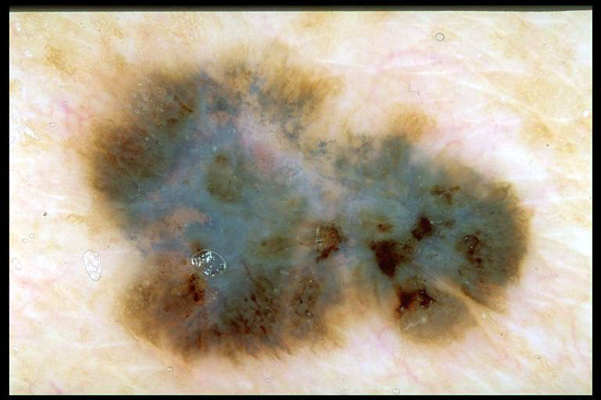
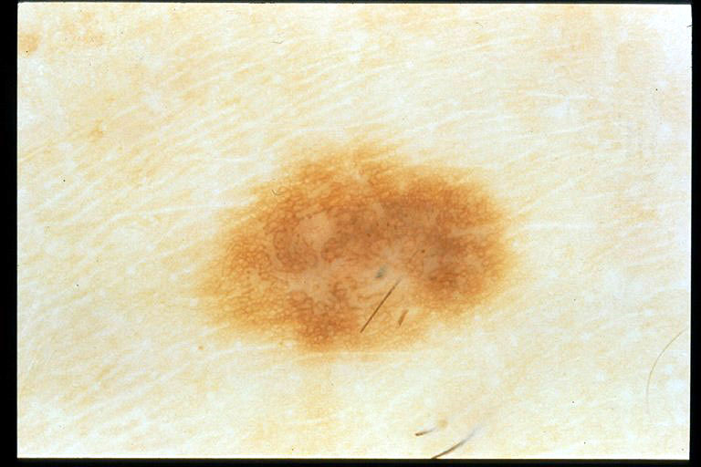
Figure 1: Two lesions with significantly different numbers of colors.

(a) Dysplastic nevus with two colors (light brown and dark brown)

(b) Invasive melanoma with five colors (white, light brown, dark brown, blue-gray, and black)

Numerous studies utilized color information for the classification of skin lesions in dermoscopy images [14 - 20]. Most of these studies, however, involved the use of simple low-level cues such as mean and variance of various color channels to characterize the color content of lesions. A notable exception is Seidenari et al.’s study [21], where a reference palette with 23 colors was determined over a training set of 369 images (326 nevi and 43 melanomas). On an independent test set of 243 images (200 nevi and 43 melanomas), the authors obtained between 63 and 79% sensitivity and between 62 and 85% specificity depending on the discriminant analysis threshold. It should be noted, however, that Seidenari et al’s approach requires both a calibrated image acquisition system and a border detection step prior to color analysis. This makes it less efficient to implement as it is unable to function without a calibrated image acquisition system, which puts the burden of obtaining one upon the dermatologist utilizing the system. Being unable to function without a border detection step also renders it less time-efficient as such a step can consume large amounts of time in dire situations where speedy action may be necessary.
A machine learning approach to the automated quantification of perceptually significant colors in dermoscopy images was developed for the purpose of this research. Machine learning is a discipline concerned with the design and development of algorithms that take empirical data as their input and attempt to detect underlying patterns in the data that are originally unknown.
A special class of machine learning algorithms includes clustering algorithms. The goal of a clustering algorithm is to attempt to group a set of n-dimensional data points into various sets or clusters [22]. They can be useful in both determining the number of groups a data set contains, as well as the assignment of a specific data point to a particular group. This is because, following the termination of most clustering algorithms, all data points will have been assigned to a cluster (fig. 2). Clustering algorithms can also make use of cluster validity criteria. Cluster validity criteria are functions whose purpose is to, when given a set of clusters for a given data set, determine which set or number of clusters best fits the data set. This is usually done mathematically through various measurements of spread and compactness.
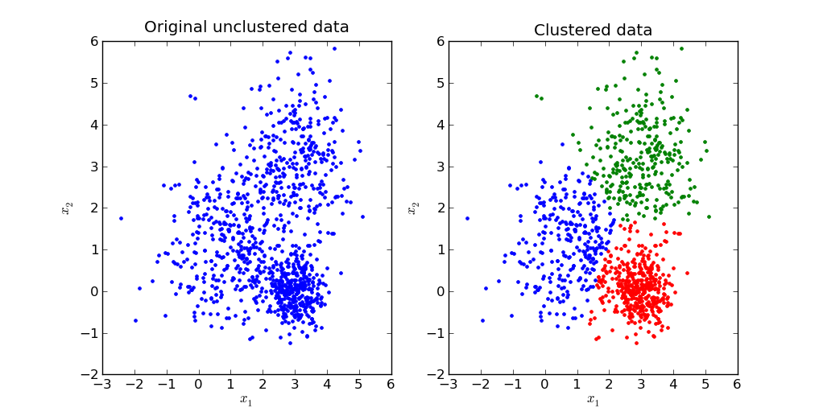

Figure 2: An example of a data set before and after clustering algorithms are performed. The data displayed has a dimensionality of 2.

Color Quantization is the process of converting an image into a set of data points that represent the converted image. The usual method of doing this is by using the RGB values of each pixel in an image as a 3-dimensional data point. However, it is also common to use special data to create a set of 5-dimensional data points that include x and y locations as values. To perform the actual conversion of images into data points, there are various different systems whose effectiveness differs with each individual image. By combining the use of color quantification and clustering algorithms to analyze images, it is hypothesized that an effective and efficient machine learning approach to the automated quantification of perceptually significant colors in dermoscopy images for the purpose of the diagnosis of melanoma can be developed.
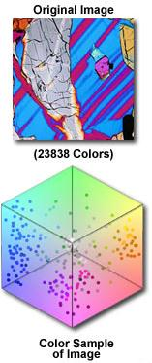
Figure 3: An example of an image before (a) and after (b) color quantization. The image is first moved into a 3 dimensional RGB palette after which the R, G, and B values can be converted into numeric values for use in clustering algorithms.

a. The original image used for quantization.

b. The image after being moved into the RGB palette.

2. Methods and Materials
A. K-Means Clustering Algorithm
K-means (KM) is undoubtedly the most widely used partitional clustering algorithm [22]. Given a data set X ={X₁, X₂,...,X_{N}} R^{D}, the objective of KM is to partition X into K exhaustive and mutually exclusive clusters S ={S₁,S₂,...,S_{K}} such that: 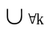 S_{k} =X and S_{i}∩S_{j} = Ø for 1≤ i = j≤ K. It does this by minimizing the Sum of Squared Error (SSE) for the clusters:
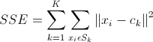

Where ||.|| denotes the Euclidean norm and c_{k} is the center of cluster S_{k} calculated as the mean of the points that belong to this cluster. This problem is known to be NP-hard even for K = 2 or D =2, but a heuristic method developed by Lloyd offers a simple solution [23 - 25]. Lloyd’s algorithm starts with K arbitrary centers, typically chosen uniformly at random from the data points. Each point is then assigned to the nearest center, and each center is recalculated as the mean of all points assigned to it. These two steps are repeated until a predeﬁned termination criterion is met.
However, for the purpose of clustering dermoscopy data, a different method of choosing centers was used. Instead of randomly selecting initial centers from the entire data set, centers were selected that would maximize the minimum distance between any two cluster centers. Each point is then assigned to the center nearest to it, and each center is recalculated as the mean of all points assigned to it. The termination criterion used for the purpose of clustering was a preset number of iterations as well as convergence of the algorithm. This means that if the algorithm were to converge, having found the globally or locally optimal way to create the k clusters so that the SSE is as small as possible, then it would terminate. Alternatively, if the algorithm does not converge by a predetermined number of iterations, then it can be assumed that the value of k in use is not feasible for clustering the data set. This is because the algorithm is unable to converge quickly when the number of clusters being created does not fit the data well, so the algorithm terminates in such a case.
The complexity of KM is O(NK) per iteration for a ﬁxed D value. In image processing applications, D typically equals three since the clustering procedure is often performed in three-dimensional color spaces such as RGB or CIELAB [26]. From a clustering perspective KM has the following advantages:
-It is conceptually simple, versatile, and easy to implement.
-It has a time/space complexity that is linear in N and K. Furthermore, numerous sequential and parallel acceleration techniques are available in the literature. [27-29]
-It is guaranteed to terminate, and its convergence rate is quadratic [30-31]
-It is invariant to data ordering, i.e., random shuffling of the data points.

Unfortunately, due to its gradient descent nature, KM often converges to a local minimum of the criterion function [30]. For the same reason, it is highly sensitive to the selection of the initial centers [22]. Adverse effects of improper initialization include empty clusters, slower convergence, and a higher chance of getting stuck in bad local minima [32]. That is why the deterministic maximin algorithm of Gonzalez, as described earlier, is used to initialize the cluster centers [33]. The first center chosen is the mean of the entire data set and the rest are selected as described previously.

B. Application of K-Means Clustering Algorithm to Dermoscopy Images
In order to reduce the number of colors in a dermoscopy image using KM, two issues needed to be addressed. First, a suitable representation for the image pixels needed be chosen. Second, an appropriate value for the K parameter needed be determined. For the purpose of this system each pixel is represented by a 5 dimensional vector (x, y, r, g, b), where sub-vectors (x, y) and (r, g, b) denote the pixel’s spatial and chromaticity (in the RGB color space) coordinates respectively.
The distance between two pixels p₁ = (x₁, y₁, r₁, g₁, b₁) and p₂ = (x₂, y₂, r₂, g₂, b₂) is then calculated using the following weighted squared Euclidean formula:
Where w, the weight, is a decimal value between 0 and 1, inclusive, and W, H, and L denote a spatial weight term, image width, image height, and maximum channel value (for 8-bits per channel RGB images L = 2⁸−1 = 255), respectively.
As described in the previous subsection, KM requires the number of clusters, K, to be speciﬁed a priori, which clearly conﬂicts with our objective of automatically determining the number of perceptually signiﬁcant colors. A straightforward approach to address this drawback consists of obtaining a set of clusterings with different K values, i.e., numbers of clusters, and then selecting the clustering and thus the corresponding K value that provides the “optimal” result according to a speciﬁc quality (validity) criterion [34]. The following ﬁve commonly used relative cluster validity criteria are evaluated to determine possible optimal K values [35]:
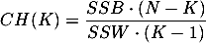
-Calinski-Harabasz (CH) Index [36]:
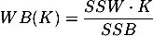
-WB Index [37]:
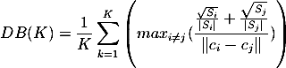
-Davies-Bouldin (DB) Index [38]:
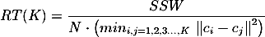
-Ray-Turi (RT) Index [39]:

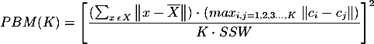
-Pakhira-Bandyopadhyay-Maulik (PBM) Index [40]:

Where x, S_{k}, SSB, and SSW are respectively the centroid or grand mean of the entire data set, scatter matrix of the k-th cluster, between-cluster scatter matrix, and within-cluster scatter matrix deﬁned as follows:

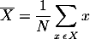
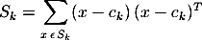
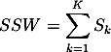

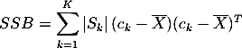

The index itself is actually used for determining the optimal k value to fit the data set. The optimal k value is the one that produces either the highest or lowest value, depending on the index, from an index’s equation across all of the k values tested. The optimal k value for the CH and PBM indices is indicated by which k value produces the highest value from their respective equations. For the RT, DB, and WB indexes, the optimal k value is indicated by whichever value of k produces the lowest value from their respective equations.
The reason it is important to know the optimal k value is that it describes how many groups the image should be broken up into when accounting for color and spatial contiguity. This tells the user how many perceptually significant colors are present in the skin lesion image being analyzed. Knowledge of the number of perceptually significant colors can then be used in trying to determine whether a person is developing melanoma.
For each image, KM was executed successively to obtain locally optimal clusterings of the pixel data for k values between 2 and 16. These 15 clusterings were then evaluated using the aforementioned ﬁve validity criteria, resulting in a set of ﬁve “optimal” K value estimates per image.

3. Results and Analysis
A. Image Set Description
The image set used in this study consists of 914 digital dermoscopy images obtained from the EDRA Interactive Atlas of Dermoscopy [2], a collection of images acquired in three institutions: University Federico II of Naples, Italy, University of Graz, Austria, and University of Florence, Italy. These were true-color images with a typical resolution of 768×512 pixels. The diagnostic distribution of the cases was as follows: 272 melanomas, 28 blue nevi, 405 dysplastic nevi, 13 combined nevi, 17 congenital nevi, 33 dermal nevi, 20 dermatofibroma, 79 Reed/Spitz nevi, and 47 seborrheic keratoses. The lesions were biopsied and diagnosed histopathologically in cases where significant risk for melanoma was present; otherwise they were diagnosed by follow-up examination. The image set was randomly divided into two mutually exclusive sets: a training set of size 617 and a test set of size 297. The split was performed in a manner that ensures approximately the same proportion of benign and malignant cases in the two subsets.

B. Symbolic Regression Using Eureqa
Symbolic regression [41] is an established method based on evolutionary computation for searching the space of mathematical expressions while minimizing various error metrics [42]. Unlike traditional linear and nonlinear regression methods that fit parameters to an equation of a given form, symbolic regression searches both the parameters and the form of equations simultaneously. Initial expressions are formed by randomly combining mathematical building blocks such as algebraic operators, analytical functions, constants, and state variables. New equations are formed by recombining previous equations and probabilistically varying their sub-expressions. The algorithm retains equations that better model the experimental data and discards unpromising solutions. After equations reach a desired level of accuracy, the algorithm terminates, returning a set of equations that are most likely to correspond to the intrinsic mechanisms underlying the observed system.
In this study, we used the Eureqa II software [43] to perform symbolic regression on our training data set, which is comprised of ﬁve estimated K values for each training image given by the cluster validity criteria described previously. In order to discover simple mathematical equations with high generalization capability, we used only the most basic building blocks including the four algebraic operators, i.e., {+, −, ×, ÷}, and constants. Four different spatial weight values, w, were tested in the experiments: 0.125, 0.250, 0.375, and 0.500. In each execution, the program was terminated after one million generations. The equations generated as a result of each execution were evaluated on the test data set using the geometric average of sensitivity and speciﬁcity. Equations that gave the best results were kept and utilized in further testing (Table 1). Here the logistic (sigmoid) function, accuracy, sensitivity, and speciﬁcity are deﬁned as follows:
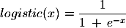
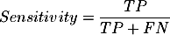

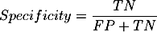
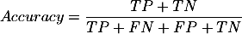

Where TP, FN, FP, TN are the numbers of true positives (correctly diagnosed melanoma lesions), false negatives (melanoma lesions diagnosed incorrectly as benign lesions), false positives (benign lesions diagnosed incorrectly as melanoma lesions), and true negatives (correctly diagnosed benign lesions), respectively.
The procedure to classify a new image is as follows. First, the image is clustered using KM successively with K values between 2 and 16. The resulting 15 clusterings are then evaluated using the ﬁve cluster validity criteria and the optimal K values given by these criteria are plugged into the appropriate equation based on weighting used (Table 1). Finally, the input image is classiﬁed as benign if the output of the logistic function is less than 0.5 and malignant otherwise, meaning that the patient is developing melanoma.
Symbolic Regression Results
Weight (w) | Best Equation | Accuracy (%) | Sensitivity (%) | Specificity (%)
.125 | logistic(1.413e4*K_{CH} −1.981e5) | 56.23 | 60.47 | 54.50
.250 | logistic(778.7*K_{CH}²−31220*K_{PBM}) | 71.72 | 61.63 | 75.83
.375 | logistic(9.232e7*K_{CH}+7.098e7*K_{DB} −7.809e7*K_{WB}) | 59.26 | 61.63 | 58.29
.500 | logistic((5.609e5*K_{WB}−5.929e6)/(K_{DB}−8.401)) | 52.53 | 69.77 | 45.50
Table 1: shows the results of symbolic regression including the various weights used, the best equation for each weight, and the accuracy, sensitivity, and specificity for each weight

It can be seen that w = 0.250 achieves the best tradeoff between sensitivity (61.63%) and speciﬁcity (75.83%), leading to the highest overall accuracy (71.72%). It should be noted that automated diagnosis based on color information alone is not likely to reach the accuracy of experienced clinicians. This is because clinicians evaluate lesions based on various factors including size (diameter), shape, color, texture, patient history, etc. and therefore obtain higher conﬁdence in their diagnoses. In fact, according to a recent large-scale clinical study, with a simple threshold of 6mm on the lesion diameter, the authors obtained 75% sensitivity and 54% speciﬁcity [44]. Therefore, single-feature approaches such as the one presented here should be combined with complementary automated approaches to provide diagnostic accuracy comparable to those of clinicians [21]. The method can also easily be combined with the analysis of clinicians easily and can assist them in doing their own analysis of the lesion’s color. It does this by creating a clustered version of the dermoscopy image, allowing for side-by-side comparison of the clustered images, one for each index, and the original dermoscopy image (Fig. 4).
Figure 4: Shows the original dermoscopy image (a) and then the same image clustered with the optimal k values as determined by the various indexes. (b, c, d, e, f)
(a) The original dermoscopy image
(b) The dermoscopy image clustered using the CH index as k
(c) The dermoscopy image clustered using the DB index as k
(d) The dermoscopy image clustered using the RT index as k
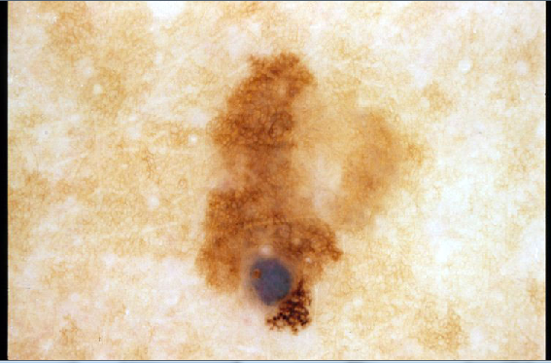
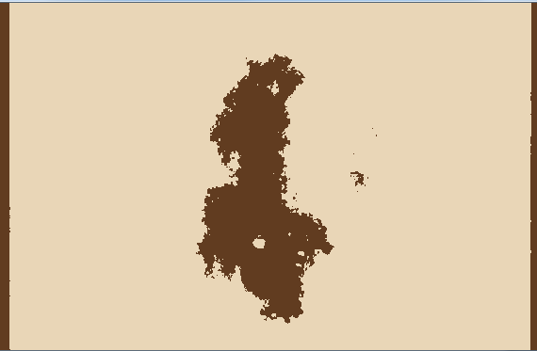
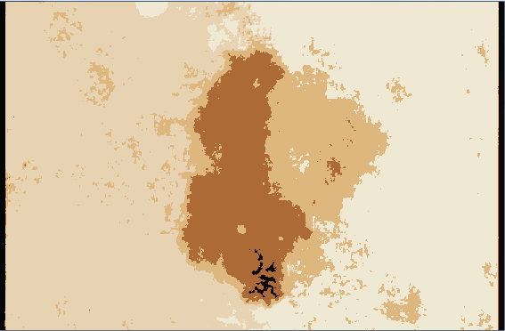
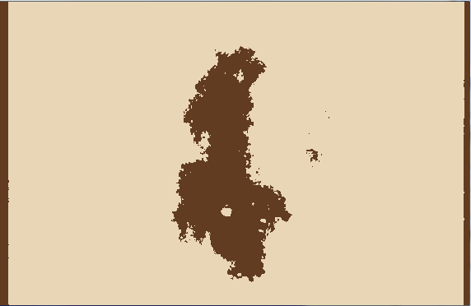
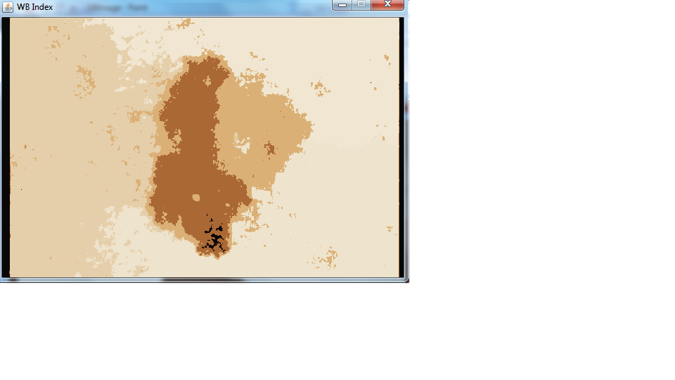
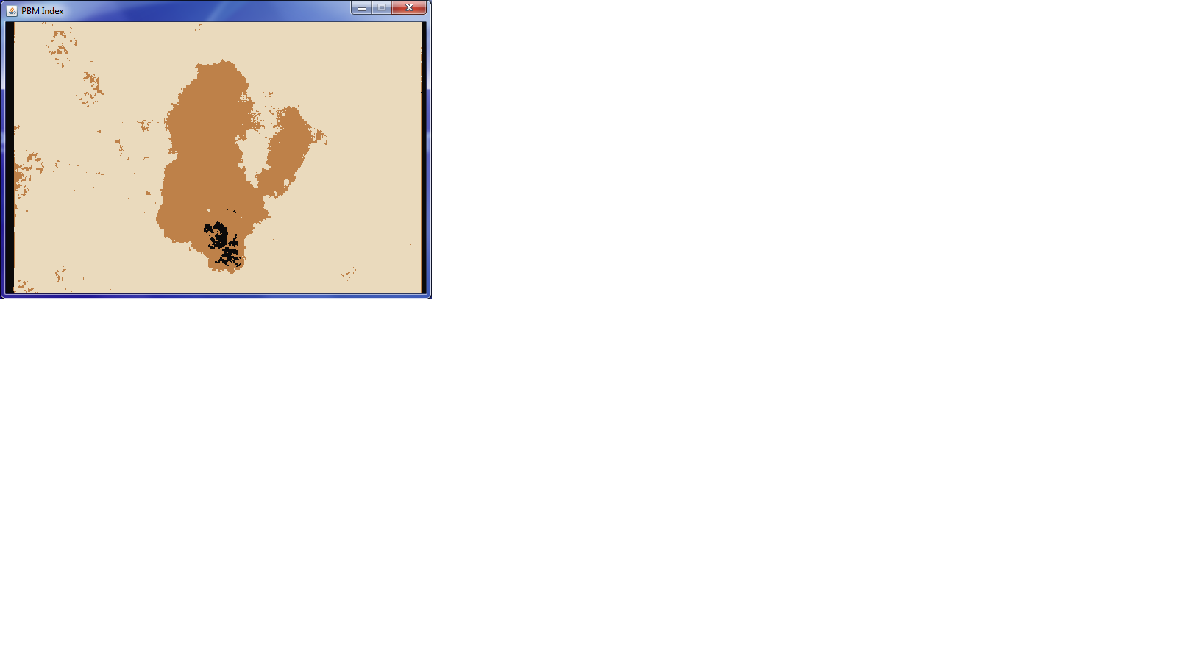
(e) The dermoscopy image clustered using the WB index as k
(f) The dermoscopy image clustered using the PBM index as k

4. Conclusions and Future Work
After tests were conducted and the results were analyzed, the data supports the hypothesis that a machine learning approach to automated quantification of perceptually significant colors in dermoscopy images with applications to skin lesion classification is feasible, efficient, and effective. Given a true-color dermoscopy image, the method performs spatial k-means clustering guided by several cluster validity criteria whose outputs are input to an explicit mathematical function derived using a symbolic regression algorithm trained on 617 images. The output of this function is then thresholded to estimate the diagnosis of the input image. The proposed method yielded a sensitivity of 62% and a speciﬁcity of 76% on an independent test set of 297 images. The method is segmentation-free, easy to implement, efﬁcient, and it does not require a calibrated image acquisition system.
In this way surpasses previous methods in several capacities. Unlike the classification methods developed by Menzies or Seidenari et al, this system does not require that a standardized high quality imaging system be used or that the lighting conditions be constant in order to function [10] [21]. It should be noted that the images used for generating the equations produced by the symbolic regression in the Eureqa software were all taken using different imaging systems and under different lighting conditions. However, the method still yielded a high specificity and sensitivity. This shows that the system developed in this study can be effective even in varying and unpredictable situations, a quality that is important in real-life application. It is also possible that if a calibrated image system was utilized with standardized lighting conditions, the method could yield an accuracy, sensitivity, and specificity to match or surpass that of trained clinicians [21][44]. It is also possible that by combining this classification system with the separate analysis of such clinicians, the overall usefulness of the method could be increased greatly, as other information could be used to compare with the single-feature analysis performed by the classification method [21]. This would allow for the rapid and accurate diagnosis of melanoma, improved treatment, and, ultimately, ameliorating the quality of life afforded to patients diagnosed with melanoma.
REFERENCES
1. R. Siegel, D. Naishadham, and A. Jemal, “Cancer Statistics, 2012,” CA: A Cancer Journal for Clinicians, vol. 62, no. 1, pp. 10–29, 2012.
2. G. Argenziano, H. Soyer, and V. De Giorgi et al., Dermoscopy: A Tutorial. EDRA Medical Publishing & New Media, 2002.
3. S. Menzies, K. Crotty, C. Ingvar, and W. McCarthy, Dermoscopy: An Atlas, 3rd ed. McGraw-Hill, 2009.
4. K. Steiner, M. Binder, M. Schemper, K. Wolff, and H. Pehamberger, “Statistical Evaluation of Epiluminescence Microscopy Criteria for Melanocytic Pigmented Skin Lesions,” Journal of the American Academy of Dermatology, vol. 29, no. 4, pp. 581–588, 1993.
5. M. Binder, M. Schwarz, A. Winkler, A. Steiner, A. Kaider, K. Wolff, and H. Pehamberger, “Epiluminescence Microscopy. A Useful Tool for the Diagnosis of Pigmented Skin Lesions for Formally Trained Dermatologists,” Archives of Dermatology, vol. 131, no. 3, pp. 286–291, 1995.
6. M. G. Fleming, C. Steger, J. Zhang, J. Gao, A. B. Cognetta, I. Pollak, and C. R. Dyer, “Techniques for Structural Analysis of Dermatoscopic Imagery,” Computerized Medical Imaging and Graphics, vol. 22, no. 5, pp. 375–389, 1998.
7. R. P. Braun, H. S. Rabinovitz, M. Oliviero, A. W. Kopf, and J. H. Saurat, “Dermoscopy of Pigmented Skin Lesions,” Journal of the American Academy of Dermatology, vol. 52, no. 1, pp. 109–121, 2005.
8. J. S. Henning, S. W. Dusza, S. Q. Wang, A. A. Marghoob, H. S. Rabinovitz, D. Polsky, and A. W. Kopf, “The CASH (Color, Architecture, Symmetry, and Homogeneity) Algorithm for Dermoscopy,” Journal of the American Academy of Dermatology, vol. 56, no. 1, pp. 45–52, 2007.
9. F. Nachbar, W. Stolz, T. Merkle, A. B. Cognetta, T. Vogt, M. Landthaler, P. Bilek, O. Braun-Falco, and G. Plewig, “The ABCD Rule of Dermatoscopy. High Prospective Value in the Diagnosis of Doubtful Melanocytic Skin Lesions,” Journal of the American Academy of Dermatology, vol. 30, no. 4, pp. 551–559, 1994.
10. S. W. Menzies, C. Ingvar, K. A. Crotty, and W. H. McCarthy, “Frequency and Morphologic Characteristics of Invasive Melanomas Lacking Specific Surface Microscopic Features,” Archives of Dermatology, vol. 132, no. 10, pp. 1178–82, 1996.
11. S. W. Menzies, C. Ingvar, and W. H. McCarthy, “A Sensitivity and Specificity Analysis of the Surface Microscopy Features of Invasive Melanoma,” Melanoma Research, vol. 6, no. 1, pp. 55–62, 1996.
12. H. Pehamberger, A. Steiner, and K. Wolff, “In Vivo Epiluminescence Microscopy of Pigmented Skin Lesions. I. Pattern Analysis of Pigmented Skin Lesions,” Journal of the American Academy of Dermatology, vol. 17, no. 4, pp. 571–583, 1987.
13. G. Argenziano, G. Fabbrocini, P. Carli, V. De Giorgi, E. Sammarco, and M. Delfino, “Epiluminescence Microscopy for the Diagnosis of Doubtful Melanocytic Skin Lesions. Comparison of the ABCD Rule of Dermatoscopy and a New 7-Point Checklist Based on Pattern Analysis,” Archives of Dermatology, vol. 134, no. 12, pp. 1563–1570, 1998.
14. H. Ganster, A. Pinz, R. Rohrer, E. Wildling, M. Binder, and H. Kittler, “Automated Melanoma Recognition,” IEEE Transactions on Medical Imaging, vol. 20, no. 3, pp. 233–239, 2001.
15. H. Iyatomi, H. Oka, M. Saito, A. Miyake, M. Kimoto, J. Yamagami, S. Kobayashi, A. Tanikawa, M. Hagiwara, K. Ogawa, G. Argenziano, H. P. Soyer, and M. Tanaka, “Quantitative Assessment of Tumor Extraction from Dermoscopy Images and Evaluation of Computer-based Extraction Methods for Automatic Melanoma Diagnostic System,” Melanoma Research, vol. 16, no. 2, pp. 183–190, 2006.
16. M. E. Celebi, H. A. Kingravi, B. Uddin, H. Iyatomi, A. Aslandogan, W. V. Stoecker, and R. H. Moss, “A Methodological Approach to the Classification of Dermoscopy Images,” Computerized Medical Imaging and Graphics, vol. 31, no. 6, pp. 362–373, 2007.
17. H. Iyatomi, H. Oka, M. E. Celebi, M. Hashimoto, M. Hagiwara, M. Tanaka, and K. Ogawa, “An Improved Internet-based Melanoma Screening System with Dermatologist-like Tumor Area Extraction Algorithm,” Computerized Medical Imaging and Graphics, vol. 32, no. 7, pp. 566–579, 2008.
18. A. Baldi, R. Murace, E. Dragonetti, M. Manganaro, O. Guerra, S. Bizzi, and L. Galli, “Definition of an Automated Content-Based Image Retrieval (CBIR) System for the Comparison of Dermoscopic Images of Pigmented Skin Lesions,” Biomedical Engineering Online, vol. 8, p. 18, 2009.
19. D. Ruiz, V. Berenguer, A. Soriano, and B. Sanchez, “A Decision Support System for the Diagnosis of Melanoma: A Comparative Approach,” Expert Systems with Applications, vol. 38, no. 12, pp. 15 217–15 223, 2011.
20. A. G. Isasi, , B. G. Zapirain, and A. M. Zorrilla, “Melanomas Non-Invasive Diagnosis Application Based on the ABCD Rule and Pattern Recognition Image Processing Algorithms,” Computers in Biology and Medicine, vol. 41, no. 9, pp. 742–755, 2011.
21. S. Seidenari, C. Grana, and G. Pellacani, “Colour Clusters for Computer Diagnosis of Melanocytic Lesions,” Dermatology, vol. 214, no. 2, pp. 137–143, 2007.
22. M. E. Celebi, H. Kingravi, and P. A. Vela, “A Comparative Study of Efficient Initialization Methods for the K-Means Clustering Algorithm,” Expert Systems with Applications, 2013, to appear.
23. D. Aloise, A. Deshpande, P. Hansen, and P. Popat, “NP-Hardness of Euclidean Sum-of-Squares Clustering,” Machine Learning, vol. 75, no. 2, pp. 245–248, 2009.
24. M. Mahajan, P. Nimbhorkar, and K. Varadarajan, “The Planar k-Means Problem is NP-hard,” Theoretical Computer Science, vol. 442, pp. 13–21, 2012.
25. S. Lloyd, “Least Squares Quantization in PCM,” IEEE Trans. on Information Theory, vol. 28, no. 2, pp. 129–136, 1982.
26. M. E. Celebi, H. A. Kingravi, and F. Celiker, “Fast Color Space Transformations Using Minimax Approximations,” IET Image Processing, vol. 4, no. 2, pp. 70–79, 2010.
27. T. Kanungo, D. Mount, N. Netanyahu, C. Piatko, R. Silverman, and A. Wu, “An Efficient K-Means Clustering Algorithm: Analysis and Implementation,” IEEE Transactions on Pattern Analysis and Machine Intelligence, vol. 24, no. 7, pp. 881–892, 2002.
28. G. Hamerly, “Making k-means Even Faster,” in Proc. of the 2010 SIAM Int. Conf. on Data Mining, 2010, pp. 130–140.
29. T. W. Chen and S. Y. Chien, “Bandwidth Adaptive Hardware Architecture of K-Means Clustering for Video Analysis,” IEEE Transactions on Very Large Scale Integration (VLSI) Systems, vol. 18, no. 6, pp. 957–966, 2010.
30. S. Z. Selim and M. A. Ismail, “K-Means-Type Algorithms: A Generalized Convergence Theorem and Characterization of Local Optimality,” IEEE Transactions on Pattern Analysis and Machine Intelligence, vol. 6, no. 1, pp. 81–87, 1984.
31. L. Bottou and Y. Bengio, Advances in Neural Information Processing Systems 7. MIT Press, 1995, ch. Convergence Properties of the K-Means Algorithms, pp. 585–592.
32. M. E. Celebi, “Improving the Performance of K-Means for Color Quantization,” Image and Vision Computing, vol. 29, no. 4, pp. 260–271, 2011.
33. T. Gonzalez, “Clustering to Minimize the Maximum Intercluster Distance,” Theoretical Computer Science, vol. 38, no. 2–3, pp. 293–306, 1985.
34. L. Vendramin, R. J. G. B. Campello, and E. R. Hruschka, “Relative Clustering Validity Criteria: A Comparative Overview,” Statistical Analysis and Data Mining, vol. 3, no. 4, pp. 209–235, 2010.
35. J. Baarsch and M. E. Celebi, “Investigation of Internal Validity Measures for K-Means Clustering,” in Proceedings of the 2012 IAENG International Conference on Data Mining and Applications (ICDMA 2012), 2012, pp. 471–476.
36. R. B. Calinski and J. Harabasz, “A Dendrite Method for Cluster Analysis,” Communications in Statistics -Theory and Methods, vol. 3, no. 1, pp. 1–27, 1974.
38. Q. Zhao, M. Xu, and P. Franti, “Sum-of-Squares Based Cluster Validity Index and Significance Analysis,” in Proceedings of the International Conference on Adaptive and Natural Computing Algorithms (ICANNGA 2009), 2009, pp. 313–322.
38. D. L. Davies and D. W. Bouldin, “A Cluster Separation Measure,” IEEE Transactions on Pattern Analysis and Machine Intelligence, vol. 1, no. 2, pp. 224–227, 1979.
39. S. Ray and R. H. Turi, “Determination of Number of Clusters in K-Means Clustering and Application in Colour Image Segmentation,” in Proceedings of the 4th International Conference on Advances in Pattern Recognition and Digital Techniques (ICAPRDT 1999), 1999, pp. 137–143.
40. M. K. Pakhira, S. Bandyopadhyay, and U. Maulik, “Validity Index for Crisp and Fuzzy Clusters,” Pattern Recognition, vol. 37, no. 3, pp. 487–501, 2004.
41. J. R. Koza, Genetic Programming: On the Programming of Computers by Means of Natural Selection. MIT Press, 1992.
42. M. Schmidt and H. Lipson, “Distilling Free-Form Natural Laws from Experimental Data,” Science, vol. 324, no. 5923, pp. 81–85, 2009.
43. Nutonian Inc., “Eureqa Formulize,” www.nutonian.com, 2012.
44. N. R. Abbasi, M. Yancovitz, D. Gutkowicz-Krusin, K. S. Panageas, M. C. Mihm, P. Googe, R. King, V. Prieto, I. Osman, R. J. Friedman, D. S. Rigel, A. W. Kopf, and D. Polsky, “Utility of Lesion Diameter in the Clinical Diagnosis of Cutaneous Melanoma,” Archives of Dermatology, vol. 144, no. 4, pp. 469–474, 2008.

