Roman pots semi-expert operation
In this mode shift crew only stops Roman pot operations and call RP expert to start after the new fill is available.
When MCR calls that they are going to dump the beam or beam is lost:
- tell them that we expect MCR to move Roman pots to home position;
- switch “OneButton” control of low voltage and bias to OFF by pressing the “OFF” button.
When new fill is available:
- call RP expert;
- remove “PP” and all triggers starting from “RP_” in the run control until the expert prepares Roman pots for operation.

Roman Pot slow control howto for the STAR shift crew

Getting detector ready for operation:
- Check that “OneButton” control (see picture below) on the right monitor on Roman Pot desk is in the OFF state.
- Press “ON”
- Wait two minutes
- It should be like this now:
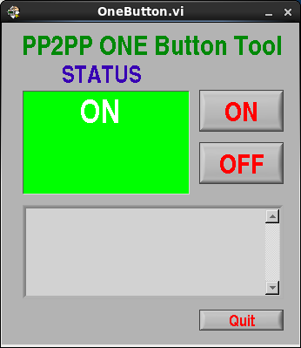

If ALARM state is shown try “OFF” and “ON” again. If ALARM persists call expert.

Switching detector OFF:
(before beam dump/injection/pC-polarimeter measurement and on ALARM)

Press “OFF” on the “OneButton” control (see above).

If there is an ALARM and “OneButton” fails (it is blue):
- Use a browser from any computer in BNL network to connect to the East and West APC power switches (normally it's already there, but you can use any other browser):
  - East: http://130.199.90.26, user: apc, password: apc
  - West: http://130.199.90.38, user: apc1, password: apc1
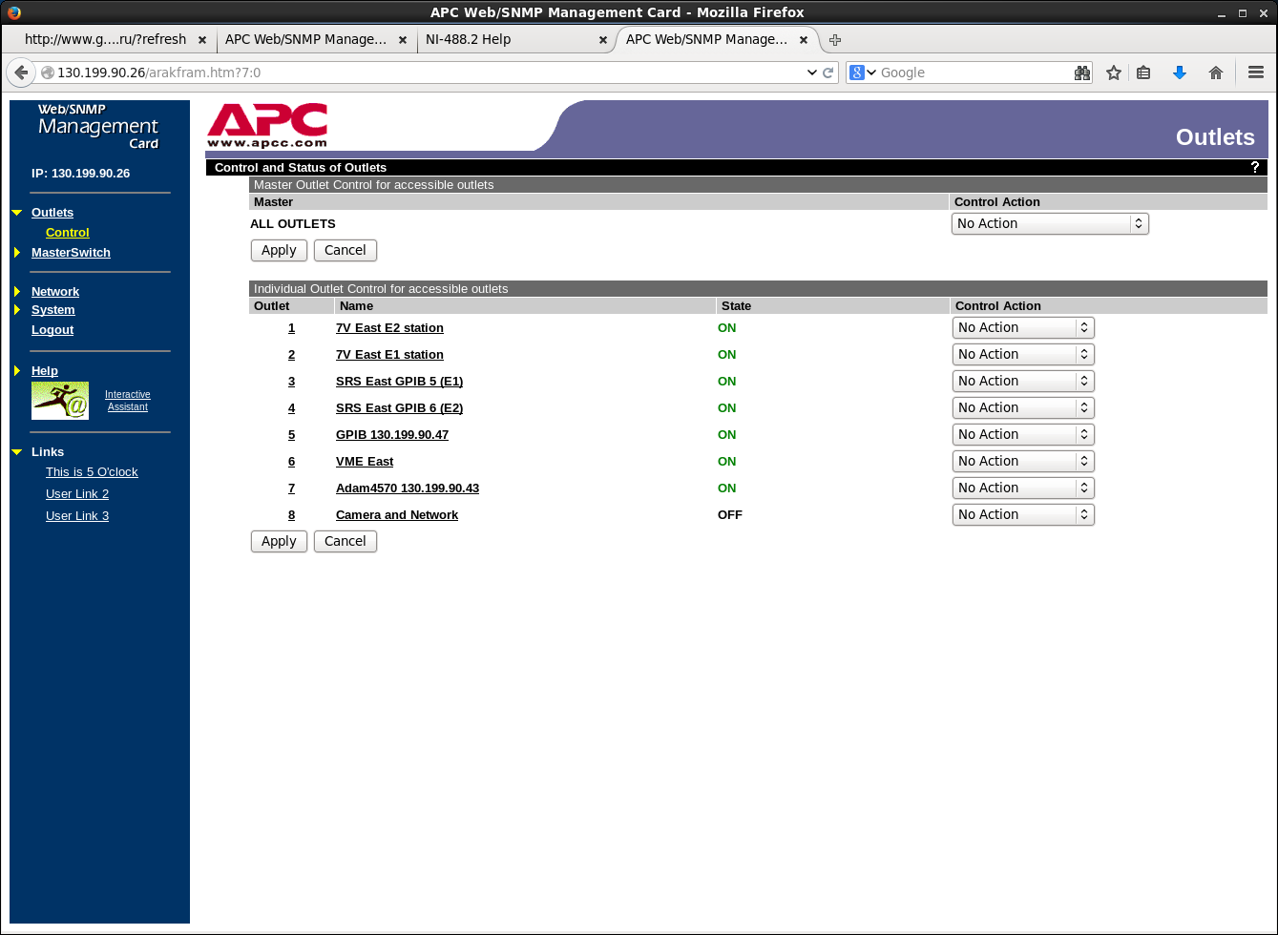
- Sequentially on both web pages:
  - Click on 'Outlets' in the left side menu
  - For the first two lines ('7V East/West E1/E2 station') in the right column ('Control action') choose 'Immediate Off'
  - Press 'Apply' button on the bottom left of the page
  - After 5-10 seconds check that the 'Status' column shows 'OFF' for the first two lines.
- Call for experts. The phone numbers are on the last page of the latest pp2pp logbook.

If “OneButton” is not on the screen
Press icon 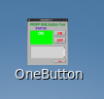 on the screen or run /home/daq/pp2pp-slow/oneButton from the terminal.

If the screen on Roman Pot slow control console is blocked:
user name: daq
password: elasticpp

