Assignment 2

igal tsirulnik, Yoni Elhanati

April 11, 2016

## Description of the dataset-

Sales in Bloomfield Township, Michigan fields: X| Y| RECORDDT| SALEAMNT| CNTASSDVAL| SALESRATIO| RESSTRTYPE| RESYRBLT| RESFLRAREA| NGHBRHDCD| LASTUPDATE

## Here you can see a small taste of the dataset-

url <- 'https://services.arcgis.com/EZzgO87vB4k7XLB1/arcgis/rest/services/BloomfieldSales/FeatureServer/0/query?where=1%3D1&outFields=RECORDDT,SALEAMNT,RESYRBLT&outSR=4326&f=json'  
web <- getURL(url)  
raw <-fromJSON(web)  
tmp <- lapply( raw, function(u)   
 lapply(u, function(x) if(is.null(x)) NA else x)  
)  
tmp <- lapply( tmp, as.data.frame )  
head(tmp$features,5)

## attributes.RECORDDT attributes.SALEAMNT attributes.RESYRBLT geometry.x  
## 1 1.101946e+12 229000 1976 -83.23149  
## 2 1.227571e+12 133000 1976 -83.23149  
## 3 1.187654e+12 147000 1976 -83.23149  
## 4 1.088467e+12 215000 1976 -83.23149  
## 5 1.158883e+12 155000 1976 -83.23149  
## geometry.y  
## 1 42.61966  
## 2 42.61966  
## 3 42.61966  
## 4 42.61966  
## 5 42.61966

## Dataset on a map-

# getting the map  
map <- get_map(location = c(lon = mean(tmp$features$geometry.x), lat = mean(tmp$features$geometry.y)), zoom = 12,maptype = "terrain", scale = 2)

## Map from URL : http://maps.googleapis.com/maps/api/staticmap?center=42.580952,-83.266366&zoom=12&size=640x640&scale=2&maptype=terrain&language=en-EN&sensor=false

# plotting the map with some points on it  
ggmap(map) +  
 geom_point(data = tmp$features, aes(x = tmp$features$geometry.x, y = tmp$features$geometry.y , alpha = 0), size = 3, shape = 21) + guides(fill=TRUE, alpha=FALSE, size=FALSE)

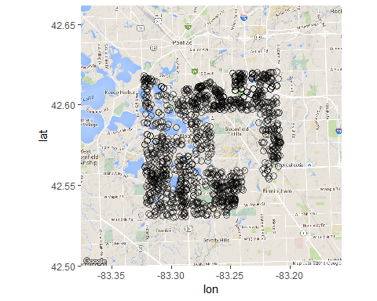

## Price destrebition by longtitude and altitude

qplot(tmp$features$geometry.y, tmp$features$geometry.x, data=tmp$features,col= tmp$features$attributes.RECORDDT)

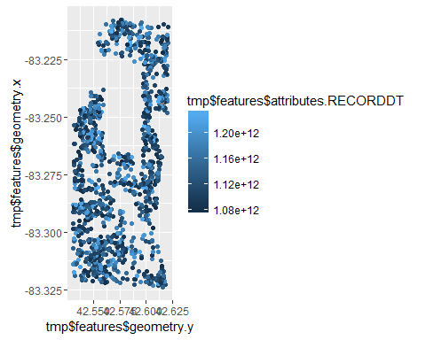

#it is clear that as you get far from the center of the city prices of property goes down

## Analysis of the times buildngs were built in bloomfield

barplot(table(tmp$features$attributes.RESYRBLT))

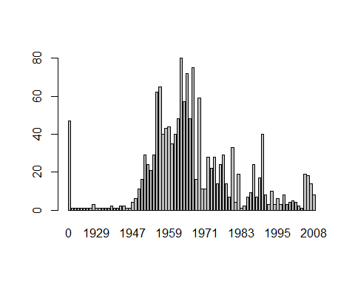

#we can see that the bigest part of the city was build around the 1950-1970 and since then development of the city slowed down

## Analysis of property prices compared to when they were built

with(tmp$features,plot(tmp$features$attributes.RESYRBLT,tmp$features$attributes.SALEAMNT, xlim=c(1950,2008)))

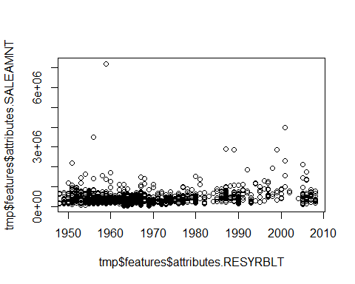

#we can see that development has slowed down but the prices keep growing steadly

## Summury

the most relevant pieace of information, is location vs prices map, I would recomend to develop some script that can get input of price ranges and x,y (location) the output would be recomended places to look for property