Assignment 3

igal tsirulnik, Yoni Elhanati

April 11, 2016

## Gray Anatomy-dataset

## 1)

library(igraph)

## Warning: package 'igraph' was built under R version 3.2.5

##   
## Attaching package: 'igraph'

## The following objects are masked from 'package:stats':  
##   
## decompose, spectrum

## The following object is masked from 'package:base':  
##   
## union

ga.data <- read.csv('ga_edgelist.csv', header=TRUE)  
g <- graph.data.frame(ga.data, directed=FALSE)  
#i) highest closeness  
max(closeness(g))

## [1] 0.003194888

#ii) highest closeness  
max(betweenness(g))

## [1] 115.3667

#iii) highest closeness  
max(graph.eigen(g)$vectors)

## [1] 0.5027688

## 2)

community1 <- g  
wc <- walktrap.community(community1)  
#i)colored plot  
plot(wc, community1)

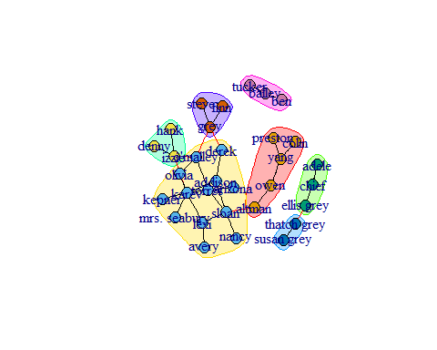

#ii) number of cmunities: 7  
#iii) modularity value is:  
modularity(wc)

## [1] 0.5147059

community2 <- g  
wc <- optimal.community(community2)  
#i)colored plot  
plot(wc, community2)

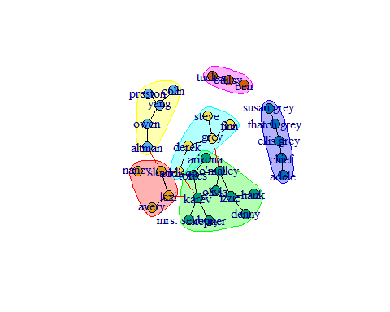

#ii) number of cmunities: 6  
#iii) modularity value is:  
modularity(wc)

## [1] 0.5947232

## Krackhardt_Kite-dataset -A social network with 10 vertices and 18 edges. Krackhardt, D. Assessing the Political Landscape: Structure, Cognition, and Power in Organizations. Admin. Sci. Quart. 35, 342-369, 1990.

## 1)

library(igraph)  
  
ga.data <- read.csv('Krackhardt_edgelist.csv', header=TRUE)  
g <- graph.data.frame(ga.data, directed=FALSE)  
g <- simplify(g)  
#i) highest closeness  
max(closeness(g))

## [1] 0.04761905

#ii) highest closeness  
max(betweenness(g))

## [1] 11

#iii) highest closeness  
max(graph.eigen(g)$vectors)

## [1] -0.1725403

## 2)

community1 <- g  
wc <- walktrap.community(community1)  
#i)colored plot  
plot(wc, community1)

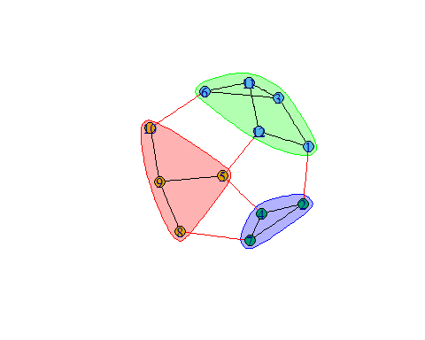

#ii) number of cmunities: 3  
#iii) modularity value is:  
modularity(wc)

## [1] 0.3546713

community2 <- g  
wc <- optimal.community(community2)  
#i)colored plot  
plot(wc, community2)

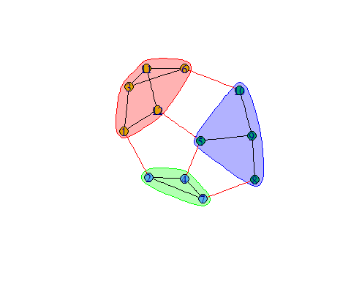

#ii) number of cmunities: 3  
#iii) modularity value is:  
modularity(wc)

## [1] 0.3546713