1、在cmd中，输入hostname 发现主机名

2、在文件夹：c:\windows\system32\drivers\etc 修改hosts文件：

|  |
| --- |
| # Copyright (c) 1993-2009 Microsoft Corp.  #  # This is a sample HOSTS file used by Microsoft TCP/IP for Windows.  #  # This file contains the mappings of IP addresses to host names. Each  # entry should be kept on an individual line. The IP address should  # be placed in the first column followed by the corresponding host name.  # The IP address and the host name should be separated by at least one  # space.  #  # Additionally, comments (such as these) may be inserted on individual  # lines or following the machine name denoted by a '#' symbol.  #  # For example:  #  # 102.54.94.97 rhino.acme.com # source server  # 38.25.63.10 x.acme.com # x client host  # localhost name resolution is handled within DNS itself.  # 127.0.0.1 localhost  # ::1 localhost  [主机IP] [主机名] |

在最后一行加入主机IP和主机名。

3、修改oracle的监听文件

打开listener.ora，在文件F:\app\young\product\11.2.0\dbhome_1\NETWORK\ADMIN目录下，里面将的localhost换速为自己的中主机名。

|  |
| --- |
| # listener.ora Network Configuration File: F:\app\young\product\11.2.0\dbhome_1\network\admin\listener.ora  # Generated by Oracle configuration tools.  SID_LIST_LISTENER =  (SID_LIST =  (SID_DESC =  (SID_NAME = CLRExtProc)  (ORACLE_HOME = F:\app\young\product\11.2.0\dbhome_1)  (PROGRAM = extproc)  (ENVS = "EXTPROC_DLLS=ONLY:F:\app\young\product\11.2.0\dbhome_1\bin\oraclr11.dll")  )  )  LISTENER =  (DESCRIPTION_LIST =  (DESCRIPTION =  (ADDRESS = (PROTOCOL = IPC)(KEY = EXTPROC1521))  (ADDRESS = (PROTOCOL = TCP)(HOST = Young-PC)(PORT = 1521))//Young-PC原为localhost  ) ) ADR_BASE_LISTENER = F:\app\young |

修改tnsnames.ora，目录同上，将也。localhost更改为中主机名。

|  |
| --- |
| # tnsnames.ora Network Configuration File: F:\app\young\product\11.2.0\dbhome_1\network\admin\tnsnames.ora  # Generated by Oracle configuration tools.  LISTENER_ORCL =  (ADDRESS = (PROTOCOL = TCP)(HOST = Young-PC)(PORT = 1521))//Young-PC原为localhost  ORACLR_CONNECTION_DATA =  (DESCRIPTION =  (ADDRESS_LIST =  (ADDRESS = (PROTOCOL = IPC)(KEY = EXTPROC1521))  )  (CONNECT_DATA =  (SID = CLRExtProc)  (PRESENTATION = RO)  )  )  ORCL =  (DESCRIPTION =  (ADDRESS = (PROTOCOL = TCP)(HOST = Young-PC)(PORT = 1521))//Young-PC原为localhost  (CONNECT_DATA =  (SERVER = DEDICATED)  (SERVICE_NAME = orcl)  )  ) |

重启TNSLSNR

打开CMD，输入以下命令。

|  |
| --- |
| lsnrctl stop  lsnrctl start  lsnrctl stat |

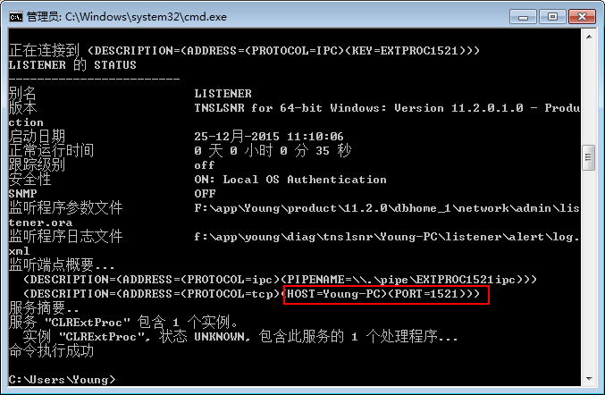

再次远程连接，用这台机器的ip已经可以连上了，成功。

Oracle错误 ora-12514 解决方法

过了两天用plsql连接的时候又报ora-12514的错误。

参考Oracle错误 ora-12514 解决方法

在listener.ora文件中的

|  |
| --- |
| SID_LIST_LISTENER =  (SID_LIST =  (SID_DESC =  (SID_NAME = PLSExtProc)  (ORACLE_HOME = E:\Oracle10gXEUniv\app\oracle\product\10.2.0\server)  (PROGRAM = extproc)  )  ) |

中添加

|  |
| --- |
| (SID_DESC =  (SID_NAME = CLRExtProc)  (ORACLE_HOME = E:\Oracle10gXEUniv\app\oracle\product\10.2.0\server)  (PROGRAM = extproc)  )  (SID_DESC =  (SID_NAME = XE)  (ORACLE_HOME = E:\Oracle10gXEUniv\app\oracle\product\10.2.0\server)  ) |

其中ORACLE_HOME以安装路径为准。  
重启监听后连接成功。

转自https://blog.csdn.net/xy2728/article/details/78919716