**转自**[GitHub - hlmd/Postman-cn: Postman汉化中文版](https://github.com/hlmd/Postman-cn#%E8%AE%BE%E7%BD%AE%E4%B8%BA%E4%B8%AD%E6%96%87)

**postman官网下载地址** <https://www.postman.com/downloads/>

**postman汉化包** <https://github.com/hlmd/Postman-cn/releases>

**1.首先从官网下载postMan安装包**

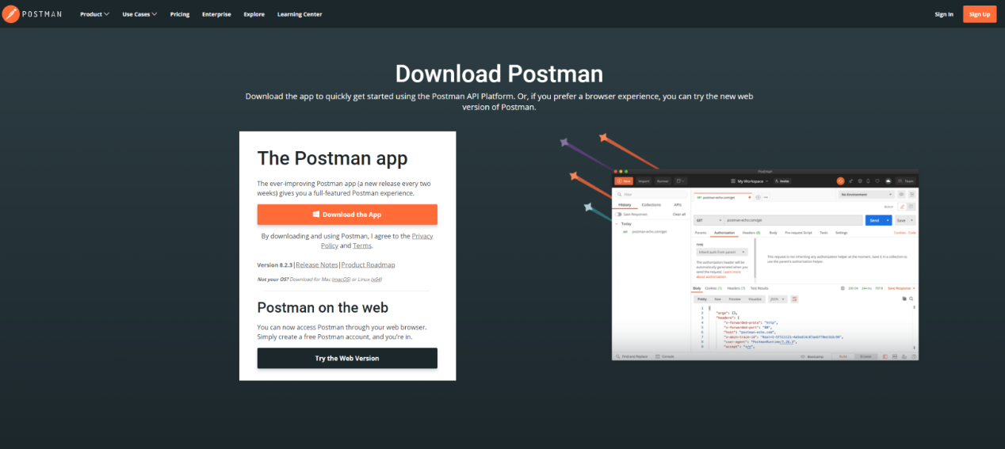

**2.下载postMan 汉化包(app.zip)**

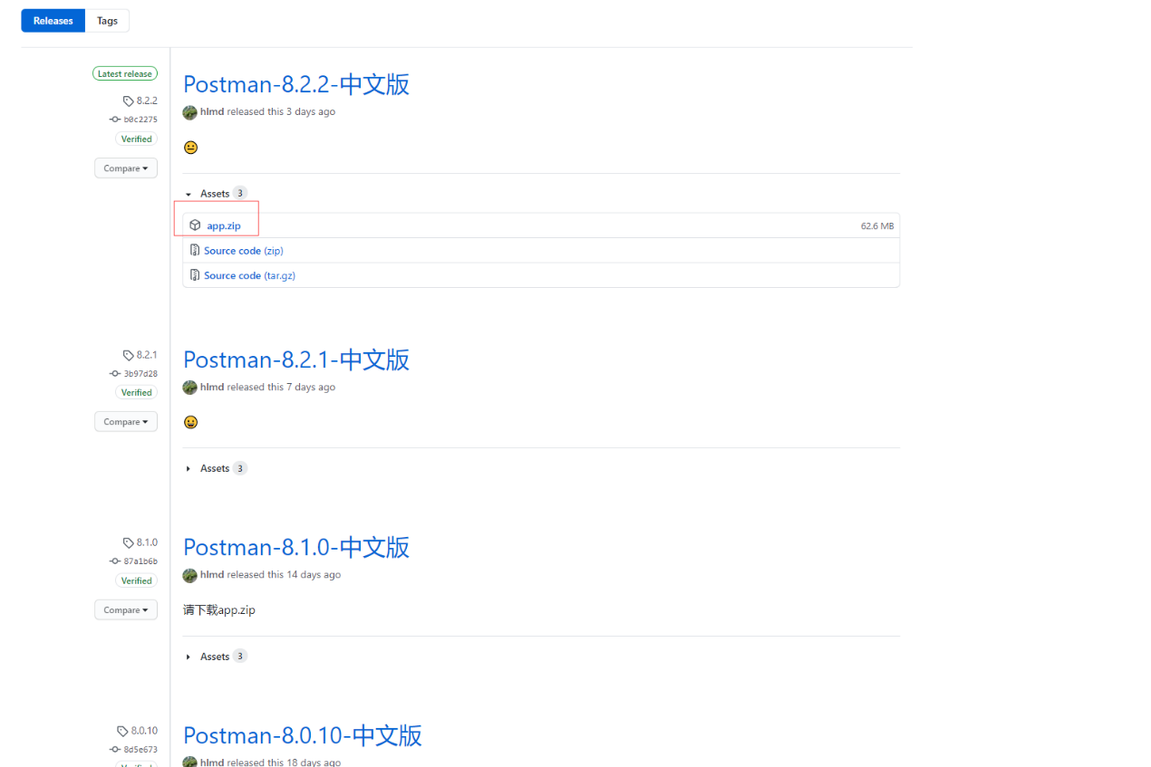

**3.将汉化包解压并复制到Postman目录下**

示例 C:\Users\user11\AppData\Local\Postman\app-8.2.3\resources

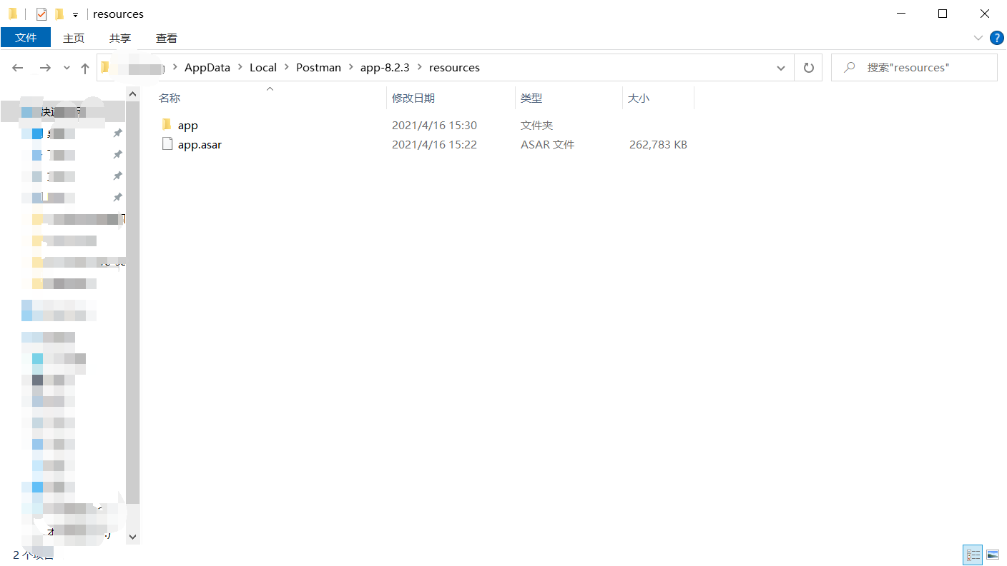

**4.重启postMan 即可完成汉化**

