**Creating a Venus (seismic velocity model) for Obspy taup package**

1. Dumoulin et al. model files:
   1. The first line gives the number of lines
   2. The columns are : Radius in km, Temperature in K, Pressure in GPa, density in kg/m^3, v_p and v_s in km/s
   3. the temperature in the metallic core is not computed (that’s why T is constant in the core in the files)
   4. The last lines concern the parameters for the atmosphere
2. Custom built velocity models can be initialized in Obspy by specifying an absolute path to a model in ObsPy’s .npz model format instead of just a model name. So we need to build a .npz file from Dumoulin et al. output.
3. To build a .npz model file, use build_taup_model functions. See more at <https://docs.obspy.org/packages/autogen/obspy.taup.taup_create.build_taup_model.html#obspy.taup.taup_create.build_taup_model>
4. This function takes a tvel file as nput, so next we need to build a tvel file.
5. The format of a tvel file is

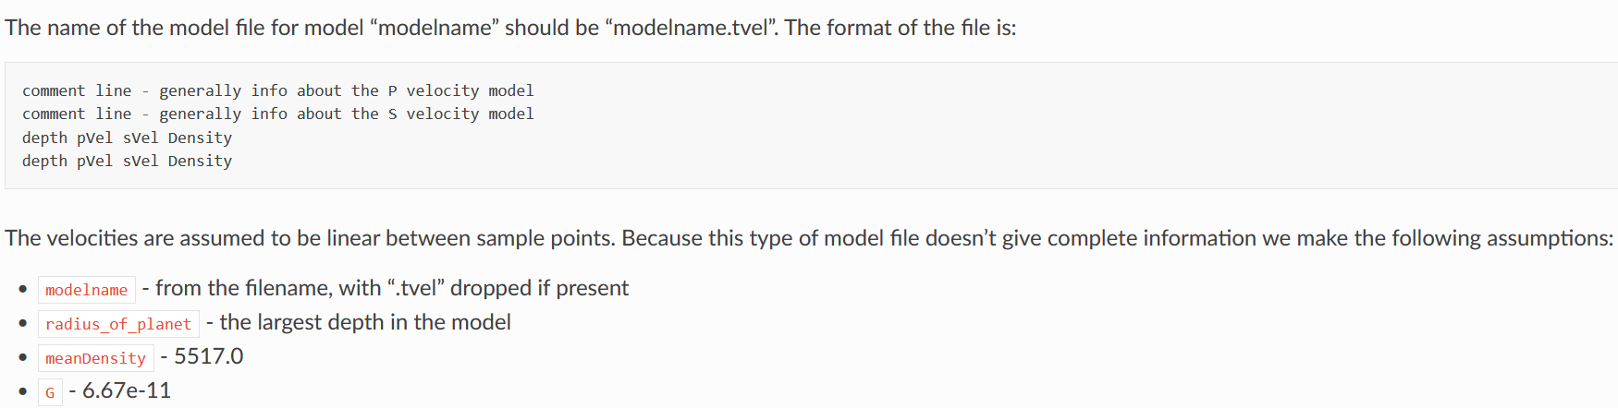

1. An example tvel file is here: https://github.com/obspy/obspy/blob/master/obspy/taup/data/iasp91.tvel
2. To make a tvel file:
   1. Read in all the columns of Dumoulin output into an array. Use np.genfromtxt and specify skip_header = 1
   2. Get rid of all the atmosphere lines (look for a sudden increase in he density column from surface density to atmosphere density)
   3. Create an empty array of appropriate dimensions (n, 4)
   4. Note that the first column in a tvel file is depth whereas the Dumoulin et al. output contains radius. To get depth, take the largest radius value in the Dumoulin output file (usually the radius value in the last row once the atmosphere rows are removed) and subtract the entire radius column from this value. The resulting depths will be the first column in the new empty array
   5. Copy the vp, vs, and density columns from the output file to columns 2,3, and 4 in the new empty array.
   6. Now, for some weird reason, obspy uses the depth value in the last row of the tvel file as the radius, instead of just using the largest depth value. Which means we need o flip out whole array upside down to make sure the largest depth value is at the bottom. Numpy has a handy function called flipud.
   7. No we have an (n,4) array where the first row corresponds to the surface and the last row corresponds to the innermost data point of the core. Use np.savetxt and write this array into “xxx.tvel” file. Use all lowercase letters.
   8. Open the tvel file in any editor of choice and add a couple of lines at the top because according to the tvel file format, rows 1 and 2 are comments.
3. Now use obspy.taup.taup_create.build_taup_model to create a .npz file with the same name as the .tvel file. The .npz file will be stored along with the other earth models in the local taup folder.
4. You can now use this custom model by initializing the model as you would with other pre-existing models: model = TauPyModel(model="custommodelname"). The “custommodelname” is the the .npz file name without the extension (.npz)