**Proactive Intellectual Property Activities for Purpose Realization**

既存ページ

**※タイトル、文面のみ修正**

**Toshihiko Kobayashi, General Administrative Manager, Intellectual Property Division**

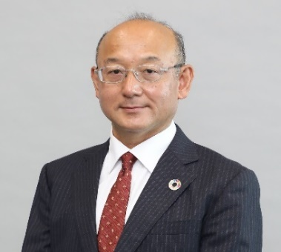

Epson's intellectual property activities are carried out proactively to address potential future intellectual property issues, and the Intellectual Property Division converts all types of "intellectual property", including not only intellectual property rights, but also brand and data, into value, supporting the sustainable growth of corporate value and the realization of purpose.