2. Annotation

First we annotated the segments with UCSC Genome Browser Data integrator tool.
The settings where as follow:

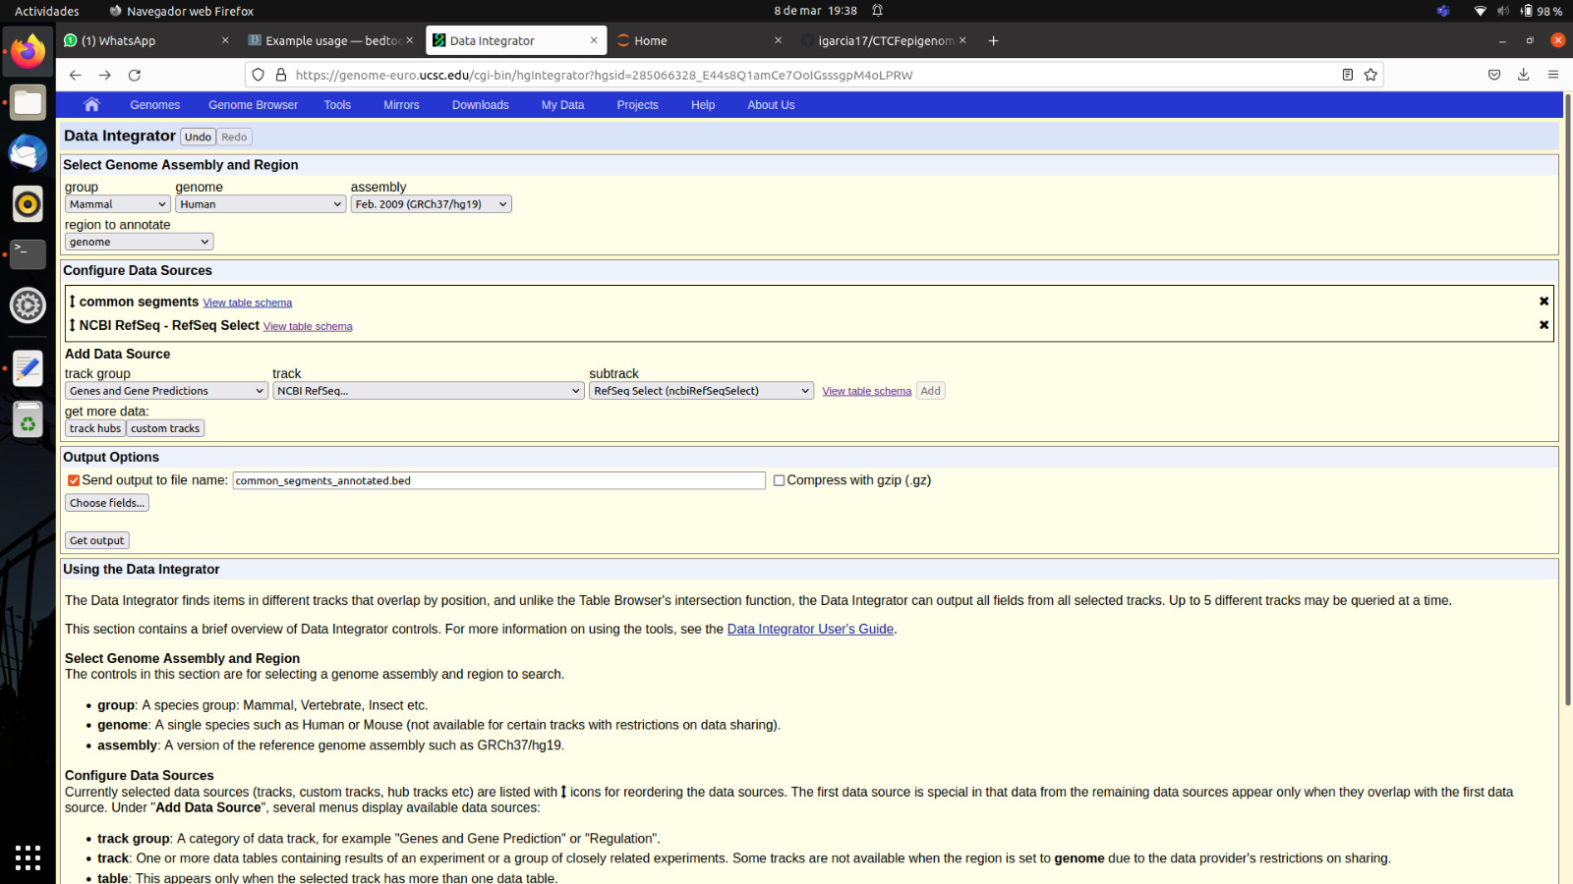

We realised with the following commands that the obtained bed file had more lines.

wc -l common_segments_annotated.bed
8066
wc -l common_segments.bed
8022

This is because some segments are in overlapping regions of genes, such as the case of chr1 1227400 1227800. For this image, the annotated file was modified to be read by UCSC.

A single Select transcript is chosen as representative for each protein-coding gene
Same command as for Ex 3 to get percentage

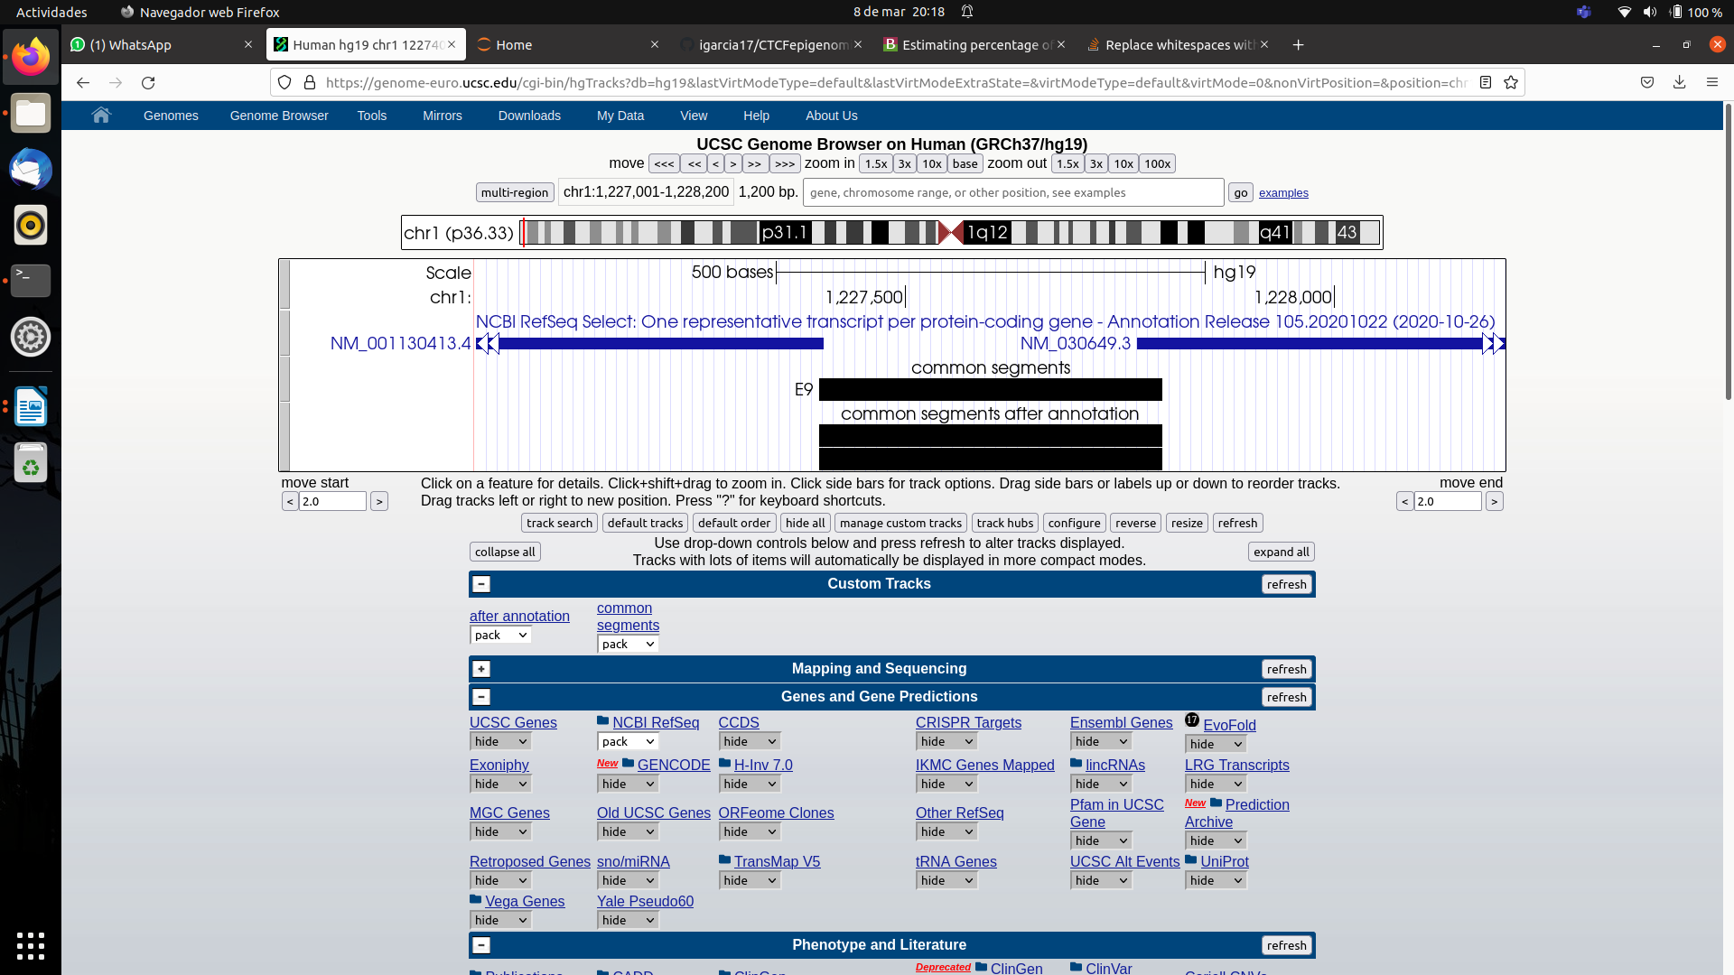
covered exons:

80035

1.522%

Complete genes:

2089126

39.73%

(2) Percentage of coding genes with CTCF segments | 39.73%
(2) Percentage of exons of coding genes with CTCF segments | 1.52%
(3) Percentage of overlapping with DNaseI | 25.88%
(6) Percentage of overlapping with hypermethylated regions | 80.87%
(6) Percentage of overlapping with hypomethylated regions | 2.55%

