Update 2 – UML
For my final project “Garage Mate”, I have identified 6 classes so far, These classes are going to power the logical “back-end” of the application. They are:
- TextFileRepository
- Garage
- VehicleBase
- Car
- Motorcycle
- MaintenanceRecord
The classes have been named according to their desired purpose. The only one that might be a bit confusing is “TextFileRepository”. This class will be used to handle retrieving from and writing to a local text file that will hold all the data in this application. For example, vehicles, maintenance records and garage will all be saved to this local file.
Below are the UML diagrams for each of these classes, as well as the relationships between them.
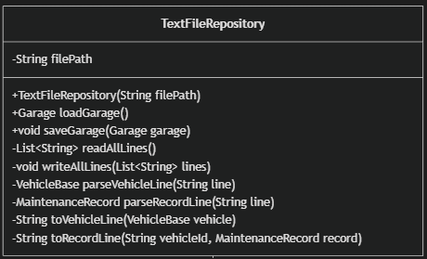
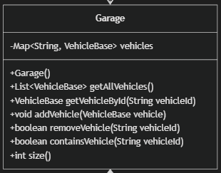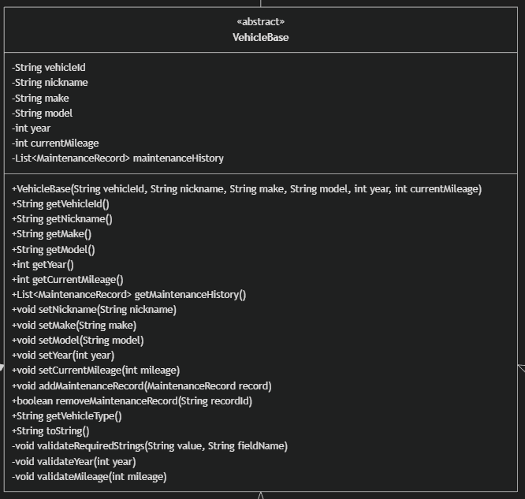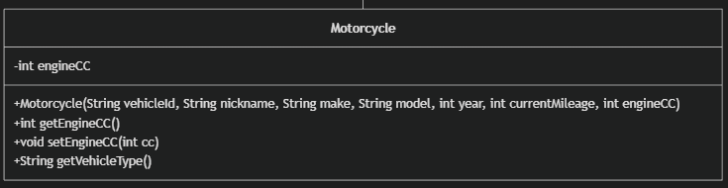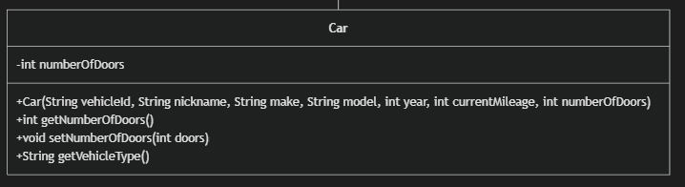
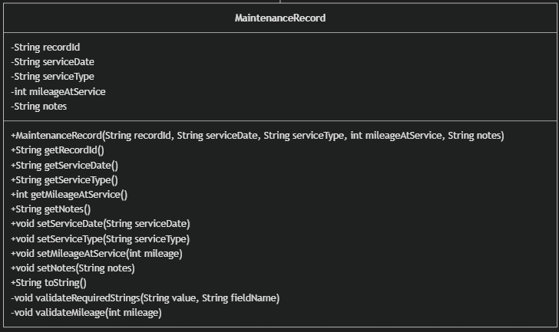
Below is the relationship between these classes.
Note: fields and methods have been omitted in the relationship diagram for readability.

