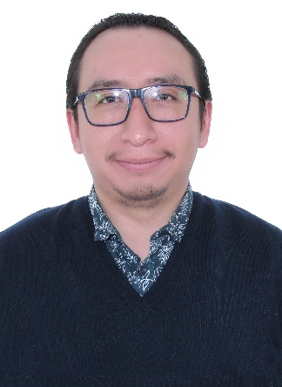­

WORK EXPERIENCE

**PHP Specialist -** SAEKO

Understand system requirements and required integration needs. Collaborate with development teams and stakeholders (such as clients or other areas) to identify integration points and establish a solid scope. Create API integration architectures and designs. Use multiple programming languages (Ruby, PHP).

2023 - Presente

The position is part of a growing global team at Cypher Learning. Ensuring that training programs are developed and implemented; collaborate with customers, sales unit, customer support, and customer education to establish effective programs.

**Administrator TIC –** Fe y Alegría en el Perú

2020 - 2021

Administrator of the various E-Learning platforms, creator of multimedia content, audiovisual production and PHP programmer.

Development of a component for Moodle that synchronizes grades with U+.

**PHP Developer –** EMOTIV

2020 - 2022

**Ed. Trainner -** CYPHER LEARNING

2021 - Presente

2012 – 2015

**COMPUTING AND INFORMATION** - CIBERTEC

EDUCATION

2016 - 2019

**COMPUTER SYSTEMS ENGINEERING** – UPN

* President of the Occupational Health and Safety Committee (UARM)

RECONOCIMIENTOS

* E-Learning
* PHP, PYTHON, MySQL
* Audiovisual design
* Functional analyst
* Applications development

SKILLS

**PHP Specialist**

©AZURIUS – Modelos-de-curriculum.com

Ivan Garcia

SUMMARY

Computer and Informatics Technician and Engineer of Systems Engineering. International certificate in the use and management of Moodle (MCCC). I have more than 10 years of experience in the e-learning field. I have been involved in various educational and development projects.

Cerro de Pasco, Perú

linkedin.com/in/igarciavega

Iva.gar.veg@gmail.com

+51 983674826

©AZURIUS – Modeles-de-cv,com