Bloque 5 — Notificaciones por email + Presupuesto de la agencia
SecreGest — Guía paso a paso, con los tests

0. Qué se construye en este bloque
Dos piezas relacionadas: un microservicio nuevo (notifications) que envía emails reales por Gmail SMTP con plantillas Thymeleaf, calcado del patrón que ya usas en tus proyectos anteriores; y el endpoint de presupuesto en tasks, que el admin usa para fijar un precio a una tarea PENDIENTE_REVISION y que dispara automáticamente el email al cliente.
- notifications (nuevo, puerto 8084): IEmailService/EmailServiceImpl con JavaMailSender + Thymeleaf, dos capacidades — correo genérico (reutilizable en bloques futuros) y correo específico de presupuesto (su propia plantilla).
- tasks: Task gana price; nuevo PUT /api/tasks/{id}/budget (solo admin) y GET /api/tasks/pending (todas las tareas pendientes, de cualquier cliente). Dos clientes RestTemplate nuevos: UserClient (llama a users) y EmailClient (llama a notifications).
- El envío de email es resiliente: si users o notifications están caídos, la tarea queda presupuestada igualmente — solo se registra un aviso en el log, nunca se deshace el presupuesto.
- Frontend: panel /admin/tasks/pending con un precio por tarea y botón "Presupuestar".

PARTE A — Microservicio nuevo: notifications
PASO 1 — pom.xml
notifications/pom.xml
spring-boot-starter-mail + spring-boot-starter-thymeleaf para el envío y renderizado; mismo patrón de seguridad/Swagger que el resto de microservicios.
<?xml version="1.0" encoding="UTF-8"?>
<project xmlns="http://maven.apache.org/POM/4.0.0" xmlns:xsi="http://www.w3.org/2001/XMLSchema-instance"
xsi:schemaLocation="http://maven.apache.org/POM/4.0.0 https://maven.apache.org/xsd/maven-4.0.0.xsd">
<modelVersion>4.0.0</modelVersion>
<parent>
<groupId>org.springframework.boot</groupId>
<artifactId>spring-boot-starter-parent</artifactId>
<version>4.0.6</version>
<relativePath/>
</parent>
<groupId>com.igarciamen</groupId>
<artifactId>notifications</artifactId>
<version>0.0.1-SNAPSHOT</version>
<name/>
<description>Microservicio de envio de emails de SecreGest</description>

<properties>
<java.version>21</java.version>
</properties>

<dependencies>
<dependency>
<groupId>org.springframework.boot</groupId>
<artifactId>spring-boot-starter-mail</artifactId>
</dependency>
<dependency>
<groupId>org.springframework.boot</groupId>
<artifactId>spring-boot-starter-thymeleaf</artifactId>
</dependency>
<dependency>
<groupId>org.springframework.boot</groupId>
<artifactId>spring-boot-starter-security</artifactId>
</dependency>
<dependency>
<groupId>org.springframework.boot</groupId>
<artifactId>spring-boot-starter-webmvc</artifactId>
</dependency>
<dependency>
<groupId>org.springframework.boot</groupId>
<artifactId>spring-boot-starter-oauth2-resource-server</artifactId>
</dependency>
<dependency>
<groupId>org.springdoc</groupId>
<artifactId>springdoc-openapi-starter-webmvc-ui</artifactId>
<version>2.8.5</version>
</dependency>

<dependency>
<groupId>org.springframework.boot</groupId>
<artifactId>spring-boot-starter-security-test</artifactId>
<scope>test</scope>
</dependency>
<dependency>
<groupId>org.springframework.boot</groupId>
<artifactId>spring-boot-starter-webmvc-test</artifactId>
<scope>test</scope>
</dependency>
</dependencies>

<build>
<plugins>
<plugin>
<groupId>org.springframework.boot</groupId>
<artifactId>spring-boot-maven-plugin</artifactId>
</plugin>
</plugins>
</build>

</project>

PASO 2 — Clase principal
notifications/src/main/java/com/igarciamen/notifications/NotificationsApplication.java

package com.igarciamen.notifications;

import org.springframework.boot.SpringApplication;
import org.springframework.boot.autoconfigure.SpringBootApplication;

@SpringBootApplication
public class NotificationsApplication {

public static void main(String[] args) {
SpringApplication.run(NotificationsApplication.class, args);
}
}

PASO 3 — DTOs de entrada
notifications/src/main/java/com/igarciamen/notifications/service/model/CorreoRequest.java
Correo genérico, de propósito general (reutilizable en bloques futuros: aceptación, rechazo, pago, entrega...). Usa la plantilla email.html.
package com.igarciamen.notifications.service.model;

// Correo generico, de proposito general (reutilizable en bloques futuros:
// aceptacion, rechazo, pago, entrega...). Usa la plantilla "email.html".
public class CorreoRequest {
private String destinatario;
private String asunto;
private String mensaje;

public CorreoRequest() {}

public String getDestinatario() { return destinatario; }
public void setDestinatario(String destinatario) { this.destinatario = destinatario; }

public String getAsunto() { return asunto; }
public void setAsunto(String asunto) { this.asunto = asunto; }

public String getMensaje() { return mensaje; }
public void setMensaje(String mensaje) { this.mensaje = mensaje; }
}

notifications/src/main/java/com/igarciamen/notifications/service/model/PresupuestoRequest.java
Correo específico de este bloque: aviso de presupuesto. Usa su propia plantilla (presupuesto.html), no la genérica.
package com.igarciamen.notifications.service.model;

import java.math.BigDecimal;

// Correo especifico del Bloque 5: aviso de presupuesto. Usa su propia
// plantilla ("presupuesto.html"), no la generica de CorreoRequest.
public class PresupuestoRequest {
private String destinatario;
private String nombreCliente;
private String tituloTarea;
private String nombreCategoria;
private BigDecimal precio;

public PresupuestoRequest() {}

public String getDestinatario() { return destinatario; }
public void setDestinatario(String destinatario) { this.destinatario = destinatario; }

public String getNombreCliente() { return nombreCliente; }
public void setNombreCliente(String nombreCliente) { this.nombreCliente = nombreCliente; }

public String getTituloTarea() { return tituloTarea; }
public void setTituloTarea(String tituloTarea) { this.tituloTarea = tituloTarea; }

public String getNombreCategoria() { return nombreCategoria; }
public void setNombreCategoria(String nombreCategoria) { this.nombreCategoria = nombreCategoria; }

public BigDecimal getPrecio() { return precio; }
public void setPrecio(BigDecimal precio) { this.precio = precio; }
}

PASO 4 — Interfaz y servicio de email
EmailServiceImpl usa JavaMailSender (envío real) + TemplateEngine de Thymeleaf (renderizado de la plantilla HTML con variables). El precio se formatea como moneda española (20,00 €), no se manda el BigDecimal en crudo.
notifications/src/main/java/com/igarciamen/notifications/service/IEmailService.java

package com.igarciamen.notifications.service;

import com.igarciamen.notifications.service.model.CorreoRequest;
import com.igarciamen.notifications.service.model.PresupuestoRequest;

public interface IEmailService {

// Correo generico (plantilla email.html).
void enviarCorreo(CorreoRequest correoRequest);

// Correo especifico de presupuesto (plantilla presupuesto.html).
void enviarPresupuesto(PresupuestoRequest presupuestoRequest);
}

notifications/src/main/java/com/igarciamen/notifications/service/impl/EmailServiceImpl.java

package com.igarciamen.notifications.service.impl;

import com.igarciamen.notifications.service.IEmailService;
import com.igarciamen.notifications.service.model.CorreoRequest;
import com.igarciamen.notifications.service.model.PresupuestoRequest;

import org.springframework.mail.javamail.JavaMailSender;
import org.springframework.mail.javamail.MimeMessageHelper;
import org.springframework.stereotype.Service;
import org.thymeleaf.TemplateEngine;
import org.thymeleaf.context.Context;
import jakarta.mail.internet.MimeMessage;

import java.text.NumberFormat;
import java.util.Locale;

@Service
public class EmailServiceImpl implements IEmailService {
private final JavaMailSender javaMailSender;
private final TemplateEngine templateEngine;

public EmailServiceImpl(JavaMailSender javaMailSender, TemplateEngine templateEngine) {
this.javaMailSender = javaMailSender;
this.templateEngine = templateEngine;
}

@Override
public void enviarCorreo(CorreoRequest correoRequest) {
try {
MimeMessage message = javaMailSender.createMimeMessage();
MimeMessageHelper helper = new MimeMessageHelper(message, true, "UTF-8");
helper.setTo(correoRequest.getDestinatario());
helper.setSubject(correoRequest.getAsunto());
Context context = new Context();
context.setVariable("mensaje", correoRequest.getMensaje());
String contenidoHtml = templateEngine.process("email", context);
helper.setText(contenidoHtml, true);
javaMailSender.send(message);
} catch (Exception e) {
throw new RuntimeException("Error al enviar el correo: " + e.getMessage(), e);
}
}

@Override
public void enviarPresupuesto(PresupuestoRequest req) {
try {
MimeMessage message = javaMailSender.createMimeMessage();
MimeMessageHelper helper = new MimeMessageHelper(message, true, "UTF-8");
helper.setTo(req.getDestinatario());
helper.setSubject("Presupuesto de tu encargo: " + req.getTituloTarea());

Context context = new Context();
context.setVariable("nombreCliente", req.getNombreCliente());
context.setVariable("tituloTarea", req.getTituloTarea());
context.setVariable("nombreCategoria", req.getNombreCategoria());
context.setVariable("precioFormateado", formatearPrecio(req.getPrecio()));

String contenidoHtml = templateEngine.process("presupuesto", context);
helper.setText(contenidoHtml, true);
javaMailSender.send(message);
} catch (Exception e) {
throw new RuntimeException("Error al enviar el correo de presupuesto: " + e.getMessage(), e);
}
}

private String formatearPrecio(java.math.BigDecimal precio) {
NumberFormat formatter = NumberFormat.getCurrencyInstance(new Locale("es", "ES"));
return formatter.format(precio);
}
}

PASO 5 — Controller
notifications/src/main/java/com/igarciamen/notifications/controller/EmailController.java

package com.igarciamen.notifications.controller;

import com.igarciamen.notifications.service.IEmailService;
import com.igarciamen.notifications.service.model.CorreoRequest;
import com.igarciamen.notifications.service.model.PresupuestoRequest;
import io.swagger.v3.oas.annotations.Operation;
import io.swagger.v3.oas.annotations.security.SecurityRequirement;

import org.springframework.http.HttpStatus;
import org.springframework.http.ResponseEntity;
import org.springframework.web.bind.annotation.PostMapping;
import org.springframework.web.bind.annotation.RequestBody;
import org.springframework.web.bind.annotation.RestController;

@RestController
public class EmailController {

private final IEmailService emailService;

public EmailController(IEmailService emailService) {
this.emailService = emailService;
}

@Operation(
summary = "Envia un correo generico (solo ROLE_ADMIN)",
security = @SecurityRequirement(name = "bearerAuth")
)
@PostMapping("/enviar-correo")
public ResponseEntity<String> enviarCorreo(@RequestBody CorreoRequest correoRequest) {
try {
emailService.enviarCorreo(correoRequest);
return new ResponseEntity<>("Correo enviado exitosamente.", HttpStatus.OK);
} catch (Exception e) {
return new ResponseEntity<>("Error al enviar el correo: " + e.getMessage(),
HttpStatus.INTERNAL_SERVER_ERROR);
}
}

@Operation(
summary = "Envia el correo de presupuesto de una tarea (solo ROLE_ADMIN)",
security = @SecurityRequirement(name = "bearerAuth")
)
@PostMapping("/notificar-presupuesto")
public ResponseEntity<String> notificarPresupuesto(@RequestBody PresupuestoRequest presupuestoRequest) {
try {
emailService.enviarPresupuesto(presupuestoRequest);
return new ResponseEntity<>("Correo de presupuesto enviado.", HttpStatus.OK);
} catch (Exception e) {
return new ResponseEntity<>("Error al enviar el correo de presupuesto: " + e.getMessage(),
HttpStatus.INTERNAL_SERVER_ERROR);
}
}
}

PASO 6 — EmailConfig — Gmail SMTP
notifications/src/main/java/com/igarciamen/notifications/config/EmailConfig.java

package com.igarciamen.notifications.config;

import org.springframework.beans.factory.annotation.Value;
import org.springframework.context.annotation.Bean;
import org.springframework.context.annotation.Configuration;
import org.springframework.mail.javamail.JavaMailSender;
import org.springframework.mail.javamail.JavaMailSenderImpl;
import java.util.Properties;

@Configuration
public class EmailConfig {

@Value("${spring.mail.username}")
private String email;

@Value("${spring.mail.password}")
private String password;

@Bean
public JavaMailSender javaMailSender() {
JavaMailSenderImpl mailSender = new JavaMailSenderImpl();
Properties props = new Properties();
props.put("mail.smtp.auth", "true");
props.put("mail.smtp.starttls.enable", "true");
props.put("mail.smtp.host", "smtp.gmail.com");
props.put("mail.smtp.port", "587");
mailSender.setJavaMailProperties(props);
mailSender.setUsername(email);
mailSender.setPassword(password);
return mailSender;
}
}

PASO 7 — SecurityConfig (con la corrección de Swagger incluida)
Todos los endpoints exigen ROLE_ADMIN salvo las rutas de Swagger, que deben quedar públicas — si no, ni la propia interfaz de Swagger carga (ver incidencias más abajo).
notifications/src/main/java/com/igarciamen/notifications/config/SecurityConfig.java

package com.igarciamen.notifications.config;

import org.springframework.beans.factory.annotation.Value;
import org.springframework.context.annotation.Bean;
import org.springframework.context.annotation.Configuration;
import org.springframework.security.config.Customizer;
import org.springframework.security.config.annotation.web.builders.HttpSecurity;
import org.springframework.security.config.http.SessionCreationPolicy;
import org.springframework.security.oauth2.jwt.JwtDecoder;
import org.springframework.security.oauth2.jwt.NimbusJwtDecoder;
import org.springframework.security.oauth2.server.resource.authentication.JwtAuthenticationConverter;
import org.springframework.security.oauth2.server.resource.authentication.JwtGrantedAuthoritiesConverter;
import org.springframework.security.web.SecurityFilterChain;
import org.springframework.web.cors.CorsConfiguration;
import org.springframework.web.cors.CorsConfigurationSource;
import org.springframework.web.cors.UrlBasedCorsConfigurationSource;

import javax.crypto.SecretKey;
import javax.crypto.spec.SecretKeySpec;
import java.nio.charset.StandardCharsets;
import java.util.List;

// Este servicio no lo llama el frontend directamente, solo otros microservicios
// (tasks, via RestTemplate con el token del admin reenviado). Aun asi valida el
// JWT igual que el resto, para que nadie pueda disparar envios sin autenticarse.
@Configuration
public class SecurityConfig {

@Value("${jwt.secret}")
private String jwtSecret;

@Bean
SecurityFilterChain filterChain(HttpSecurity http) throws Exception {
http
.cors(Customizer.withDefaults())
.csrf(csrf -> csrf.disable())
.sessionManagement(sm -> sm.sessionCreationPolicy(SessionCreationPolicy.STATELESS))
.authorizeHttpRequests(auth -> auth
.requestMatchers("/swagger-ui/**", "/v3/api-docs/**", "/swagger-ui.html", "/webjars/**").permitAll()
.anyRequest().hasAuthority("ROLE_ADMIN"))
.oauth2ResourceServer(oauth2 ->
oauth2.jwt(jwt -> jwt.jwtAuthenticationConverter(jwtAuthConverter())));
return http.build();
}

@Bean
JwtDecoder jwtDecoder() {
SecretKey key = new SecretKeySpec(
jwtSecret.getBytes(StandardCharsets.UTF_8),
"HmacSHA256"
);
return NimbusJwtDecoder.withSecretKey(key).build();
}

private JwtAuthenticationConverter jwtAuthConverter() {
JwtGrantedAuthoritiesConverter granted = new JwtGrantedAuthoritiesConverter();
granted.setAuthoritiesClaimName("roles");
granted.setAuthorityPrefix("");
JwtAuthenticationConverter converter = new JwtAuthenticationConverter();
converter.setJwtGrantedAuthoritiesConverter(granted);
return converter;
}

@Bean
CorsConfigurationSource corsConfigurationSource() {
CorsConfiguration cfg = new CorsConfiguration();
cfg.setAllowedOrigins(List.of("http://localhost:4200"));
cfg.setAllowedMethods(List.of("GET", "POST", "PUT", "DELETE", "OPTIONS"));
cfg.setAllowedHeaders(List.of("*"));
cfg.setExposedHeaders(List.of("Authorization"));
cfg.setAllowCredentials(true);

UrlBasedCorsConfigurationSource src = new UrlBasedCorsConfigurationSource();
src.registerCorsConfiguration("/**", cfg);
return src;
}
}

PASO 8 — OpenApiConfig
notifications/src/main/java/com/igarciamen/notifications/config/OpenApiConfig.java

package com.igarciamen.notifications.config;

import io.swagger.v3.oas.annotations.OpenAPIDefinition;
import io.swagger.v3.oas.annotations.enums.SecuritySchemeType;
import io.swagger.v3.oas.annotations.security.SecurityScheme;
import org.springframework.context.annotation.Configuration;

@Configuration
@OpenAPIDefinition
@SecurityScheme(
name = "bearerAuth",
type = SecuritySchemeType.HTTP,
scheme = "bearer",
bearerFormat = "JWT"
)
public class OpenApiConfig {
}

PASO 9 — Plantillas Thymeleaf
notifications/src/main/resources/templates/email.html
Plantilla genérica: título + un párrafo con la variable mensaje.
<!DOCTYPE html>
<html xmlns:th="http://www.thymeleaf.org">
<head>
<title>SecreGest</title>
</head>
<body>
<h1 style="color: #007b5e;">SecreGest</h1>
<p th:text="${mensaje}"></p>
</body>
</html>

notifications/src/main/resources/templates/presupuesto.html
Plantilla específica: cabecera de marca, tabla con encargo/categoría/precio formateado.
<!DOCTYPE html>
<html xmlns:th="http://www.thymeleaf.org">
<head>
<title>Presupuesto de tu encargo</title>
</head>
<body style="font-family: Arial, sans-serif; background-color: #f4f4f4; padding: 24px;">
<table role="presentation" width="100%" cellpadding="0" cellspacing="0">
<tr>
<td align="center">
<table role="presentation" width="480" cellpadding="0" cellspacing="0"
style="background-color: #ffffff; border-radius: 8px; overflow: hidden;">
<tr>
<td style="background-color: #007b5e; padding: 20px 24px;">
<span style="color: #ffffff; font-size: 22px; font-weight: bold;">SecreGest</span>
</td>
</tr>
<tr>
<td style="padding: 24px;">
<p style="font-size: 16px; color: #333;">
Hola <span th:text="${nombreCliente}">cliente</span>,
</p>
<p style="font-size: 15px; color: #444;">
Hemos revisado tu encargo y ya tenemos un presupuesto listo:
</p>

<table role="presentation" width="100%" cellpadding="8" cellspacing="0"
style="background-color: #f9f9f9; border-radius: 6px; margin: 16px 0;">
<tr>
<td style="color: #777; font-size: 13px;">Encargo</td>
<td style="color: #222; font-size: 14px; font-weight: bold; text-align: right;"
th:text="${tituloTarea}">Titulo</td>
</tr>
<tr>
<td style="color: #777; font-size: 13px;">Categoria</td>
<td style="color: #222; font-size: 14px; text-align: right;"
th:text="${nombreCategoria}">Categoria</td>
</tr>
<tr>
<td style="color: #777; font-size: 13px;">Presupuesto</td>
<td style="color: #007b5e; font-size: 18px; font-weight: bold; text-align: right;"
th:text="${precioFormateado}">0,00 &#8364;</td>
</tr>
</table>

<p style="font-size: 14px; color: #555;">
Entra en la plataforma para aceptar o rechazar este presupuesto.
</p>
</td>
</tr>
<tr>
<td style="background-color: #f4f4f4; padding: 14px 24px;">
<span style="font-size: 12px; color: #999;">SecreGest &middot; Agencia de secretariado</span>
</td>
</tr>
</table>
</td>
</tr>
</table>
</body>
</html>

PASO 10 — application.properties y Dockerfile
Con tus credenciales reales de Gmail (contraseña de aplicación). Mismo jwt.secret que el resto de microservicios.
notifications/src/main/resources/application.properties

spring.application.name=notifications
server.port=8084

# Gmail SMTP
spring.mail.host=smtp.gmail.com
spring.mail.port=587
spring.mail.username=programacion2026test@gmail.com
spring.mail.password=vssu vlen tqqq jqjd
spring.mail.properties.mail.smtp.auth=true
spring.mail.properties.mail.smtp.starttls.enable=true

# Mismo secreto JWT que el resto de microservicios: asi valida los tokens sin llamar a users.
jwt.secret=0123456789ABCDEFGHIJKLMNOPQRSTUV

notifications/Dockerfile

# --- Etapa 1: build con Maven ---
FROM maven:3.9-eclipse-temurin-21 AS build
WORKDIR /app
COPY pom.xml .
RUN mvn -B -q dependency:go-offline
COPY src ./src
RUN mvn -B -q clean package -DskipTests

# --- Etapa 2: imagen de ejecucion, solo el jar ---
FROM eclipse-temurin:21-jre-alpine
WORKDIR /app
COPY --from=build /app/target/*.jar app.jar
EXPOSE 8084
ENTRYPOINT ["java", "-jar", "app.jar"]

PARTE B — Tests de notifications
PASO 11 — Test de integración del controller (seguridad + llamada al servicio)
IEmailService se sustituye por un mock (@MockitoBean): no se manda ningún correo real durante los tests.
notifications/src/test/resources/application.properties

spring.mail.host=smtp.gmail.com
spring.mail.port=587
spring.mail.username=test@example.com
spring.mail.password=test-password

jwt.secret=test-secret-solo-para-tests-0123456789

notifications/src/test/java/com/igarciamen/notifications/controller/EmailControllerIT.java

package com.igarciamen.notifications.controller;

import tools.jackson.databind.ObjectMapper;
import com.igarciamen.notifications.service.IEmailService;
import org.junit.jupiter.api.Test;
import org.mockito.Mockito;
import org.springframework.beans.factory.annotation.Autowired;
import org.springframework.boot.test.context.SpringBootTest;
import org.springframework.boot.webmvc.test.autoconfigure.AutoConfigureMockMvc;
import org.springframework.http.MediaType;
import org.springframework.security.core.authority.SimpleGrantedAuthority;
import org.springframework.test.context.bean.override.mockito.MockitoBean;
import org.springframework.test.web.servlet.MockMvc;

import java.util.Map;

import static org.mockito.Mockito.verify;
import static org.springframework.security.test.web.servlet.request.SecurityMockMvcRequestPostProcessors.jwt;
import static org.springframework.test.web.servlet.request.MockMvcRequestBuilders.post;
import static org.springframework.test.web.servlet.result.MockMvcResultMatchers.status;

// IEmailService se sustituye por un mock: no se manda ningun correo real durante los tests.
@SpringBootTest
@AutoConfigureMockMvc
class EmailControllerIT {

@Autowired
private MockMvc mockMvc;

@Autowired
private ObjectMapper objectMapper;

@MockitoBean
private IEmailService emailService;

@Test
void notificarPresupuesto_sinToken_devuelve401() throws Exception {
String body = objectMapper.writeValueAsString(Map.of(
"destinatario", "cliente@mail.com", "nombreCliente", "Marco",
"tituloTarea", "Agendar reunion", "nombreCategoria", "Agenda", "precio", 20.0));

mockMvc.perform(post("/notificar-presupuesto")
.contentType(MediaType.APPLICATION_JSON)
.content(body))
.andExpect(status().isUnauthorized());
}

@Test
void notificarPresupuesto_conRolUser_devuelve403() throws Exception {
String body = objectMapper.writeValueAsString(Map.of(
"destinatario", "cliente@mail.com", "nombreCliente", "Marco",
"tituloTarea", "Agendar reunion", "nombreCategoria", "Agenda", "precio", 20.0));

mockMvc.perform(post("/notificar-presupuesto")
.with(jwt().authorities(new SimpleGrantedAuthority("ROLE_USER")))
.contentType(MediaType.APPLICATION_JSON)
.content(body))
.andExpect(status().isForbidden());
}

@Test
void notificarPresupuesto_conRolAdmin_llamaAlServicioYDevuelve200() throws Exception {
String body = objectMapper.writeValueAsString(Map.of(
"destinatario", "cliente@mail.com", "nombreCliente", "Marco",
"tituloTarea", "Agendar reunion", "nombreCategoria", "Agenda", "precio", 20.0));

mockMvc.perform(post("/notificar-presupuesto")
.with(jwt().authorities(new SimpleGrantedAuthority("ROLE_ADMIN")))
.contentType(MediaType.APPLICATION_JSON)
.content(body))
.andExpect(status().isOk());

verify(emailService).enviarPresupuesto(Mockito.any());
}

@Test
void enviarCorreo_conRolAdmin_llamaAlServicio() throws Exception {
String body = objectMapper.writeValueAsString(Map.of(
"destinatario", "cliente@mail.com", "asunto", "Prueba", "mensaje", "Hola"));

mockMvc.perform(post("/enviar-correo")
.with(jwt().authorities(new SimpleGrantedAuthority("ROLE_ADMIN")))
.contentType(MediaType.APPLICATION_JSON)
.content(body))
.andExpect(status().isOk());

verify(emailService).enviarCorreo(Mockito.any());
}
}

PASO 12 — Test unitario del servicio (plantillas y JavaMailSender mockeados)
Complementa al de integración: EmailControllerIT prueba la capa HTTP + seguridad con el servicio mockeado; EmailServiceImplTest prueba la lógica real (qué plantilla se usa, qué variables se pasan, que el mensaje se manda) sin depender de Gmail.
notifications/src/test/java/com/igarciamen/notifications/service/EmailServiceImplTest.java

package com.igarciamen.notifications.service;

import com.igarciamen.notifications.service.impl.EmailServiceImpl;
import com.igarciamen.notifications.service.model.CorreoRequest;
import com.igarciamen.notifications.service.model.PresupuestoRequest;
import jakarta.mail.internet.MimeMessage;
import org.junit.jupiter.api.Test;
import org.junit.jupiter.api.extension.ExtendWith;
import org.mockito.ArgumentCaptor;
import org.mockito.InjectMocks;
import org.mockito.Mock;
import org.mockito.junit.jupiter.MockitoExtension;
import org.springframework.mail.javamail.JavaMailSender;
import org.thymeleaf.TemplateEngine;
import org.thymeleaf.context.Context;

import java.math.BigDecimal;

import static org.junit.jupiter.api.Assertions.assertThrows;
import static org.mockito.ArgumentMatchers.any;
import static org.mockito.ArgumentMatchers.eq;
import static org.mockito.Mockito.*;

@ExtendWith(MockitoExtension.class)
class EmailServiceImplTest {

@Mock
private JavaMailSender javaMailSender;

@Mock
private TemplateEngine templateEngine;

@InjectMocks
private EmailServiceImpl emailService;

@Test
void enviarCorreo_procesaLaPlantillaEmailYManda() {
MimeMessage mimeMessage = mock(MimeMessage.class);
when(javaMailSender.createMimeMessage()).thenReturn(mimeMessage);
when(templateEngine.process(eq("email"), any(Context.class))).thenReturn("<html>contenido</html>");

CorreoRequest req = new CorreoRequest();
req.setDestinatario("cliente@mail.com");
req.setAsunto("Prueba");
req.setMensaje("Hola, esto es una prueba.");

emailService.enviarCorreo(req);

verify(templateEngine).process(eq("email"), any(Context.class));
verify(javaMailSender).send(mimeMessage);
}

@Test
void enviarPresupuesto_procesaLaPlantillaPresupuestoConLasVariablesCorrectas() {
MimeMessage mimeMessage = mock(MimeMessage.class);
when(javaMailSender.createMimeMessage()).thenReturn(mimeMessage);

ArgumentCaptor<Context> contextCaptor = ArgumentCaptor.forClass(Context.class);
when(templateEngine.process(eq("presupuesto"), contextCaptor.capture())).thenReturn("<html>presupuesto</html>");

PresupuestoRequest req = new PresupuestoRequest();
req.setDestinatario("cliente@mail.com");
req.setNombreCliente("Marco");
req.setTituloTarea("Agendar reunion");
req.setNombreCategoria("Agenda");
req.setPrecio(new BigDecimal("20.00"));

emailService.enviarPresupuesto(req);

verify(templateEngine).process(eq("presupuesto"), any(Context.class));
verify(javaMailSender).send(mimeMessage);

Context usedContext = contextCaptor.getValue();
assert usedContext.getVariable("precioFormateado") != null;
}

@Test
void enviarCorreo_siJavaMailSenderFalla_lanzaRuntimeException() {
when(javaMailSender.createMimeMessage()).thenThrow(new RuntimeException("SMTP caido"));

CorreoRequest req = new CorreoRequest();
req.setDestinatario("cliente@mail.com");
req.setAsunto("Prueba");
req.setMensaje("Hola");

assertThrows(RuntimeException.class, () -> emailService.enviarCorreo(req));
}
}

PARTE C — tasks: presupuesto
PASO 13 — Task gana el campo price
tasks/src/main/java/com/igarciamen/tasks/model/Task.java

package com.igarciamen.tasks.model;

import com.igarciamen.tasks.enums.ConfidentialityLevel;
import com.igarciamen.tasks.enums.TaskStatus;
import jakarta.persistence.*;

import java.time.LocalDateTime;

@Entity
@Table(name = "tasks", schema = "public")
public class Task {

@Id
@GeneratedValue(strategy = GenerationType.IDENTITY)
private Long id;

// El cliente vive en el microservicio "users"; aqui solo guardamos su id
// (extraido del claim "userId" del JWT), sin llamar a users para esto.
@Column(nullable = false)
private Long clientUserId;

// La categoria vive en el microservicio "categories" (base de datos distinta),
// por eso aqui NO hay una relacion @ManyToOne, solo el id. La validez del id
// y el nombre de la categoria se resuelven via CategoryClient (RestTemplate).
@Column(nullable = false)
private Long categoryId;

@Column(nullable = false, length = 120)
private String title;

@Column(length = 1000)
private String description;

@Enumerated(EnumType.STRING)
@Column(nullable = false, length = 30)
private TaskStatus status = TaskStatus.PENDIENTE_REVISION;

@Column(nullable = false)
private LocalDateTime createdAt = LocalDateTime.now();

// Fecha y hora limite deseada por el cliente. Opcional: alimenta el futuro
// bloque de calendario, no bloquea la creacion de la tarea si no se indica.
private LocalDateTime dueDate;

@Column(length = 30)
private String contactPhone;

@Column(length = 500)
private String relevantUrl;

@Enumerated(EnumType.STRING)
@Column(length = 20)
private ConfidentialityLevel confidentialityLevel = ConfidentialityLevel.NORMAL;

// Precio fijado por el admin al presupuestar (Bloque 5). Null hasta entonces.
@Column(precision = 8, scale = 2)
private java.math.BigDecimal price;

public Task() {}

public Task(Long clientUserId, Long categoryId, String title, String description) {
this.clientUserId = clientUserId;
this.categoryId = categoryId;
this.title = title;
this.description = description;
}

public Long getId() { return id; }
public void setId(Long id) { this.id = id; }

public Long getClientUserId() { return clientUserId; }
public void setClientUserId(Long clientUserId) { this.clientUserId = clientUserId; }

public Long getCategoryId() { return categoryId; }
public void setCategoryId(Long categoryId) { this.categoryId = categoryId; }

public String getTitle() { return title; }
public void setTitle(String title) { this.title = title; }

public String getDescription() { return description; }
public void setDescription(String description) { this.description = description; }

public TaskStatus getStatus() { return status; }
public void setStatus(TaskStatus status) { this.status = status; }

public LocalDateTime getCreatedAt() { return createdAt; }
public void setCreatedAt(LocalDateTime createdAt) { this.createdAt = createdAt; }

public LocalDateTime getDueDate() { return dueDate; }
public void setDueDate(LocalDateTime dueDate) { this.dueDate = dueDate; }

public String getContactPhone() { return contactPhone; }
public void setContactPhone(String contactPhone) { this.contactPhone = contactPhone; }

public String getRelevantUrl() { return relevantUrl; }
public void setRelevantUrl(String relevantUrl) { this.relevantUrl = relevantUrl; }

public ConfidentialityLevel getConfidentialityLevel() { return confidentialityLevel; }
public void setConfidentialityLevel(ConfidentialityLevel confidentialityLevel) {
this.confidentialityLevel = confidentialityLevel;
}

public java.math.BigDecimal getPrice() { return price; }
public void setPrice(java.math.BigDecimal price) { this.price = price; }
}

PASO 14 — Repositorio y DTO de presupuesto
tasks/src/main/java/com/igarciamen/tasks/repository/TaskRepository.java
findByStatusOrderByCreatedAtAsc: el listado de pendientes del admin, de todos los clientes.
package com.igarciamen.tasks.repository;

import com.igarciamen.tasks.enums.TaskStatus;
import com.igarciamen.tasks.model.Task;
import org.springframework.data.jpa.repository.JpaRepository;

import java.util.List;

public interface TaskRepository extends JpaRepository<Task, Long> {
List<Task> findByClientUserIdOrderByCreatedAtDesc(Long clientUserId);

// Panel del admin: todas las tareas de todos los clientes en un estado dado
// (de momento, PENDIENTE_REVISION para presupuestar).
List<Task> findByStatusOrderByCreatedAtAsc(TaskStatus status);
}

tasks/src/main/java/com/igarciamen/tasks/payloads/request/BudgetTaskRequest.java

package com.igarciamen.tasks.payloads.request;

import jakarta.validation.constraints.DecimalMin;
import jakarta.validation.constraints.NotNull;

import java.math.BigDecimal;

public class BudgetTaskRequest {

@NotNull
@DecimalMin(value = "0.01")
private BigDecimal price;

public BudgetTaskRequest() {}

public BigDecimal getPrice() { return price; }
public void setPrice(BigDecimal price) { this.price = price; }
}

tasks/src/main/java/com/igarciamen/tasks/payloads/response/TaskResponse.java

package com.igarciamen.tasks.payloads.response;

import com.igarciamen.tasks.model.Task;

import java.math.BigDecimal;
import java.time.LocalDateTime;

public class TaskResponse {

private Long id;
private Long categoryId;
private String categoryName;
private String title;
private String description;
private String status;
private LocalDateTime createdAt;
private LocalDateTime dueDate;
private String contactPhone;
private String relevantUrl;
private String confidentialityLevel;
private BigDecimal price;

public TaskResponse() {}

public TaskResponse(Long id, Long categoryId, String categoryName, String title, String description,
String status, LocalDateTime createdAt, LocalDateTime dueDate,
String contactPhone, String relevantUrl, String confidentialityLevel, BigDecimal price) {
this.id = id;
this.categoryId = categoryId;
this.categoryName = categoryName;
this.title = title;
this.description = description;
this.status = status;
this.createdAt = createdAt;
this.dueDate = dueDate;
this.contactPhone = contactPhone;
this.relevantUrl = relevantUrl;
this.confidentialityLevel = confidentialityLevel;
this.price = price;
}

// categoryName llega ya resuelto desde el controller (via CategoryClient), porque
// Task ya no la tiene embebida (vive en otro microservicio/BBDD).
public static TaskResponse from(Task task, String categoryName) {
return new TaskResponse(
task.getId(),
task.getCategoryId(),
categoryName,
task.getTitle(),
task.getDescription(),
task.getStatus().name(),
task.getCreatedAt(),
task.getDueDate(),
task.getContactPhone(),
task.getRelevantUrl(),
task.getConfidentialityLevel() != null ? task.getConfidentialityLevel().name() : null,
task.getPrice()
);
}

public Long getId() { return id; }
public Long getCategoryId() { return categoryId; }
public String getCategoryName() { return categoryName; }
public String getTitle() { return title; }
public String getDescription() { return description; }
public String getStatus() { return status; }
public LocalDateTime getCreatedAt() { return createdAt; }
public LocalDateTime getDueDate() { return dueDate; }
public String getContactPhone() { return contactPhone; }
public String getRelevantUrl() { return relevantUrl; }
public String getConfidentialityLevel() { return confidentialityLevel; }
public BigDecimal getPrice() { return price; }
}

PASO 15 — UserClient — llama a users (equivalente a CategoryClient)
tasks/src/main/java/com/igarciamen/tasks/service/UserClient.java

package com.igarciamen.tasks.service;

import jakarta.persistence.EntityNotFoundException;
import org.springframework.beans.factory.annotation.Value;
import org.springframework.stereotype.Component;
import org.springframework.web.client.RestClientException;
import org.springframework.web.client.RestTemplate;

import java.util.Map;
import java.util.Objects;

// Igual que CategoryClient, pero llamando a "users" para obtener los datos del
// cliente (username/email) que necesita el correo de presupuesto. El token del
// admin que hace la peticion se reenvia automaticamente (RestTemplateConfig),
// asi que llega autenticado a GET /api/user/{id} en users.
@Component
public class UserClient {

private final RestTemplate http;
private final String usersBase;

public UserClient(RestTemplate http, @Value("${users.base-url}") String usersBaseUrl) {
this.http = http;
this.usersBase = usersBaseUrl;
}

public Map<String, Object> fetchUserOrThrow(Long id) {
try {
var body = http.getForObject(usersBase + "/" + id, Map.class);
if (body == null || !Objects.equals(((Number) body.getOrDefault("id", -1)).longValue(), id)) {
throw new EntityNotFoundException("User not found: " + id);
}
return body;
} catch (RestClientException e) {
throw new IllegalStateException("Error calling the users service: " + e.getMessage(), e);
}
}
}

PASO 16 — EmailClient — llama a notifications
tasks/src/main/java/com/igarciamen/tasks/service/EmailClient.java

package com.igarciamen.tasks.service;

import org.springframework.beans.factory.annotation.Value;
import org.springframework.stereotype.Component;
import org.springframework.web.client.RestClientException;
import org.springframework.web.client.RestTemplate;

import java.math.BigDecimal;
import java.util.Map;

// Llama al microservicio "notifications" para disparar el correo de presupuesto.
// Un fallo aqui NO debe impedir que la tarea quede presupuestada (ver TaskService):
// por eso este cliente lanza una excepcion propia que TaskService puede capturar
// y solo loguear, sin deshacer el presupuesto ya guardado.
@Component
public class EmailClient {

private final RestTemplate http;
private final String notificationsBase;

public EmailClient(RestTemplate http, @Value("${notifications.base-url}") String notificationsBaseUrl) {
this.http = http;
this.notificationsBase = notificationsBaseUrl;
}

public void sendBudgetEmail(String destinatario, String nombreCliente, String tituloTarea,
String nombreCategoria, BigDecimal precio) {
try {
Map<String, Object> body = Map.of(
"destinatario", destinatario,
"nombreCliente", nombreCliente,
"tituloTarea", tituloTarea,
"nombreCategoria", nombreCategoria,
"precio", precio
);
http.postForObject(notificationsBase + "/notificar-presupuesto", body, String.class);
} catch (RestClientException e) {
throw new IllegalStateException("Error calling the notifications service: " + e.getMessage(), e);
}
}
}

PASO 17 — TaskService — listPending() y budget()
budget() exige que la tarea esté en PENDIENTE_REVISION (si no, 409). El envío de email nunca deshace el presupuesto ya guardado: si users o notifications fallan, solo se registra un WARN en el log.
tasks/src/main/java/com/igarciamen/tasks/service/TaskService.java

package com.igarciamen.tasks.service;

import com.igarciamen.tasks.enums.TaskStatus;
import com.igarciamen.tasks.model.Task;
import com.igarciamen.tasks.payloads.request.BudgetTaskRequest;
import com.igarciamen.tasks.payloads.request.CreateTaskRequest;
import com.igarciamen.tasks.repository.TaskRepository;
import jakarta.persistence.EntityNotFoundException;
import org.slf4j.Logger;
import org.slf4j.LoggerFactory;
import org.springframework.http.HttpStatus;
import org.springframework.stereotype.Service;
import org.springframework.web.server.ResponseStatusException;

import java.util.List;
import java.util.Map;

@Service
public class TaskService {

private static final Logger log = LoggerFactory.getLogger(TaskService.class);

private final TaskRepository taskRepo;
private final CategoryClient categoryClient;
private final UserClient userClient;
private final EmailClient emailClient;

public TaskService(TaskRepository taskRepo, CategoryClient categoryClient,
UserClient userClient, EmailClient emailClient) {
this.taskRepo = taskRepo;
this.categoryClient = categoryClient;
this.userClient = userClient;
this.emailClient = emailClient;
}

public Task create(Long clientUserId, CreateTaskRequest req) {
// Valida la categoria llamando al microservicio "categories" (RestTemplate),
// no con una consulta a base de datos local: son bases de datos distintas.
Map<String, Object> category;
try {
category = categoryClient.fetchCategoryOrThrow(req.getCategoryId());
} catch (EntityNotFoundException e) {
throw new ResponseStatusException(HttpStatus.NOT_FOUND, e.getMessage());
} catch (IllegalStateException e) {
throw new ResponseStatusException(HttpStatus.SERVICE_UNAVAILABLE,
"No se pudo validar la categoria: " + e.getMessage());
}

Long categoryId = ((Number) category.get("id")).longValue();
Task task = new Task(clientUserId, categoryId, req.getTitle(), req.getDescription());
task.setDueDate(req.getDueDate());
task.setContactPhone(req.getContactPhone());
task.setRelevantUrl(req.getRelevantUrl());
if (req.getConfidentialityLevel() != null) {
task.setConfidentialityLevel(req.getConfidentialityLevel());
}
return taskRepo.save(task);
}

public List<Task> listMine(Long clientUserId) {
return taskRepo.findByClientUserIdOrderByCreatedAtDesc(clientUserId);
}

// Panel del admin: todas las tareas pendientes de presupuestar, de cualquier cliente.
public List<Task> listPending() {
return taskRepo.findByStatusOrderByCreatedAtAsc(TaskStatus.PENDIENTE_REVISION);
}

public Task budget(Long taskId, BudgetTaskRequest req) {
Task task = taskRepo.findById(taskId)
.orElseThrow(() -> new ResponseStatusException(HttpStatus.NOT_FOUND,
"Task not found: " + taskId));

if (task.getStatus() != TaskStatus.PENDIENTE_REVISION) {
throw new ResponseStatusException(HttpStatus.CONFLICT,
"Solo se pueden presupuestar tareas en PENDIENTE_REVISION (estado actual: "
+ task.getStatus() + ")");
}

task.setPrice(req.getPrice());
task.setStatus(TaskStatus.PRESUPUESTADA);
Task saved = taskRepo.save(task);

notifyBudgetByEmail(saved);

return saved;
}

// El envio de email NUNCA deshace el presupuesto ya guardado: si "users" o
// "notifications" estan caidos, la tarea se queda igualmente en PRESUPUESTADA
// y solo se registra un aviso en el log.
private void notifyBudgetByEmail(Task task) {
try {
Map<String, Object> user = userClient.fetchUserOrThrow(task.getClientUserId());
String email = (String) user.get("email");
String username = (String) user.get("username");
String categoryName = fetchCategoryName(task.getCategoryId());

emailClient.sendBudgetEmail(email, username, task.getTitle(), categoryName, task.getPrice());
} catch (Exception e) {
log.warn("No se pudo enviar el correo de presupuesto de la tarea {}: {}",
task.getId(), e.getMessage());
}
}

// Usado por TaskController para incluir el nombre de la categoria en la respuesta,
// sin duplicar esa informacion en la propia tabla "tasks".
public String fetchCategoryName(Long categoryId) {
try {
Object name = categoryClient.fetchCategoryOrThrow(categoryId).get("name");
return name != null ? name.toString() : null;
} catch (Exception e) {
return null;
}
}
}

PASO 18 — TaskController
tasks/src/main/java/com/igarciamen/tasks/controller/TaskController.java

package com.igarciamen.tasks.controller;

import com.igarciamen.tasks.model.Task;
import com.igarciamen.tasks.payloads.request.BudgetTaskRequest;
import com.igarciamen.tasks.payloads.request.CreateTaskRequest;
import com.igarciamen.tasks.payloads.response.TaskResponse;
import com.igarciamen.tasks.service.TaskService;
import io.swagger.v3.oas.annotations.Operation;
import io.swagger.v3.oas.annotations.security.SecurityRequirement;
import jakarta.validation.Valid;
import org.springframework.http.HttpStatus;
import org.springframework.http.MediaType;
import org.springframework.http.ResponseEntity;
import org.springframework.security.core.annotation.AuthenticationPrincipal;
import org.springframework.security.oauth2.jwt.Jwt;
import org.springframework.web.bind.annotation.*;

import java.util.List;
import java.util.stream.Collectors;

@RestController
@RequestMapping("/api/tasks")
public class TaskController {

private final TaskService taskService;

public TaskController(TaskService taskService) {
this.taskService = taskService;
}

@Operation(
summary = "Solicita una tarea nueva (solo ROLE_USER)",
security = @SecurityRequirement(name = "bearerAuth")
)
@PostMapping(consumes = MediaType.APPLICATION_JSON_VALUE, produces = MediaType.APPLICATION_JSON_VALUE)
public ResponseEntity<TaskResponse> create(@AuthenticationPrincipal Jwt jwt,
@Valid @RequestBody CreateTaskRequest req) {
Long clientUserId = extractUserId(jwt);
Task created = taskService.create(clientUserId, req);
String categoryName = taskService.fetchCategoryName(created.getCategoryId());
return ResponseEntity.status(HttpStatus.CREATED).body(TaskResponse.from(created, categoryName));
}

@Operation(
summary = "Lista las tareas del usuario autenticado (\"Mis tareas\")",
security = @SecurityRequirement(name = "bearerAuth")
)
@GetMapping(path = "/mine", produces = MediaType.APPLICATION_JSON_VALUE)
public ResponseEntity<List<TaskResponse>> mine(@AuthenticationPrincipal Jwt jwt) {
Long clientUserId = extractUserId(jwt);
List<TaskResponse> body = taskService.listMine(clientUserId).stream()
.map(t -> TaskResponse.from(t, taskService.fetchCategoryName(t.getCategoryId())))
.collect(Collectors.toList());
return ResponseEntity.ok(body);
}

@Operation(
summary = "Lista las tareas pendientes de presupuestar, de todos los clientes (solo ROLE_ADMIN)",
security = @SecurityRequirement(name = "bearerAuth")
)
@GetMapping(path = "/pending", produces = MediaType.APPLICATION_JSON_VALUE)
public ResponseEntity<List<TaskResponse>> pending() {
List<TaskResponse> body = taskService.listPending().stream()
.map(t -> TaskResponse.from(t, taskService.fetchCategoryName(t.getCategoryId())))
.collect(Collectors.toList());
return ResponseEntity.ok(body);
}

@Operation(
summary = "Fija el presupuesto de una tarea PENDIENTE_REVISION (solo ROLE_ADMIN)",
security = @SecurityRequirement(name = "bearerAuth")
)
@PutMapping(path = "/{id}/budget", consumes = MediaType.APPLICATION_JSON_VALUE, produces = MediaType.APPLICATION_JSON_VALUE)
public ResponseEntity<TaskResponse> budget(@PathVariable Long id, @Valid @RequestBody BudgetTaskRequest req) {
Task updated = taskService.budget(id, req);
String categoryName = taskService.fetchCategoryName(updated.getCategoryId());
return ResponseEntity.ok(TaskResponse.from(updated, categoryName));
}

// El claim "userId" lo pone JwtUtils (en users) como numero; segun el parser puede
// llegar como Long o Integer, por eso se convierte via Number en vez de castear directo.
private Long extractUserId(Jwt jwt) {
Object claim = jwt.getClaim("userId");
if (claim == null) {
throw new IllegalStateException("El token no contiene el claim 'userId'");
}
return ((Number) claim).longValue();
}
}

PASO 19 — SecurityConfig de tasks
GET /pending y PUT /*/budget: solo ROLE_ADMIN, añadidas antes de la regla general de "cualquier autenticado".
tasks/src/main/java/com/igarciamen/tasks/config/SecurityConfig.java

package com.igarciamen.tasks.config;

import org.springframework.beans.factory.annotation.Value;
import org.springframework.context.annotation.Bean;
import org.springframework.context.annotation.Configuration;
import org.springframework.http.HttpMethod;
import org.springframework.security.config.Customizer;
import org.springframework.security.config.annotation.web.builders.HttpSecurity;
import org.springframework.security.config.http.SessionCreationPolicy;
import org.springframework.security.oauth2.jwt.JwtDecoder;
import org.springframework.security.oauth2.jwt.NimbusJwtDecoder;
import org.springframework.security.oauth2.server.resource.authentication.JwtAuthenticationConverter;
import org.springframework.security.oauth2.server.resource.authentication.JwtGrantedAuthoritiesConverter;
import org.springframework.security.web.SecurityFilterChain;
import org.springframework.web.cors.CorsConfiguration;
import org.springframework.web.cors.CorsConfigurationSource;
import org.springframework.web.cors.UrlBasedCorsConfigurationSource;

import javax.crypto.SecretKey;
import javax.crypto.spec.SecretKeySpec;
import java.nio.charset.StandardCharsets;
import java.util.List;

@Configuration
public class SecurityConfig {

// MISMO jwt.secret que el microservicio users: asi este servicio puede validar,
// sin llamar a users, los tokens que users emitio en el login.
@Value("${jwt.secret}")
private String jwtSecret;

@Bean
SecurityFilterChain filterChain(HttpSecurity http) throws Exception {
http
.cors(Customizer.withDefaults())
.csrf(csrf -> csrf.disable())
.sessionManagement(sm -> sm.sessionCreationPolicy(SessionCreationPolicy.STATELESS))
.authorizeHttpRequests(auth -> auth
.requestMatchers("/swagger-ui/**", "/v3/api-docs/**", "/swagger-ui.html", "/webjars/**").permitAll()
// Solo ROLE_USER puede solicitar tareas: el admin es la agencia que las
// gestiona (presupuesta/asigna en bloques siguientes), no quien las pide.
.requestMatchers(HttpMethod.POST, "/api/tasks/**").hasAuthority("ROLE_USER")
// Solo ROLE_ADMIN puede ver el listado de pendientes de presupuestar
// (de todos los clientes) y fijar el presupuesto de una tarea.
.requestMatchers(HttpMethod.GET, "/api/tasks/pending").hasAuthority("ROLE_ADMIN")
.requestMatchers(HttpMethod.PUT, "/api/tasks/*/budget").hasAuthority("ROLE_ADMIN")
// /api/tasks/mine: cualquier autenticado (a un admin le devolvera vacio).
.anyRequest().authenticated())
.oauth2ResourceServer(oauth2 ->
oauth2.jwt(jwt -> jwt.jwtAuthenticationConverter(jwtAuthConverter())));
return http.build();
}

@Bean
JwtDecoder jwtDecoder() {
SecretKey key = new SecretKeySpec(
jwtSecret.getBytes(StandardCharsets.UTF_8),
"HmacSHA256"
);
return NimbusJwtDecoder.withSecretKey(key).build();
}

private JwtAuthenticationConverter jwtAuthConverter() {
JwtGrantedAuthoritiesConverter granted = new JwtGrantedAuthoritiesConverter();
granted.setAuthoritiesClaimName("roles");
granted.setAuthorityPrefix("");
JwtAuthenticationConverter converter = new JwtAuthenticationConverter();
converter.setJwtGrantedAuthoritiesConverter(granted);
return converter;
}

@Bean
CorsConfigurationSource corsConfigurationSource() {
CorsConfiguration cfg = new CorsConfiguration();
cfg.setAllowedOrigins(List.of("http://localhost:4200"));
cfg.setAllowedMethods(List.of("GET", "POST", "PUT", "DELETE", "OPTIONS"));
cfg.setAllowedHeaders(List.of("*"));
cfg.setExposedHeaders(List.of("Authorization"));
cfg.setAllowCredentials(true);

UrlBasedCorsConfigurationSource src = new UrlBasedCorsConfigurationSource();
src.registerCorsConfiguration("/**", cfg);
return src;
}
}

PASO 20 — pom.xml y application.properties de tasks
Se añaden las URLs de users y notifications, además de la ya existente de categories.
tasks/pom.xml

<?xml version="1.0" encoding="UTF-8"?>
<project xmlns="http://maven.apache.org/POM/4.0.0" xmlns:xsi="http://www.w3.org/2001/XMLSchema-instance"
xsi:schemaLocation="http://maven.apache.org/POM/4.0.0 https://maven.apache.org/xsd/maven-4.0.0.xsd">
<modelVersion>4.0.0</modelVersion>
<parent>
<groupId>org.springframework.boot</groupId>
<artifactId>spring-boot-starter-parent</artifactId>
<version>4.0.6</version>
<relativePath/>
</parent>
<groupId>com.igarciamen</groupId>
<artifactId>tasks</artifactId>
<version>0.0.1-SNAPSHOT</version>
<name/>
<description>Microservicio de categorias y encargos de SecreGest</description>

<properties>
<java.version>21</java.version>
</properties>

<dependencies>
<dependency>
<groupId>org.springframework.boot</groupId>
<artifactId>spring-boot-starter-data-jpa</artifactId>
</dependency>
<dependency>
<groupId>org.springframework.boot</groupId>
<artifactId>spring-boot-starter-security</artifactId>
</dependency>
<dependency>
<groupId>org.springframework.boot</groupId>
<artifactId>spring-boot-starter-validation</artifactId>
</dependency>
<dependency>
<groupId>org.springframework.boot</groupId>
<artifactId>spring-boot-starter-webmvc</artifactId>
</dependency>
<dependency>
<groupId>org.springframework.boot</groupId>
<artifactId>spring-boot-starter-oauth2-resource-server</artifactId>
</dependency>

<dependency>
<groupId>org.postgresql</groupId>
<artifactId>postgresql</artifactId>
<scope>runtime</scope>
</dependency>
<dependency>
<groupId>org.apache.httpcomponents.client5</groupId>
<artifactId>httpclient5</artifactId>
</dependency>
<dependency>
<groupId>org.springdoc</groupId>
<artifactId>springdoc-openapi-starter-webmvc-ui</artifactId>
<version>2.8.5</version>
</dependency>

<dependency>
<groupId>com.h2database</groupId>
<artifactId>h2</artifactId>
<scope>test</scope>
</dependency>
<dependency>
<groupId>org.springframework.boot</groupId>
<artifactId>spring-boot-starter-data-jpa-test</artifactId>
<scope>test</scope>
</dependency>
<dependency>
<groupId>org.springframework.boot</groupId>
<artifactId>spring-boot-starter-security-test</artifactId>
<scope>test</scope>
</dependency>
<dependency>
<groupId>org.springframework.boot</groupId>
<artifactId>spring-boot-starter-webmvc-test</artifactId>
<scope>test</scope>
</dependency>
</dependencies>

<build>
<plugins>
<plugin>
<groupId>org.springframework.boot</groupId>
<artifactId>spring-boot-maven-plugin</artifactId>
</plugin>
</plugins>
</build>

</project>

tasks/src/main/resources/application.properties

spring.application.name=tasks
server.port=8082

# PostgreSQL BBDD (misma instancia de Postgres que usa "users", base de datos distinta)
spring.datasource.url=jdbc:postgresql://localhost:5432/tasksSecGest
spring.datasource.username=postgres
spring.datasource.password=apertura15

# Configuracion de Hibernate
spring.jpa.hibernate.ddl-auto=update
spring.jpa.show-sql=true
spring.jpa.properties.hibernate.format_sql=true
spring.jpa.properties.hibernate.dialect=org.hibernate.dialect.PostgreSQLDialect
spring.jpa.properties.hibernate.default_schema=public

# Mismo secreto JWT que el microservicio users: asi valida sus tokens sin llamarlo.
jwt.secret=0123456789ABCDEFGHIJKLMNOPQRSTUV

# URL base del microservicio "categories" (RestTemplate, ver CategoryClient).
categories.base-url=http://localhost:8083/api/categories

# URL base del microservicio "users" (RestTemplate, ver UserClient). Usa /api/user
# (sin barra final) porque UserClient anade "/" + id.
users.base-url=http://localhost:8081/api/user

# URL base del microservicio "notifications" (RestTemplate, ver EmailClient).
notifications.base-url=http://localhost:8084

PARTE D — Tests de tasks
PASO 21 — application.properties de test (con las 3 URLs necesarias)
tasks/src/test/resources/application.properties

spring.datasource.url=jdbc:h2:mem:tasksdb;DB_CLOSE_DELAY=-1;MODE=PostgreSQL
spring.datasource.driver-class-name=org.h2.Driver
spring.datasource.username=sa
spring.datasource.password=

spring.jpa.hibernate.ddl-auto=create-drop
spring.jpa.properties.hibernate.dialect=org.hibernate.dialect.H2Dialect

jwt.secret=test-secret-solo-para-tests-0123456789

categories.base-url=http://localhost:8083/api/categories
users.base-url=http://localhost:8081/api/user
notifications.base-url=http://localhost:8084

PASO 22 — Tests unitarios del servicio
9 tests: los 4 ya existentes de create()/listMine() más 5 nuevos de listPending()/budget() (correcto, 404, 409, y resiliencia si falla el email).
tasks/src/test/java/com/igarciamen/tasks/service/TaskServiceTest.java

package com.igarciamen.tasks.service;

import com.igarciamen.tasks.enums.TaskStatus;
import com.igarciamen.tasks.model.Task;
import com.igarciamen.tasks.payloads.request.BudgetTaskRequest;
import com.igarciamen.tasks.payloads.request.CreateTaskRequest;
import com.igarciamen.tasks.repository.TaskRepository;
import jakarta.persistence.EntityNotFoundException;
import org.junit.jupiter.api.Test;
import org.junit.jupiter.api.extension.ExtendWith;
import org.mockito.InjectMocks;
import org.mockito.Mock;
import org.mockito.junit.jupiter.MockitoExtension;
import org.springframework.web.server.ResponseStatusException;

import java.math.BigDecimal;
import java.util.List;
import java.util.Map;
import java.util.Optional;

import static org.junit.jupiter.api.Assertions.*;
import static org.mockito.ArgumentMatchers.any;
import static org.mockito.Mockito.*;

@ExtendWith(MockitoExtension.class)
class TaskServiceTest {

@Mock
private TaskRepository taskRepo;

@Mock
private CategoryClient categoryClient;

@Mock
private UserClient userClient;

@Mock
private EmailClient emailClient;

@InjectMocks
private TaskService taskService;

@Test
void create_creaTareaCuandoLaCategoriaExiste() {
CreateTaskRequest req = new CreateTaskRequest();
req.setCategoryId(1L);
req.setTitle("Agendar reunion");
req.setDescription("Con el proveedor X el jueves");

when(categoryClient.fetchCategoryOrThrow(1L))
.thenReturn(Map.of("id", 1, "name", "Agenda"));
when(taskRepo.save(any(Task.class))).thenAnswer(inv -> {
Task t = inv.getArgument(0);
t.setId(100L);
return t;
});

Task result = taskService.create(5L, req);

assertEquals(100L, result.getId());
assertEquals(5L, result.getClientUserId());
assertEquals(1L, result.getCategoryId());
assertEquals("PENDIENTE_REVISION", result.getStatus().name());
}

@Test
void create_lanza404SiLaCategoriaNoExiste() {
CreateTaskRequest req = new CreateTaskRequest();
req.setCategoryId(99L);
req.setTitle("Da igual");

when(categoryClient.fetchCategoryOrThrow(99L))
.thenThrow(new EntityNotFoundException("Category not found: 99"));

ResponseStatusException ex = assertThrows(ResponseStatusException.class,
() -> taskService.create(5L, req));

assertEquals(404, ex.getStatusCode().value());
}

@Test
void create_lanza503SiCategoriesNoResponde() {
CreateTaskRequest req = new CreateTaskRequest();
req.setCategoryId(1L);
req.setTitle("Da igual");

when(categoryClient.fetchCategoryOrThrow(1L))
.thenThrow(new IllegalStateException("Error calling the categories service: timeout"));

ResponseStatusException ex = assertThrows(ResponseStatusException.class,
() -> taskService.create(5L, req));

assertEquals(503, ex.getStatusCode().value());
}

@Test
void listMine_devuelveSoloLasTareasDeEseCliente() {
Task t1 = new Task(5L, 1L, "Tarea 1", "desc");
Task t2 = new Task(5L, 1L, "Tarea 2", "desc");

when(taskRepo.findByClientUserIdOrderByCreatedAtDesc(5L)).thenReturn(List.of(t2, t1));

List<Task> result = taskService.listMine(5L);

assertEquals(2, result.size());
assertTrue(result.stream().allMatch(t -> t.getClientUserId().equals(5L)));
}

@Test
void listPending_devuelveTareasEnPendienteRevision() {
Task t1 = new Task(5L, 1L, "Tarea 1", "desc");
when(taskRepo.findByStatusOrderByCreatedAtAsc(TaskStatus.PENDIENTE_REVISION))
.thenReturn(List.of(t1));

List<Task> result = taskService.listPending();

assertEquals(1, result.size());
}

@Test
void budget_fijaPrecioYCambiaEstadoAPresupuestada() {
Task task = new Task(5L, 1L, "Agendar reunion", "desc");
task.setId(10L);
BudgetTaskRequest req = new BudgetTaskRequest();
req.setPrice(new BigDecimal("20.00"));

when(taskRepo.findById(10L)).thenReturn(Optional.of(task));
when(taskRepo.save(any(Task.class))).thenAnswer(inv -> inv.getArgument(0));
when(userClient.fetchUserOrThrow(5L)).thenReturn(Map.of("id", 5, "username", "marco", "email", "marco@mail.com"));
when(categoryClient.fetchCategoryOrThrow(1L)).thenReturn(Map.of("id", 1, "name", "Agenda"));

Task result = taskService.budget(10L, req);

assertEquals(new BigDecimal("20.00"), result.getPrice());
assertEquals(TaskStatus.PRESUPUESTADA, result.getStatus());
verify(emailClient).sendBudgetEmail("marco@mail.com", "marco", "Agendar reunion", "Agenda", new BigDecimal("20.00"));
}

@Test
void budget_lanza404SiLaTareaNoExiste() {
BudgetTaskRequest req = new BudgetTaskRequest();
req.setPrice(new BigDecimal("20.00"));
when(taskRepo.findById(99L)).thenReturn(Optional.empty());

ResponseStatusException ex = assertThrows(ResponseStatusException.class,
() -> taskService.budget(99L, req));

assertEquals(404, ex.getStatusCode().value());
}

@Test
void budget_lanza409SiLaTareaNoEstaPendienteDeRevision() {
Task task = new Task(5L, 1L, "Agendar reunion", "desc");
task.setId(10L);
task.setStatus(TaskStatus.PRESUPUESTADA);
BudgetTaskRequest req = new BudgetTaskRequest();
req.setPrice(new BigDecimal("20.00"));

when(taskRepo.findById(10L)).thenReturn(Optional.of(task));

ResponseStatusException ex = assertThrows(ResponseStatusException.class,
() -> taskService.budget(10L, req));

assertEquals(409, ex.getStatusCode().value());
verify(taskRepo, never()).save(any());
}

@Test
void budget_siFallaElEmail_laTareaQuedaPresupuestadaIgualmente() {
Task task = new Task(5L, 1L, "Agendar reunion", "desc");
task.setId(10L);
BudgetTaskRequest req = new BudgetTaskRequest();
req.setPrice(new BigDecimal("20.00"));

when(taskRepo.findById(10L)).thenReturn(Optional.of(task));
when(taskRepo.save(any(Task.class))).thenAnswer(inv -> inv.getArgument(0));
when(userClient.fetchUserOrThrow(5L)).thenThrow(new IllegalStateException("users caido"));

Task result = taskService.budget(10L, req);

assertEquals(TaskStatus.PRESUPUESTADA, result.getStatus());
assertEquals(new BigDecimal("20.00"), result.getPrice());
}
}

PASO 23 — Test de integración del controller
CategoryClient/UserClient/EmailClient se sustituyen por mocks: ni categories, ni users, ni notifications están levantados durante los tests.
tasks/src/test/java/com/igarciamen/tasks/controller/TaskControllerIT.java

package com.igarciamen.tasks.controller;

import tools.jackson.databind.ObjectMapper;
import com.igarciamen.tasks.repository.TaskRepository;
import com.igarciamen.tasks.service.CategoryClient;
import com.igarciamen.tasks.service.EmailClient;
import com.igarciamen.tasks.service.UserClient;
import jakarta.persistence.EntityNotFoundException;
import org.junit.jupiter.api.AfterEach;
import org.junit.jupiter.api.BeforeEach;
import org.junit.jupiter.api.Test;
import org.springframework.beans.factory.annotation.Autowired;
import org.springframework.boot.webmvc.test.autoconfigure.AutoConfigureMockMvc;
import org.springframework.boot.test.context.SpringBootTest;
import org.springframework.http.MediaType;
import org.springframework.security.core.authority.SimpleGrantedAuthority;
import org.springframework.test.context.bean.override.mockito.MockitoBean;
import org.springframework.test.web.servlet.MockMvc;

import java.util.Map;

import static org.mockito.ArgumentMatchers.any;
import static org.mockito.ArgumentMatchers.eq;
import static org.mockito.Mockito.verify;
import static org.mockito.Mockito.when;
import static org.springframework.security.test.web.servlet.request.SecurityMockMvcRequestPostProcessors.jwt;
import static org.springframework.test.web.servlet.request.MockMvcRequestBuilders.*;
import static org.springframework.test.web.servlet.result.MockMvcResultMatchers.*;

// CategoryClient/UserClient/EmailClient se sustituyen por mocks (@MockitoBean): ni
// "categories", ni "users", ni "notifications" estan levantados durante los tests.
@SpringBootTest
@AutoConfigureMockMvc
class TaskControllerIT {

@Autowired
private MockMvc mockMvc;

@Autowired
private ObjectMapper objectMapper;

@Autowired
private TaskRepository taskRepo;

@MockitoBean
private CategoryClient categoryClient;

@MockitoBean
private UserClient userClient;

@MockitoBean
private EmailClient emailClient;

@BeforeEach
void setUp() {
when(categoryClient.fetchCategoryOrThrow(eq(1L)))
.thenReturn(Map.of("id", 1, "name", "Agenda"));
when(categoryClient.fetchCategoryOrThrow(eq(99L)))
.thenThrow(new EntityNotFoundException("Category not found: 99"));
when(userClient.fetchUserOrThrow(eq(5L)))
.thenReturn(Map.of("id", 5, "username", "marco", "email", "marco@mail.com"));
}

@AfterEach
void cleanUp() {
taskRepo.deleteAll();
}

@Test
void create_sinToken_devuelve401() throws Exception {
String body = objectMapper.writeValueAsString(Map.of("categoryId", 1, "title", "Agendar reunion"));

mockMvc.perform(post("/api/tasks")
.contentType(MediaType.APPLICATION_JSON)
.content(body))
.andExpect(status().isUnauthorized());
}

@Test
void create_conRolAdmin_devuelve403() throws Exception {
String body = objectMapper.writeValueAsString(Map.of("categoryId", 1, "title", "Agendar reunion"));

mockMvc.perform(post("/api/tasks")
.with(jwt().authorities(new SimpleGrantedAuthority("ROLE_ADMIN"))
.jwt(j -> j.claim("userId", 1)))
.contentType(MediaType.APPLICATION_JSON)
.content(body))
.andExpect(status().isForbidden());
}

@Test
void create_conTokenValido_devuelve201() throws Exception {
String body = objectMapper.writeValueAsString(Map.of("categoryId", 1, "title", "Agendar reunion", "description", "Con el proveedor"));

mockMvc.perform(post("/api/tasks")
.with(jwt().authorities(new SimpleGrantedAuthority("ROLE_USER"))
.jwt(j -> j.claim("userId", 5)))
.contentType(MediaType.APPLICATION_JSON)
.content(body))
.andExpect(status().isCreated())
.andExpect(jsonPath("$.title").value("Agendar reunion"))
.andExpect(jsonPath("$.categoryName").value("Agenda"))
.andExpect(jsonPath("$.status").value("PENDIENTE_REVISION"));
}

@Test
void create_categoriaInexistente_devuelve404() throws Exception {
String body = objectMapper.writeValueAsString(Map.of("categoryId", 99, "title", "Da igual"));

mockMvc.perform(post("/api/tasks")
.with(jwt().authorities(new SimpleGrantedAuthority("ROLE_USER"))
.jwt(j -> j.claim("userId", 5)))
.contentType(MediaType.APPLICATION_JSON)
.content(body))
.andExpect(status().isNotFound());
}

@Test
void mine_devuelveSoloLasTareasDelUsuarioDelToken() throws Exception {
String body = objectMapper.writeValueAsString(Map.of("categoryId", 1, "title", "Tarea de Marco"));

mockMvc.perform(post("/api/tasks")
.with(jwt().authorities(new SimpleGrantedAuthority("ROLE_USER")).jwt(j -> j.claim("userId", 5)))
.contentType(MediaType.APPLICATION_JSON)
.content(body))
.andExpect(status().isCreated());

mockMvc.perform(post("/api/tasks")
.with(jwt().authorities(new SimpleGrantedAuthority("ROLE_USER")).jwt(j -> j.claim("userId", 8)))
.contentType(MediaType.APPLICATION_JSON)
.content(body))
.andExpect(status().isCreated());

mockMvc.perform(get("/api/tasks/mine")
.with(jwt().authorities(new SimpleGrantedAuthority("ROLE_USER")).jwt(j -> j.claim("userId", 5))))
.andExpect(status().isOk())
.andExpect(jsonPath("$.length()").value(1))
.andExpect(jsonPath("$[0].title").value("Tarea de Marco"));
}

@Test
void pending_sinRolAdmin_devuelve403() throws Exception {
mockMvc.perform(get("/api/tasks/pending")
.with(jwt().authorities(new SimpleGrantedAuthority("ROLE_USER"))))
.andExpect(status().isForbidden());
}

@Test
void pending_conRolAdmin_devuelveTareasDeTodosLosClientes() throws Exception {
String body = objectMapper.writeValueAsString(Map.of("categoryId", 1, "title", "Tarea pendiente"));
mockMvc.perform(post("/api/tasks")
.with(jwt().authorities(new SimpleGrantedAuthority("ROLE_USER")).jwt(j -> j.claim("userId", 5)))
.contentType(MediaType.APPLICATION_JSON)
.content(body))
.andExpect(status().isCreated());

mockMvc.perform(get("/api/tasks/pending")
.with(jwt().authorities(new SimpleGrantedAuthority("ROLE_ADMIN"))))
.andExpect(status().isOk())
.andExpect(jsonPath("$.length()").value(1));
}

@Test
void budget_conRolAdmin_presupuestaYEnviaCorreo() throws Exception {
String createBody = objectMapper.writeValueAsString(Map.of("categoryId", 1, "title", "Agendar reunion"));
String createResponse = mockMvc.perform(post("/api/tasks")
.with(jwt().authorities(new SimpleGrantedAuthority("ROLE_USER")).jwt(j -> j.claim("userId", 5)))
.contentType(MediaType.APPLICATION_JSON)
.content(createBody))
.andReturn().getResponse().getContentAsString();
Long taskId = objectMapper.readTree(createResponse).get("id").asLong();

String budgetBody = objectMapper.writeValueAsString(Map.of("price", 20.0));

mockMvc.perform(put("/api/tasks/" + taskId + "/budget")
.with(jwt().authorities(new SimpleGrantedAuthority("ROLE_ADMIN")))
.contentType(MediaType.APPLICATION_JSON)
.content(budgetBody))
.andExpect(status().isOk())
.andExpect(jsonPath("$.status").value("PRESUPUESTADA"))
.andExpect(jsonPath("$.price").value(20.0));

verify(emailClient).sendBudgetEmail(eq("marco@mail.com"), eq("marco"), eq("Agendar reunion"), eq("Agenda"), any());
}

@Test
void budget_conRolUser_devuelve403() throws Exception {
String budgetBody = objectMapper.writeValueAsString(Map.of("price", 20.0));

mockMvc.perform(put("/api/tasks/999/budget")
.with(jwt().authorities(new SimpleGrantedAuthority("ROLE_USER")))
.contentType(MediaType.APPLICATION_JSON)
.content(budgetBody))
.andExpect(status().isForbidden());
}

@Test
void budget_idInexistente_devuelve404() throws Exception {
String budgetBody = objectMapper.writeValueAsString(Map.of("price", 20.0));

mockMvc.perform(put("/api/tasks/999/budget")
.with(jwt().authorities(new SimpleGrantedAuthority("ROLE_ADMIN")))
.contentType(MediaType.APPLICATION_JSON)
.content(budgetBody))
.andExpect(status().isNotFound());
}
}

PARTE E — Frontend
PASO 24 — Modelo y servicio
src/app/model/task.ts
Se añade price.
export type TaskStatus =
| 'PENDIENTE_REVISION'
| 'PRESUPUESTADA'
| 'ACEPTADA'
| 'RECHAZADA'
| 'PAGADA'
| 'ASIGNADA'
| 'EN_PROCESO'
| 'ENTREGADA'
| 'COMPLETADA';

export type ConfidentialityLevel = 'NORMAL' | 'SENSIBLE';

export interface Task {
id: number;
categoryId: number;
categoryName: string;
title: string;
description?: string;
status: TaskStatus;
createdAt: string;
dueDate?: string;
contactPhone?: string;
relevantUrl?: string;
confidentialityLevel?: ConfidentialityLevel;
price?: number;
}

export interface CreateTaskRequest {
categoryId: number;
title: string;
description?: string;
dueDate?: string;
contactPhone?: string;
relevantUrl?: string;
confidentialityLevel?: ConfidentialityLevel;
}

src/app/service/task-service.ts
Nuevos métodos: getPendingTasks(), budgetTask().
import { Injectable } from '@angular/core';
import { HttpClient } from '@angular/common/http';
import { Observable } from 'rxjs';
import { CreateTaskRequest, Task } from '../model/task';

@Injectable({
providedIn: 'root',
})
export class TaskService {
// Microservicio "tasks" (puerto 8082).
private tasksUrl = 'http://localhost:8082/api/tasks';

constructor(private http: HttpClient) {}

createTask(req: CreateTaskRequest): Observable<Task> {
return this.http.post<Task>(this.tasksUrl, req);
}

getMyTasks(): Observable<Task[]> {
return this.http.get<Task[]>(`${this.tasksUrl}/mine`);
}

// Solo admin: tareas de todos los clientes pendientes de presupuestar.
getPendingTasks(): Observable<Task[]> {
return this.http.get<Task[]>(`${this.tasksUrl}/pending`);
}

budgetTask(id: number, price: number): Observable<Task> {
return this.http.put<Task>(`${this.tasksUrl}/${id}/budget`, { price });
}
}

PASO 25 — Panel de administración: tareas por presupuestar
src/app/components/budget-admin-component/budget-admin-component.ts

import { Component, OnInit } from '@angular/core';
import { CommonModule } from '@angular/common';
import { FormsModule } from '@angular/forms';
import { TaskService } from '../../service/task-service';
import { Task } from '../../model/task';

@Component({
selector: 'app-budget-admin-component',
imports: [CommonModule, FormsModule],
templateUrl: './budget-admin-component.html',
styleUrl: './budget-admin-component.css',
})
export class BudgetAdminComponent implements OnInit {
tasks: Task[] = [];
loading = true;
errorMessage = '';
successMessage = '';
// Precio que el admin va escribiendo para cada tarea, indexado por id.
priceInputs: Record<number, number | null> = {};
submittingId: number | null = null;

constructor(private taskService: TaskService) {}

ngOnInit(): void {
this.loadPending();
}

loadPending(): void {
this.loading = true;
this.taskService.getPendingTasks().subscribe({
next: (tasks) => {
this.tasks = tasks;
this.loading = false;
},
error: () => {
this.errorMessage = 'No se pudieron cargar las tareas pendientes.';
this.loading = false;
},
});
}

submitBudget(task: Task): void {
this.errorMessage = '';
this.successMessage = '';
const price = this.priceInputs[task.id];

if (!price || price <= 0) {
this.errorMessage = 'Indica un precio valido antes de presupuestar.';
return;
}

this.submittingId = task.id;
this.taskService.budgetTask(task.id, price).subscribe({
next: () => {
this.submittingId = null;
this.successMessage = `Presupuesto enviado para "${task.title}".`;
this.loadPending();
},
error: () => {
this.submittingId = null;
this.errorMessage = 'No se pudo guardar el presupuesto.';
},
});
}
}

src/app/components/budget-admin-component/budget-admin-component.html

<div class="container mt-4">
<h2>Tareas por presupuestar</h2>

@if (loading) {
<p>Cargando tareas pendientes...</p>
}

@if (errorMessage) {
<div class="alert alert-danger">{{ errorMessage }}</div>
}
@if (successMessage) {
<div class="alert alert-success">{{ successMessage }}</div>
}

@if (!loading) {
@if (tasks.length === 0) {
<p>No hay tareas pendientes de presupuestar.</p>
}

<div class="list-group">
@for (task of tasks; track task.id) {
<div class="list-group-item">
<div class="row align-items-center">
<div class="col-md-7">
<h5 class="mb-1">{{ task.title }}</h5>
<p class="mb-1 text-muted">{{ task.categoryName }}</p>
<p class="mb-1">{{ task.description }}</p>
@if (task.dueDate) {
<p class="mb-1 small">📅 Fecha limite: {{ task.dueDate | date:'dd/MM/yyyy HH:mm' }}</p>
}
@if (task.confidentialityLevel === 'SENSIBLE') {
<span class="badge bg-warning text-dark">Sensible</span>
}
</div>
<div class="col-md-5">
<div class="input-group">
<span class="input-group-text">€</span>
<input
type="number"
min="0.01"
step="0.01"
class="form-control"
placeholder="Precio"
[(ngModel)]="priceInputs[task.id]"
name="price-{{ task.id }}"
/>
<button
class="btn btn-success"
[disabled]="submittingId === task.id"
(click)="submitBudget(task)"
>
@if (submittingId !== task.id) { <span>Presupuestar</span> }
@if (submittingId === task.id) { <span>Enviando...</span> }
</button>
</div>
</div>
</div>
</div>
}
</div>
}
</div>

PASO 26 — Rutas y navbar
src/app/app.routes.ts

import { Routes } from '@angular/router';
import { SignupComponent } from './components/signup-component/signup-component';
import { LoginComponent } from './components/login-component/login-component';
import { CategoriesListComponent } from './components/categories-list-component/categories-list-component';
import { CategoryAdminComponent } from './components/category-admin-component/category-admin-component';
import { NewTaskComponent } from './components/new-task-component/new-task-component';
import { MyTasksComponent } from './components/my-tasks-component/my-tasks-component';
import { BudgetAdminComponent } from './components/budget-admin-component/budget-admin-component';
import { AuthGuard } from './guards/auth-guard';

export const routes: Routes = [
{ path: '', redirectTo: 'categories', pathMatch: 'full' },
{ path: 'categories', component: CategoriesListComponent },
{
path: 'admin/categories',
component: CategoryAdminComponent,
canActivate: [AuthGuard],
data: { roles: ['ROLE_ADMIN'] },
},
{
path: 'admin/tasks/pending',
component: BudgetAdminComponent,
canActivate: [AuthGuard],
data: { roles: ['ROLE_ADMIN'] },
},
// Sin roles en "data": solo exige sesion iniciada, cualquier usuario autenticado.
{ path: 'tasks/new', component: NewTaskComponent, canActivate: [AuthGuard] },
{ path: 'tasks/mine', component: MyTasksComponent, canActivate: [AuthGuard] },
{ path: 'signup', component: SignupComponent },
{ path: 'login', component: LoginComponent },

];

PARTE F — Tests de frontend
PASO 27 — Test del servicio
src/app/service/task-service.spec.ts

import { TestBed } from '@angular/core/testing';
import { provideHttpClient } from '@angular/common/http';
import { HttpTestingController, provideHttpClientTesting } from '@angular/common/http/testing';

import { TaskService } from './task-service';
import { Task } from '../model/task';

describe('TaskService', () => {
let service: TaskService;
let httpMock: HttpTestingController;

const tasksUrl = 'http://localhost:8082/api/tasks';

beforeEach(() => {
TestBed.configureTestingModule({
providers: [TaskService, provideHttpClient(), provideHttpClientTesting()],
});

service = TestBed.inject(TaskService);
httpMock = TestBed.inject(HttpTestingController);
});

afterEach(() => {
httpMock.verify();
});

it('createTask hace POST con el body correcto', (done) => {
const created: Task = {
id: 1, categoryId: 1, categoryName: 'Agenda', title: 'Agendar reunion',
status: 'PENDIENTE_REVISION', createdAt: '2026-01-01T00:00:00',
};

service.createTask({ categoryId: 1, title: 'Agendar reunion' }).subscribe((task) => {
expect(task.id).toBe(1);
done();
});

const req = httpMock.expectOne(tasksUrl);
expect(req.request.method).toBe('POST');
req.flush(created);
});

it('getMyTasks hace GET a /mine', (done) => {
service.getMyTasks().subscribe((tasks) => {
expect(tasks.length).toBe(0);
done();
});

const req = httpMock.expectOne(`${tasksUrl}/mine`);
expect(req.request.method).toBe('GET');
req.flush([]);
});

it('getPendingTasks hace GET a /pending', (done) => {
service.getPendingTasks().subscribe((tasks) => {
expect(tasks.length).toBe(0);
done();
});

const req = httpMock.expectOne(`${tasksUrl}/pending`);
expect(req.request.method).toBe('GET');
req.flush([]);
});

it('budgetTask hace PUT a /{id}/budget con el precio', (done) => {
const budgeted: Task = {
id: 5, categoryId: 1, categoryName: 'Agenda', title: 'Agendar reunion',
status: 'PRESUPUESTADA', createdAt: '2026-01-01T00:00:00', price: 20,
};

service.budgetTask(5, 20).subscribe((task) => {
expect(task.status).toBe('PRESUPUESTADA');
expect(task.price).toBe(20);
done();
});

const req = httpMock.expectOne(`${tasksUrl}/5/budget`);
expect(req.request.method).toBe('PUT');
expect(req.request.body).toEqual({ price: 20 });
req.flush(budgeted);
});
});

PASO 28 — Test del panel de administración
src/app/components/budget-admin-component/budget-admin-component.spec.ts

import { ComponentFixture, TestBed } from '@angular/core/testing';
import { of, throwError } from 'rxjs';
import { FormsModule } from '@angular/forms';

import { BudgetAdminComponent } from './budget-admin-component';
import { TaskService } from '../../service/task-service';
import { Task } from '../../model/task';

describe('BudgetAdminComponent', () => {
let fixture: ComponentFixture<BudgetAdminComponent>;
let component: BudgetAdminComponent;
let taskServiceStub: { getPendingTasks: jasmine.Spy; budgetTask: jasmine.Spy };

const pending: Task = {
id: 3, categoryId: 1, categoryName: 'Agenda', title: 'Agendar reunion',
status: 'PENDIENTE_REVISION', createdAt: '2026-01-01T00:00:00',
};

beforeEach(async () => {
taskServiceStub = {
getPendingTasks: jasmine.createSpy().and.returnValue(of([pending])),
budgetTask: jasmine.createSpy(),
};

await TestBed.configureTestingModule({
imports: [BudgetAdminComponent, FormsModule],
providers: [{ provide: TaskService, useValue: taskServiceStub }],
}).compileComponents();

fixture = TestBed.createComponent(BudgetAdminComponent);
component = fixture.componentInstance;
fixture.detectChanges();
});

it('should create y cargar las tareas pendientes', () => {
expect(component).toBeTruthy();
expect(component.tasks.length).toBe(1);
});

it('submitBudget muestra error si no hay precio', () => {
component.priceInputs[3] = null;
component.submitBudget(pending);

expect(component.errorMessage).toContain('precio valido');
expect(taskServiceStub.budgetTask).not.toHaveBeenCalled();
});

it('submitBudget llama a budgetTask con el precio indicado', () => {
taskServiceStub.budgetTask.and.returnValue(of({ ...pending, status: 'PRESUPUESTADA', price: 20 }));
component.priceInputs[3] = 20;

component.submitBudget(pending);

expect(taskServiceStub.budgetTask).toHaveBeenCalledWith(3, 20);
expect(component.successMessage).toContain('Agendar reunion');
});

it('submitBudget muestra error si falla la peticion', () => {
taskServiceStub.budgetTask.and.returnValue(throwError(() => ({ status: 500 })));
component.priceInputs[3] = 20;

component.submitBudget(pending);

expect(component.errorMessage).toContain('No se pudo guardar');
});
});

PARTE G — Docker
PASO 29 — docker-compose.yml
Nuevo servicio notifications; tasks recibe USERS_BASE_URL y NOTIFICATIONS_BASE_URL además de CATEGORIES_BASE_URL.
docker-compose.yml

services:

db:
image: postgres:16-alpine
environment:
POSTGRES_DB: usersSecGest
POSTGRES_USER: postgres
POSTGRES_PASSWORD: apertura15
volumes:
- secregest_db_data:/var/lib/postgresql/data
# Solo se ejecuta la primera vez (volumen vacio): crea ademas tasksSecGest y categoriesSecGest.
- ./init-databases.sql:/docker-entrypoint-initdb.d/init-databases.sql
ports:
- "5437:5432"
healthcheck:
test: ["CMD-SHELL", "pg_isready -U postgres"]
interval: 5s
timeout: 5s
retries: 5

users:
build: ./users
depends_on:
db:
condition: service_healthy
ports:
- "8081:8081"
environment:
SPRING_DATASOURCE_URL: jdbc:postgresql://db:5432/usersSecGest

categories:
build: ./categories
depends_on:
db:
condition: service_healthy
ports:
- "8083:8083"
environment:
SPRING_DATASOURCE_URL: jdbc:postgresql://db:5432/categoriesSecGest

notifications:
build: ./notifications
ports:
- "8084:8084"

tasks:
build: ./tasks
depends_on:
db:
condition: service_healthy
categories:
condition: service_started
users:
condition: service_started
notifications:
condition: service_started
ports:
- "8082:8082"
environment:
SPRING_DATASOURCE_URL: jdbc:postgresql://db:5432/tasksSecGest
# Sobreescriben las *.base-url fijas en localhost de application.properties,
# para que dentro de la red de Docker cada microservicio se encuentre por su
# nombre de servicio en vez de por localhost.
CATEGORIES_BASE_URL: http://categories:8083/api/categories
USERS_BASE_URL: http://users:8081/api/user
NOTIFICATIONS_BASE_URL: http://notifications:8084

frontend:
build: "./proyecto frontend"
depends_on:
- users
- tasks
- categories
- notifications
ports:
- "4200:80"

volumes:
secregest_db_data:

Incidencias detectadas y resueltas durante la puesta en marcha real
Este bloque dio más guerra de lo habitual — se documenta con detalle porque las lecciones son reutilizables en el resto del proyecto.
- Swagger de notifications inaccesible (401 en la propia página): el SecurityConfig inicial exigía ROLE_ADMIN para TODO, sin excepción para las rutas de Swagger. Corregido añadiendo el permitAll de /swagger-ui/**, /v3/api-docs/** ANTES de la regla general — ya incluido en el Paso 7.
- El error más serio del bloque: src/main/resources/application.properties de tasks (el de verdad, no el de test) tenía por error el contenido del de TEST — H2 en memoria y, sobre todo, jwt.secret=test-secret-solo-para-tests-... en vez del secreto real compartido con users. Esto habría hecho que ningún token real emitido por users validara nunca en tasks fuera de los tests. Se detectó pidiendo confirmar el contenido exacto del archivo con Get-Content, no asumiéndolo.
- TaskServiceTest.java quedó desactualizado tras añadir budget()/listPending(): le faltaban los @Mock de UserClient y EmailClient (con @InjectMocks, Mockito los rellena con null si no encuentra mock, lo que habría dado NullPointerException en cuanto se ejecutara un test de budget()) y los 5 tests nuevos en sí. Corregido con el archivo completo del Paso 22.
- "There are no Maven projects to display": IntelliJ perdió la vinculación del pom.xml de tasks como proyecto Maven (puede pasar simplemente al reabrir el IDE). Solución: click derecho sobre pom.xml -> "Add as Maven Project".
- Ejecutar TasksApplication con el botón ▶ verde daba "Failed to configure a DataSource" con application.properties correcto en disco: IntelliJ estaba compilando/ejecutando con su propio motor en vez de con Maven, y no recogía bien los recursos. Solución: File -> Settings -> Build, Execution, Deployment -> Build Tools -> Maven -> Runner -> activar "Delegate IDE build/run actions to Maven".
Lección general para el resto del proyecto:
Cuando un test o la aplicacion fallan con un error que no cuadra con el contenido real de un archivo de configuracion, sospechar primero de: (1) un target/ desactualizado (solucion: borrar la carpeta y reconstruir), (2) IntelliJ no delegando en Maven, o (3) el pom.xml no vinculado como proyecto Maven. Pedir siempre Get-Content del archivo real antes de dar una correccion, en vez de asumir su contenido.

Testing — resumen final

Automatizado — backend
- notifications: mvn test -> 4 tests de EmailControllerIT + 3 de EmailServiceImplTest.
- tasks: mvn test -> 9 tests de TaskServiceTest + 11 de TaskControllerIT + contextLoads.

Automatizado — frontend
- ng test: 4 casos nuevos en task-service.spec.ts, 4 en budget-admin-component.spec.ts.

Manual — con Swagger, de principio a fin
- 1) Login como cliente (users, 8081) -> POST /api/tasks (tasks, 8082) -> crea tarea PENDIENTE_REVISION.
- 2) Login como admin -> GET /api/tasks/pending -> aparece la tarea.
- 3) PUT /api/tasks/{id}/budget con un precio -> 200, PRESUPUESTADA.
- 4) Revisar la bandeja de entrada real del cliente: debe llegar el email con la plantilla de presupuesto.
- 5) Repetir el PUT sobre la misma tarea -> 409. Probar con token de cliente -> 403. Probar POST /api/tasks con token de admin -> 403.
- 6) Probar directamente en Swagger de notifications (8084) POST /notificar-presupuesto y POST /enviar-correo con un email propio, para confirmar el envío real fuera del flujo de tasks.

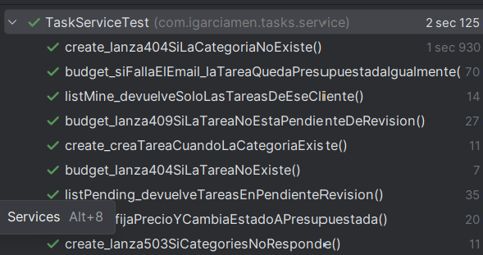

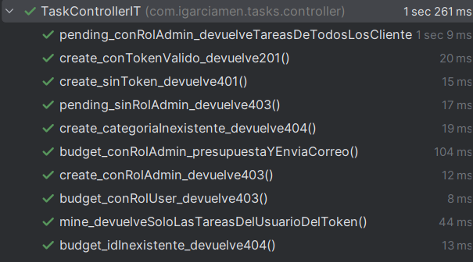

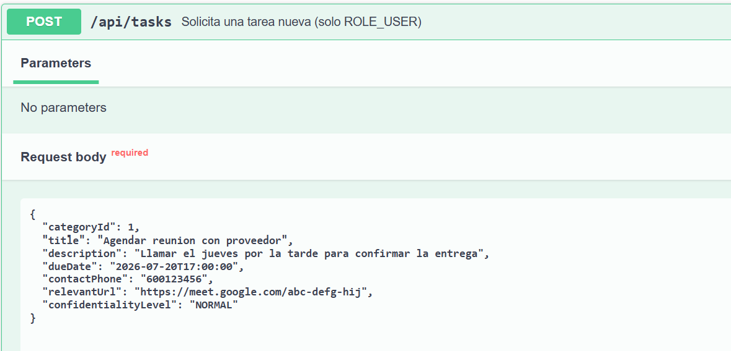

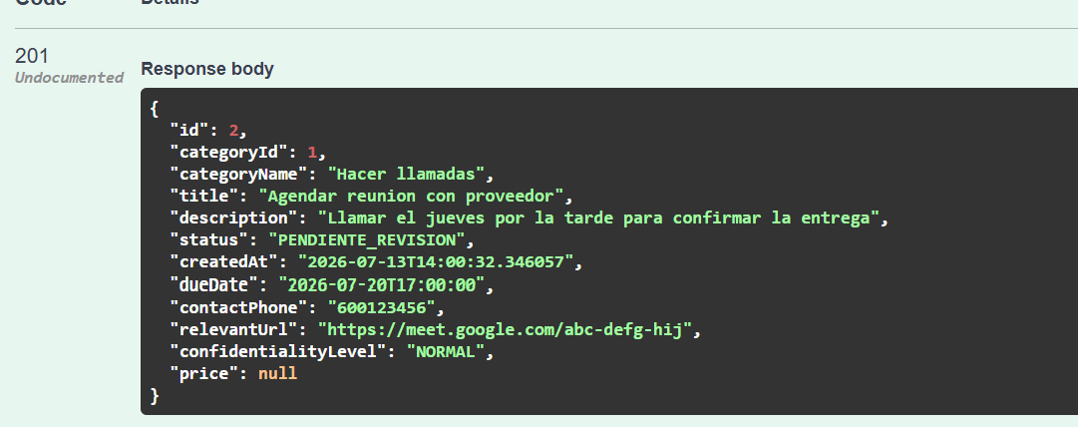

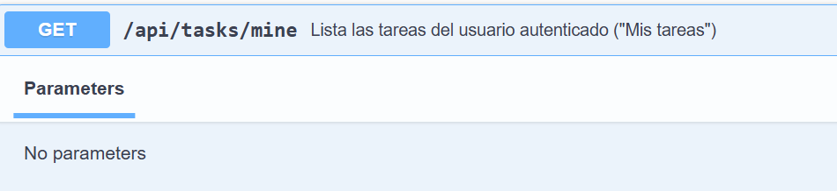

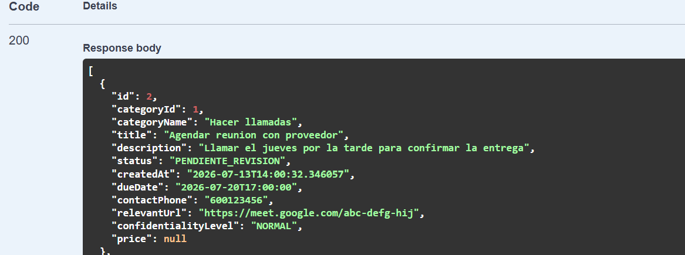

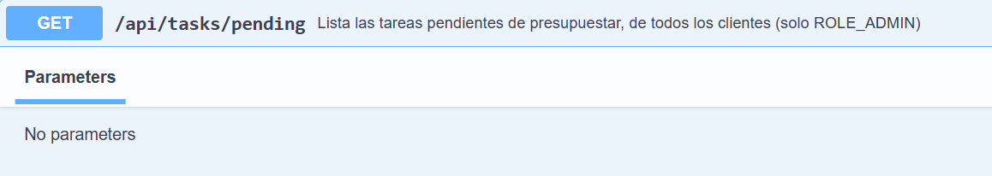

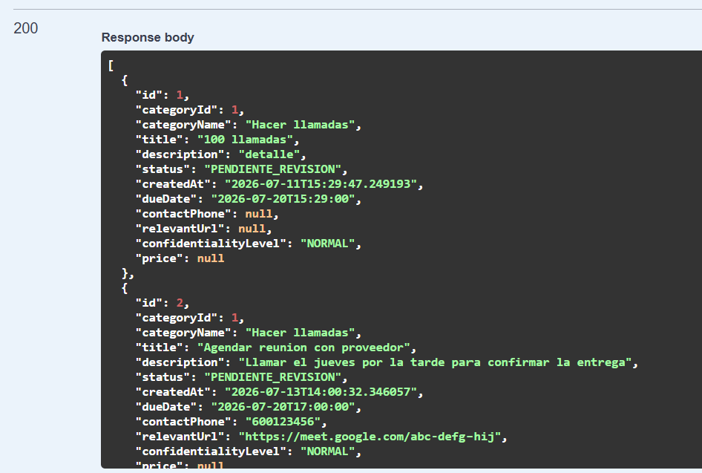

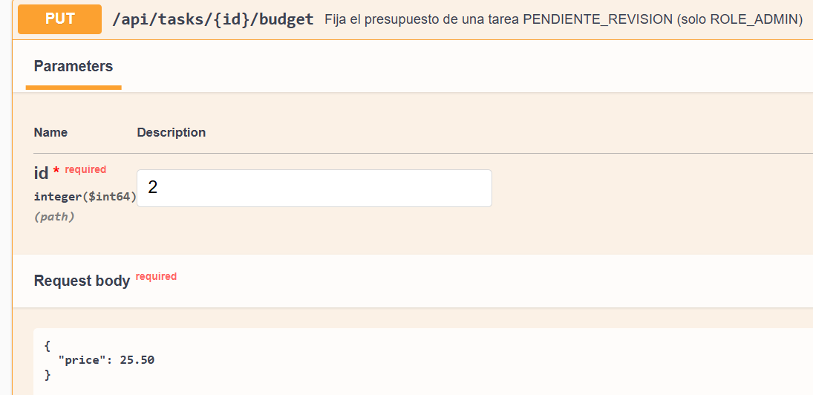

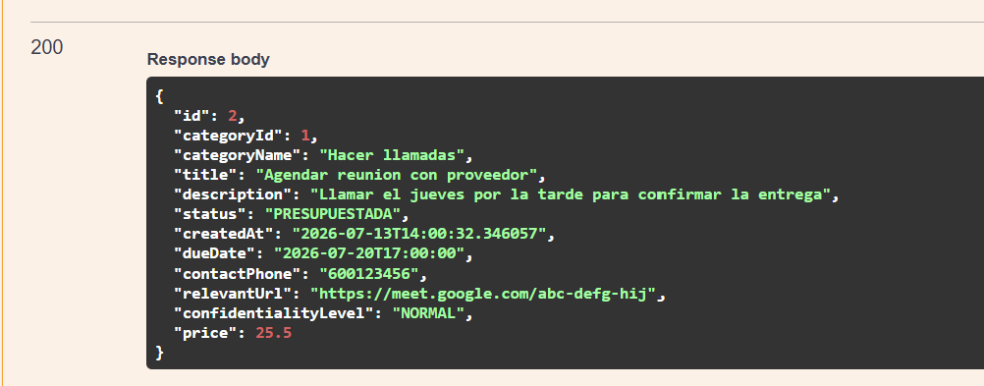

UNA VEZ PRESUPUESTADA, SE VA AL USUARIO “USER” PARA COMPROBAR QUE APARECE CON EL PRCIO
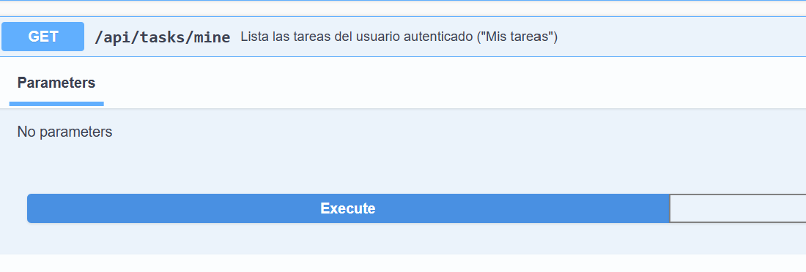

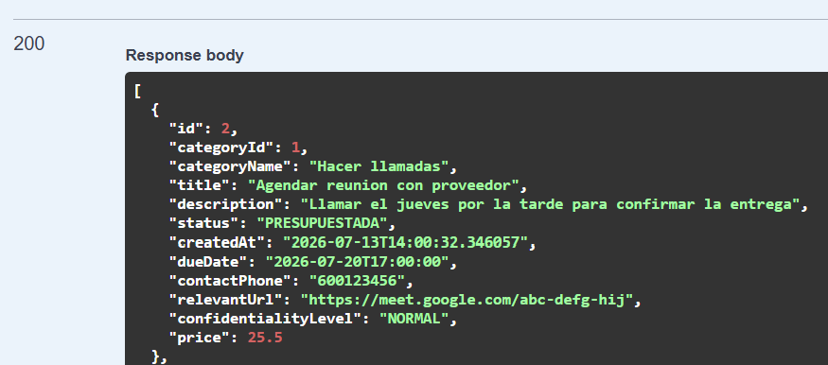

NOTIFICATIONS SERVICE TEST
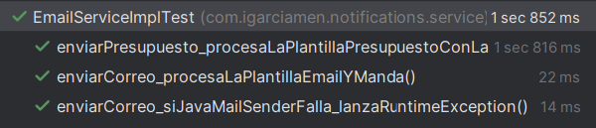

TEST DEL CONTROLADOR DE SPRINGBOOT
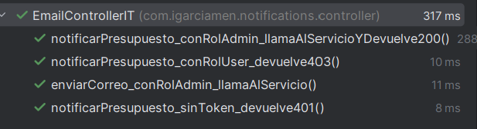

TESTS DE SWAGGER NOTIFICATION
