Sessions do not properly timeout when a window is closed, or after idling. If an account is accessed on a public computer and the user simply closes the browser and walks away, the next person to enter the site’s url will automatically be signed in to the previous user’s account.

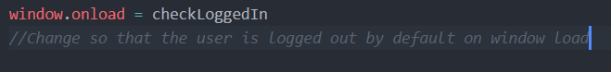

This is found within the logic.js file and checks to see if there is a cookie stored for the current session, but this token never gets cleared. So it after a user logs in once, if(token) will always be true, or in other words, if(!token) as seen in line 18, will always be false.

