Started by changing the type of password to text within the html to make it easier to see the exact input being used for password. This was done on Google Chrome using the built in devtools window, accessible by hitting f12.

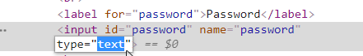

Then the text “’ OR 1=1;--” was used as the input for password. The use of the apostrophe broke the SQL’s SELECT by marking the end of the user’s input. Then the added conditional OR 1=1 was entered, resulting in a “password” that will always satisfy the requirements of the SELECT, and the rest of the code was commented out.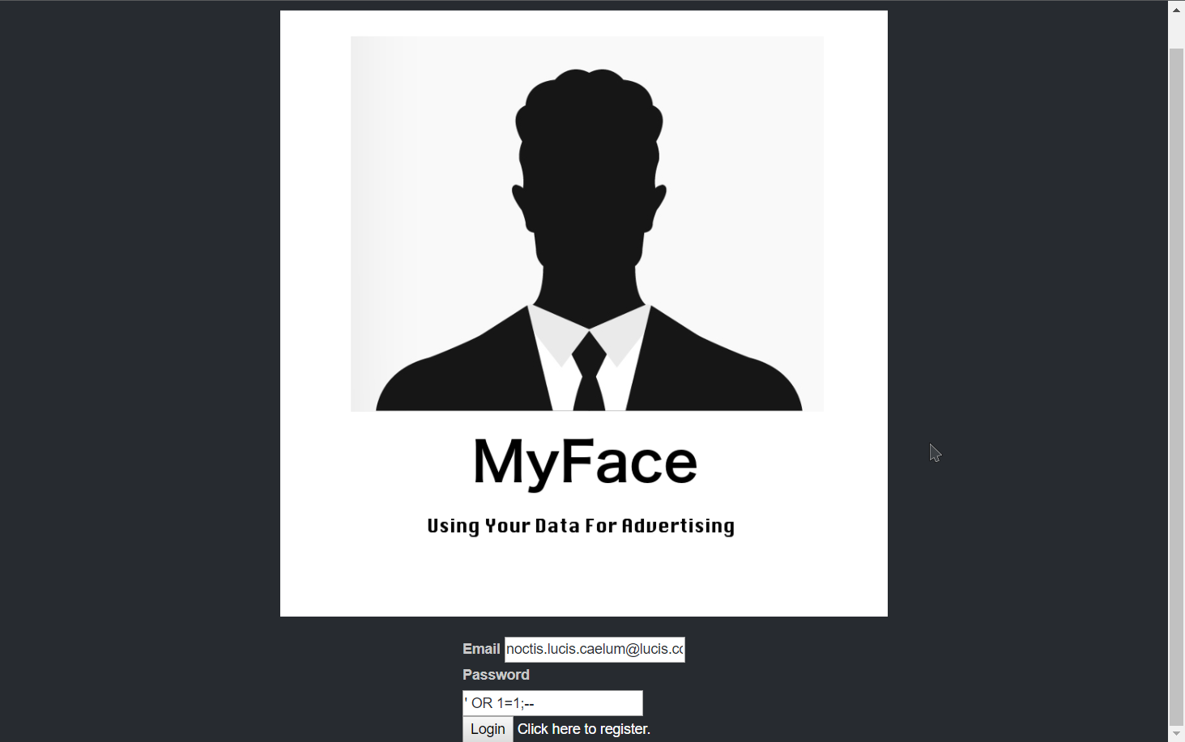

This resulted in a successful login, and earlier on the account e-mail could be broken using the same injection. This provided access to accounts which were not apart of the user table within the site’s database. This was, however, patched and no longer works.s